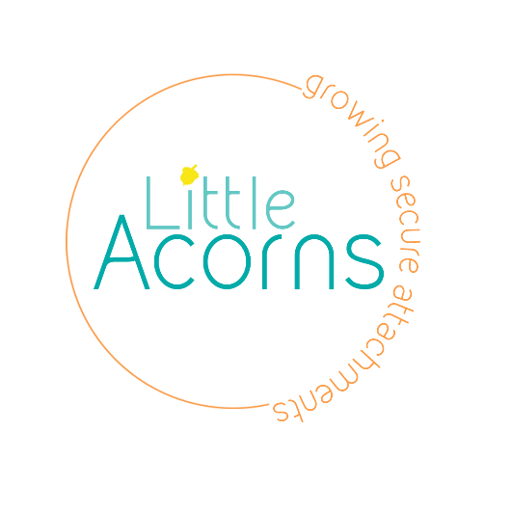

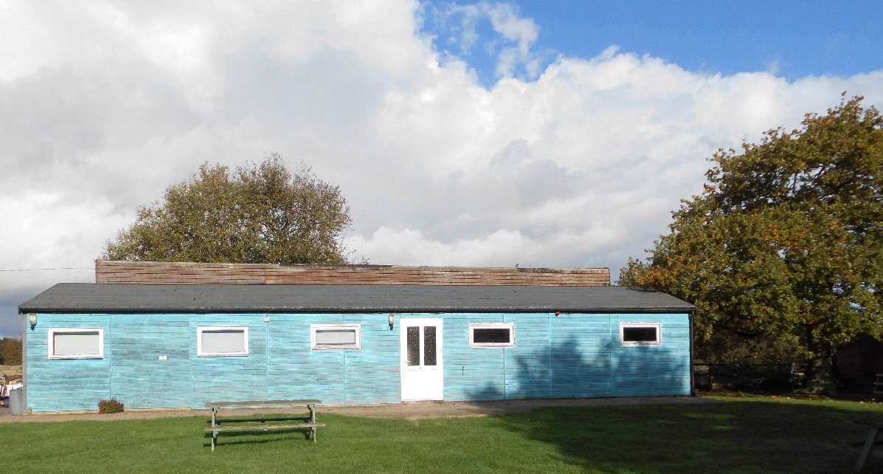
Little Acorns Therapeutic School

Little Acorns School
We are a happy and welcoming school, providing a combination of educational learning, play and emotional support to pupils.
Little Acorns is more than just a school we work on helping to teach pupils how to be functional members of society.
We are AQA accredited and encourage pupils to undertake various modules both educational and life skills.

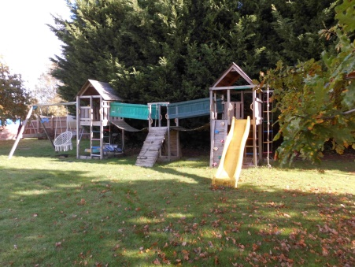
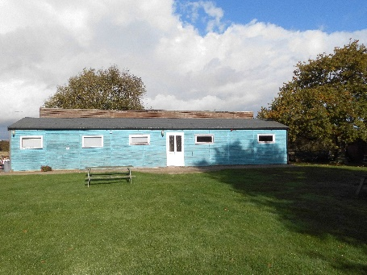
Main School Building
Outside Play Area
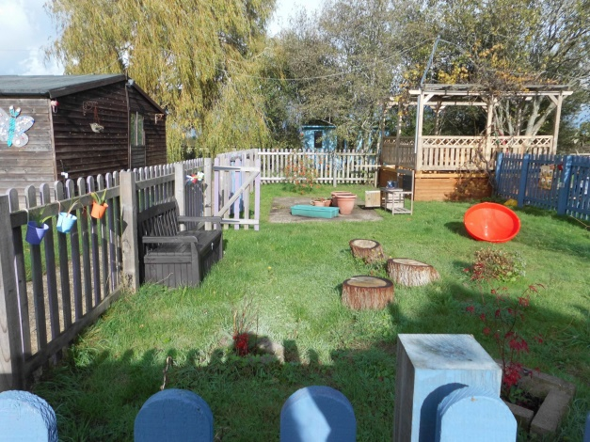

Sensory Garden

School Staff
Alison Neal Laurel Button
Headteacher LSA

Joanna Curley David Bromnick
Maple Class Teacher LSA

Matthew Goldsmith Sophie Cox
Oak Class Teacher LSA

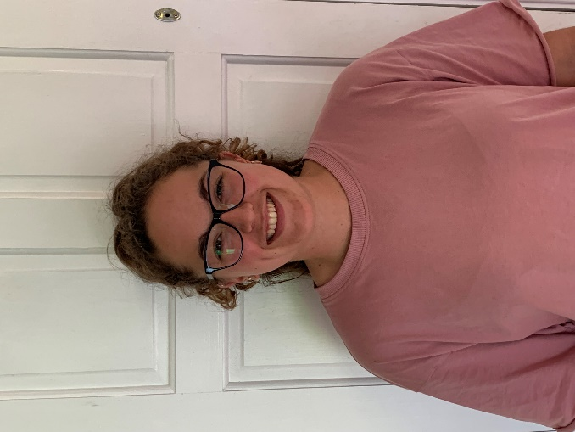

Little Acorns School
Statement of Principles and Practice
Little Acorns aims to foster a happy, safe, and positive environment in which openness, trust, tolerance, and respect supports the learning and developmental objectives of all its boarders. This is achieved within the ‘OUTCOMES’ identified by OFSTED and include Social development, Personal Development, Health, Happiness and Enjoyment, Transitions, Behaviour.
The objectives of Little Acorns School are:
- To provide a safe and caring environment in which the mode of communication is appropriate to the needs of those who are enrolled.
- To support pupils in maximising their individual and educational potential.
- To encourage pupils to function and/or integrate within the wider community.
- To meet the recommended guidelines and safeguards of the Children Act 1989 (as amended by the Care Standards Act 2000 and The National Care Standards Commission Regulations 2002) as well as the 22 national minimum standards for special schools 2011.
- To enhance the physical, emotional, educational, social, and behavioural development of each pupil.
- We actively promote the fundamental British Values through our learning and RSE lessons, Democracy, Rule of Law, Individual Liberty, Mutual respect, tolerance.
- To promote pupils’ spiritual, moral, social, and cultural well-being - irrespective of gender, race, religion, sexuality, or disability.
- To listen to pupils and treat them fairly, equally, sensitively and, where appropriate, to treat information they give in confidence.
- To provide a positive and supportive residential and educational experience for pupils. This will be achieved by: - providing additional information to support the assessment of educational progress, meeting individual needs, preparing pupils to be independent, and responding to varied and changing need.
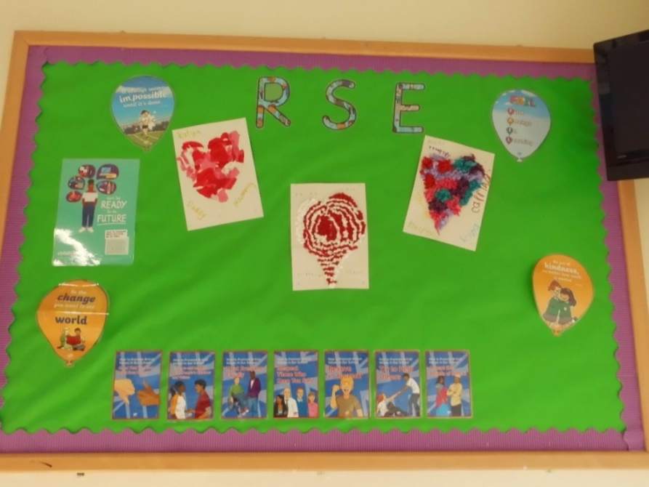

At Little Acorns we want you to….
- Be Happy
- Be Safe
- Be proud of yourself
- Do interesting things
- Do things for yourself
- Be looked after
- Have fun
- Have friends
- Learn and grow
- Be kind

Little Acorns School

Child Protection Policy

Little Acorns School has a Child Protection Policy so that all adults know about their responsibilities to look after children in school. School staff will get to know you well and are trained to notice when you are upset. Little Acorns School is a place where you should always feel safe and happy. You can talk to any of the staff about any worries and you will always be listened to.
Laws are made by the government and the council that the school must follow. It is the responsibility of staff to make sure all children are safe and happy. If you do have a problem, we will try to help you sort it out, which may involve telling other adults.

Alison Neal is Little Acorns Designated Safeguarding Lead any concerns raised are passed over to follow the Safeguarding procedure. Little Acorns Child Protection policy can be found on our website https://littleacornsschool.co.uk/
We believe safeguarding our pupils is everyone’s responsibility and we work constantly to Keeping Children Safe in Education.

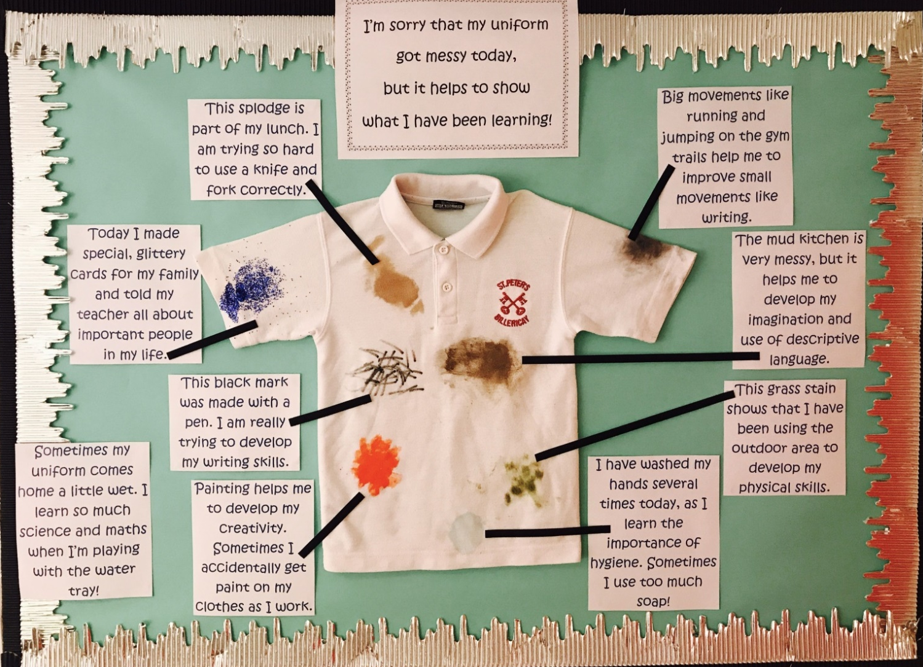
At Little Acorns we believe…………

We are learning all the time! Sometimes this means we get a bit messy!

Activity’s to engage in are tailored to each individual pupil’s needs…
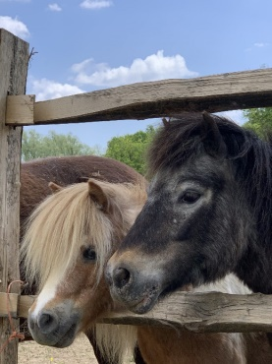
Equine Therapy
Spending time with therapy ponies and a qualified Occupational Therapist once a week, grooming the ponies, cleaning their area, and lunging.

Forest School (seasonal)
Outside activities run by a Forest school Teacher, spending time outside in the woods making fires, building dens, and crafts. This builds pupils confidence and team building skills.

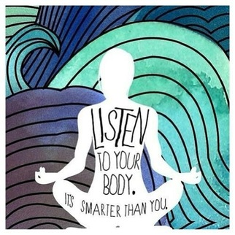
Yoga
DBS checked external yoga instructor specialising in SEN and additional needs, meditation and self-regulation.

Onsite Gardening
Seasonal gardening, starting from building the raised beds, visiting the garden centre for flowers and seeds and soil. Run by the school they get the chance to grow vegetables, flowers and be responsible for taking care of them, watering and then harvesting and enjoying eating the end results.
Interventions and behaviour management programmes
Emotional Regulation Intervention
Friendship Skills
Social Stories
Sensory circuit- for emotional regulation
Drawing and talking therapy
Lego intervention therapy

A typical day at Little Acorns School

8:40 – 8:50 | Settling Activity / Sensory Circuit
8:50 – 9:00 | Makaton days of the week and signs
9:00 – 10:20 | Lesson 1
10:20 – 10:40 | Break time
10:40 – 10:50 | Story and Snack time
10:50 – 11:20 | Lesson 2
11:20 – 12:15 | Lesson 3
12:15 -1:15 | Lunch and Play Time
1:15 – 1:25 | Reading
1:25 – 2:25 | Lesson 4
2:25 – 3:00 | Lesson 5

At Little Acorns we follow the National Curriculum adapting this using various education programmes for those with additional needs:
Read Write Inc – it provides a cohesive and creative approach to teaching children to read and write. Split over 5 days per book children build confidence and expand vocabulary at a speed that suits them. The repetition of reading the same book for 5 days enhances the ability of the child to remember words.
Numicon - giving children confidence and understanding in maths. Learning through a multi-sensory approach. Numicon builds a deep understanding of maths through a multi-sensory approach, developing children's fluency, reasoning and problem-solving.
Timetables Rockstar - is a carefully sequenced programme of daily times tables practice. It allows for learning and fun to be combined earning coins to dress and style your chosen Rockstar.
Makaton - is a language programme that uses signs together with speech and symbols, to enable people to communicate. It supports the development of essential communication skills such as attention, listening, comprehension, memory and expressive speech and language. It is used throughout the school day to allow pupils to communicate in an accessible, inclusive way.
Clicker8 - Clicker is the complete writing solution for the primary classroom, providing every pupil with just the right level of support and challenge. Clicker is used in thousands of schools around the world to develop pupils’ literacy skills, raise writing attainment and enjoyment, and help learners work more independently.

What you will need to succeed:
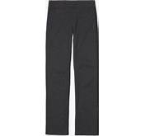

You may need to bring with you some days:
A pair of waterproof wellies,
A waterproof coat,
A spare pair of clothes,
PE kit; white t shirt, trainers, navy blue jumper, navy blue shorts/ jogging bottoms.
A bottle of water

Little Acorns in pictures

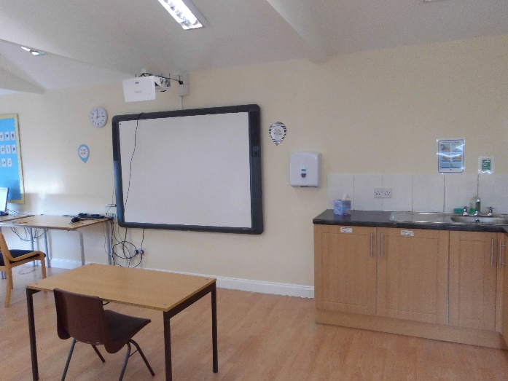
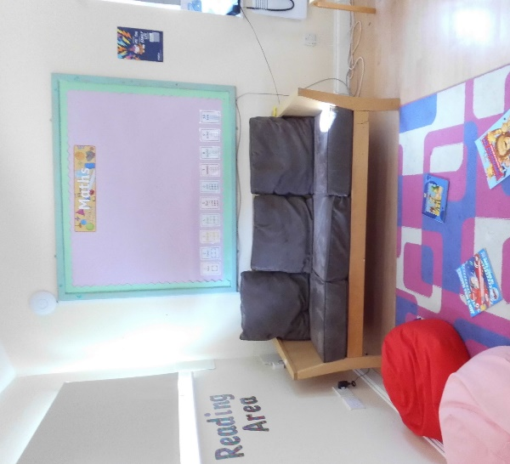
Quite Reading Area / time out area
Oak Classroom situated in the main building, equipped with interactive white board for inclusive learning

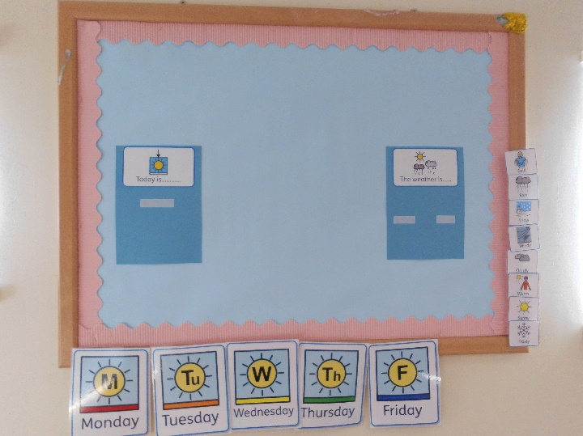
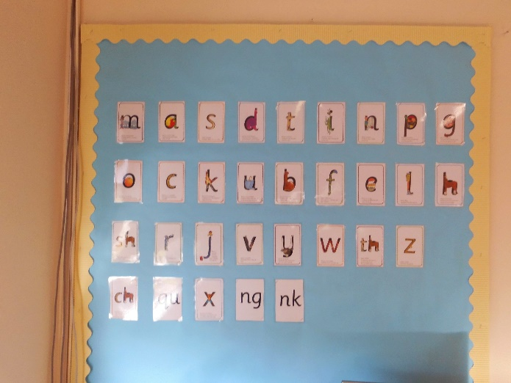
Read Write Inc is a proven way of increasing pupil’s verbal and written skills
Makaton Days of the week and sign practice every morning.

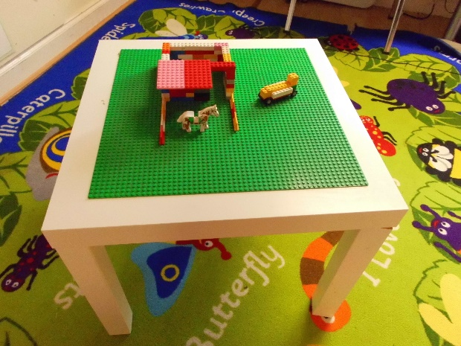
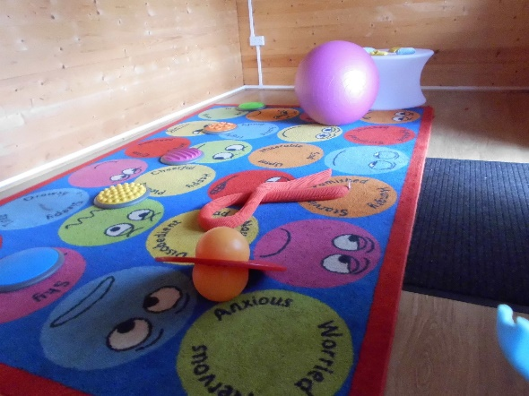

Construction play including Lego intervention therapy, k’nex, wooden train set, sensory circuits set up in Willow class for help with self-regulation.

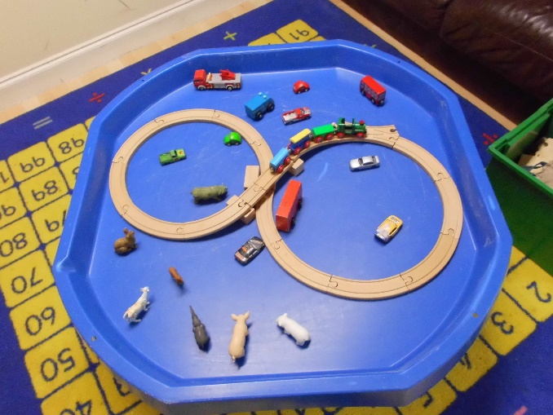

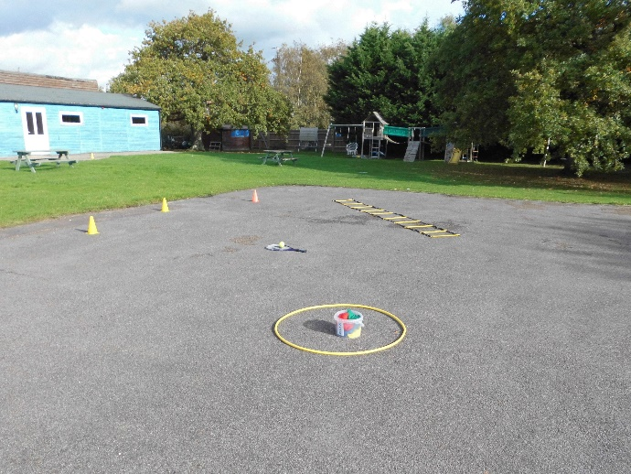

We look forward to welcoming you to the Little Acorns School Community
Onsite and offsite PE is incorporated in the curriculum, Swimming, tennis, badminton, squash, Athletics, basic ball skills, catching running and most of all having fun.

