 |  | 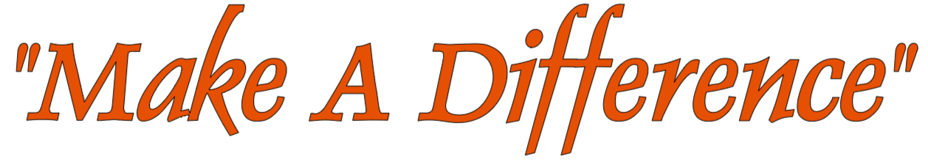  CP Make a Difference is classified as a 501(c)(3) non-profit organization by the standards of the Internal Revenue Service (IRS). Therefore, your donation may be tax deductible to the extent allowed by law Tax ID: 92-1949998  My business/organization is interested in donating to assist Make A Difference (MAD) with continuing to provide free holiday meals to individuals in need in the community.  Sponsorship Levels:  Platinum: ($700 or more) – Recognition as a platinum sponsor contributing MAD’s free holiday meals for 2025. Name will be included on event signage as well as in social media promotions as a PLATINUM sponsor.  Gold: ($350 to $699) – Recognition as a gold sponsor contributing to MAD’s free holiday meals for 2025. Name will be included on event signage as well as in social media promotions as a GOLD sponsor.  Silver: ($50 TO $349) – Recognition as a silver sponsor contributing to MAD’s free holiday meals for 2025. Name will be included on event signage as well as in social media promotions as a SILVER sponsor.  We cannot thank you enough for your generosity and support.  __________________________________________________________________  Business/Organization Name:  __________________________________________________________________  Contact Person:___________________________________________________  Address: __________________________________________________________________  __________________________________________________________________  Phone Number:___________________________________________________  Email Address:____________________________________________________

2025 DONATION DRIVE

MAKE A DIFFERENCE
EIN: 92-1949998
Executive Board:
Susan Patrick - President
Jennifer Lynch - Secretary
Peter Wood - Treasurer

CONTACT
Make A Difference
c/o Susan Patrick
615 Strawcutter Road
Derry, PA 15627
PHONE: 724-694-6945

EMAIL:
susan@cpmakeadifference.org

