 |  | 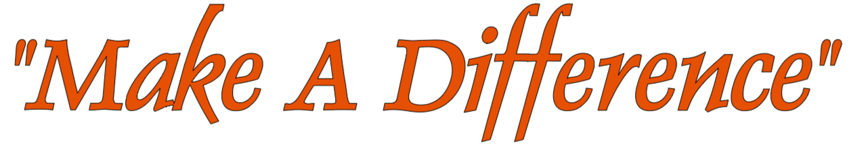  I am writing on behalf of Caring People (CP) Make A Difference (MAD), a local 501(c)(3) organization based in Derry. We are reaching out to request your support in the form of a donation to help provide free holiday meals for individuals and families in need in our community.  One hundred percent of your donation will directly go toward providing home-cooked holiday meals for those who need it most. We are a small group of compassionate individuals committed to working toward the greater good with empathy and care. Our motto is simple: “We can all make a difference, no matter how big or small.”  Last year, with the generosity of our supporters, MAD was able to provide nearly 1,200 meals. As the need continues to grow each year, we know we can count on organizations like yours to help us meet this ever-increasing demand. In 2024, we also partnered with the students of Grace Bible Academy to create 150 hand-made Christmas cards for residents at local nursing homes, further expanding our reach and showing love to those who may be elderly, shut-in, or alone during the holidays.  This year, the cost to prepare each holiday meal is approximately $7, and with food and supply costs continuing to rise, your support is more crucial than ever. We would be truly grateful for any contribution you can make to sponsor these meals and help us spread kindness and joy to our neighbors.  Please find the donation form attached. Every dollar counts, and together, we can make a meaningful difference for those who need it most.  Thank you for considering a donation to support this important cause. We look forward to your partnership in making this holiday season brighter for our community.  Sincerely,  Susan Patrick

Make a Difference
Executive Board:
Susan Patrick - President
Jennifer Lynch - Secretary
Peter Wood - Treasurer

CONTACT
Susan Patrick
615 Strawcutter Road
Derry, PA 15627
PHONE: 724-694-6945

EMAIL:
susan@cpmakeadifference.org

