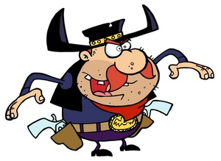 9th Annual
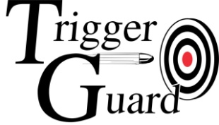
TOP GUN CHALLENGE
Saturday September 21st at 9:00 am
TOP SHOOTER WINS A
Glock Pistol Certificate
2nd Place receives a
A $250 Mantis X shooting performance system

Entry Fee: $30 Members - $35 Non Members
For complete Rules and to Register go to:
www.triggerguardonline.com

Competitors will shoot 10 different stages
with prizes for the top shooter in each stage

Firearms: Competitor supplies Firearms for all stages except stage 9 (Shotguns)
Ammo required: 65 rounds center fire handgun ammunition 110 rounds of .22 rim fire ammunition 16 rounds of center fire rifle ammunition 25 rounds of 12 ga, 8 shot field load
Scoring: Each stage having a point value (stages 1-5) will be added together for a subtotal. Each stage having a time as a score (stages 6-9) will be subtracted from the subtotal points to determine a total point score.
Prize Allocation: The competitor with the most points after shooting all 9 stages will be the Top Gun winner. Top Gun and 2nd place winners are not eligible for Stage Prizes.
Stage winners will be determined by top shooter, providing that shooter has not already won a prize. Shooters can win only 1 prize. Stage prizes are $50 worth of merchandise from our stage sponsors
Stage 1: “Center Fire Handgun Accuracy”
Firearm: Any Center Fire handgun with iron sights, minimum caliber of 9mm
Competitor supplies ammo
Competitor will fire 25 rounds from an unsupported standing position at a B27-C target from 25 yards.
Time limit is 3 minutes 250 points possible

Stage 2: “Rim Fire Handgun Accuracy”
Firearm: Any .22 caliber Rim Fire handgun with iron sights
Competitor supplies ammo
Competitor will fire 25 rounds from an unsupported standing position at a B-27-C target from 25 yards.
Time limit is 3 minutes 250 points possible

Stage 3: “Long Range Center Fire Rifle”
Firearm: Any semi auto, center fire rifle with maximum of 4X scope
Competitor will fire 15 rounds from a seated bench rest position at a
paper target from 140 yards
Time limit is 2 minute 150 points possible

Stage 4: “Long Range Rim Fire Rifle”
Firearm: Any .22 caliber rim fire rifle with iron sights.
Competitor will fire 15 rounds from a seated bench rest position at a
paper target from 100 yards
Time limit is 2 minute 150 points possible

Stage 5: “Long Range Handgun”
Firearm: Any Center Fire handgun with iron sights, minimum caliber of 9mm
Competitor supplies ammo
Competitor will fire 10 rounds from an unsupported standing position at a Steel target from 100 yards.
Each hit on the steel target is worth 10 points. Misses are 0
Time limit is 2 minute 100 points possible

Stage 6: “Center Fire Pistol Speed Steel”
Firearm: Any Center Fire handgun with iron sights, minimum caliber of 9mm Competitor supplies ammo

Competitor will engage 8 steel targets of varying shapes size at distances from 10 to 25 yards. Shooters will shoot this 3 times (strings). You can load 10 rounds per string, so you are allowed 2 make up shots per string if needed.
There is a 5 second penalty for each missed target.
Score is your total time plus any penalties

Stage 7: “Rim Fire Pistol Speed Steel”
Firearm: Any .22 caliber Rim fire Pistol with Iron sights
Competitor supplies ammo

Competitor will engage 8 steel knock over targets of varying shapes size at distances from 10 to 25 yards. Targets must fall to score a hit. Shooters will shoot this 3 times (strings). You can load 10 rounds per string, so you are allowed 2 make up shots per string if needed.
There is a 5 second penalty for each missed target.
Score is your total time plus any penalties

Stage 8: “Shooting Gallery”
Firearm: Any .22 caliber Rim Fire Rifle with Iron sights or red dot.
No Magnification Allowed
Competitor supplies ammo
At 20 yards there will be a rack with 4 rows of steel animal silhouettes, (25 total).
You will be allowed 10 shots per row. Each row of silhouettes will be timed separately, allowing shooters to reload between rows. There will be a 5 second penalty for each missed target.

Score is your total time plus any penalties
Stage 9: “Shotgun Speed Shoot”
Firearm: 2 Mossberg 930 JM pro 12 ga shotguns supplied by Trigger Guard
Competitor supplies ammo. 25 rounds of 12 ga field load 8 shot
There will be 2 shooting positions, with a shotgun loaded with 10 rounds at each stage. Competitor will engage 10 knock over steel targets and clay pigeons at distances of 10-25 yards from position 1, ground the shotgun then move to position 2 and engage those 10 targets. There will be 2 extra shells at each shooting position if need for any make up shots.
There is a 5 second penalty for any targets missed or left standing

Score is your total time plus any penalties

Stage 10: “Accu-Shot One Shot Challenge” Sponsored by B&T Industries

Competitors will fire ONE shot at a 2.5 X 3.5 inch target from 100 yards, using the
same rifle as in Stage 3 . The competitor shooting closest to the center of the
target will receive a $300 gift certificate for merchandise at B&T Industries in
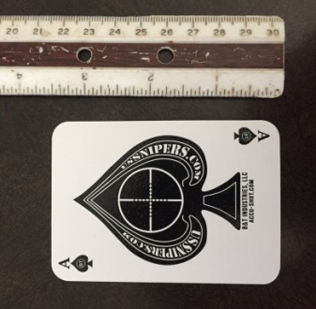
This is a separate stage from the Top Gun Stages and does not count towards the
total points for Top Gun
Winner of this stage IS eligible for all prizes in the Top Gun Challenge

