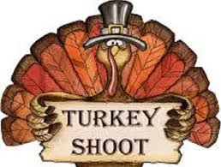
Shotgun Knock Out Tournament
Start with 7 shooters (Squad) on the trap field. Shooter 1 calls for a bird, if they hit the bird, they are safe and we move on to shooter 2 to call for a bird. However if shooter 1 misses, then shooter 2 has the opportunity to shoot the missed bird and knock out shooter 1. If shooter 2 also misses, then shooter 3 has the opportunity to shoot at the missed bird. If shooter 3 hits, that knocks shooters 1 and 2 out. If everyone shooting at the bird misses, then no one is knocked out. Once a shooter has been knocked out, they are eliminated from shooting and step off of the shooting line
This continues until only 1 shooter is left to win the turkey!
Shooters will be lined 10 yards behind trap house
Shooters are allowed to load one round at a time until there are only 2 shooters left, then two rounds may be loaded

