Trigger Guard 2 Gun Match

Concept: The Trigger Guard Run & Gun pistol match is designed for the shooter at any level. It has simple stages that can be shot with stock over the counter equipment. The intent is to create a match that is fun to shoot for everyone. Safety procedures will always be foremost even though the match rules and stage procedures are kept as simple as possible. Range Master will have final ruling on all disputes and questions.
Safety: Trigger Guard is a “cold” range and weapons will not be loaded except on the designed firing line as and directed by the range officer. Shooters are not to break the “180” plane with their weapons and the stages will be designed to minimize that possibility. Magazines may be loaded anywhere on the range except the safe area which is designated for handling weapons only (no ammunition allowed in safe areas). Trigger Guard range safety rules will apply.
Equipment: Pistol holsters and magazine pouches/shell holders are encouraged but not required. Any Center Fire handgun can be used. No special equipment is necessary to participate.
Divisions: There are 3 Divisions, Tac Ops - Open - PCC
**Tactical Optics, aka Tac Ops**
Pistol - You are allowed to shoot a pistol in 9mm or larger caliber. The pistol must have iron sights. Magazine capacity is limited by stock magazine length. Extended +2 base pads for your magazines are allowed
Rifle - You are allowed to use a .223 or larger caliber semi-automatic rifle. You are allowed one magnified optic. You can use iron sights or a red dot as well. You are allowed to run offset iron sights with your magnified optic. You cannot use bipods in this division. Magazine capacity is not limited unless stated.
**Open Division**
No limitations on accessories, providing the guns are still safe to operate.
**PCC Division**
This division is exactly the same as Tactical Optics, expect instead of a rifle you are using a Pistol Caliber Carbine. You can only use iron sights or a red dot as your sighting system, no magnified optic. The pistol rules are identical to Tactical Optics.
Sub-Divisions:
Junior: Any shooter under the age of 18
Senior: Any shooter over the age of 60
Lady: Any female (at birth) shooter

Ammunition: Any standard TMJ, FMJ, lead or hollow point are allowed. Steel core, armor piercing or magnum rounds are NOT allowed

Stage design: There will typically be four stages with a range officer at each stage and squads will be open so each shooter can, on their own, go to the stage of their choice. Stages will not be high round count. Typical stage round count will be approx. 25-30 rounds. Stages will have a limit on number of rounds that can be loaded, typically 10 rounds, and reloading is required.
Procedure: Shooters will start pistols holstered or on the barrel in front of you fully loaded and chambered with safety on(if so equipped). On the buzzer, engage targets in any order with as many rounds as necessary to hit the targets. Once targets are hit move to the next shooting position and engage those targets. Magazines can be carried your person and/or staged on the barrels. Knock over steel targets must fall to score, static steel can be engaged as many times as necessary but must be hit once to score, all paper targets are engaged with 2 rounds. More than 2 rounds on paper will be a 10 second penalty per round.
Targets: A combination of NRA D-1, USPSA paper and steel targets will be used.
Scoring: Scoring is time plus penalty. Paper targets will have 3 scoring areas A-B hits add 0 penalties, C hits add 1 seconds, D hits add 3 seconds and misses on any target add 10 second penalty to your time. Steel targets are hit or miss

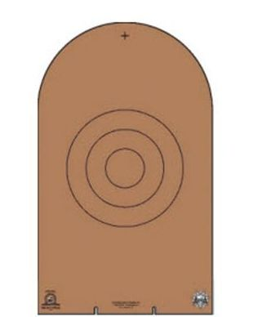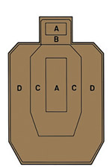
A B C D

