**INDIANTOWN GAP**

**NATIONAL CEMETERY**

**MEMORIAL COUNCIL**

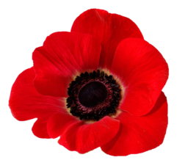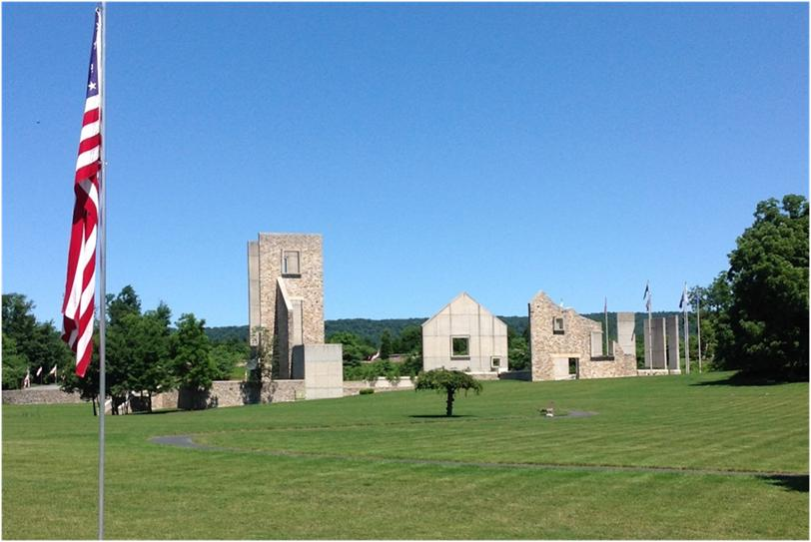

**40th Annual Veterans Day Ceremony**

**Sunday, November 6, 2022, 2:00 P.M.**

**Co-sponsored by**

**Catholic War Veterans, Department of Pennsylvania**

**Public Invited – Ceremony Held Rain or Shine**

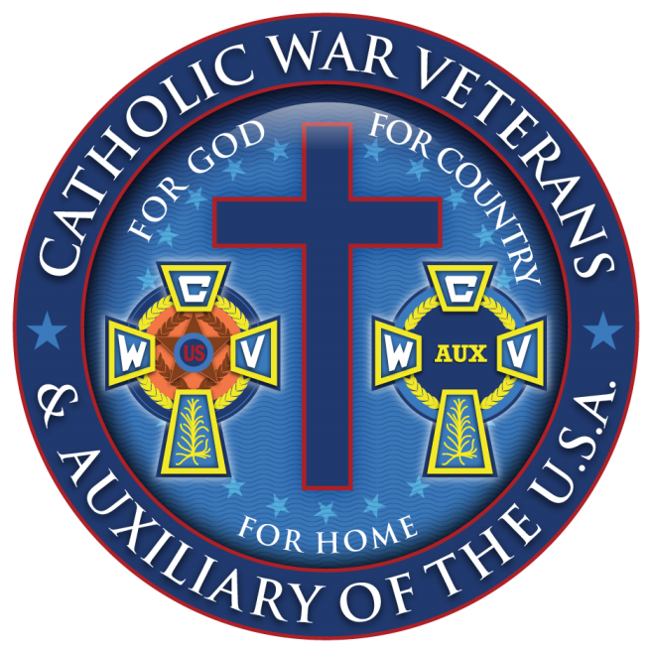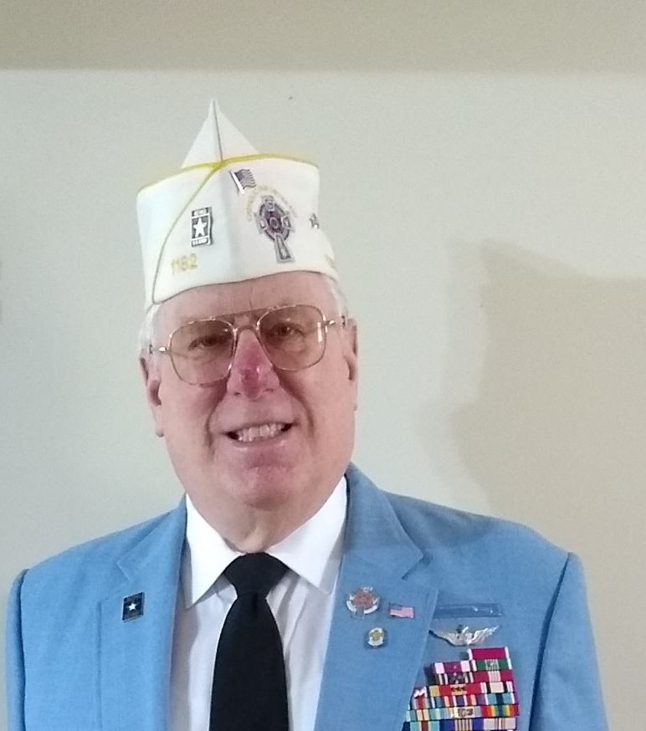

Department of Pennsylvania

**Nicholas M. Taylor, Commander**

LTC Nicholas M. Taylor is a native of Norristown, PA. After enlisting in the US Army Reserve in 1979 and serving over three years as an Enlisted soldier, he was commissioned from LaSalle College in Philadelphia, as a Second Lieutenant in the Ordnance Corps in 1982.

LTC Taylor has completed numerous schools including the Infantry Officer Basic and Advanced Courses at Fort Benning; the Instructor Training Course; the US Air Force Squadron Officer School at Maxwell Air Force Base; the Quartermaster Officer Advanced Course, Petroleum Laboratory Officer Course, and the Associate Logistics Executive Development Courses at Fort Lee; the Senior Transportation Officer Qualification Course at Fort Eustis; the Advanced Military Police Branch Orientation Course at Fort Leonard Wood; and the US Army Command and General Staff College.

During the period of March 2004 through June 2008, LTC Taylor was called to Active Duty with US Army Materiel Command in direct support of Operation Iraqi Freedom III, Operation Enduring Freedom, and Operation Noble Eagle. In challenging command and staff duty assignments of significant importance, LTC Taylor has served as Deputy Director of the Logistics Operations Center, HQ, Army Field Support Command (now Army Sustainment Command), Rock Island; Chief, Logistics Assistance Office, later, Commander, Logistics Support Battalion, 3d Infantry Division, Fort Stewart and also in Baghdad, Iraq; Commander, Logistics Support Battalion, 1st Cavalry Division, Baghdad, Iraq; Commander, Logistics Support Battalion, Fort McCoy; Executive Officer, 406th Army Field Support Brigade, Fort Bragg. His last assignment on Active Duty was Commander, Logistics Support Battalion, Fort Knox, Kentucky.

LTC Taylor and his wife Tanya currently reside with their one daughter in Norristown, PA.

LTC Taylor is the current Department of Pennsylvania Commander of the Catholic War Veterans, a position that he has held since June 2019. He is also the appointed National Adjutant of the Catholic War Veterans since 2017, and a Life Member of CWV.

The Indiantown Gap National Cemetery Memorial Council wishes to thank the Catholic War Veterans Department of Pennsylvania for their generous support and assistance to make this event possible.

40**th Annual Veterans Day Program**

**Indiantown Gap National Cemetery**

**November 6, 2022 at 2:00 PM**

**Sponsored by the Indiantown Gap National Cemetery Memorial Council & The Catholic War Veterans, Department of Pennsylvania**

Welcome Joan Barkley, President, IGNC Memorial Council

Master of Ceremony Jay Snyder,IGNC Memorial Council Vice President

Presentation of Colors Lebanon VFW Composite Squadron 307,

Civil Air Patrol Honor Guard

Invocation James W. Franklin, Chaplain Service

Lebanon VAMC

Pledge of Allegiance BG(PA) Robert J. DeSousa, Commander

Catholic War Veterans Post 707

National Anthem John Bernesky, State Police Ceremonial Unit

IGNC Director’s Welcome John Spruyt, Director, IGNC

Veterans Day Proclamation William T. Wright, Sr. Department Adjutant

Catholic War Veterans

Recognition of Guests Jay Snyder, IGNC Memorial Council

Armed Forces Medley Jay Snyder, IGNC MC / with Sound System

Veterans Day Address Nicholas M. Taylor, Department Commander

Catholic War Veterans

POW/MIA Ceremony Thomas Campbell, IGNC MC Trustee

Wreath Presentation Nicholas Taylor, Department Commander

Joan Barkley, IGNC MC President

God Bless America John Bernesky, State Police Ceremonial Unit

Rifle Salute IGNC, Vet- 21 Salute Honor Guard

Taps Robert Goodman, VFW Post 6704

Minuteman Honor Guard

Benediction James W. Franklin, Chaplain Service

Lebanon VAMC

Retire Colors Lebanon VFW Composite Squadron 307

Civil Air Patrol Honor Guard

**INDIANTOWN GAP NATIONAL CEMETERY**

Indiantown Gap National Cemetery opened in September 1982 and is the eighth largest of 155 national cemeteries administered by the Department of Veterans Affairs National Cemetery Administration. The cemetery’s mission is to provide a dignified and respectful burial for those qualified as provided for by the 37th Congress and the National Cemeteries Act of 1973. Eligibility is based on a military service discharge that was other than dishonorable. Burial arrangements for the veteran, spouse and dependent children who qualify are made at the time of their death.

With the completion of the 2019 expansion project, the 677acre National Cemetery has approximately 225 acres developed to provide over 63,000 gravesites. A dedicated crew of 33 tends to the maintenance of the grounds and performs internments.



**INDIANTOWN GAP NATIONAL CEMETERY MEMORIAL COUNCIL, INC.**

The Indiantown Gap National Cemetery Memorial Council started on March 10, 1983 for the purpose of coordinating and conducting public programs to honor veterans, primarily at the cemetery. The cemetery dedication ceremony and the first Memorial Day observance were held May 29, 1983. The Memorial Council dedicated the first Avenue of Flags during the annual Memorial Day program on May 26, 1985. The Avenue of Flags consists of internment flags donated by the families of deceased veterans. The flags are placed on special flag staffs that line the roads throughout the cemetery and are displayed continuously from the first Saturday in May until after Veterans Day. The State and Territorial flags displayed on the Avenue of Flags are purchased with donations from program patrons and friends of the cemetery.

The Memorial Day program is held at 2 p.m. on the Sunday immediately before Memorial Day and the Veterans Day program is held at 2 p.m. on the Sunday immediately before November 11th. If the 11th is a Sunday, the Veterans Day program is held on that day. The Wreaths Across America (WAA) and Candlelight Service events are usually held on the 2nd Saturday of December (occasionally on the 3rd Saturday) with the WAA ceremony beginning at noon and the wreaths being placed on the graves beginning about 1 p.m. The Candlelight Service begins at 4:30 p.m. All these events are held in the Pennsylvania Veterans Memorial, the largest memorial in any national cemetery; which was dedicated on October 7, 2001.

The Memorial Council events receive assistance from the VA Medical Center which provides security, the National Guard Training Site, and the Pennsylvania Department of Military and Veterans Affairs.

Memorial Council Officers

President: Joan Barkley - Vice President: Joseph Snyder

Treasurer: Randy Eckert - Secretary: Robert Hauser

Trustee’s: Michael Yavor, Donald Person, and Thomas Campbell

Indiantown Gap National Cemetery (IGNC) Memorial Council is a 501(c)(3) nonprofit organization. IGNC Memorial Council is not part of

the Department of Veterans Affairs or any of its components, has no governmental status, and receives no government funding.