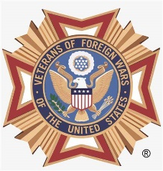 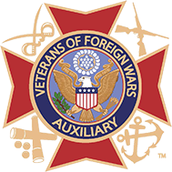

**PEARL HARBOR REMEMBERANCE CEREMONY**

Fox Eichelberger VFW Post 7415 is hosting a Pearl Harbor Remembrance Day Ceremony, December 6, 2024.

Ceremony to begin at 12 noon, lunch will follow the ceremony.

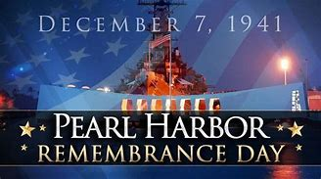

Please come and join us as we remember the brave men and women who perished in the attack on Pearl Harbor in Hawaii on December 7, 1941. Special recognition to our Post namesakes ENS Lee Fox and PVT Paul R. Eichelberger