VETERANS OF FOREIGN WARS OF THE UNITED STATES
DISTRICT 18, DEPARTMENT OF PENNSYLVANIA
6218 Elmer Avenue, Harrisburg, PA 17112
(717) 671-9012
Email: persiangulfvet91@gmail.com

●●●

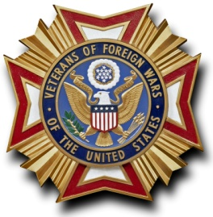
Office of
District 18 Commander

14 December 2021

TO: District 18 Members and Auxiliaries

SUBJECT: District 18 Smart/Maher National Citizenship Education Teacher Winners 2021 - 2022

Elementary School Teacher – Post 8023 - Miss Adrianna Hickey – Lebanon School District – 1st Grade
Middle School – VFW Post 477 - Mrs. Kathleen Hickey – Saint Patrick School, US History and World Geography
High School – VFW Post 6704 - Mr. Marc Anderson – Northern York High School, US Government and History

Respectfully,

//Signed//
Fred Hechler

