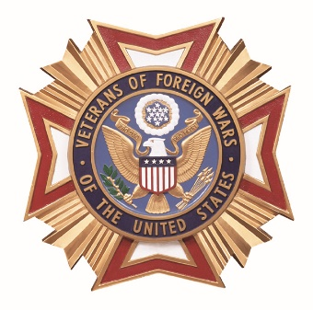 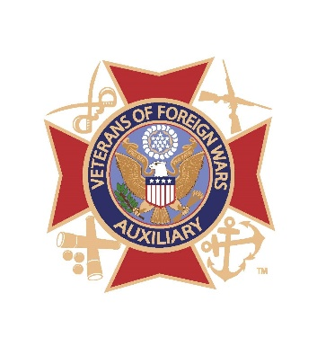

***DEPARTMENT OF PENNSYLVANIA***

***VETERANS OF FOREIGN WARS AND AUXILIARY***

SOCK, HAT AND GLOVE DONATION DRIVE

*for Homeless Veterans*

*Comrades, Auxiliary Brothers and Sisters:*

*This year the, VFW and its Auxiliary are partnering**in the Departments annual collection of white socks, gloves and hats for the Homeless Veterans Campaign* ***(NO USED CLOTHING)****. Please bring items to the Mid-Winter Conference, 19 - 21 January 2023 at the Wyndham Gettysburg, 95 Presidential Circle, Gettysburg, PA.*

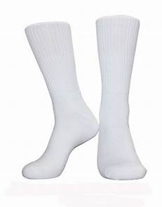 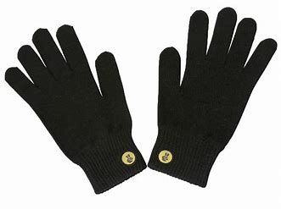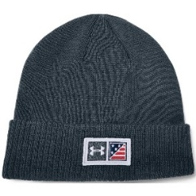

*Any questions or concerns, please feel free to contact Department of PA Headquarters* or myself,

David “Spike” Gyger 717-991-1473