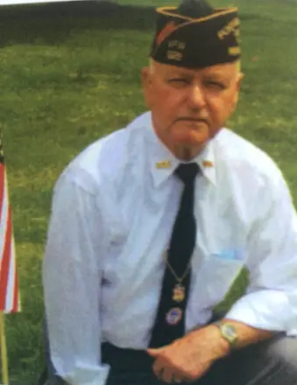

Thomas A. Brown Obituary

Thomas A. Brown, 92, of Swarthmore PA passed away on Friday, October 31, 2025.

Born in Chester, PA he was the son of the late William E. and Ethel nee Marshall Brown.

Thomas was a proud U.S. Navy Veteran who honorably served his country during the Korean War. Following his service, he dedicated 50 years of his career to Westinghouse Electric. For a time, he lived in Winter Springs, Florida, where he was an active and well-loved member of the community.

Thomas was deeply involved with VFW Post 3460 in Media, where his leadership and dedication to fellow veterans led him to serve as VFW Commander for the State of Pennsylvania from 2016 to 2017.

In addition to his service and community involvement, Thomas was a talented artist and author. He wrote two books, Candlelight Christmas and Unsung Heroes of All Wars Including Current Conflicts, reflecting his deep appreciation for those who served.

Above all, Thomas was a loving husband, father, grandfather, and great-grandfather who will be remembered for his kindness, creativity, and unwavering devotion to family and country.

Survived by his beloved wife Anna Buzan nee Johnson, his children William (Patricia) Brown, Thomas A. Brown Jr., and Patricia (Louis) Heenan, as well as many grandchildren, great-grandchildren and friends.

A visitation will be held on Saturday, November 8, 2025 from 10:00 am – 12:00 pm at Kevin Lyons & The Marvil Family Funeral Home, followed by a service at 12:00 pm.

In lieu of flowers memorial donations can be made to The Wounded Warriors Project of PA.

Arrangements are by The Marvil Family Funeral Homes, Darby, Aldan & Glenolden. Please visit www.marvilfuneralhome.com for the online obituary, guestbook and condolence messages.

Address of the funeral home is:
Kevin Lyons & The Marvil Family Funeral Home
202 S. Chester pike
Glenolden, PA 19036

