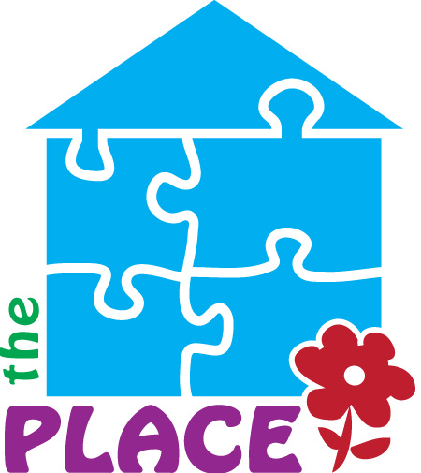 | Activity Kit Registration Form  Fun, hands-on activities for families to enjoy together
Complete this form to register your family for The Place Activity Kits.
Each monthly kit includes five activities or crafts, all needed materials, and easy-to-follow instructions for families to enjoy together.
Parent / Caregiver Information
Parent/Guardian Name: _______________________________________________
Phone Number: _________________________________________________________
Email Address: _________________________________________________________
School District: _______________________________________________________
Children in Household
Number of Children in Household: _______________________________________
Ages of Children Receiving Activity Kits: _______________________________
Please list the age of each child who will be participating so activities can be planned appropriately.
Child 1 Age |  | Child 2 Age
Child 3 Age |  | Child 4 Age
Child 5 Age |  | Child 6 Age
Child 7 Age |  | Child 8 Age
Activity Kit Registration
Please check: ☐ Yes, I would like to register my family to receive Activity Kits.
Preferred way to receive updates: ☐ Phone ☐ Text ☐ Email
Additional Information
Comments or information we should know: _______________________________
Parent / Guardian Acknowledgment
I understand that Activity Kits are available while supplies last and that The Place will provide information regarding kit availability and distribution.
Parent/Guardian Signature: ________________________________________
Date: ______________________________________________________________
For Staff Use
Registration Received | Kit Distributed | Date Distributed | Staff Initials
☐ | ☐
Questions? Contact The Place at 607-336-9696
22 East Main Street, Norwich, New York 13815 | Serving Chenango County since 1983
Great things are happening at The Place...be a part of it.

