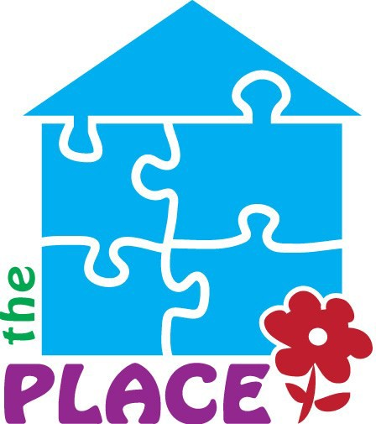
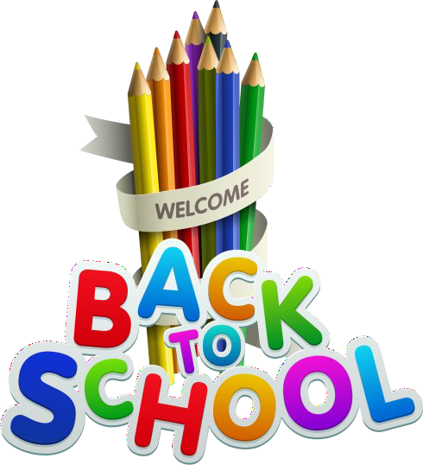
School Supply Request Form

2026-2027 School Year

Complete and Check Off Needed Items for Your Student
This form is designed for parents and guardians to indicate which school supplies their child needs for the upcoming school year. Please check off the supplies you wish to request, and provide any additional information needed. Return this completed form to The Place ASAP.

Student & Parent Information
Student Name: Grade/School District: Parent/Guardian Name:
Address:
Contact Email/Phone:

Supply Checklist

Check | Item Name | Quantity Needed
( ) | Pencils (regular)
( ) | Pens
( ) | Colored Pencils
( ) | Notebook Paper (wide-ruled)
( ) | Notebook Paper (college-  ruled)
( ) | Crayons
( ) | Markers
( ) | Glue Sticks
( ) | Scissors
( ) | Folders (with pockets)
( ) | Composition Notebooks
( ) | Binders (1 inch)
( ) | Highlighters
( ) | Erasers
( ) | Backpack
( ) | Index cards
( ) | Spiral Notebook
( ) | Pencil case

Additional Needs or Comments
Other supplies needed:
Comments or special requests:

Signature
Parent/Guardian Signature:
Date:

Instructions
Please check each item your child needs and specify quantity.
If additional supplies are needed, list them under “Other supplies needed.” We will try our best to fill that
need.

For questions, please contact The Place at 607-336-9696.
Completed forms can be emailed to info@theplacenorwich.com prior to September 3. Exact times and dates of distribution will be announced.

The Place
22 East Main Street, Norwich, New York 13815 607-336-9696
Serving Chenango County since 1983

