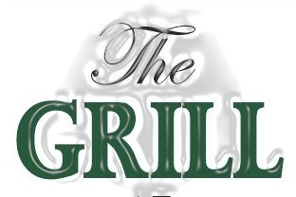

The Little Grill with a Bistro Twist

Breakfast Service
Saturday, Sunday & Holiday Mondays 8:30am – 10:30am
Breakfast Plates
Burleigh $17
2 Poached Eggs, served atop toasted English muffin, sliced tomato, pea-meal bacon and finished with double smoked cheddar, breakfast potato, and fruit garnish
Traditional $14
2 Eggs (Scrambled or Over), served with sliced bacon & farmer sausage with toasted artisan bread, breakfast potato, sliced field tomato, and fruit garnish
Stony Stack $15
3 Buttermilk Pancakes, finished with warmed maple syrup, dollop of creamery butter, and sliced berries
Quiche $14
Slice of our Inn made vegetarian quiche, with breakfast potato, sliced field tomato, and fruit garnish
Lovesick $19
2 Poached Eggs, served atop toasted English muffin, with cream cheese spread and smoked salmon breakfast potato, and fruit garnish
Breakfast Sandwich Include breakfast potato, and fruit garnish
The Grill - $13
Fried Egg, Pea meal Bacon, Slice Tomato, Cheddar Cheese served on Artisan Bread
B.L.T Bagel – $12
sliced side bacon, crispy romaine lettuce, sliced field tomato, mayo on toasted everything bagel
Lighter Breakfast
Yogurt & Honey, Inn Made Granola, Fresh Fruit Bowl, Toasted Everything Bagel $9
1 Egg (scrambled or over) , slice artisan bread, sliced field tomato $10
Steel Cut Oats & Berries, finished with honey $8
Toasted Artisan Bread (2 slice) or Toasted Everything Bagel , with creamery butter & jam $6

Beverages & Sides
Coffee, Decaf or Orange Pekoe Tea $2, Fruit Juice (Orange, Apple, Pineapple, Cranberry) $2.50
Herbal Tea, Hot Chocolate $2.75
Add Side Bacon (3) $2.50, Farmer Sausage (2) $2.50, Pea meal Bacon (2) $3.50

