**Peterborough Racial Equality Council Annual Report 2019/20 and 20/21**

**Executive Committee 2019/20**

**Chair** Bernadetta Omondi

**Vice Chair** Alison Davies

**Secretary** Gary Huskisson

**Treasurer** Geoff Johnson

**Members:** Kit Hubback

Sameena Aziz

Tim Cox

Katy Hawkins (res)

Leonie McCarthy *

Karima Shah

Sandra Varela

Paulina Williams

Petr Torak *

*Elected but withdrew before registration with Charity Commission

**Executive Committee 2020/21**

**Chair** Bernadetta Omondi

**Vice Chair** Alison Davies

**Secretary** Jackie Chibamu (res)

**Treasurer** Geoff Johnson

**Members:** Kit Hubback (Minutes Secretary)

Sameena Aziz

Gary Huskisson

Paul Watkins

**Co-opted members until AGM:**

Mohammed Osaman

Farshid Raoufi

Since the formation of the new Exec Committee in April 2019, and throughout the Covid-19 pandemic, we have worked on the following priorities:

* Issues raised by Black community leaders, coordinating, and bringing these to the attention of city authorities.
* Community engagement and partnership working, particularly with smaller community groups who feel they do not have a voice in the city.
* Research with young people from diverse ethnic backgrounds to promote their concerns to community leaders and city authorities.
* Casework and signposting clients to appropriate services.

An initial priority for the new Executive was to locate new office premises, as the previous accommodation at the Millennium Centre was no longer accessible. This was achieved through moving our equipment, archives, and library to a new office on the top floor of the Dominion Church in Broadway. We are grateful to the former director MJ Ladha, for his assistant in packing and sorting during the relocation, and to Stephen at the church.

We also established a new website: prec.info and contact email address [contact@prec.info](mailto:contact@prec.info)

We are grateful to Canon Mostyn Davies for designing and maintaining the website, and for monitoring the email inbox.

**Black Communities’ Issues**

The death of George Floyd in May 2020 sparked a wave of international protests under the banner of Black Lives Matter. PREC played a leading role in identifying the inequalities experienced by Black communities and bringing them to the attention of city leaders. Bernadetta Omondi assisted the City Council ensuring that the Peterborough protest, in Cathedral Square (6th June 2020) was conducted safely in spite of the pandemic, and that protesters stood in socially distanced positions. Several PREC members attended the protest, and organised a follow-up meeting at the Millennium Centre (8 July 2020) where leaders of Black Communities raised their concerns. The main areas of inequality were collated by PREC under the headings of Policing and Justice, Youth and Education, Health and employment, resulting in a meeting with Council leaders (January 20th) jointly chaired by Bernadetta Omondi and Gillian Beasley (CEO of Peterborough and Cambridgeshire). The issues were raised by PREC Executive members and responses given by Council Officers and Police Chief Andy Gipp. Working groups were established including community representatives, PREC members and representatives of the Local Authority and Police. The outcomes of this project have been delayed by the pandemic and also the retirement of both Gillian Beasley and Jawaid Khan in 2021; however, a meeting to present outcomes is planned for January 2022.

**Community engagement and partnership working**

PREC is continuing to work in partnership with a wide range of organisations in the City, and to establish links with the newer and smaller community groups. Through our Chair, Bernadetta Omondi, we have strengthened our links and worked on events with Black History Month, GLADCA, PARCA, PCVS, Compas and Peterborough Interfaith Council, and have developed new links with organisations including Family Voice, Community First, and Dominion Church.

In 2019, Executive member Sameena Aziz worked with Near Neighbours to organise a series of ‘Real People Honest Talk’ discussion events with people from minority communities, including many women whose voices are often unheard. These discussions culminated in a ‘Big Conversation’ event in September 2019, including groups and service providers from across the city which was supported by PREC members.

Throughout 20/21, Executive member Gary Huskisson has promoted PREC online through ‘Say It Louder’ performance poetry events, celebrating Martin Luther King Day, Stephen Lawrence day, and International Women’s Day with contributions from several PREC members.

Our PREC network was significantly developed by Farshid Raoufi, whom we were able to employ for 3 months during the Summer of 2021 as the result of a successful bid to UK Communities Foundation. Working with Bernadetta Omondi, PREC volunteers and Northamptonshire Black Communities Together, Farsh achieve the following objectives during May, June and July 2021:

* Engagement with 60 Peterborough community organisations, of which 38 represent small, relatively new BAME communities in the city.
* Construction of a GDPR-compliant database of organisations and individuals, with whom PREC will maintain contact and provide information about future opportunities, events and support.
* Individual contact with around 50 community representatives and organisations to provide advice about funding opportunities and to offer support with bid writing.
* Attending those community meetings that were permitted under government restrictions, to promote networking and contacts, as listed below under ‘further information’.
* Creation of a database of funding opportunities to share with community organisations now that UKCF BAME-Infrastructure funding is no longer available.

Farsh provided guidance. Information, and networking opportunities to support smaller communities that feel they have no voice in the city. He signposted these groups and others to access available services and information on available funding.

During the period of the funding it was impossible to hold face-to-face community meetings because of Covid restrictions, so PREC funded a part-time extension of Farsh’s employment until September 2021. This enabled us to organise a community networking event on September 25th, with food and stands for local organisations, to share information about current and future funding opportunities and other forms of support for smaller organisations. The event was well attended and provided a platform for a range of organisations to explain their services to community representatives.

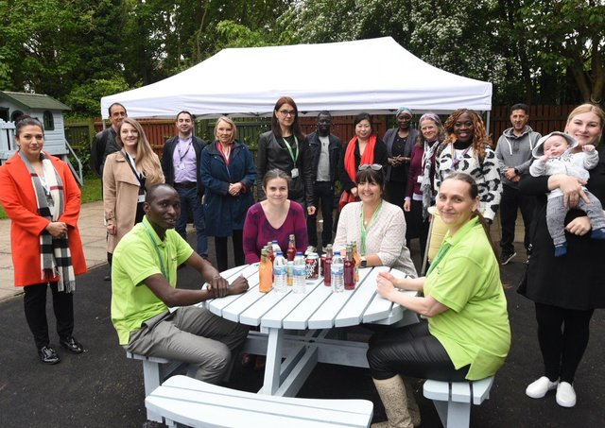

Farsh and Bernadetta with Family First and community representatives at a networking meeting.

**Research**

PREC has a long history of research and data analysis of issues which reveal inequalities based on race or ethnicity in the City, particularly those involving young people. ‘For City’s Sake’ is a report based on extensive research undertaken by PREC Research officer Alison Davies in collaboration with the Open University, with 450 young people from Black, Asian and Minority ethnic backgrounds in Peterborough schools between 2016 and 2019. The report was published in 2020 with funding from Near Neighbours, and we are grateful to Femi Olasoko for her support with dissemination of the report. Although the planned community launch was delayed by Covid restrictions, the key findings, in the voices of the young people, were presented by PREC in 2019 and early 2020 at the British Educational Research Association conference in Newcastle; University Centre Peterborough research conference; Shropshire Equalities Forum; and online in 2021 at the National Faiths and Beliefs Forum. The Peterborough launch was held online in November 2020, with faith leaders, community contacts, and council officers including Wendi Ogle Welbourn (Deputy CEO of Cambridgeshire and Peterborough). At the meeting, Wendi committed to meet representatives of the young people whose views were represented in the research to explore ways of addressing their issues. The outcome of further meetings in 2021 was an ongoing project led by Jo Proctor with the young people to create video materials for distribution to schools, supporting teachers in addressing racism and racial discrimination in schools. Copies of the report were also distributed widely to promote the young people’s experiences and views to teachers, community leaders, political leaders and faith leaders in Peterborough, Cambridgeshire, Berkshire and beyond. Copies are available on request from [contact@prec.info](mailto:contact@prec.info) (please include a postal address).

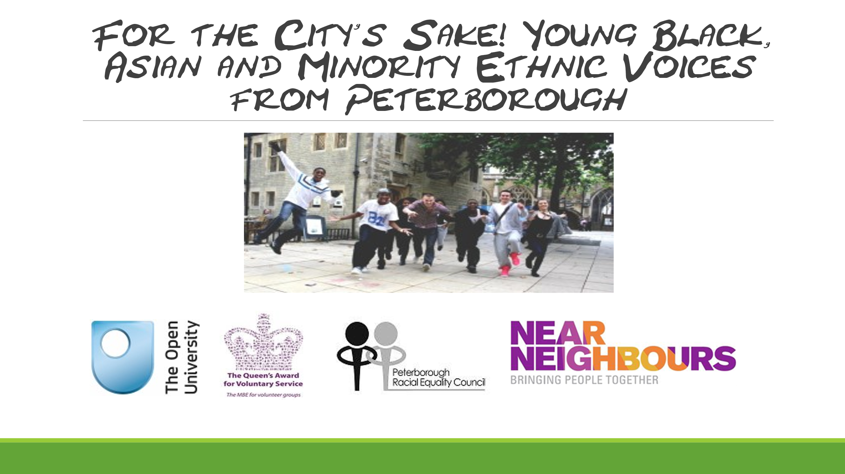

**Young Researchers**

PREC also supported a group of young researchers in 2020/2021 who conducted their own research on knife crime in the area, and young people’s views on how the problem should be addressed among their peers. We are particularly grateful to Faa’izah Akhtar and Urte Urtele who have now both progressed to university to study law.

**Casework And Signposting**

Where we have in-house expertise and training, we have supported a number of clients with complaints related to racial discrimination against the NHS and various schools. In all cases our involvement has resulted in a constructive outcome, for example, additional staff training or change of practice in the organisation concerned.

As we receive no funding for this work, we regularly signpost clients to partner organisations who are funded such as GLADCA, PARCA and PCVS. For legal advice on matters of discrimination we are able to refer clients to a group of solicitors while work willing to undertake *pro Bono* work in certain cases. We are grateful to them and to former Executive member, Katy Hawkins, for engaging their services.

**Accounts**

We are very grateful to our Honorary Treasurer, Geoff Johnson, for maintaining our accounts in good order and for preparing the accounts for 2020/21 and 2019/20 for this Report. These are attached separately, and also available on the website prec.info.

**Looking ahead**

At PREC we are excited by the prospects for new life and community action we can see coming with the long awaited end of Covid 19 and all its restrictions. There will be a ‘new normal’ and new ways of working which PREC will need to adopt and understand. There will also be new energies and opportunities and a better climate in which to develop new approaches to old issues, like fighting the curses of racism, inequality and division. But the city’s demography is always evolving, more diverse than ever, and much of the public debate and influencing now happens on social media. Climate change, poverty and war are driving global migrations and the humanitarian issues that arise from them for refugees, asylum seekers and hosts alike. The fight for racial equality isn’t going to go away; the need to do it well, and together, goes on. We hope that the AGM will bring forward new volunteers to work with us on the Executive and in the community, and new funding opportunities to support the work that we undertake entirely on a voluntary basis.

**Bernadetta Omondi, Chair, and Alison Davies, Vice Chair January 2022**