Tubbataha Reefs Natural Park
and World Heritage Site

Research Permit Application Form
This application form is to be filled out by any individual or institution who wishes to conduct a study in the Tubbataha Reefs Natural Park. This may include actual fieldwork in TRNP or the use of secondary data collected from the park.

Applicant Information
A research permit may be granted to an individual or an institution. Please tick the appropriate box:
☐ An individual Complete Section 1 applicant details – then proceed to section 3
☐ An institution Complete Section 2 applicant details – then proceed to section 3

- Application Details (Individual)
TITLE | FAMILY NAME | GIVEN NAME
EMAIL ADDRESS |  | MOBILE NUMBER | PHONE NUMBER
AFFILIATION |  | POSITION
FOR STUDENTS, PLEASE CHOOSE YOUR CURRENT DEGREE
PROGRAM |  | MAJOR / SPECIALIZATION
COMPANY ADDRESS

SUPERVISOR / CO-INVESTIGATOR |  | EMAIL ADDRESS

- Application Details (Institutions)
NAME OF INSTITUTION |  | MOBILE NUMBER |  | PHONE NUMBER
EMAIL ADDRESS |  | COMPANY ADDRESS
HEAD OF INSTITUTION | POSITION |  | EMAIL ADDRESS
PRINCIPAL INVESTIGATOR | POSITION |  | EMAIL ADDRESS
CO-INVESTIGATOR | POSITION |  | EMAIL ADDRESS
- Previous Research Permit
HAVE YOU BEEN ISSUED A RESEARCH PERMIT BEFORE? ☐ YES ☐ NO
IF YES, PLEASE STATE THE DETAILS OF YOUR LAST PERMIT
TITLE OF THE STUDY/PROJECT:
YEAR CONDUCTED:
TECHNICAL REPORT SUBMITTED? ☐ YES ☐ NO
IF YES, PLEASE INDICATED THE YEAR IT WAS SUBMITTED:

- Research Title
RESEARCH TITLE

- Organization sponsoring the study
NAME OF ORGANIZATION

COMPANY ADDRESS

HEAD OF OFFICE | POSITION | EMAIL ADDRESS
Note: Please extend the table if there is more than one sponsor. If the study is funded by paying volunteers, please list all their names in section 20.

- Partner Institution
NAME OF ORGANIZATION

COMPANY ADDRESS

HEAD OF OFFICE | POSITION | EMAIL ADDRESS
Note: Please extend the table if there is more than one partner institution

- Duration of the Study
DURATION OF STUDY (Proposed commencement and completion of the project, including report submission)

SCHEDULE OF FIELDWORK IN TUBBATAHA (If applicable) | VESSEL TO BE USED

- Summary of the Research

- Study Sites within TRNP
Describe the areas in TRNP where you propose to conduct your study (i.e., walls, reef flat, intertidal areas, lagoon, islets). Please indicate in the map your proposed sampling locations. If the coordinates are available, kindly include them.

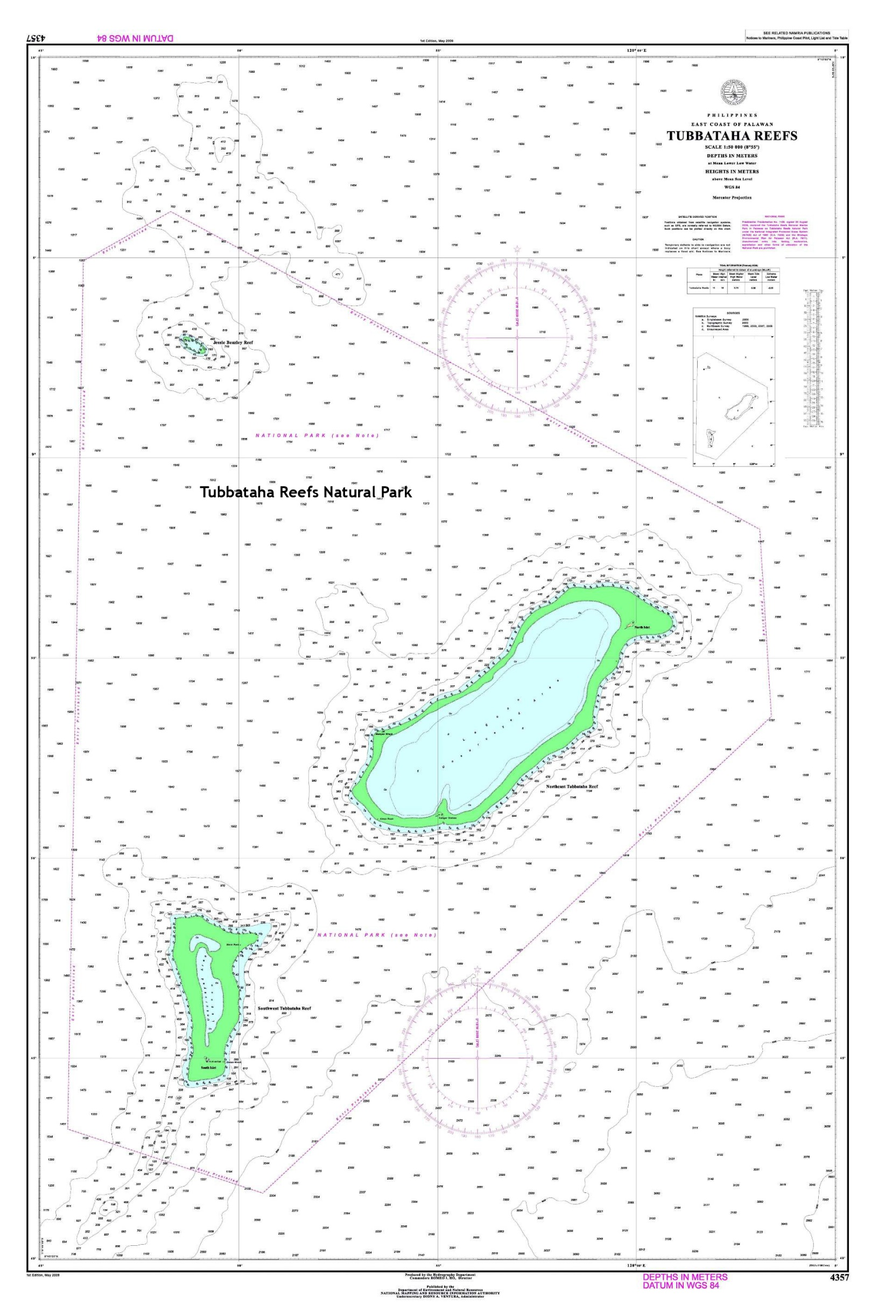
- Research Objectives

- Rationale of the Study
- Methods and Protocols

- Wildlife
- WILL THE STUDY INVOLVE HANDLING OF WILDLIFE?  ☐ YES ☐ NO | - WILL THE STUDY INVOLVE COLLECTION OF WILDLIFE? ☐ YES ☐ NO
IF YES, PLEASE LIST THE SPECIES BELOW  (Scientific and common names) | IF YES, PLEASE LIST THE SPECIES BELOW  (Scientific and common names)  Note: This includes parts and derivatives, e.g., tissue samples
- WILL THE STUDY INVOLVE COLLECTION OF ABIOTIC SAMPLES? ☐ YES ☐ NO | WILL EQUIPMENT / APPARATUS BE INSTALLED?  ☐ YES ☐ NO
IF YES, PLEASE LIST THE SAMPLES AND QUANTITY TO BE COLLECTED | IF YES, PLEASE DESCRIBE THE EQUIPMENT / APPARATUS TO BE INSTALLED, QUANTITY AND PROPOSED LOCATION
WILL THE STUDY INVOLVE THE USE OF EQUIPMENT (MOTORIZED AND NON-MOTORIZED) OTHER THAN SCUBA? ☐ YES ☐ NO | WILL A DRONE BE USED?  ☐ YES ☐ NO
IF YES, PLEASE LIST AND DESCRIBE THE EQUIPMENT

- Collection and Handling
If you answered YES in items 10.a or 10.b or 10.c, please describe below the methods of handling and collection of wildlife and other samples.

- Environmental Impacts
Please describe the environmental impacts of the study.

- Measures to minimize environmental impacts
Please specify the measures to be taken to minimize the environmental impacts of your study.

- Benefits of the study to the management of TRNP

- Proposed timeline for submission of technical report
(Must be not later than one year after the fieldwork in TRNP)

- Plan for communicating research results
Indicate how you plan to communicate the results of your study (i.e., book, journal publication, information materials, website)

- Research team
Name | Affiliation / Position | Email Address
1
2
3
4
5
6
7
8
9
10
11
12

I hereby declare that all the information provided is true and correct. I have read and fully understood RA 10076 (Tubbataha Reefs Natural Park Act) and its Implementing Rules and Regulations (TPAMB Admin Order No. 1 Series of 2017), and I will take full responsibility for the project and the team.

APPLICANT’S FULL NAME

IF THE APPLICANT IS AN INSITUTION, PLEASE INDICATE THE NAME AND POSITION OF THE PERSON IN-CHARGE OF THE PROJECT

APPLICANT’S SIGNATURE | DATE

Please send this form to tmo@tubbatahareefs.org together with the following:
☐ Curriculum vitae of applicant and co-investigator/s
☐ Other supporting documents (e.g., letter of support from sponsor, endorsement from university, research institution and government agencies)

