VENDOR CONTRACT

4th Street Festival 2024

June 22nd 11AM-11PM
June 23rd 11AM – 9PM

COMPANY NAME CONTACT NAME / TITLE

ADDRESS | CITY | STATE | ZIP
PHONE | FAX
MOBILE | E-MAIL

DEFINITIONS
Tacos Los Hermanos & Hear GI will be reffered to as "Organizer".

VENDOR RESPONSIBILITY
EACH Vendor MUST PROVIDE:
- Specialty food items from their company (must be pre-approved by event committee)
- Staffing for event booth for at least 8 hours each day.
- Attain appropriate food permits for Grand Island PRIOR to first day of event
- Tables, chairs, and tablecloth if needed
- All equipment necessary to prepare, cook, and keep food warm
- Marketing Materials for participants about your business (menus, business cards, etc.)

PARTICIPATION
All participants must submit menu selections to Agustin Sanchez. Selections must be a representation of dishes available for special order or on the regular restaurant menu. Food and beverages will be sold to event attendees by individual vendors. This event is free to the public. No tickets will be sold at any point to attendees. To minimize duplication and allow time to market appropriately and print other collateral materials, the Organizer must know by May 23, 2023 what each vendor will be preparing. Event submissions may be included in flyers, websites and media broadcasts. NO OUTSIDE FOOD, DRINK OR ALCOHOL ALLOWED. NO COOLERS ALLOWED. Any violation will result in forfeiture of contract without reimburstment.

VENDOR SIGNATURE DATE
Note: Terms and Conditions governing exhibit are attached to this form and are a part of this contract herein.


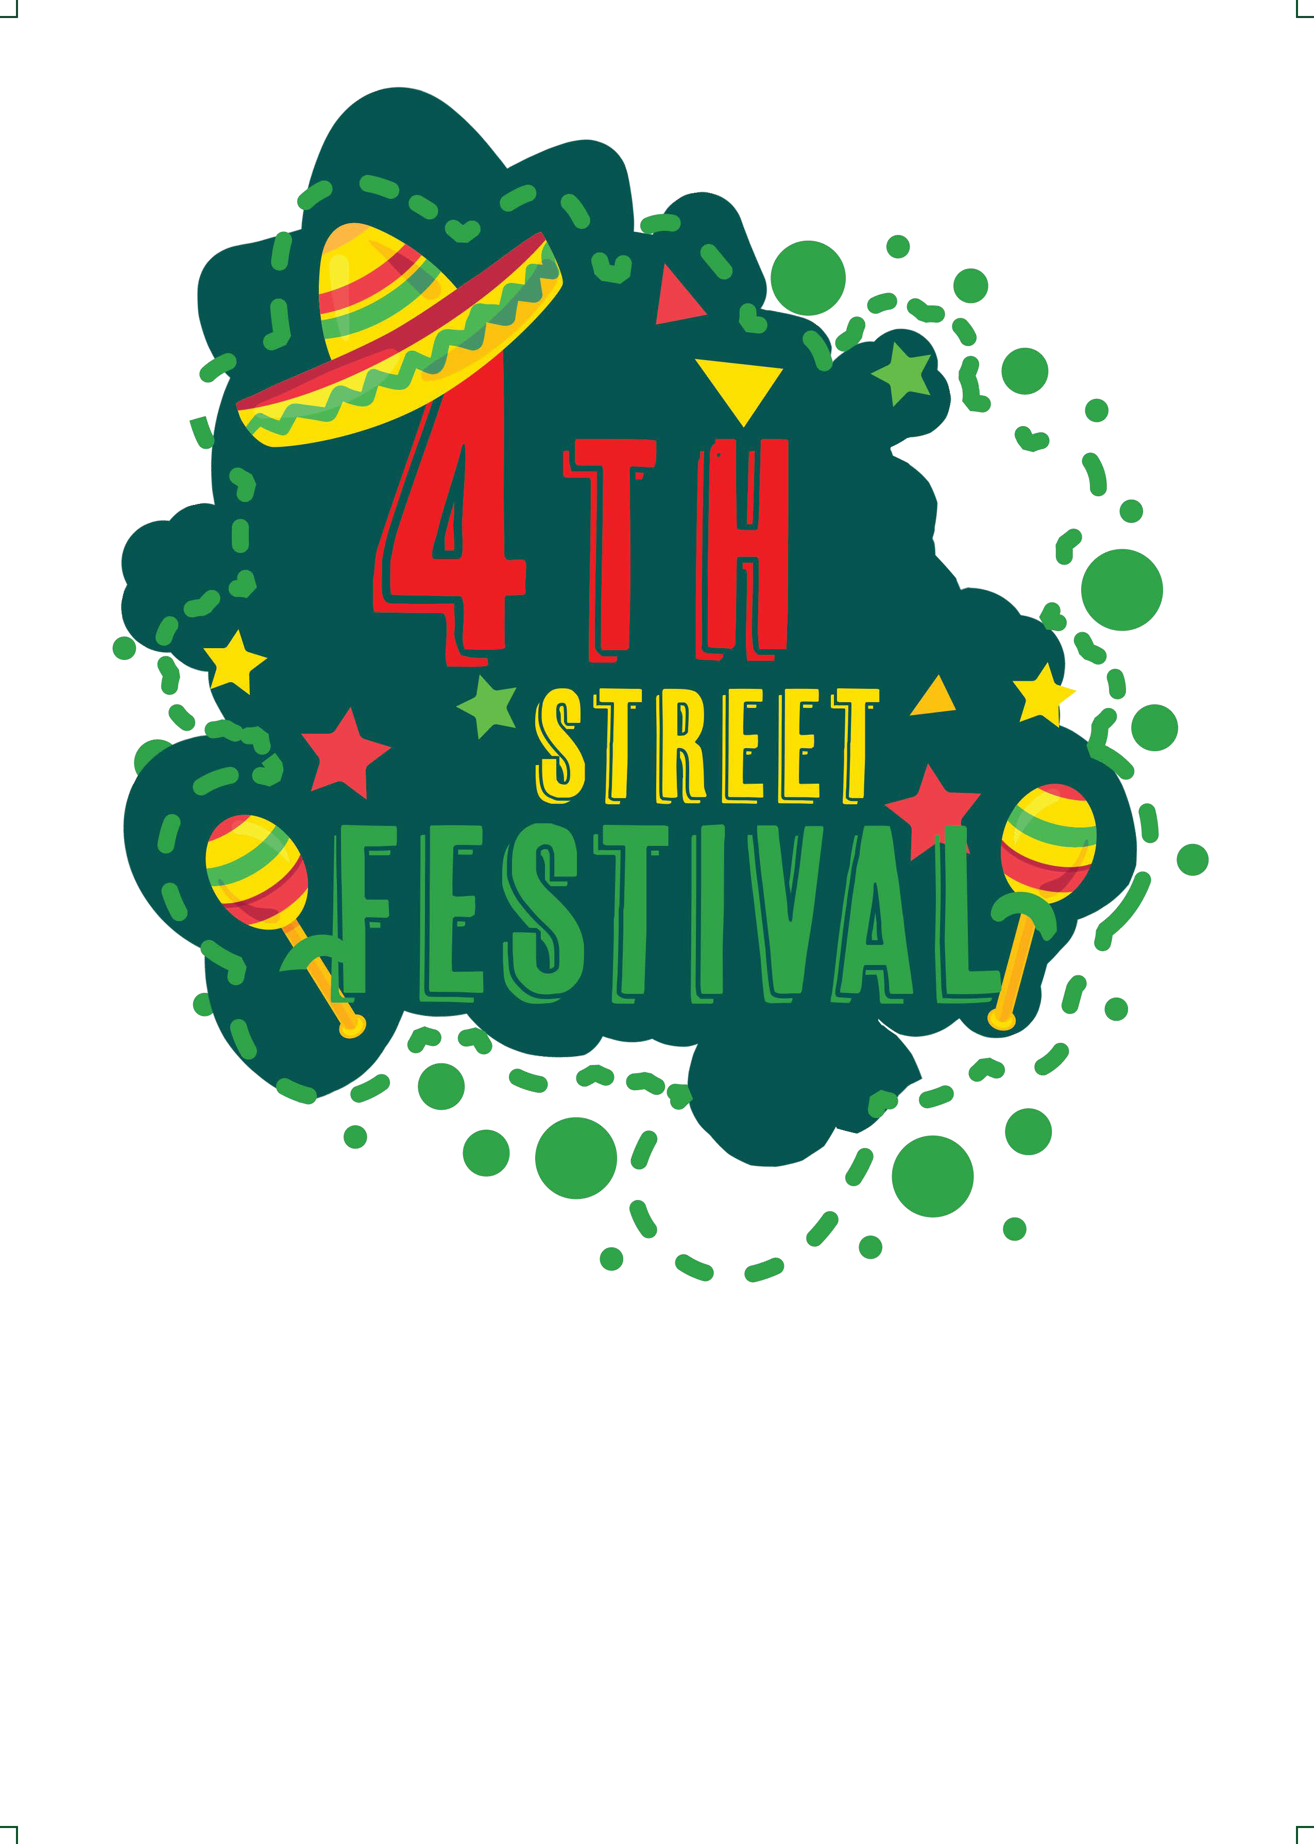
Completed contract may be dropped at Tacos Los Hermanos 602 W 4th St Grand Island, Ne 68801
By Mail: Tacos Los Hermanos

Attn: Agustin Sanchez

602 W 4th Street Grand Island, NE 68801
Email:
augustinsanchez919@gmail.com
Phone:
308.391.1050

Page 1
OFFICE USE ONLY

CONTRACT RECEIVED
DATE
PAYMENT AMOUNT SENT
CHECK NUMBER
SPACE NUMBER

TERMS AND CONDITIONS

CONTRACT SUBMISSION
To ensure participation, this signed contract is due by May 24, 2024.
Business name on event map is provided by Organizer. Business Vendors will receive a 10’x10’ booth space. (Please let us know if you will need an additional 10'x10' booth space.) Food Vendors will be alloted appropriate space as needed upon approval by organizer.

This agreement supersedes any and all other agreements, either oral or in writing, between the parties with respect to the event. This document is a contract when signed by both parties and signifies that the Vendor has read the entire contract, including the section of Terms and Conditions, received a copy, and agrees to its
terms. Acceptance by 4th St Festival is subject to approval of a correctly completed contract. Producer: Tacos Los Hermanos

SETUP & TEAR DOWN
Vendors may enter event facility for the purpose of exhibit setup beginning on Saturday, June 22nd at 6:00 am. Vendors must use authorized loading areas and remove vehicles immediately after unloading. Setup of exhibit must be completed no later than 10:30 am for inspection.
Food MUST be available a minimum of 12 hours between 11:00 am to 11:00pm Saturday June 24th, and a minimum of 10 hours between 11 am to 9pm Sunday June 23rd. Should vendor fail to occupy specified space during the scheduled period, Organizer shall have the right to take possession of and reallocate unoccupied said space without any liability. In that case, all rights vendor participation fees for the event will be forfeited. Vendors MUST receive any deliveries for the event. Organizer is not responsible for receiving or setting up any deliveries on behalf of the vendors. Exhibits must not be dismantled or removed before the event has closed. Exhibits may be left set up overnight on the 22nd. Organizer is not responsible for damage, theft or any other adverse wear and tear. Exhibits must be removed no later than 10:00 pm on Sunday June 23rd. Vendor shall be liable for all storage and handling charges resulting from failure to remove exhibit material for the event before conclusion of tear down period. Vendor will indemnify Organizer for all costs incurred for property being left at the event site outside stated hours. It is the Vendor’s responsibility to clean exhibit space and leave in the condition in which is was found prior to the event. Once an Event Volunteer has inspected and confirmed your tear down, you will be approved for disengagement for the event. Vendor is charged with having knowledge of and compliance with all laws, ordinances, and regulations pertaining to licensing, sales tax, health, fire prevention, public safety, copyright, and American with Disabilities Act.

LIABILITY AND INDEMNIFICATION
Organizer shall not be responsible for the personal safety of the exhibitor or his/her representatives from injury, nor the safety of the property of the exhibitor from theft or damage. Exhibitor waives all claims of every kind against Organizer, event facility, and representatives of the same including, without limitation, all claims for damages based on personal property damage, destruction, loss or theft, personal injury or death, and any other act or failure to act of Organizer. Food vendors agree to assume all liability, and indemnify and hold harmless event management, event facility, and Organizer representatives of the same for damage or injury, which might ensue by reason of such distribution, and must provide proof of liability insurance. Food of any kind may only be served by licensed food exhibitors and must be approved.

VENDOR INITIALS


PAYMENT / CANCELLATION
Payment to participating vendors will take place upon receipt. $275 for business vendors. $700 for Food Vendors. Non-Refundable.
All cancellation requests must be made in writing 30 days prior to the event. In the event of breach of this agreement by Vendor, Organizer reserves the right to cancel the agreement without liability for a refund of fees promised.

LEGAL ACTION
In the event it becomes necessary for Organizer to institute legal action for any
claim arising out of the terms and conditions of this contract, the losing party to those proceedings shall pay all attorney fees and court costs incurred in connection with said proceedings. The parties agree that jurisdiction for any such suit shall be in NE and venue shall be in Hall County.

CHANGES AND MODIFICATIONS
Any promotional and/or instructional information provided by Organizer to exhibitors is accurate as of publication; however, Organizer reserves the right to change or modify details of the event without notice. Organizer may issue additional rules, as is deems necessary for the orderly presentation for the show. Any rules may be amended at any time by show management provided that such amendment shall not substantially diminish the rights or increase the liability of the exhibitor.

PUBLICITY / USE OF PHOTOS OR VIDEO
Exhibitor agrees that Organizer may list the Vendor in event promotional materials and use photography and/or video at the event without compensation to the Vendor.

I have read this contract in full, and agree to the terms and conditions.

VENDOR SIGNATURE DATE

4th Street Festival

CONDENSED EVENT RULES

(See Contract for complete rules.)

FOOD VENDOR SPACE
- Absolutely no booth sharing of any kind is allowed. No collateral material of any kind may be displayed or handed out for companies other than the contracted Vendor. This includes outside vendors who may have decorated booth.
- Vendor must stay within the boundaries of their assigned space, out of aisles and other exhibit spaces.
- Absolutely NO moving or exchanging of spaces is allowed.
- No early tear down (before 5:00 pm) allowed; you may be barred from participating in future events.
- It is the Vendor’s responsibility to clean exhibit space and leave in the condition in which it was found prior to the event. Once a Vendor Supply Volunteer has inspected and confirmed your tear down, you will be approved for disengagement.
- Food vendors to provide ALL of their own equipment including everything needed for prep, display & service.
- Food vendors must load-in at designated times. No items or product may be dropped off beforehand.
- Food vendors must remove everything at the close of event. Nothing will be allowed to be left overnight under any circumstances.
- Food vendors must be checked out by a 4th Street Festival staff member before leaving.
- All vehicles must be immediately moved after unloading is complete & parked outside event area.
- All food vendors must bring their own tables and chairs.
- Food vendors must leave their booths as they are found. This includes disposing of all trash, empty boxes, etc.
- Any guidelines not adhered to is subject to a fine of up to $250.

DELIVERIES
Vendors MUST receive any deliveries for their space. Management is not responsible for receiving or setting up any deliveries on behalf of the Vendor.

INSURANCE AND LICENSING
You must have proof of valid business insurance and if applicable, be a licensed food vendor to participate in the event.

SETUP
All setup must be complete by 10:30 am for inspection.

SIGNAGE
Restaurant banners / Promotions Materials allowed

STAFFING AND LATE ENTRY
Your space must be staffed at least 8 hours per day.

