European Soccer Tour
2016
Section V All Stars



Barcelona, Spain
Presented by
EuroSports Network

EUROSPORTS NETWORK SELECT
SOCCER TEAM

2016
European Soccer Tour

TABLE OF CONTENTS
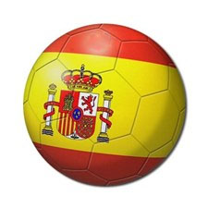

I Tour Information

1. Introduction
2. The Organizers of the Tour
3. Itinerary
4. Travel Arrangements for Barcelona, Spain
5. Uniforms
6. Coaching
7. Supervision
8. Tour Fee
9. Passport Information
10. Tour Conditions

II Tour Preparation

1. Application form
2. Medical release form
3. General release form
4 Uniform ordering form
5. Affidavit of Parental Consent
6. Passport Information

Copyright, 1989
Eurosports Network Inc.
All Rights Reserved.

No part of this publication may be reproduced for any purpose without the express consent of
Eurosports Network First Edition: August 23, 1989

Introduction

Congratulations! You are invited to join the Eurosports Network Select Soccer program to Europe during Spring break 2016. This invitation recognizes you as a dedicated and promising athlete. As you know, for the Eurosports Network Select Soccer Program, the best players are selected to represent New York State West in Europe.

The tour will take you to Spain where you will meet superior European competition.

This will be the Twenty Seventh All Star Trip to Europe. In the past, our teams have made a great impression in competition against teams from Germany, Russia, Italy, England, Australia, France, Sweden, Spain, Norway, Belgium, Switzerland, Czech Republic, Denmark and the Netherlands.

The tour will be more than just games. You will be representing New York and the USA. You will meet many European soccer friends, and, of course, you will discover the spirit of Europe.

Enclosed please find the documentation about the tour. Read the information carefully and be sure to return the forms immediately.

Please do not hesitate to contact me at info@eurosportsnetwork.com if you need and additional information or check out our website at www.eurosportsnetwork.com

Yours in Soccer,
Nino Pilato
1.1

THE SPIRIT OF INTERNATIONAL SPORTSMANSHIP

The EuroSports Network select soccer program started in Rochester in 1987, with the objective of offering America’s soccer talent a great challenge by competing against European top-level teams. We have expanded the program to include all of New York. The program enables the players to become part of the international soccer community.

The tour will introduce the participants to European soccer. They will gain an inside view on how the game is played, a better understanding of other customs and habits and they will see and learn things about the game they never dreamed existed.

In 2016, we will travel to Barcelona Spain. We will visit many of the most famous landmarks in the Casa Brava area of Spain.

Our teams will play games against top-level Spanish Club teams but the players will do more than just compete. They will represent our country at receptions by our hosts, and will enjoy plenty of sightseeing and cultural activities.

Your participation will identify you as an international athlete. You will catch the spirit of international sportsmanship.

1.2

EUROSPORTS NETWORK SELECT SOCCER TEAM

The Organizers

The Founder of Eurosports Network - Rochester, NY

Mike Balducci

Mike Balducci was the head soccer coach at Greece Arcadia and at Greece Athena High School. During his years in Greece, his teams won 12 league titles. Coach Balducci compiled a record of 274-52-43, winning seven Section V titles, four trips to the state finals with two state championships. In addition, with his roots originating in Italy, Mike Balducci knows the in’s and out’s of Europe and European soccer. The All County Soccer Team program started in 1987. Each year Mike has sent many young athletes to Europe, in close cooperation with European Soccer Foundations and Soccer Clubs.

Tour Director and Head Coach – Rochester, NY

Nino Pilato

Coach Pilato is the head coach at Odyssey Academy in Greece. In the past 12 years he has been the Girl’s Varsity Head Coach, they have Won Sectional Titles 6 times, in 2003, 2005, 2007, 2008, 2010, and 2011. His dedication to his players overall development have been rewarded his being selected as coach of the year in Monroe County Division III 5 times, Section V Class CC once, CCC, once and Class B 3 times and Section V All Greater Rochester Coach of the year in 2005. He was a four-year college starter and an All-American sweeper at Canisius College. After his college career ended, he played 4 years of professional soccer in both Europe and the USA. Deciding it was time to settle down he began his teaching career as a physical education instructor in the Rochester City School District. He is married and has two children.

Sport Contact International

"For the past 19 years Sport Contact International has been organizing football tournaments and friendly matches for young players mainly in the town of Blanes on the Costa Brava, just 50 minutes away from fashionable Barcelona. The tournaments are organised together with the local Football Clubs, C.D. Blanes and Racing Blanenc, in cooperation with the Catalan Football Association and the Official Referees Association of Girona.

1. 3
EUROSPORTS NETWORK SELECT SOCCER TOUR
Barcelona Spain

Saturday, March 26th Departure from Greece, NY to Toronto International Airport for you flight to Barcelona, Spain.
KLM 692 Departs Toronto at 7:10 PM Arrives in Amsterdam at 8:25 AM
KLM 1671 Departs Amsterdam at 11:00 AM arrives in Barcelona a 12:15AM

Sunday, March 27th This morning, you will arrive at the El Prat International Airport in Barcelona. Waiting for you will be a Sport Tour International representative who will take care of all your arrangements for the remainder of your European tour. We will transfer your team by private charter bus to your Superior Class Hotel in Lloret de Mar. The remainder of the day enjoy the hotel facilities, which include indoor and outdoor pools or take a short walk to the beach and enjoy the Mediterranean Sea.

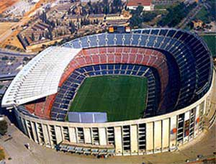
Monday, March 28th This morning, you will travel to the Great city of Barcelona. You will visit the most famous soccer stadium in Spain Nou Camp Stadium were you will see the dressing rooms, the spectacular field and & beautiful museum with all the trophies won by the most important team in Catalonia.


This afternoon we will discover Barcelona, while walking along the Ramblas to the Boqueria and then to the medieval Barri Gothic, the original Gothic Quarter, where narrow streets and squares date back to the Middle Ages. Visit the 13th-century “La Seu” cathedral.

Next, take in views of the Mediterranean Sea and the Barcelona Coast on the way to the Olympic Village (Vila Olimpica), home to athletes during the 1992 summer Olympics, and the Port Olympic then we will see Gaudi’s La Sagrada Familia Cathedral.
In the evening, your bus will departs to a local soccer club for your first game vs. a Local Spanish Club team.

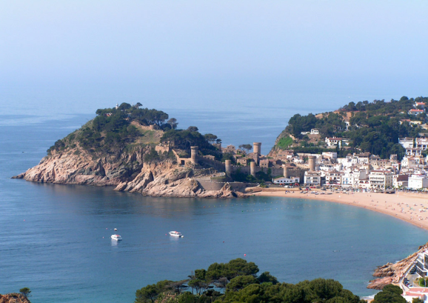
Tuesday, March 29th Today, we travel to Visit Tossa De Mar beautifully restored and overlooking its sheltered horseshoe bay, Tossa de Mar is undoubtedly one of the prettiest resort towns on the entire coast. The Vila Vella (Old Town) - more than 800 years old and declared a National Historic Monument – walk through its perfectly preserved cobbled streets and stone and whitewashed houses. Protected by its 12th century wall and seven towers, the Old Town is a maze of artists’ galleries, cafés and is smothered in dazzling flowers for much of the year.
Evening match with local Spanish club.
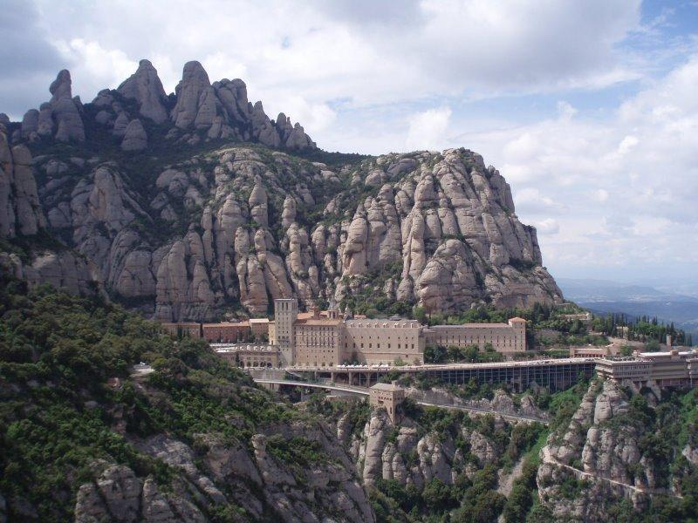
Wednesday, March 30th This morning we will visit - the sacred mountain of Montserrat. The Benedictine monastery resembles a gigantic fortress, which offers you some of the most spectacular mountain views of Catalunya. You will be able to listen to the World famous Montserrat Choir boys sing during your visit.

Thursday, March 31st This morning, we will travel to the Dali Museum in Figueres. After the museum visit, the trip continues to Girona the ancient town several thousand years old in Catalonia. We will walk through Girona's historical city center and visit the old Jewish quarter, which is one of the best, preserved in Europe, Saint Felix church, the Cathedral with its Tapestry of Creation and walk the paths around the old Roman city walls with its fantastic views of the city below. The tour will also include a visit to 13th Century Arabian Baths and Archaeological Museum. This evening your team will visit another Spanish Soccer Complex to play your last game vs. a local Spanish Team.

Friday, April 1st This morning, we will journey to the town of Besalú, a wonderful medieval town in the comarca of Garrotxa, in Catalonia. The town features arcaded streets and squares, a 12th-century Romanesque bridge over the Fluvià river and also a restored mikveh, a ritual Jewish bath dating from the eleventh or twelfth century and the church of Sant Pere, which was consecrated in 1003.
This evening we will have dinner and see a flamenco show at Castell Medieval "Comte de Valltordera” in Tordera.

April 2nd Depart Spain for our flight back to the USA!
KLM 1662 depart Barcelona 6:20am to Amsterdam arrives at 8:45 AM
KLM 691 departs Amsterdam at 9:45 AM arrives in Toronto at 11:40AM

Adiós España


I. 4

EUROSPORTS NETWORK SELECT SOCCER TEAM



Arrangements 2016 Spring Break Tour

Transportation
Intercontinental KLM Airlines

Transportation - Land
Greece, NY to Airport Chartered bus
Europe Comfortable tour bus equipped for long distances.

Accommodation/Meals

Tossa, Spain March 27th - April 2nd 2016

Hotel A tourist class hotels, two and three bedded rooms all with private facilities, TV and phones.
Meals Daily breakfast and dinner are included.
Lunches and drinks during dinner are not included.

Sport Program

In Barcelona, Spain, the teams will play in three friendly games versus top-level local teams.

Sightseeing/Excursions

The tour will include visits to cultural and tourist highlights of Barcelona, Girona, Figueres, Besalú and Tossa, Spain.

1.5
EUROSPORTS NETWORK SELECT SOCCER TEAM

EuroSports Network has a special outfit for the Spring Tour.
The official players outfit is a Nike… This outfit is included in the tour fee.

Red shirt Blue short Blue socks
If you wish, you can order the following accessories:
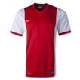
- Extra Nike Uniform set (Jersey, short, socks)
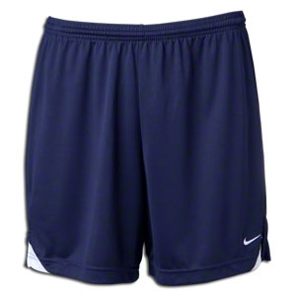
Price: $ 70.00 per set

- EuroSports Network Select Soccer…. Nike Academy 14 Sideline Navy jacket
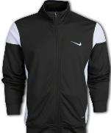
Price: $ 50.00


-EuroSports Network Select Soccer…. Nike Libero Pant
Price: $ 35.00

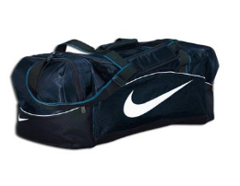
-EuroSports Network Soccer…. Nike Brasilia 6 Travel Bag:
Large Size (28x15x14) Price $ 44.00
Medium Size (24x12x13) Price $ 35.00


- EuroSports Network Select …. Three Color Spanish Design
T-shirt Price: $ 15.00 per shirt

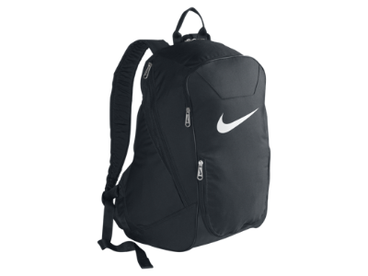

-EuroSports Network Nike Club Team Backpack
$ 44.00 (16 x 12.5 x 9)

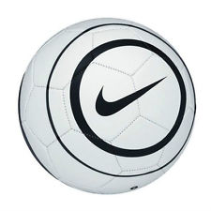
-EuroSports Network Nike Acuto Soccer Ball
$ 18.00

- Extra Socks $6.00 per pair

Complete the order form enclosed in section II.4, and return the form to EuroSports Network with your deposit check.

1.6
EUROSPORTS NETWORK SELECT SOCCER TEAM
COACHING STAFF
(Present and Past)

Michael Balducci Greece Athena High School
Nelson Cupelo Monroe Community College
Nick Christou Frontier High School
Tom Davieu Chittenango High School
Phil De Nuncio Buffalo State College
Larry Disatuels Nichols School
Jennifer Debronski Alfred University
Tracy Britton Monroe Community College
Jerry Forton University of Buffalo
Bill Garno Rochester Institute of Technology
Dan Gorham Alfred State College
Ann Haggerty William Smith College
Steve Kahn Vestal High School
Steven Locker Harvard University
Jill Mc Cabe St. John Fisher University
Ray Lasky TCCC
Vince Lupinetti West Virginia University
Tim Mc Nally Broome Community College
Rigo Maximo New York State West ODP State Coach
Kathy Moss SUNY Plattsburgh
Carlos Obiano Canisius College
Mark Palma Roberts Wesleyan College
Mike Pilger University of Rochester
Nick Picardo Kendall High School
Nino Pilato Greece Odyssey
Bill Rich Broome Community College
Bob Sokolinsky BU United
Paul Van Hooydonk Misericordia College
Matt Vergamini Greece Odyssey

I.7
SUPERVISION

The Eurosports Network group leader and coach are in charge of supervision. The group leader is responsible for the proper administration of the program. The coach will make sure everyone is doing his or her assigned job.

The following rules and regulations apply to all participants:
1. The possession or use of any alcoholic beverages and non-prescribed drugs is forbidden.
2. Players must get permission from the coaching staff before ever leaving the group.
3. All players must participate in the activities described in the program, including training, games, receptions, sightseeing and excursions.
4. Each player is responsible for contributing to team spirit by exhibiting a positive attitude and loyalty toward teammates, coaches and tour leaders.
5. Each player will respect the property of the other tour members, and the suppliers providing the tour.

1.8

EUROSPORTS NETWORK
SELECT SOCCER TEAM


TOUR COSTS

Tour fee $ 2,840.00

Including airfares
- Bus transportation
- Accommodations
- Meals
- Nike uniform
- Sightseeing program
- Tour staff

Excluding Lunches
Beverages during dinner

Payment schedule

Deposit $ 400.00 deposit (non-refundable)

February 12, 2012 $ 1,100.00

March 11, 2012 $ 1,340.00 (Balance)

This last check should include all monies owed as well as monies for extra uniforms, travel bags, socks etc.

Payments by checks payable to: Eurosports Network – mail to:

Euro Sports Network
PO BOX 16201
Rochester, NY 14616-0201

Website www.eurosportsnetwork.com
E-mail info@eurosportsnetwork.com

I.9

EUROSPORTS NETWORK TOUR CONDITIONS

In these conditions, EuroSports Network (“ESN”) stands for the Eurosports Network Inc. agents and representatives in Europe and the U.S.A.

1. Application
An application will be binding after the confirmation of acceptance of EuroSports Network (ESN).Upon confirmation of acceptance; all arrangements are under proviso of availability.

ESN withholds the right to substitute at any moment the housing accommodation, and/or to alternate the program for circumstances, which are beyond control. The substitute housing accommodation, and/or the alternate program, should meet the same criteria as established in the confirmation of acceptance.

- Tour payments US$ 400.00 deposit (non-refundable) per person upon Booking.
The remaining amount will be paid according to the schedule as mentioned on page I.10. ESN reserves the right to void the booking in case of serious delay of payment. In this case, ESN will refund the received payments minus the cancellation fees. (See 4)

3. Rate of exchange
The tour costs are based figuring the exchange rate of US $ towards the Euro in August 2013. The tour costs may fluctuate based on changes in the exchange rate. Eventual surcharges must be paid together with the final payment.

4. Cancellation
All cancellations must be received in writing. The day that the notification is received by ESN is the effective cancellation date. The cancellation charges are US $ 400.00 per person plus eventual additional costs incurred by ESN with respect to its obligations to its purveyors such as, but not limited to: airlines, bus companies, housing accommodations and sports clubs.

5. Passport
All participants must be able to present a valid passport. The fee for the passport is not included in the tour costs.

6. Exclusion from participation
ESN withholds the right to exclude any participant from further participation due to serious behavior. There will be no refund for the unused portion of the tour. Serious or unacceptable behavior includes, but is not limited to violation of regulations of the tour management, housing accommodations and transportation companies. If any participant is found to be responsible for any damage while on the tour, he/she will be required to pay immediately for such damages.

7. Sport program
ESN acts as an intermediary and will prepare the desired sport program with great care. Neither ESN nor the hosting sports club accepts any responsibility for the omission or partial omission of the sport program due to circumstances beyond control, such as, but not limited to, bad weather conditions.

8. Responsibility and liability
The responsibility of ESN and hosting sports clubs is limited. ESN acts in the capacity of an agent for the participating in all matters pertaining to the tours, such as, but not limited to, the arrangement of meals, transportation, housing accommodation, and sightseeing, other social and cultural activities, and sport programs. ESN, its coaches and the hosting sports clubs are not responsible for any personal injury, illness or death, for any loss, damage or theft of belongings (such as baggage, possessions or money), for any error, accident, delay, deviation or curtailment of any kind caused directly or indirectly by any actions, omissions, acts of neglect of failure or facilities by:

a) Any person or company retained for the benefit of the participant, including, but not limited to: housing accommodation, transportation companies and tour guides.
- acts of God; acts of public enemy, arrest or process; quarantine restrictions, riots or civil commotions; strikes; lockouts or labor stoppages; war hazards or dangers incident to the state of war; local rules or regulations of any airplane, automobile, motor coach, ship, train or other vehicles;
d) Improper or insufficient passports or other documents;
e) Participation in sport activities.

Additional expenses incurred under any of these circumstances are to be borne by the participant.

9. General
The ESN will assume that the participant and the parents or legal guardians are in agreement with the conditions above, as well as the conditions mentioned in the documentation, and that an authorized person has undertaken all engagements with the ESN.

Parent Name: __________________________________Date: _______________

Parent Signature: _______________________________Date: _______________

Player Name: __________________________________Date: _______________

Player Signature: _______________________________Date: _______________

EuroSports Network

Tour Preparation Forms

II. 1
EUROSPORTS NETWORK SELECT SOCCER TEAM
APPLICATION FORM

Herewith we declare that we agree with all terms and conditions as mentioned in page I.7 and I.9 and the rest of this documentation for the Spring break tour to Europe from March 26th – April 2nd, 2016 organized by EuroSports Network to Spain. We fully understand the rules and conditions.

As parent/guardian, we certify that the participant has no physical and/or mental disability that might, with all reasonable consideration, indicate that participation is not appropriate.

We have enclosed a $400.00 deposit check and the following Forms:
The Application form
The medical release form
The general release form
The uniform ordering form, Letter of Agreement form

Name (As it appears or will appear on your passport):

____________________ ______________ ___________________________
First Name Middle Name Last Name

Address _________________________________________________________

City _________________________________ State _________ Zip__________

Home Telephone # ( ) _______________ Cell # ( ) _____________

E-mail _________________________________________________

Date of birth _______________________________

School Attending _____________________ Grade in School ______________

Male  Female  Position ______________________

____________________________ ________________________________
(Date) (Signature parent/guardian) (Date) (Signature parent/guardian)

_______________________________
(Signature player)
Please return to Euro Sports Network
PO BOX 16201
Rochester, NY 14616-0201
II.2

Medical Release Form

Name ________________________________ Age __________

Home Address________________________________________________

_________________________________________ ________ ________________
City State Zip

Home telephone ( ) __________________ Work ( ) ________________ Cell ( ) _____________

Name and Address of Parents/ Guardian ___________________________
______________________________________ ____________________ ______ __________
Street City State Zip

In case of an emergency, notify _______________________________________________

Home Telephone # _____________________________ Parents Cell # __________________________

Parents E-Mail Address___________________________________________________________

Work Telephone # __________________________

Doctor’s Name __________________________________________________

Doctor’s Telephone # ____________________________

Type of Health / Accident Insurance Coverage ______________________________________________

Policy #Company ____________________________________________

Any known medical problems, which should be known by the coach. __________________________________________________________________________________

ALLERGIES ____________________DRUG REACTIONS ______________

Note: All information contained herein is confidential, and as such, will remain only with the coaching staff.

In the unlikely event that medical attention may be necessary for my/our child, I/we recommend the following:
I, the parent or guardian of _________________________________, gives my consent for emergency medical / surgical treatment of my child.
Signature of parent or guardian ______________________________________________________

Date: _____/_______/_______

II.3

GENERAL RELEASE

I hereby acknowledge that participation in soccer competition and traveling abroad carries with it a potential hazard. I therefore release the EUROSPORTS NETWORK SELECT SOCCER TEAM CLUB and ALL its coaches, chaperones and any other persons involved with EuroSports Network of ALL liability in the event of any injury during the 2016 Spring Soccer European Trip. I also understand that EuroSports Network carries NO accidental insurance.

I also understand that EuroSports Network coaches are acting as chaperons for the group, and may as such be permitted to advise me of any breach of local rules, regulations and customs by my/our son/daughter.

EuroSports Network reserves the right, in its sole discretion, to discontinue said player’s participation in any tour or any activity of EuroSports Network for any violation of the EuroSports Network rules and regulations, including, without limitation, the right to send said player home from the tour at the player’s expense in which event there shall be no refund for any unused portion of the tour.

Participant’s Signature __________________________________________

Participant’s Birth date ____________________________

Address __________________________________________________

_______________________ _____________ __________________
City State Zip

Phone # ____________________________

Parent / Guardian Signature _________________________________________

Date _______/_______/_______

II. 4
EUROSPORTS NETWORK SELECT SOCCER TEAM
UNIFORM ORDERING FORM
For Information, see page I.5. (You can order additional items now and pay with your last payment)

Name: ____________________________________
Address: ________________________________________________________________
City: _________________________________ New York Zip________________

Field Players
Jersey Size  XL  L  M  S
Short Size  XL  L  M  S
Socks Large (9-12 Men’s or 11-12 Ladies)  Medium (4-8 men’s 8-10 ladies)  Small (4-7 Ladies)
Goalies– please chose only one, either GK jersey below or Uniform set above
Goalie Jersey  XL  L  M  S

Extra order All County Soccer Team accessories:
Nike Extra uniform set Quantity: x $ 70.00 Jersey  XL  L  M  S
Short  XL  L  M  S
Socks  L  M  S
Nike Jersey Only Quantity: x $ 34.00  XL  L  M  S
Nike Short Only Quantity: x $ 20.00  XL  L  M  S
Nike Warm-up Jacket Quantity: x $ 50.00  XL  L  M  S
Nike Warm-up Pants Quantity x $ 35.00  XL  L  M  S
Nike Brasilia 6 Large Bag Quantity x $ 44.00 Size (28x15x14)
Nike Brasilia 6 Medium Bag Quantity x $ 35.00 Size (24x 12x13)
Extra Socks Quantity x $ 6.00  per pair
European T-Shirt Quantity x $ 15.00  XL  L  M  S
Nike Back Pack Quantity x $ 44.00 ___________
Nike Soccer Ball Quantity x $ 18.00 ___________

Total Price $____________

Complete this form by checking applicable boxes and return this form immediately. You can order now and make your extra equipment order with any of the remaining payments.
Please make all checks to EuroSports Network and mail to:
PO Box 16201
Rochester, NY 14616-0201

II.5
LETTER OF AGREEMENT
AFFIDAVIT OF PARENTAL CONSENT

For Travel Outside The United States of A Minor Child Without Parents Traveling

I _______________________________________________ understand that my child
(Parent’s name)
________________________________________________ will be traveling to
(Child’s name)

Destination – Barcelona, Spain on March 26th to April 2nd, 2016 (date of travel) Aboard Airline Flight #’s: KLM 692/1671 and # KL 1662/691 with Coach Nino Pilato and other accompanying Coaches, adults/parent chaperones. Their expected date of return is April 2nd 2016.

Signed: _________________________________________________________________
Parent(s) signature(s)

Address _______________________________________ St_________ Zip_____________

Telephone #’s ________________________________________________________________

Witness Name: _______________________________________________________________

Witness Signature: ___________________________________________________________

Notary Public Signature/Seal:

Subscribes and sworn to before me this ________ day of _________________________2012.

Signature of Notary Public _____________________________________________________

Notary Public in and for the County of ____________________, And the State of _________.

My Commission Expires: _________________________. Affix Notary Seal at the Bottom of This Page.


II. 6
PASSPORTS
Everyone traveling in our group must have a valid passport from their country of citizenship. United States passport applications are available at U.S. post offices, clerical courts, local passport offices, and some DMV offices. Application for a new passport must be done in person. The following documents are necessary:
Obtaining a new passport is a seven-step process:
- Complete the passport application form DS-11. Passport applications can be acquired at the DMV. (Note: Do not sign the application until the clerk instructs you to do so.)
- Present proof of U.S. Citizenship. You may prove citizenship by presenting one of the following:
  - Previous U.S. passport
  - Naturalization certificate
  - Birth certificate
  - Certificate of citizenship
Present proof of identity. You may prove your identity with the following documents:
  - Previous U.S. passport
  - Naturalization certificate
  - Driver's license
  - Military identification
Please note: Your Social Security card does not prove your identity.
- Provide two passport photos. It is highly advised that passport photos be taken by a professional agency. You can also try an online service to save time and money http://www.epassportphoto.com/
- Pay the applicable fee. Total fees are $97 for applicants 16 years of age or older and $82 for applicants under 16 years of age.
- Provide your Social Security number.
If you are not an American citizen then go to this website for further information:
Foreign Embassies websites in the US for all the countries in the World
Passport and Visa information http://www.embassy.org/embassies/
How to Get a Visa http://travel.state.gov/visa/americans/americans_1252.html

Go to this link to find the closest Passport Office in your area…………. http://iafdb.travel.state.gov/
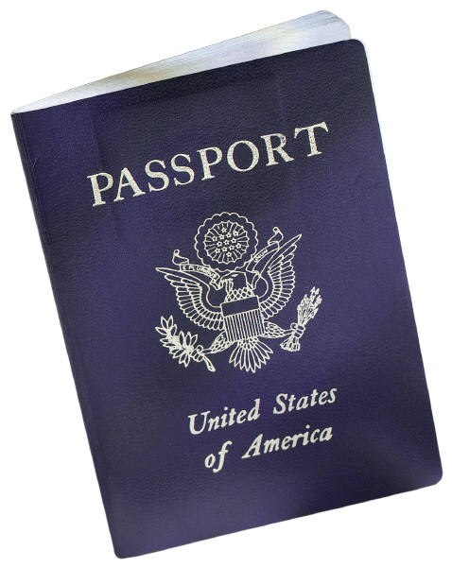

PASSPORTS
The Town Clerk's office offers Passport Application services.
For more information, call the Rochester City Clerk's office at (585) 428-7129.
For More information, call the Binghamton Clerks Office at (607) 773-2162

Go to this link to get passport information from the U.S. State Department
http://www.travel.state.gov/passport/passport_1738.html
Click here to print out a passport application.
http://www.travel.state.gov/passport/forms/forms_847.html
Or call the National Passport Information Center at 1-877-487-2778
(TDD/TTY: 1-888-874-7793)
http://iafdb.travel.state.gov/ Go to this link to find the closest Passport Office in your area!

Passport information center: 1-877-487-2778 ( At this Phone number you can find out the status of your passport and what name you may used to place on your passport) Or you can check at this website. You may find that the toll free number is more up-to-date!

www.travel.state.gov


Student Group-Benefits
Comprehensive Plan
Schedule of Insurance Coverage and Other Services

Trip Cancellation.......................................................................Tour Cost*
(Not applicable to $0 trip cost)
Trip Interruption......................................................150% of Tour Cost*
($500 return air only for $0 trip cost)
Trip Delay (6 hrs)............................................................$750($150/day)
Missed Connection................................................$500 (3 or more hours) Baggage & Personal Effects........................$1,500($250 per article) Baggage Delay (24 hours)...........$300
Emergency Accident & Sickness Medical Expense...........$25,000
Emergency Evacuation & Repatriation...............................$100,000
Worldwide Emergency Assistance Services......................Included

The cost for the Comprehensive Insurance is $ 60.00

There must be a minimum of 10 travelers sign up for this group insurance policy.

Plans are underwritten by the United States Fire Insurance Company. Fairmont Specialty and Crum & Forster are registered trademarks of United State Fire Insurance Company. The Crum & Forster group of companies is rated A (Excellent) by AM Best Company 2011.

I ______________________________________ would like to purchase the Comprehensive Group student insurance policy. I understand that for this group insurance policy to take affect there must be 10 other travelers on this tour also opting for this group insurance policy.

Signed __________________________________ Dated ________________________

