***OPPORTUNITIES FOR MINISTRY***

><>Sunday, November 10th

9:45 a.m. Adult Sunday School

10:00 a.m. Youth Sunday School

11:00 a.m. Worship

12:30 p.m. Session

Wednesday, November 13th

5:30 p.m. WCC @ CPC

7:00 p.m. Bible Study Isaiah 5:1-7; 11:1-5

><>Sunday, November 17th

9:45 a.m. Adult Sunday School

10:00 a.m. Youth Sunday School

11:00 a.m. Worship

6:00 p.m. FCA Movie-RUN THE RACE @ Life Chapel

*PRAYER CONCERNS*

Church Members

Roger Lees

C.B Potter CHF/Kidney

Pat Deacon Heart

Jim Hamilton, Mary Jarvis and family

Tate Knick

Shelley, John and Morgan Martin

Hilda & Ellis Morris

Nellie Leech

Libby Clark

Harriett Lees Cancer

Nelson Hall Cancer

Family and Friends

Ricky and Mamie Trussell Cancer

Stanley and Rhonda Trussell Cancer

John Bolen Stroke

David Orr Cancer

Paul Thompson Cancer

Johnny Crutchfield Cancer

Hunter McClung Cancer

Tammy Thomas Stage 4 kidney failure

Amy Woody Cancer

Janice Blevins Cancer

Jeff Nicely Cancer

Lindy Emory Cancer

Barry Deacon Kidney and Liver

Bob Dunlap Cancer

Sally Carlton Cancer

**Shut In’s**

Jean Black Borden Center

Jean Fontenot The Mayflower

Ecalean Entsminger Home

**Military and Government Service**

Lt. Col. Benjamin Cartwright, 304 Highland Pointe Drive, Manhattan, KS 66503

**Missionaries**

PCUSA Missionaries in Ethiopia;

Rev. Michael Weller and Rachel Weller

**Ushers:**

NOVEMBER - FRANCES RULEY

DECEMBER – JANET SCOTT

**TLC Persons**

CPC’s Tender Loving Care Person this week is Mrs. Shirley Hostetter. Thinking of you and Get Well cards can be sent to her at 71 Smith Hollow Road, Lexington VA 24450. She is also a patient at Kendal in room 413 for the next couple of weeks should you like to visit.

**CHOIR PRACTICE AND CHRISTMAS REHEARSAL**

Thursday 11-14 at 5:30 p.m.

Thursday 12-5 at 5:30 p.m.

Thursday 12-12 at 5:30 p.m.

Saturday 12-14 at 10:00 a.m.

(Dress Rehearsal Performance Sunday December 15 at 11am during service.) Please spread the word. If you want to do this, please commit to rehearsals and performance. - Thanks, Kelly

**ANNUAL DINNER THANK YOU:** On behalf of PW and the dinner steering committee, I thank you all, for the gifts you bring to annual dinner season. With your gifts, talents and hard work we were able to serve 949 meals this year. This grand total is up by 41 meals from last year. We truly are blessed to be part of the CPC church family who works so well together in serving our LORD and doing his mission work. God bless you all! Mary and Karey

**Dinner Day Details:** Still got an Annual Church Dinner Name Tag? Don’t throw it away! Please put it in the marked container near the water fountain in the hallway across from the kitchen. We will recycle them next year. The recycling jar will remain near the water fountain for another week.

**Thank Offering Sunday:** On Sunday, November 24 the Presbyterian Women will receive its annual Thank Offering as an expression of thanks to God for the many blessings and opportunities He has given us. The gifts received will be used to support sixteen ministries that seek to meet health needs, provide proper nutrition, give assistance to the homeless, and provide safe and accessible housing for displaced individuals and families. *As Thank Offering Sunday draws closer, PW would like to ask each church family member to pause and reflect on the many ways God has met your personal needs this year.* After reflecting, we ask that you start setting aside funds that you could give on November 24 to help someone else who has those same needs that must be met. The “Blue Thank Offering” envelope in today’s bulletin should be taken home for use in setting aside your gift for Thank Offering Sunday.

*Submitted by: Debbie McCormick- PW Special Offerings Coordinator*

.

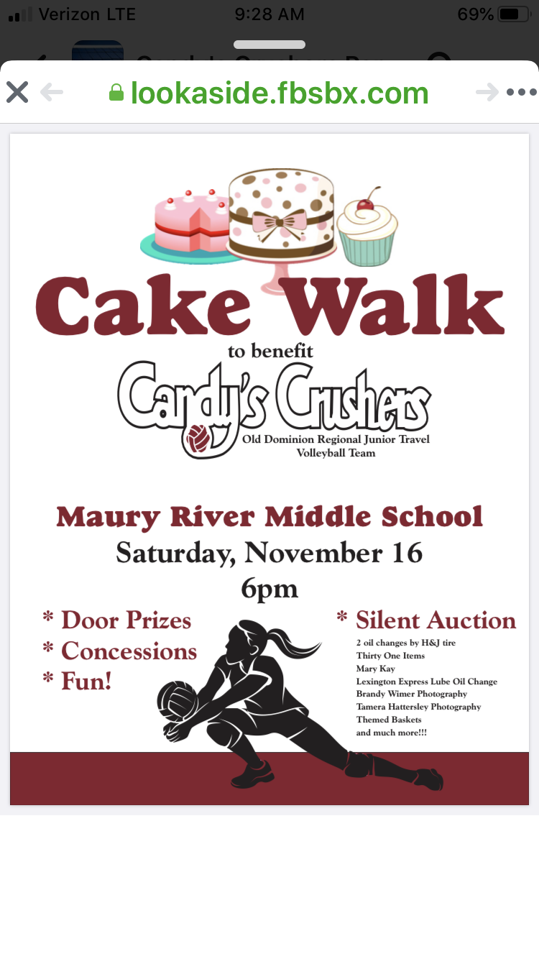

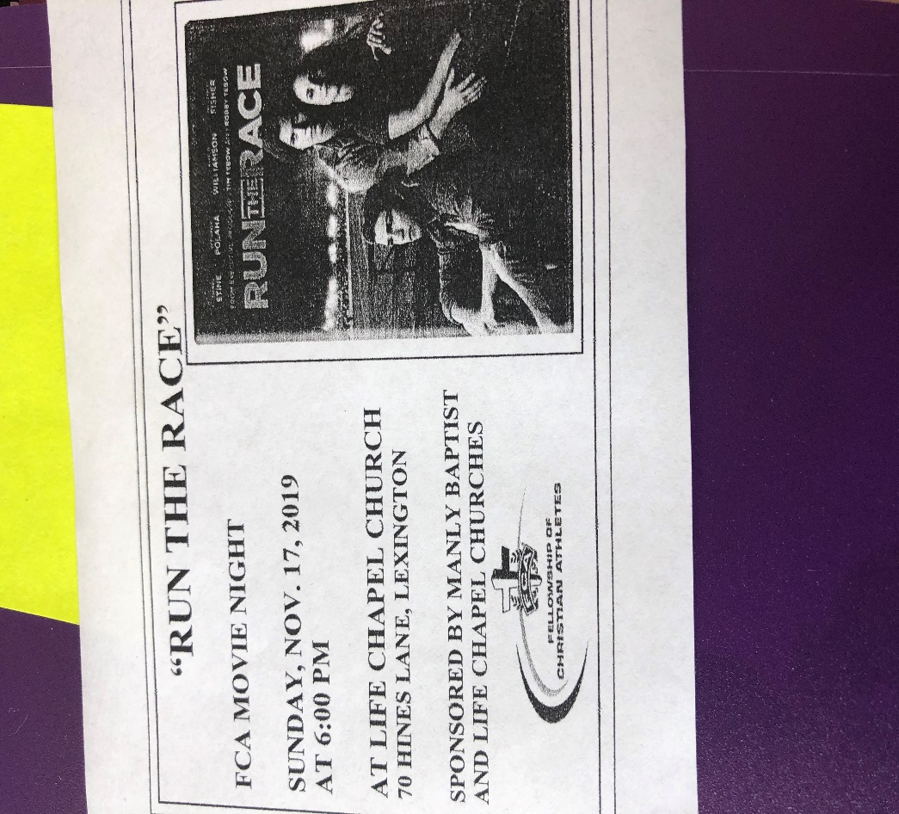



**A BIG THANK YOU FROM THE BAZAAR ROOM**

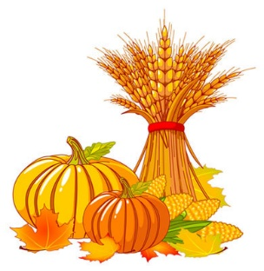

A huge thank you to everyone that came together to pack the Bazaar Room this year! We greatly appreciate all of your time, efforts, and talents! Everything looked so good and sold very well.

We had a record year with total sales reaching $2,600.00! Our two benefactors, The Jamie Martin Memorial Scholarship and the Rockbridge County Fellowship of Christian Athletes will be thrilled with our donations.

Thanks again and please if you have any suggestions on items we should try or things we should do please don’t hesitate to let one of us know so we can add it to our list. We were able to purchase apples, applebutter, hoop cheese, and some bagged candies again this year with the help of monetary donations. This would not have been possible without those donations and people always come in looking for those items.

Thanks again and blessings to all!

Jennifer, Joyce, and Shelley