FIGURE 1: DIAGRAM OF CARBON ACCOUNTING PROCESSES

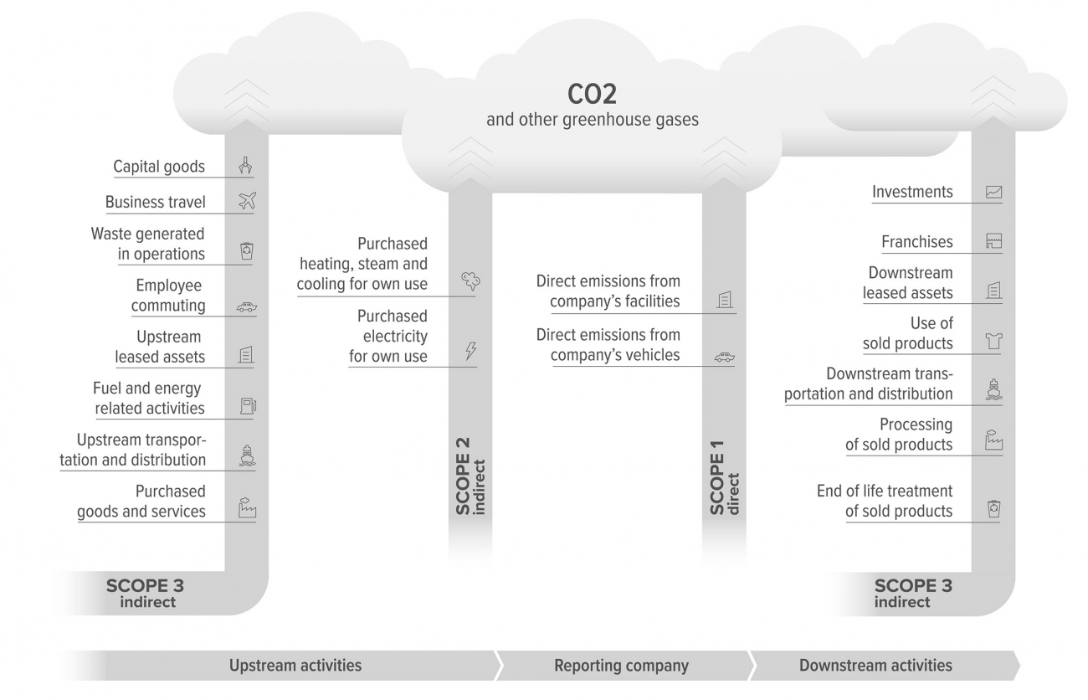

FIGURE 2: DIAGRAM OF GHG PROTOCOL DEFINITION OF SCOPE 1, 2, AND 3 ACCOUNTING
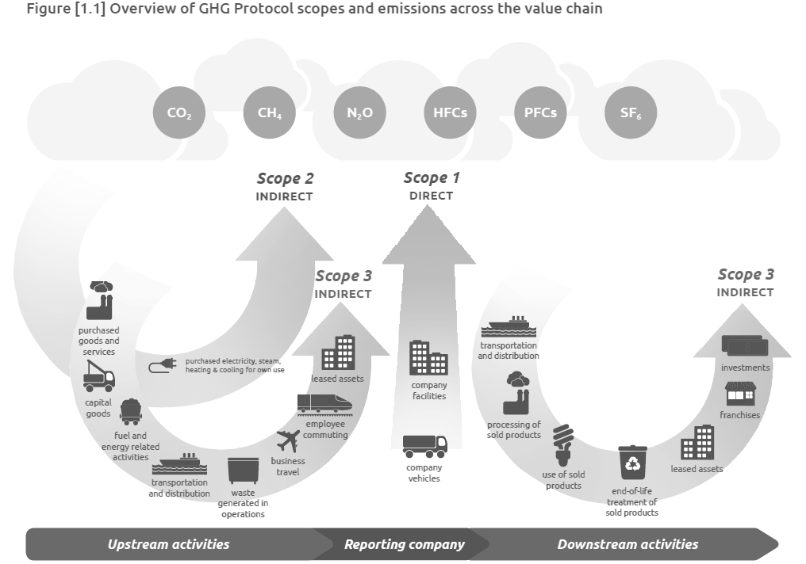

FIGURE 3: DIAGRAM OF DIGITAL MONITORING, REPORTING, AND VERIFICATION
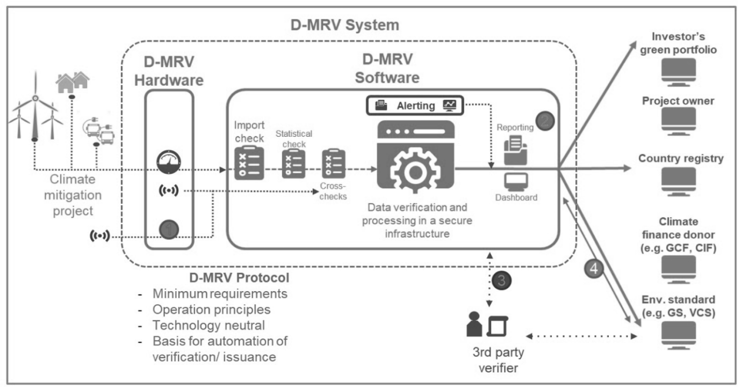

FIGURE 4: DIGITAL MRV AS PROPOSED BY THE WORLD BANK CLIMATE WAREHOUSE
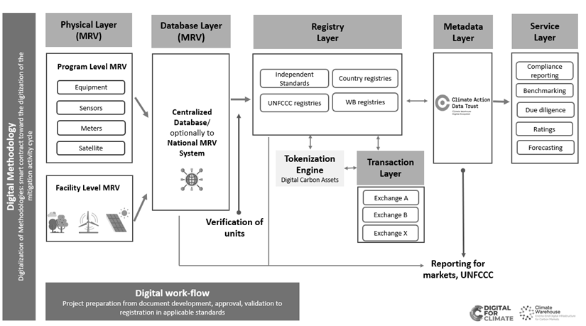

FIGURE 5: COMPARISON OF DeFED BANK TO TRADITIONAL BANK (JP MORGAN)

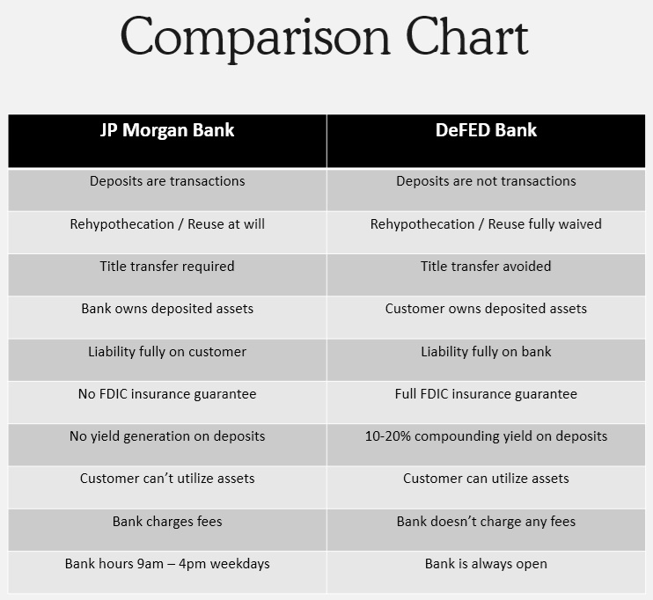

FIGURE 6: DIAGRAM OF ALL 17 SUSTAINABLE DEVELOPMENT GOALS

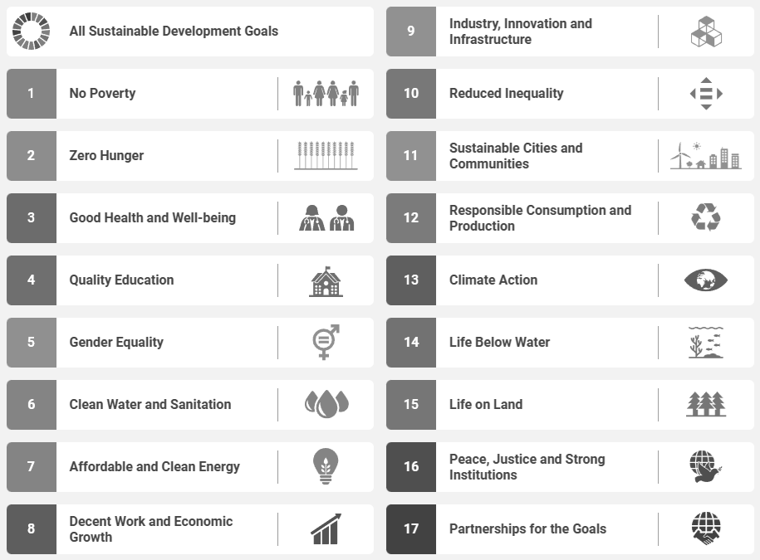

FIGURE 7: DEPOSIT TOKEN PROCESS
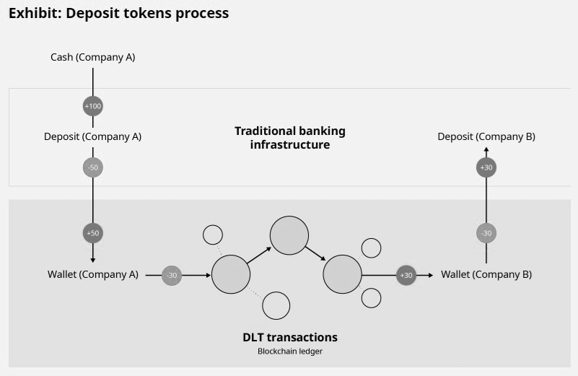

FIGURE 8: BANK SERVICES AND MENU OUTLINE
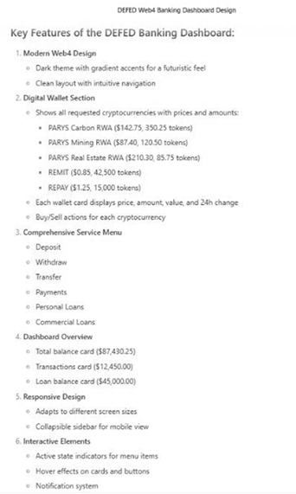

FIGURE 9: DIGITAL BEARER INSTRUMENT MODEL OF PRIVATE TOKENIZED MONEY
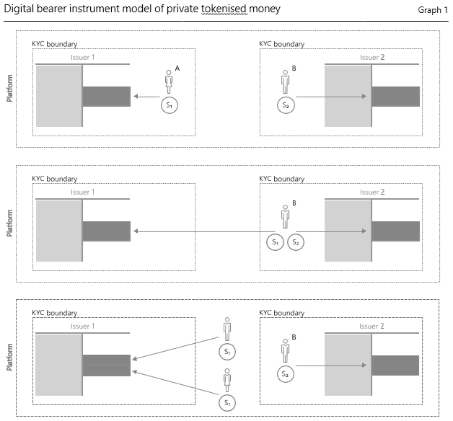

FIGURE 10: BURN/ISSUE MODEL OF PRIVATE TOKENIZED MONEY
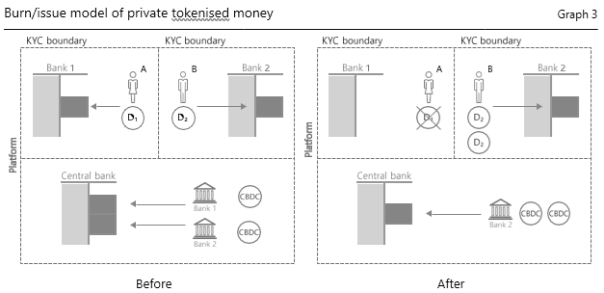

FIGURE 11: DIAGRAM: AGENTIC SYSTEMS CN ACCESS TOOLS FOR DISCOVERY AND EXECUTION, AND CAN PLAN GOALS TO ACHIEVE REAL-WORLD EVENTS.
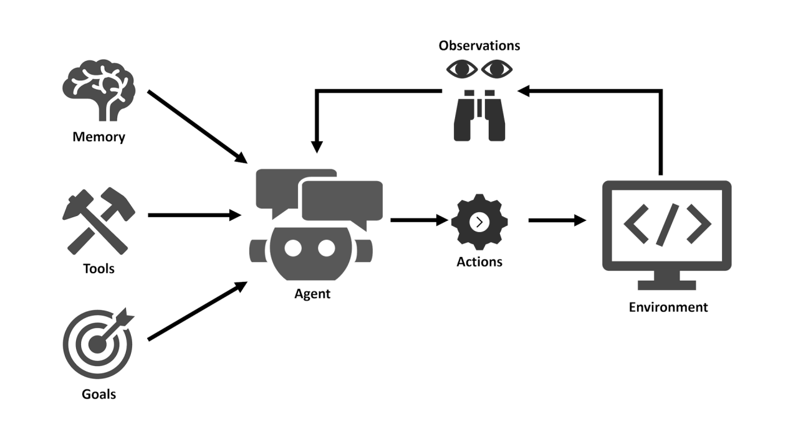

FIGURE 12: USING LOCAL LLMS WITH LOCAL DATA

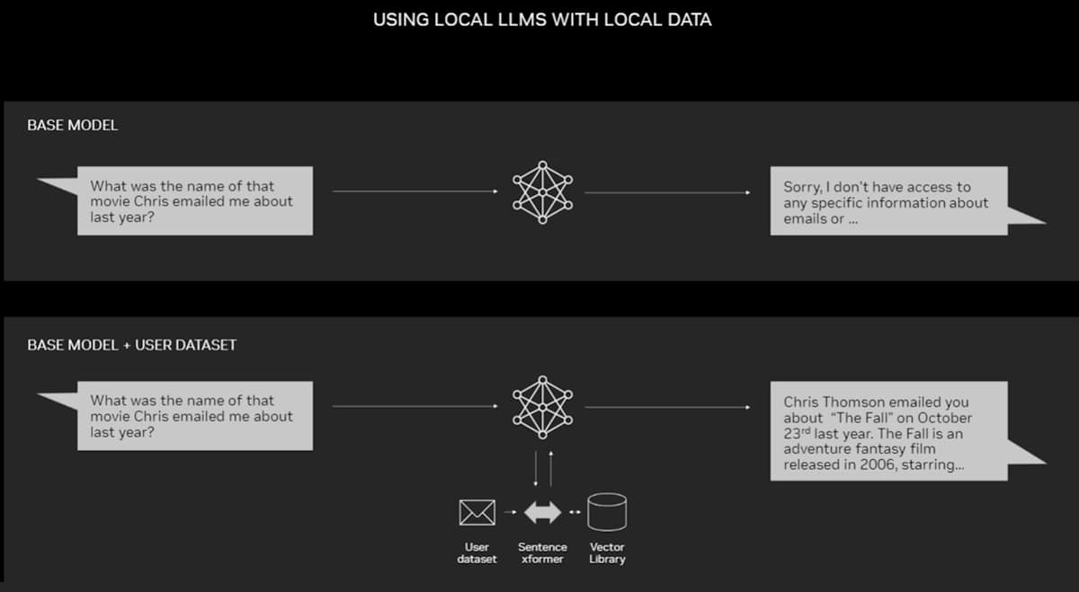

FIGURE 13: RETRIEVAL-AUGMENTED GENERATION SEQUENCE DIAGRAM THAT COMBINES LLMS WITH EMBEDDING MODELS AND VECTOR DATABASES.

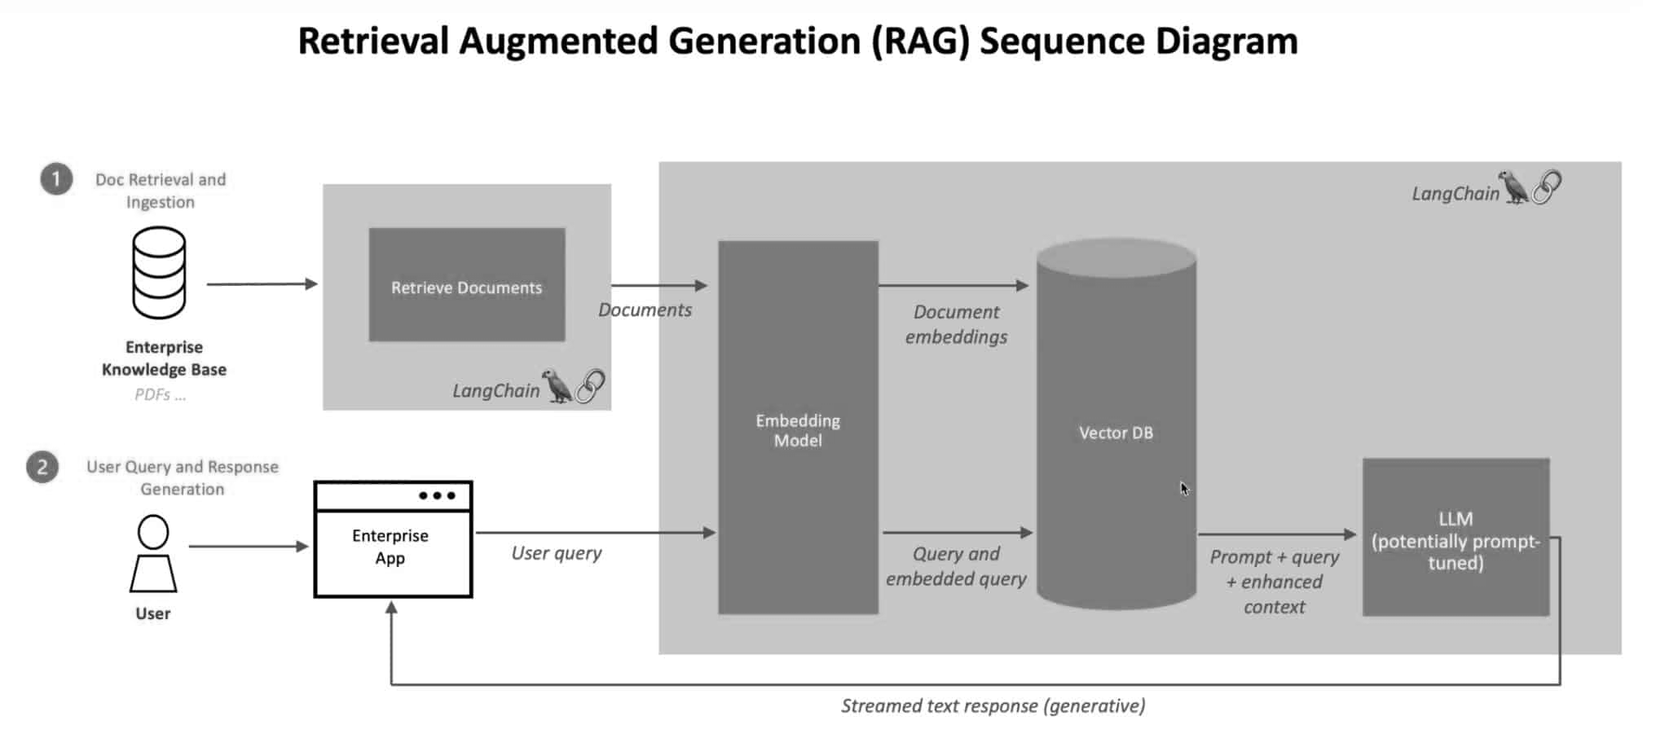

FIGURE 14: RETRIEVAL-AUGMENTED GENERATION FLOW CHART COMBINES LLMS WITH EMBEDDING MODELS AND VECTOR DATABASES.

