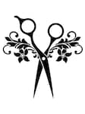
CHEW’S MULTI-CULTURAL
HAIR AFFAIR EXPO 2020

CELEBRATING 20 YEARS

With a RAPACIOUS APPETITE for the Hair and Beauty Industry…The Legendary Mr. Russell Chew invites you to Experience Amazing at this EPIC Hair/Beauty Show as we CELEBRATE 20 Years of SWLA Biggest B2B EXHIBITION. Trade Show, conference and networking event for the Hair and Beauty industry. Having your charisma would make this event the most significant area interactive session for the Hair and Beauty industry when your business is based on networking leads, this is the place to see and be seen. Treat yourself to CS (Creativity Start-up) Therapy by attending the CHEW’S Multicultural Hair Affair Expo 2020.

CHEW ON IT: Business expenses are tax-deductible. Then look for a serious ROI (return on investment) for your time and capital. CHA CHA (Come Home Ability) @Chew’s Multicultural Hair Affair Expo 2020 in Lake Charles, LA, Lake Charles Civic Center.

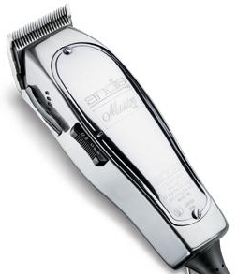
“GIT CHA SUM”
EXHIBITORS FYI
We’re Pleased to Offer
20% OFF BOOTH PURCHASES
NOW thru MARCH 01, 2020

Please Order in Advance to Save Time & Money
After the Deadline Standard Rate Will Apply. Inform
Chew’s Multicultural Hair Affair Expo
of all your Additional Needs on or before May 30, 2020.

SALE SALE SALE……….18 HOURS
Sales Floor Opens:
SUNDAY, JULY 19, 2020 9:00 a.m. – 6:00 p.m.
MONDAY, JULY 20, 2020 9:00 a.m. – 6:00 p.m.
Please have your area set-up and ready to receive customers at
9:00 a.m. on both days.

Send Exhibitor Application and Correspondence to:
CHEW’S MHA EXPO
Attention: DiAnna Guillory
530 Jumping Jack Lane
Lake Charles, LA 70615

PLEASE MAKE ALL CHECKS or MONEY ORDERS PAYABLE to:
RUSSELL CHEW
Mail Payments to:
Russell Chew
609 S. Helen Street
DeRidder, LA 70634

CONTACT IMFORMATION

RUSSELL CHEW: 337-540-7617

TEAM CHEW: 337-405-9978

DIANNA GUILLORY: 337-884-1144

EMAIL: BYYOURCHOICE@YAHOO.COM

EMAIL: CHEWSHAIRAFFAIR@YAHOO.COM

FACEBOOK: RUSSELL CHEW (CHEWS HAIR AFFAIR)

WEB ADDRESS: WWW.CHEWSHAIRAFFAIR.COM

INSTAGRAM: CHEW’S HAIR AFFAIR

TWITTER: RUSSELLCHEW@chewshairaffair

