Wisteri-Yoga & Reiki LLC
Follow Up Confidential Health Intake Form

Name __________________________________________ Date ____________________
Medical History and Information Update
Check any or all that apply to your present health:

__headaches __chronic pain __varicose veins
__vision problems __muscle/joint pain __blood clots
__sinus problems __numbness/tingling __high/low blood pressure
__teeth grinding/jaw pain __sprains/strains __diabetes
__fatigue __scoliosis __cancer/tumors
__depression __arthritis __infectious disease
__sleep difficulties __tendonitis __skin problems

Other/Notes___________________________________________________________________
Current list of all medications/herbs/vitamins and dosage:___________________________________________________________________________________________________________________________________________________________________________________________________________________________________
List physical activities you participate in regularly:_____________________________________ ___________________________________________________________________________________________________________________________________________________________
What movements or activities are limiting?___________________________________________
If injury, describe the events of the injury or accident:__________________________________ ____________________________________________________________________________________________________________________________________________________________
Updated list of major injuries/surgeries: ____________________________________________________________________________________________________________________________________________________________
What other treatments are you receiving and by whom (acupuncture, physical therapy, chiropractic, naturopathic):_______________________________________________________ ______________________________________________________________________________
Do you have a particular area of concern? ___________________________________________ __________________________________________________________________________________________________________________________________________________________
What treatment seems to help the most? ____________________________________________
What seems to aggravate the condition most? ________________________________________
What is your main activity at work? On phone_____ Sitting____ Computer_____ Driving_____ Walking______ Other___________________________________________________________
What do you do to relieve stress? ________________________________________________ ____________________________________________________________________________________________________________________________________________________________
What is your intention for this session (s)? ___________________________________________

Please identify current problem areas in your body by drawing circles where pain exists:
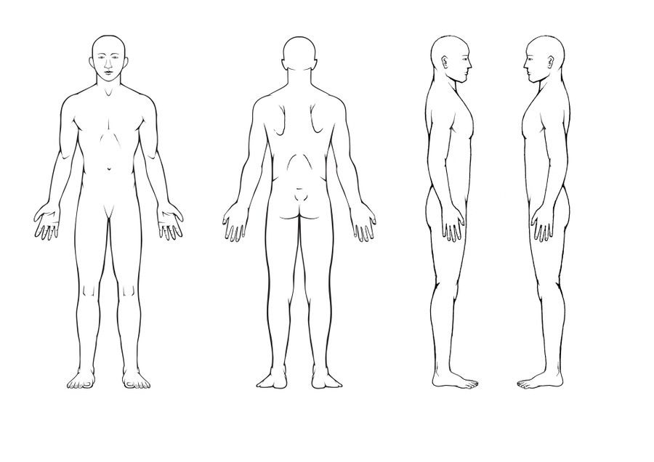
Comments:____________________________________________________________________
Release Form
(Please initial)

I understand that Reiki is a simple, gentle, hands-on energy technique that is used for stress reduction and relaxation. ____
I understand that Reiki practitioners do not diagnose conditions nor do they prescribe or perform medical treatment, prescribe substances, nor interfere with the treatment of a licensed medical professional. ____
I understand that Reiki does not take the place of medical care. It is recommended that I see a licensed physician or licensed health care professional for any physical or psychological ailment I may have. ____
I understand that Reiki can complement any medical or psychological care I may be receiving and that the body has the ability to heal itself and to do so, complete relaxation is often beneficial. I acknowledge that long term imbalances in the body sometimes require multiple sessions in order to facilitate the level of relaxation needed by the body to heal itself. ____
I understand that because massage energy therapy is contra-indicated (should not be done) under certain medical conditions, I affirm that I have stated all my known medical conditions, and answered all questions honestly. I agree to keep the practitioner’s part should I forget to do so. ____
I understand that, should I need to cancel future sessions, I agree to give my practitioner 24hours notice or I will be financially responsible for the session time. ____
I release Greenshire Institute and Wisteri-Yoga & Reiki LLC, the practitioner and/or coach from any liability during any and all sessions. ____

Signed: ________________________________ Date: _________________

Privacy Notice:
No information about any client will be discussed or shared with any third party without written consent of the client or parent/guardian if the client is under 18.
Reiki Documentation Form
Client Name: _____________________________________ Date: _____________________
Reason for Session___________________________________________________________
Specific Issue:
Physical______________________________________________________________________
______________________________________________________________________________Emotional___________________________________________________________________________________________________________________________________________________
Mental/Spiritual______________________________________________________________________________________________________________________________________________
Observation / Scan before Reiki Session: ____________________________________________ _____________________________________________________________________________ ____________________________________________________________________________________________________________________________________________________________
Session Notes: _____________________________________________________________ ___________________________________________________________________________ ___________________________________________________________________________ _____________________________________________________________________________ ___________________________________________________________________________
Observation / Scan after Reiki Session: _____________________________________________ _____________________________________________________________________________ _____________________________________________________________________________ ______________________________________________________________________________
Follow up Planned: ___________________________________________________________ ____________________________________________________________________________ ___________________________________________________________________________
Length / Type of Session: _______________________________________________________
Practitioner Name: ________________________________________

