***To all High School Greek Orthodox Youth***

**About**

The George and Venetia Pallis Memorial Youth Fund is a 501(c)(3) non-profit organization formed to honor the memory and contributions of George and Venetia Pallis to the Greek Orthodox youth of the Greater Seattle Area. The Fund provides Ionian Village Camp scholarships to students entering their Junior or Senior of High School or, Freshman year of college, based on individual excellence, financial need, and community involvement.

**Eligibility**

Interested candidates must:

* Be US Citizens or US permanent resident
* Baptized Orthodox Christian
* Be a full-time high school student going into their Junior or Senior year of High School or, Freshman year of college.
* Parents must be a steward of good standing for at least three years at one of the aforementioned parishes
* Submit short essay on their qualifications for scholarship

**Scholarship to include:**

1. Attendance Fee for the students’ attendance of the upcoming year’s Ionian Village.
2. Airfare from NY to Athens and back to NY.

**Essay**

Type a short essay on, “What Orthodoxy means to me and how I apply it to my life.”

* Your typed essay should be between 300 to 500 words.

**Deadline & Submission**

Email your completed [scholarship application form](https://gvpallisyouthfund.org/id-love-to-go-1) to [info@gvpallisyouthfund.org](mailto:info@gvpallisyouthfund.org). All entries must be received by January 1, 2025.

**Selection**

Final selection is made by the GVOYF Scholarship Committee and the award recipient will be notified.

**Contact**

Please contact us anytime at [info@gvpallisyouthfund.org](mailto:info@gvpallisyouthfund.org)

*All emails and attached files transmitted between and among the foregoing are considered confidential. The emails and attached files are intended solely for the use of the individual or entity to which they are addressed and reading, disclosing, disseminating, distributing or copying by a recipient other than that named therein is strictly prohibited. Any email described herein that is received by an entity or individual to which it is not specifically addressed should be immediately deleted by the unnamed recipient.*

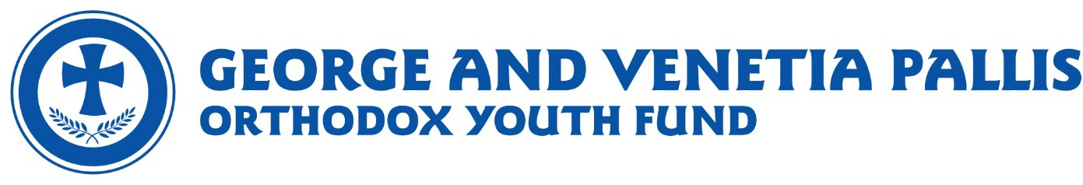

Applicant’s Name

Applicant’s Address

Applicant’s City, State Zip

Applicant’s Phone

Applicant’s Email

Applicant’s Present School Grade

Parent’s Name

Parent’s Email

Parent’s Phone

Parish Name

Parish Phone

Parish Priest Name

Have you attended IV in the past? Yes ⬜ No ⬜

**What Orthodoxy means to me and how I have applied it to my life (300-500 words).**

MAIL TO:

George & Venetia Pallis Youth Fund  
PO Box 84123  
Seattle, WA 98124

Or email to: [info@gvpallisyouthfund.org](mailto:info@gvpallisyouthfund.org)