Kirkton



**Kirkton community centre SCIO**

**Business Plan**

About us

**Kirkton Community Centre SCIO**

C/O Downfied Junior Football Club

Balgowan Avenue

Dundee

DD3 0HB

We are a Scottish Charitable Incorporated Organisation - SC052701

The organisations community is the area of Kirkton and Trottick bounded by; Kingsway, Forfar Road (including Caird Park), Claverhouse Road, Trottick (including Ponds), Harestane Road and Strathmartine Road.

Purposes of our organisation:

1. The prevention of relief of poverty
2. The provision of recreational facilities
3. Organisation of recreational activities with the object of improving the conditions of life for the persons for whom the facilities or activities are primarily intended.
4. To promote the benefit of the inhabitants of Kirkton Neighbourhood without distinction of gender, political, religious, or other
5. By associating the local and statutory authorities, voluntary organisations, and inhabitants in a common effort to advance education and to provide facilities in the interests of social welfare, for recreation and other leisure time.

General structure

The structure of the organisation consists of:

The MEMBERS - who have the right to attend members' meetings (including any annual general meeting) and have important powers under the constitution; in particular, the members appoint people to serve on the board and take decisions on changes to the constitution itself.

The BOARD - who hold regular meetings and generally control the activities of the organisation; for example, the board is responsible for monitoring and controlling the financial position of the organisation.

Mission

At Kirkton SCIO, we are dedicated to improving the lives of those in need by providing essential resources and support. Our mission is to make a positive impact in our community and beyond.

This business plan was developed with support and input from the following organisations:

Contents

[1. Introduction and Background 5](#_Toc173249229)

[1.1 Background and Original Drivers 5](#_Toc173249230)

[1.2 The Organisation 5](#_Toc173249231)

[1.3 Trustee Pen Portraits 7](#_Toc173249232)

[1.4 About the Community 10](#_Toc173249233)

[1.5 About the Asset 11](#_Toc173249234)

[1.6 How this Business Plan was developed: Methodology. 13](#_Toc173249235)

[2. Summary of Research 15](#_Toc173249236)

[2.1 Summary 15](#_Toc173249237)

[Community spaces in Kirkton 15](#_Toc173249238)

[Support for the Project 17](#_Toc173249239)

[2.2 Strategic Fit 18](#_Toc173249240)

[Community Hubs 20](#_Toc173249241)

[Dundee City Council 20](#_Toc173249242)

[2.3 Social Need: Evidenced 22](#_Toc173249243)

[2.4 Partner Analysis 23](#_Toc173249244)

[Asset Mapping 28](#_Toc173249245)

[3. What will we do and our outcomes 29](#_Toc173249246)

[3.1 Vision 29](#_Toc173249247)

[3.2 Kirkton Community Centre SCIO 30](#_Toc173249248)

[The Main Building 30](#_Toc173249249)

[Multi Use Community Space 30](#_Toc173249250)

[Community Café 30](#_Toc173249251)

[Private meeting/Consultation room 31](#_Toc173249252)

[Reception area and Office 31](#_Toc173249253)

[Changing Places 31](#_Toc173249254)

[Public Toilets 31](#_Toc173249255)

[Outdoor Community Space 32](#_Toc173249256)

[Food Larder 32](#_Toc173249257)

[Community Garden 32](#_Toc173249258)

[Car Park 32](#_Toc173249259)

[3.3 Activities and Services 33](#_Toc173249260)

[Activities for children and families 33](#_Toc173249261)

[Training and Employability 33](#_Toc173249262)

[Community Café 34](#_Toc173249263)

[Food Larder 34](#_Toc173249264)

[Advice and support 34](#_Toc173249265)

[3.4 Broad Social Outcomes 35](#_Toc173249266)

[4. Delivering the project - Governance & Management 37](#_Toc173249267)

[4.1 Governance 37](#_Toc173249268)

[Succession Planning 38](#_Toc173249269)

[4.2 Staffing 39](#_Toc173249270)

[4.3 Volunteers 46](#_Toc173249271)

[4.4 Monitoring and Evaluation 48](#_Toc173249272)

[4.5 Partners 49](#_Toc173249273)

[4.6 Marketing Plan 52](#_Toc173249274)

[4.7 Risk Mitigation 54](#_Toc173249275)

[5. Funding & Finance 59](#_Toc173249276)

[5.1 Capital Costs 59](#_Toc173249277)

[5.2 Indicative Funding Strategy 60](#_Toc173249278)

[5.3 Income Generation and Sustainability 63](#_Toc173249279)

[6. Environmental Sustainability 64](#_Toc173249280)

[Appendices 65](#_Toc173249281)

[Appendix 1: Demographic Study 65](#_Toc173249282)

[Appendix 2: Trustees Skills Audit 67](#_Toc173249283)

[Appendix 3: Community Survey Results 76](#_Toc173249284)

[Appendix 4 – Cash Flow Forecast 81](#_Toc173249285)

[Appendix 5 – Projected Weekly Timetable and Income 87](#_Toc173249286)

# 1. Introduction and Background

# 1.1 Background and Original Drivers

The Kirkton Community Centre (SCIO) is a community organisation set up to run activities and programmes for the community of Kirkton.  Kirkton & Trottick is in the northwest of Dundee.

Kirkton Local Management Group currently run activities and programmes from Kirkton Community Centre.  The current Kirkton Community Centre was built in 1972 and is owned by Dundee City Council.  A committee meeting held in 2023 confirmed that the building will close in March 2025.  Dundee City Council has a lease arrangement with the SCIO to run activities from the current Community Centre.

Link to committee report - [303-2023.pdf (dundeecity.gov.uk)](https://www.dundeecity.gov.uk/reports/reports/303-2023.pdf)

Link to comments from committee meeting - [Article | Dundee City Council](https://www.dundeecity.gov.uk/minutes/article?articlekey=91049)

This Business Plan sets out the case for developing a new community owned community centre in Kirkton.  Dundee City Council’s future investment will be in school community hubs.  Library, sport activities, fitness classes and some evening provision would move to local schools.  However, a gap has been identified where daytime anti-poverty work needs community-based accommodation.

Kirkton & Trottick has a population of 5,161 people.

The Kirkton Community Centre SCIO have developed this business plan with support from the Strathmartine Community Empowerment Team of Dundee City Council and Jon Frullani Architects.  This business plan will set out how the project will be set up, financed, operationally managed, and sustained.

# 1.2 The Organisation

Founded in 1998, Kirkton Local Management Group (LMG), now Kirkton Community Centre SCIO has grown from a small group of volunteers to a thriving organisation with a wide range of programmes and services. Over the years, we have helped thousands of individuals and families in need. In July 2023, the LMG became the Kirkton Community Centre SCIO (two tier).

Our team is made up of passionate and dedicated individuals who are committed to making a difference. Everyone at Kirkton SCIO shares a common goal of helping those in need.

At Kirkton SCIO, we are dedicated to improving the lives of those in need by providing essential resources and support. Our mission is to make a positive impact in our community and beyond.

The Kirkton LMG and now SCIO Trustees have managed the existing Kirkton Community Centre as a registered charity for 25 years in partnership with Dundee City Council. They have raised a substantial amount of funds and planned / organised hundreds of events and activities to respond to the needs of the Kirkton community.

 A food larder was set up by the members of the then Kirkton LMG.  The Larder is now a Scottish Charitable Incorporated Organisation with a Board of Trustees which employ three members of staff.  The Strathmartine Community Larder also lease two retail units based in the St Marys Community of Strathmartine.  The Larder runs two weekly pop-up sessions from Kirkton Community Centre and work closely with the Kirkton SCIO.

The Kirkton Community Centre SCIO currently employ two children's workers.  This was in response to a need in the community to provide provision for children aged under 10.

The Kirkton Community Centre SCIO have run numerous community events over the years with an average of 200 people attending each event.

The current Kirkton Community Centre has an average footfall of over 3,000 visitors per month.

## 1.3 Trustee Pen Portraits

**Jacqueline Nicoll (Jacky) – Chairperson**

Jacky has lived in Kirkton for over forty years. She has over twenty years’ experience as a charity trustee. Jacky has worked/volunteered in the local bakery for eleven years always with a listening ear to her customers, many of whom are residents of Kirkton. She has been a Local Girl Guide Leader and church elder for over twenty-five years. Jacky was a volunteer with the old Beauly lounge (now Attic Charity) and has offered support to people in Kirkton of all ages. She has been a trustee with Kirkton Community Centre since 1998 and was pivotal in establishing a Gymnastics club and the Kirkton Kids holiday programme for local children and young people.  Jacky has completed a vast and varied amount of training ranging from a Diploma in Hotel Management, tax office training, protecting people training, OSCR Governance training, first aid and training on mental health first aid.  Jacky enjoys meeting people from all walks of life, listening and helping when she can or being able to signpost people to where they can access support.

**Priscilla Christie (Cilla) – Vice Chair**

Cilla has lived in Kirkton for over 30 years. She has around 3 years of experience as a charity trustee. Cilla has worked within the public sector and retail industry since she was 13 years old. Cilla joined Kirkton Community Larder in 2019 as a volunteer and is now a paid member of staff within Strathmartine Community Larder SCIO. Cilla enjoys interacting with and supporting members of the Kirkton community. Cilla is also an experienced fund raiser and has raised funds for both Strathmartine Community Larder and Kirkton Community Centre SCIO. Cilla has completed a vast amount of online training courses ranging from Health and Safety to Customer Service. She has also completed her REHIS food hygiene training, First Aid at work, Mental Health First Aid and Community Guiders training. Cilla is a highly active member of our community and has a vast knowledge of the area and the people we support. She knows where to direct people for help and has great listening skills.

**Melanie Kiyani – Treasurer**

Melanie grew up in Kirkton and moved back with her family 8 years ago and has 6 years' experience as a charity trustee and 10 years as a business owner. Melanie began her career as an Insurance Representative in Dundee and for 12 years she gained experience of all aspects of insurance. After having her daughter, Melanie retrained as a Learning Disability and Mental Health Nurse. Due to ill health she had to give this up and now concentrates on making a difference to the people of the Kirkton Community. Melanie is a qualified Mental Health First Aid Instructor with Public Health Scotland and delivers training to other charities and volunteers. Melanie and her family currently run small businesses across Dundee and Angus, and this gives Melanie the experience of the business sector, managing staff and budgets. Melanie is the current chairperson for Strathmartine Community Larder SCIO and oversees the line management the larder staff team. Melanie has a proven track record of securing funding for the Larder and Kirkton Community Centre SCIO. Melanie oversees the community cafe in Kirkton Community Centre and supports local people to volunteer at community cafe.  Melanie has been heavily involved in the development of this business plan and is a highly active member of the community.

**Gillian Gordon – Secretary**

Gillian has lived in Kirkton for 43 years and has 4 years' experience as a charity trustee.  For over 20 years, Gillians career has been dedicated to working with vulnerable adults. Gillian has qualifications in health and social care, a Professional Development Award in Supervision and Leadership, along with Open University qualifications in Social Science and Management.  Gillian’s experience in this field has provided the SCIO with expert knowledge on accessibility, inclusion and ensuring that the needs of people with additional support are at the heart of planning activities and programmes from the current Kirkton Community Centre.

**Joan Whyte – Trustee**

Joan has lived in Kirkton for 57 years and has been involved in the community centre for fifteen years.  Over the years, Joan has been actively involved in various community groups and organisations.  Joan has been a school cook for twenty-seven years and has extensive experience of the catering industry.  Joan is an active member of the Kirkton Community Centre SCIO and has been involved with designing activities and programmes for children over many years. Joan was also involved in setting up the current evening community cafe which is a huge success. The evening cafe was developed in response to the recent cost of living crisis to provide support to community members and families struggling with the rise in food costs.

**Ruth Button – Trustee**

Ruth was born in Kirkton and spent much of her childhood there, however she moved from the area as a young adult and returned fifteen years ago.  Ruth has been a charity trustee for the last four years.  She works in a school as a classroom assistant and has been supporting young people with their learning for nineteen years.  She has lots of experience of supporting families and currently volunteers at the Monday evening community cafe.  Ruth has completed numerous online courses including Food Hygiene, Customer Service, and others.  Ruth is an active member of Kirkton Community Centre SCIO and is heavily involved with all our ongoing fundraising efforts.

**Toni Christie – Trustee**

Toni has lived in Kirkton all her life and has been a trustee for around eight years involved in developing and running activities for children and young people. Toni also volunteers at the Monday evening community cafe and has experience of fundraising and securing funding for the charity.  Toni has a great knowledge of the community and through working in nurseries and care homes she has a wide knowledge of individual's needs.

**Helen Smith – Trustee**

Helen has been a trustee for over seventeen years and has lived in Kirkton for over fifty years. Helen has extensive experience of organising large community events, programmes, and activities. Helen began her working life as an administrative officer for an engineering company. Towards the end of her career, she worked in catering becoming a supervisor overseeing a large staff team which often catered to hundreds of people. Helen has excellent communication and organisational skills.

**Scott Eley – Trustee**

Scott grew up in Kirkton and has been a trustee with the community centre for two years.  Scott is a qualified Chef with over ten years of experience working in the catering industry.  Throughout his career in catering, Scott has gained good experience of customer service, food standards, designing menus and nutrition. Scott is involved with the planning and implementation of large community activities, the planning of the community cafe and securing funding.  Scott has completed several training programmes both through work and the Kirkton SCIO these range from Food Hygiene, Risk Assessment, Emergency First Aid to Manual Handling.

**Patricia Wilson (Pat) – Committee Member**

Pat has lived in Kirkton for over fifty years.  She has recently become a trustee with Kirkton Community Centre SCIO.  Pat was the Manager of a Local Charity shop and has worked in business and retail for fourteen years. Pat was also a support worker in education and developed a sound knowledge and understanding around support for families and children with additional support needs.

**Valerie Johnston (Val) – Committee Member**

Val has lived in Kirkton for around thirty years and has been a committee member with Kirkton Community Centre SCIO for the last eighteen months.  Val has extensive experience of charities and has been involved with many local charities as a volunteer, being a trustee and / or office bearer. Val has designed and ran many groups and programmes for elderly members of the community. These projects ranged from tackling social isolation, health & wellbeing, and support with the cost of living. Val is also experienced in fund raising and has secured funding for Kirkton SCIO from a range of funding providers.

**Pauline Simpson – Committee Member**

Pauline has lived in Kirkton for over twenty years and has been a committee member of the Kirkton SCIO for the last five years.  Pauline is a very active member of the community and volunteers with Strathmartine Community Larder.  Pauline has completed several online and face to face training courses ranging from Customer Services, Mental Health First Aid, Basic First Aid, Conflict Management and Recruitment training.  Pauline is very active in all our fundraising events and has extensive knowledge of fundraising and securing funding from local and national funding bodies.

**Frank Robertson – Committee Member**

Frank moved to the Kirkton area several years ago and was coopted on as a committee member of the KLMG. Frank has many years of experience in the voluntary sector having been a trustee on the Hilltown Community Centre Local Management Group. Frank is an allotment owner, and his growing and environmental knowledge will be beneficial when the group begin working on the green space development, planned for the outdoor space.

# 

# 1.4 About the Community

Kirkton and Trottick is a large area based within the Strathmartine electoral ward of Dundee.

As of the 2020 SIMD profile for Strathmartine, Kirkton & Trottick has a population of 5,161 people. A further breakdown of the population shows that 25% of the population are aged 0 to 16, 61.6% are aged 16 to 64 and 13.5% are aged 65 and over.

2020 SIMD Data shows us that Kirkton & Trottick has seven data zones.  Of the seven data zones two are in the 5% most deprived. Of these two data zones, one (S01007812) has remained within the 5% most deprived since 2012.  The other (S01007810) has fallen into the 5% most deprived since the last SIMD figures released in 2016. There are three data zones which fall into the 15% most deprived.  The SIMD Data shows that data zone (S01007812) within the 5% most deprived has shown no improvements in Education, Health, Employment, Income Domain, and Crime since 2012.

Of the 5,161 people living in Kirkton & Trottick, 82% live in data zones ranked in the 20% most deprived whilst 16.1% live in the data zones ranked in the 5% most deprived.  It should be noted that the 16.1% living in the 5% most deprived data zones are within walking distance to the location of the current Community Centre.

The child population (0 to 15) of Kirkton & Trottick is 1,291. 85.6% of the children (0 to 15) live in the 20% most deprived and 17.7% live in the 5% most deprived.

In terms of Health, 82% of the population of Kirkton & Trottick live in data zones ranked 20% within the most deprived.

86.8% of the population of Kirkton & Trottick aged 0 to 15 are living in the data zone ranked in the 20% most deprived in relation to education. This is the largest figure in relation to education in Strathmartine. The figure stands at 47.3% for Dundee City overall.

Under income, 82.0% of the population of Kirkton & Trottick are living in data zones ranked as being in the 20% most income deprived. In contrast, other areas of Strathmartine such as Baldragon, Clatto and Sherbrook have 0% of people living in the 20% most deprived data zones in relation to income deprived. 36.6% of the population of Dundee City live in data zones ranked in the 20% most deprived in relation to income deprived.

As of 2020, 65.9% of the population of Kirkton & Trottick live in data zones ranked within the data zones ranked 20% most deprived in relation to crime. In 2016, this figure was 41.6%.

Figure 1 – Map of Kirkton

# 1.5 About the Asset

The Kirkton SCIO have identified the existing site of the current Kirkton Community Centre for a new community owned facility.  This site is approximately 4,900 sq. m and is owned by Dundee City Council.   Kirkton Community Centre SCIO have agreed a 99-year lease from Dundee City Council for the land highlight in the red area below. The Kirkton SCIO plan to retain the current carpark with Dundee City Council agreeing to pay for and carry out the demolition of the existing community centre. Dundee City Council estimate that the cost of demolition to be around £300,000.

Figure 2 shows the location of site of current community centre and future community owned community centre.

# 1.6 How this Business Plan was developed: Methodology.

The Kirkton SCIO realised that engaging with the Kirkton Community was a priority in terms of demonstrating the research element of the business plan.  A series of engagement opportunities and events took place with over 500 people taking part.

The SCIO recognised that the community voice needed to be heard. This was to ensure that the project was community led and addressed gaps in the community.  The Kirkton SCIO and members of the Community Empowerment Team of Dundee City Council have engaged with:

* Over 300 existing users of the current community centre
* Local school children at Primary Schools in Kirkton
* Engaged with the community online via social media and their own website.
* 6 Local organisations and groups were interviewed as project stakeholders.
  + Large community engagement event was held with over 200 people attending in partnership with the University of Dundee.

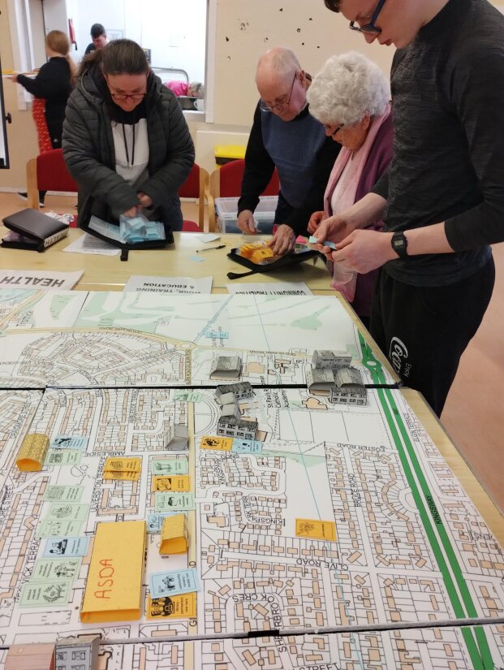

The stages for this study are outlined below:

|  |  |
| --- | --- |
| Awareness Raising | Information was shared online via social media.  The SCIO also designed their own website.  Discussions with key partners are also ongoing. |
| Demographic and Policy Analysis | Study of key demographic trends in the local area taken from SIMD Data and Health statistics.    Analysis of key national, city-wide, and local policies and priorities including the Dundee City Plan.  The Strathmartine Local Community Plan was also used to determine priorities. |
| Asset Mapping | A full mapping exercise to identify what is available locally to maximise partnership and to avoid duplication and displacement. |
| Community Events | A large community event was held in partnership with the University of Dundee in April 24 with over 200 people in attendance.    Follow up consultation sessions have also been held with existing groups and service users with around 300 people engaging. |
| Community Survey | 202 people took part in the survey. |
| Stakeholder Interviews | In depth interviews and focus groups were held with local groups and organisations to develop an understanding of needs and challenges. |
| Feedback Event | A feedback drop in was held to give residents an opportunity to view draft proposals and raise any concerns. |
| Business Plan | Feedback and comments led to the business plan as set out here. |

All the community engagement exercises detailed above have fed into the development of this business plan.

# 2. Summary of Research

# 2.1 Summary

**Demographic Profile of the Area**

* Kirkton demographically has a population breakdown as follows.
* 25% are aged between 0 – 16 years.
* 61.6% are aged between 16-64 years.
* 13.5% are aged over 65 years.
* Stakeholder insights told us that many people living in the area feel strongly connected to their own specific neighbourhood and in many cases will not access key services and activities out with this area.
* A full demographic profile and analysis of the area can be found in Appendix 1 of this report.

**Challenges and issues in the area**

**The local community plan for the Strathmartine Electoral Ward seeks to make five significant contributions to reducing inequalities.  These include:**

* Work around recovery and substance use.
* Improving life quality for children & families
* Improving greenspace
* Support with the cost-of-living crisis.
* Community spaces in Kirkton

## Community spaces in Kirkton

A consultation took place pre-covid asking residents of Kirkton to prioritise needs and activities.  Two hundred and fifty-four people took part, consultations were carried out at school parent’s evenings, community events, adult learning groups, the library, youth work provision, local businesses.  The consultation was a useful tool in assessing the needs of the community.  Activities and services which stood out in terms of having unanimous demand from community members were family activities, youth work, community café, adult learning, library, money/legal/benefits advice, and free Wi-Fi.

Kirkton & Trottick has a population of 5161 people of which 1296 are under the age of sixteen.  There are 785 people aged 25 to 34 and 639 people aged 35 to 44.  It is no surprise to see that many young families are looking for a place within their community which can provide free or very low-cost family activities and meals.  Many people aged 16 to 24 and over 65 stated they felt that money / legal and benefits advice were a priority.  It was also noted that free Wi-Fi is a priority as it enables people to access benefits online along with job applications and the ability to work remotely.  The community café, and adult learning groups were seen as priorities by people aged 35 and over.  A flexible programme of learning opportunities is required for people of all ages to access to improve education, confidence, and self-esteem. A facility which aims to tackle social isolation and actively provide activities for families to come together will help tackle poverty, strengthen family bonds, and build community cohesion.  A facility which encourages volunteering and community empowerment that can become a focal point for recovery around economics, employment, and health for people of all ages.

## Support for the Project

* On October 31st, 2022, the community of Kirkton made the national headlines as a large-scale social disorder took place involving young people.  This included projectiles and fireworks being thrown at Police, fire raising, acts of violence and vandalism.
* [BBC News - Kirkton 2022](https://www.bbc.co.uk/news/uk-scotland-tayside-central-63465597)
* As a result of this incident local people are very supportive of the idea of a community facility which offers opportunities for jobs, volunteering, and enterprise.
* All project ideas for the facility were well supported with a community cafe open five days a week offering breakfast, lunch and dinner at affordable prices being a particular priority.
* Retail space where local people can set up pop up businesses is also supported by the community.
* A multi-purpose space which can generate income through being hired out for events or alternatively be used for targeted work around mental health, recovery work or family activities is supported by the community.
* A large community garden where people can grow vegetables, learn gardening skills, and use as a sensory space was also supported.
* A building with access to free Wi-Fi was also welcomed by the community including young people.
* A car wash facility.
* Electric charging points for cars.
* Community Washing Machines.

# 2.2 Strategic Fit

**Local Strategies**

**City Plan for Dundee 2022-2032**: the key focus of the City Plan is to reduce inequality and poverty, improving the city’s economy and tackling climate change. The plan identifies 3 strategic priorities:

* Reducing child poverty and inequalities in incomes, education, and health
* Tackling climate change and reaching net zero carbon emissions by 2045
* Delivering inclusive economic growth, including community wealth building.

The development of a new community enterprise facility in Kirkton supports all three of these priorities:

* The centre will work to support inequalities in income, education, and health, providing access for local people to key services such as job clubs, health advice, benefits advice, volunteering opportunities etc. It aims to support local people to address challenges in their lives, reducing the number of families living in poverty and improving quality of life.
* In replacing a 1960s building, the new development will build in low carbon energy systems and reduce the level of emissions, supporting the decarbonisation agenda.
* The facility, run by local people, for local people will directly support through the development of enterprise units, the need to deliver inclusive economic growth, generating business/jobs opportunities in the local area. The project also directly addresses the community wealth building agenda, bringing ownership and control of local facilities into community hands.

**Local Development Plan Dundee 2019**: a key aim of the Local Development Plan is to shape the future of our places by developing infrastructure, addressing climate change, and creating better places, with a sustainable economy and sustainable communities. It also recognises the benefits of place-making and 20-minute neighbourhood, key benefits that the Kirkton project seeks to deliver on, making services more accessible for local residents and instilling a sense of pride in their neighbourhood through quality infrastructure. Local architect Jon Frullani has been working with the management group to develop high quality designs for the building, addressing Policy 1 of the Local Development Plan: High Quality Design and Placemaking. Small scale commercial uses in residential areas, such as those proposed by the Kirkton development will be permissible under Policy 17: Small Scale Commercial Uses within Residential Areas. The Plan also recognises the need for community facilities that support and enhance education, health, safety, and the overall quality of life by providing essential services, resources, and opportunities. Proposals for new community facilities are supported under Policy 18: Community Facilities, where they are in locations convenient to the community and are accessible by public transport and active travel. Buildings or land formerly in community use become surplus (such as the existing community centre) to current or future requirements, alternative uses or developments which are compatible with adjoining uses and any remaining community uses, will be supported.

**Local Community Plan, Strathmartine Ward 2022-2027**: the Local Community Plan covering the Kirkton area (Strathmartine) highlights the need to ensure community spaces in Kirkton meet the future needs of the local community, identifying the need for a community hub model in Kirkton including developing future plans for a community facility.

**National Strategies**

**Scottish Government 20 Minute Neighbourhoods**: local living and 20-minute neighbourhoods can help to deliver the healthy sustainable and resilient places required to support a good quality of life, providing people with the opportunity to meet the majority of their needs within reasonable distance of their home (walking, wheeling, or cycling). The strategy recognises that some areas need change to improve their liveability or to maintain it into the future – as Kirkton does with the proposed demolition of the existing community facility. Effective community engagement at the start of the process is core to these approaches, and the local management group have been engaging with their local community since the proposals to demolish the existing centre were first mooted. The aim of 20-minute neighbourhoods is to improve the local economy (a key element of the proposed project is to create commercial spaces in the area and a community café offering much needed services, volunteering, training, and employment opportunities.

**Scottish Government Regeneration Approach**: the Scottish Government’s approach to regeneration recognises that it is about people identifying issues and opportunities in their local area, deciding what to do about them and making positive changes in their communities. This is a role that the Kirkton Local Management Group have undertaken in the running of the existing centre and in developing plans for a new facility that better meets the needs of their community, is more cost effective to run and offers enterprise opportunities. The Scottish Government supports community-led regeneration that increases the number and strength of locally controlled, enterprising community organisations, supports local organisations to take ownership of assets such as buildings or land, helps people to co-ordinate action and respond to challenges in areas where there are high levels of disadvantage (such as Kirkton) and helps people identify and act on the priorities in their areas.

**Scottish Government Community Wealth Building**: the Scottish Government has adopted the CWB approach to economic development and support for the wellbeing economy objectives. CWB seeks to enable more local communities and people to own, have a stake in, access and benefit from the wealth our economy generates. This project supports community ownership and delivery and directly delivers on the community wealth building agenda.

## Community Hubs

## Dundee City Council

Dundee City Council are moving towards a policy of having 365 schools as community hubs.  This will mainly focus on sport, fitness, swimming, library, and other activities.  However, there is a need for a facility in Kirkton with a focus on anti-poverty work during the daytime.    The Kirkton SCIO have identified through an asset mapping exercise that this project will complement the work of Dundee City Councils school / community hubs model.  The SCIO are represented on the Dundee City Council Kirkton Community Hubs Governance Group.  There is support from Dundee City Council for the SCIO’s plans for a new community facility and this was confirmed by Dundee City Council’s, Neighbourhood Services Committee Report.

Through adopting a Planning for Real engagement approach, the community of Kirkton prioritised the following activities and services.

* A community owned facility
* A community cafe
* A place for elderly people to go during the day.
* Community garden
* Disabled access
* Sensory garden
* Advice and information
* Community events
* Legal Advice
* Support for recovery.
* More local shops / businesses
* Post office.
* Volunteering opportunities
* Parent & toddler groups
* Family work

# 2.3 Social Need: Evidenced

**Need Identified** **Evidence of that need.**

|  |  |
| --- | --- |
| **A Community Cafe with**  **Wi-Fi serving low-cost breakfast, lunch, and evening meals.** | Cost of Living / Social Isolation and loneliness   * The Joseph Rowantree 2024 report on poverty shows the levels of poverty are rising across the UK.  A rise in food / fuel costs / unemployment / inflation with benefits and wages struggling to keep up. * SIMD 2020 – 82% of the population of Kirkton & Trottick live in the 20% most deprived. * 16.1% of the population of Kirkton & Trottick live in the 5% most deprived. * Population – 5,161   **A neighbourhood specific space**   * Competitive analysis showed that there is no other cafe in Kirkton & Trottick which is open five days per week. * The cafe would be available for hire at the weekends for social events, birthday parties. * Local people advised that they want somewhere local where they can go for low-cost meals. * A place with free Wi-Fi * A place where they can socialise, obtain advice, and develop local networks. |
| **Enterprise / Employment & Volunteering opportunities** | **Attainment**   * There are two secondary schools based within Kirkton & Trottick. Data shows that for the academic year 22/23 both schools recorded the number of pupils leaving school with 5 SCQF Level qualifications at either level 4 or 5 are below the Scottish average.     **Enterprise**   * There are no available retail units in the area for lease to the community and no post office in Kirkton & Trottick. * Local people advised the LMG that they want more volunteering opportunities and space for local businesses. |
| **Multi-Purpose Space** | **Social Gatherings**   * Local people have reported that they would like somewhere local for functions.   **Business**   * Local organisations have given feedback that they would use this space for training and seminars.   Targeted Work   * The community have reported that they would like this space during the day where people can get support with recovery, mental health, family work and other preventative approaches. |
| **Community Garden** | **Sensory Garden**   * Feedback from the community demonstrates support for a sensory garden.   **Community Growing and Outdoor Learning**   * Opportunities for outdoor learning are a priority for people in Kirkton. |

# 2.4 Partner Analysis

There are two churches, two primary schools and two secondary schools based within Kirkton & Trottick.  There is also a Junior Football Club, and a voluntary organisation called the Attic based within the community. There are two small rows of shops located in Kirkton at Beauly Avenue and Haldane Avenue respectively and an Asda supermarket.

Both secondary schools will open for community use primarily during the evening and weekends.  However, space is limited for daytime provision and one of the schools is not on a bus route.

**Downfield Junior Football Club**

Have a football ground, grass pitch with internal space which they hope to hire out to generate income.

**Churches**

Downfield Mains Church is in the Downfield area of Kirkton.  Many residents of Kirkton do not associate Downfield as being part of Kirkton due to its location on the outskirts of the Kirkton Community.  St Columba’s Church is located close to the existing Community Centre; however, the future of the church is uncertain.

**Food Provision**

Downfield Mains and St Columba’s Church both run community cafes.  However, these run one day per week and offer lunches only.  There is nowhere in Kirkton & Trottick offering a purpose-built cafe five days per week serving quality food and drink which is affordable for the community. The Asda Supermarket does not contain a cafe within its premises.

**Enterprise / Retail**

Although Kirkton & Trottick has two small rows of shops and a supermarket there is no Post Office in the community.  All retail units currently located in the community are full, with no units currently available for lease.  The row of shops at Beauly Avenue contains the following: Mini Market – A large newsagent, small bakery, Kohenoor Take Away Food, Desserts This Way – shop selling homemade desserts, Turkish Barbers, and the Attic Charity. The row of shops on Haldane Avenue contains a Pharmacy, Large newsagents, Take Away, Hairdressers, Karate Instructors studio and a small shop offering tailoring services.

**Kameni Fitness gym and a dance studio**

Are located on Balgowan Avenue and are privately owned businesses. The gym offers free weights and personal training.

**Asda Supermarket**

Located off Gilburn Road and was built around the same time as the current Kirkton Community Centre. The supermarket is busy and is situated across the road from the proposed site of the new community facility. This would bring opportunities for customers of the supermarket to visit the new community centre to use the community cafe, use the car wash, charging points as none of these are provided by the supermarket.

**Employment & Volunteering**

Opportunities for local organisations to employ local people are limited.  The Kirkton SCIO have ambitions to employ local people through the creation of several jobs which will be required to run the new facility. Alongside this there will be opportunities for volunteering through the cafe and community garden. The retail units would also enable local people to run startup businesses from the retail units.  This will also increase local services for the Kirkton Community.  The employment opportunities would range from part time to full time and therefore appeal to people of all ages from school leavers to more mature members of the community. The community centre would also work with colleagues in Youth Work, local schools, and Dundee & Angus College to offer volunteering opportunities to support young people sustain further education and employment.

**Community Support**

The Attic currently offer a limited programme three days per week of aimed at supporting community members. As stated previously schools will be able to offer leisure & recreation activities primarily in the evening and weekends.  There is a need to have a facility in the community which allows scope for developing new initiatives aimed at reducing inequalities.

**Environment & Greenspace**

The new facility will be energy efficient and modern in its design.  Food waste would be reduced through initiatives such as the community cafe, growing space, and links with other organisations such as Strathmartine Community Larder. The facility would be ideally located to encourage active travel as opposed to a reliance on cars and would also support the 20-minute neighbourhood principle.  There is a large area of greenspace adjacent to the site of the proposed community centre. Kirkton Community Partnership is a Neighbourhood Representative Structure made up of local residents. They are currently working with residents and Dundee City Council to make improvements to this area which is mainly grass with a small play park. A multi-use games arena along with benches, a fitness / climbing frame, and the refurbishment of a shelter for young people have recently been added to the area. Another new development was the creation of a “wee forest” outdoor classroom which was a partnership with the Botanical Gardens of the University of Dundee. Kirkton Community Partnership have ambitions to continue to develop this greenspace to include a path network, improved play areas, tree planting, benches etc. This development along with plans for the new community centre would be part of a greater regeneration provide of the area which would benefit the entire community.

**Identifying Gaps**

Through a mix of consultation, asset mapping and analysing data the Kirkton Community Centre SCIO have identified gaps within the community of Kirkton & Trottick. Dundee City Councils plan for 365 schools / Kirkton Community Hubs model will address opportunities for some adult learning, youth work and leisure sports activities but will struggle to find suitable space during the day.

**Food Provision**

As stated previously there is not a cafe in Kirkton & Trottick open a minimum of five days per week.

The new community centre would provide an opportunity for community members to access a community cafe providing low-cost meals, social events, and a quality space where people in the community can come together to socialise, strengthen community bonds, improve health & wellbeing whilst tackling social isolation.

The new community centre would also provide an outdoor cabin type space for a pop-up larder to continue to run in the community. This would be overseen by the Strathmartine Community Larder and be based in the garden area next to the cafe. This would allow community members to be able to access support around food without fear of stigma and would encourage people to become more environmentally aware through reducing food waste as the cafe, garden and larder would work in tandem.

**Internet Access**

Post covid, there is a greater opportunity than ever before for people to work remotely. An emerging young workforce will rely on the internet for business opportunities, communication, and innovation. The new community centre will have free internet access available during opening hours. Community members will be able to use the cafe space for work purposes particularly if they live in chaotic households where space, peace and quiet and rising energy costs can make working from home difficult.

**Accessibility**

 The current Community Centre is built on various levels and due to its age, it is not fully accessible to people with mobility issues. Apart from the school estate many buildings in Kirkton such as the two churches, existing shops, Downfield Juniors Football Ground, and the Attic all present issues for people to access who have issues with mobility due to their age and design.

The new community centre would be built on one level and be fully accessible. The building would also contain a changing room facility which would be accessible to all. This would make the building attractive to people with mobility issues who may want to attend the community centre from across Dundee.

The school estate in Kirkton is relatively modern however, through consultation by the Kirkton Community Centre SCIO with a large group of people mainly wheelchair users many expressed that they would be uncomfortable using schools during the day due to concerns around safety and a lack of space in schools during the school day.

**Volunteering & Employment Opportunities**

The new community centre would provide volunteering opportunities for local people through the Larder, Cafe, Retail Units, Garden and by supporting some activities in the multi-purpose space. All volunteers would provide support and training by the Kirkton Community Centre SCIO. However, partners such as schools, third sector organisations and Youth Workers would also support volunteers from the community. The new community centre would provide multiple opportunities for training around retail, enterprise, gardening, horticulture, social care, and hospitality.

The Kirkton Community Centre SCIO would also employ a small staff team who would ensure the smooth day to day running of the Community Centre whilst providing quality customer service to community members. These employment opportunities would be open to local people including young school leavers looking for a mix of full time and part time posts.

**Retail Units & Enterprise**

The Kirkton area currently has a limited number of shops all ranging in size. However, all retail units are full and there are none available for aspiring local businesses. Many of the existing retail units are hairdressers, take aways or a newsagent. The new community centre would contain two retail units which could be leased out to earn and income or possibly overseen and ran by the SCIO to generate income. Potential business opportunities could include a tool hire where people on a limited income can hire tools for home improvements / gardening. A post office / parcel drops off collection point as there are none located in Kirkton or a second-hand community shop to encourage the reuse of household items and clothes.

Alternatively, the retail units could provide opportunities for community members to run pop up businesses. This would support local people, young or old to begin their own business journey whilst juggling other commitments such as parenting, further education, or the lack of finance / knowledge to run a business as a full-time concern.

# Asset Mapping

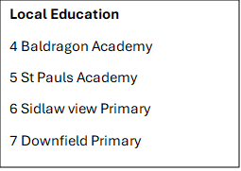 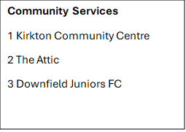

# 3. What will we do and our outcomes

# 3.1 Vision

Our objectives over the next 5 years are to:

* Provide a welcoming and fully accessible space for the community to come together and connect around shared activities and events, supporting our community to be more connected and build community wealth.
* Join up with other support providers in the area to offer a holistic service to our community, which has a range of needs, and benefits people from birth through to older people.
* Take steps to reduce food insecurity and poverty in our community by helping to improve household finances and providing a venue for community food-based activity and learning.
* Promote the health and wellbeing of our community by encouraging and supporting healthy, sustainable living by improving diet and supporting positive mental health.
* Encourage and provide opportunities for local people to develop skills and experience that will improve employment prospects.

Our values and ways of working

We are:

* Open and transparent: Sharing information and updates with the community, our partners, and stakeholders.
* Welcoming to all: creating a space where everyone feels a sense of belonging, particularly those who have never engaged in our activities before.
* Community Controlled: ensuring everyone, regardless of age, background or circumstances can influence and get involved in the work we do.
* True partners: collaborating with all agencies, locally and regionally, increasing mutual benefit and minimising displacement.

# 3.2 Kirkton Community Centre SCIO

The committee has developed a vision for the site based on the research, evidence of need and demand. Substantial work has been done to develop a space that will enable both the Kirkton Community Centre SCIO and partner organisations to deliver on the vision and mission outlined above. The Community Centre will be a flexible single storey community space which function as a ‘BASE CAMP’ for a variety of uses, with the flexibility to accommodate multiple users of varying ages.

The community centre will be developed in two parts, the main building and outdoor space.

## The Main Building

## Multi Use Community Space

This will be a flexible and multi-use community space which can be used for a diversity of uses such as workshops, classes, clubs, meetings, and play. This would be a single space which can cater for around 150 people seated. The multi-use space will serve as a gathering place for people living in the area to come together around shared activities:

* This space would be used to provide targeted provision which aims to reflect the ever-changing needs of the community.
* Suggestions during the consultation included community meals and social teas, café (drop in for recovery, parents’ café), internet/computer access and free Wi-Fi.  The space can also be hired out for social gatherings, private functions or for training / seminars.

This space will also be available to hire by a range of community based and regional organisations looking to establish services within the local community and support local people. Third and public sector organisations that align with the Kirkton SCIO and the project’s aims will take priority. This space would also be available for hire by the community for family and community events.

## Community Café

This would be a single space which can cater for around 60 people seated and when needed can open out into the multi-use space.

* Low-cost Cafe running five days per week. Serving Breakfast, Lunch, and evening meals. Tea / Coffee Cakes. Events fundraisers / evening events.
* The kitchen would be used to prepare food for cafes and community meals and provide opportunities for use in conjunction with the food larder and neighbourhood garden projects. Outside of café use this would be available to organisations hiring the main community space as a breakout room space.

## Private meeting/Consultation room

Small private space for 1-1 meetings or small group sessions. This would be a sensory room but could also be used for legal advice / financial advice / Counselling etc.  Near Reception, close to a quieter part of the building.  This would be used by most partner organisations providing advice and support.

* Shared Desk/Office Space 2 hot desks, one available to hire and the other for Kirkton SCIO staff use.

Social Enterprise units

* Retail Unit – Second hand community shop – low-cost retail in Kirkton – to encourage the community to reduce waste, reuse and recycle goods.
* Retail Unit – Rent a chair – Hair & Beauty
* Community Post office
* Income generated from the lease of both retail units will go back into community initiatives.

## Reception area and Office

Small reception area to greet community members with a small office adjacent to the reception with desk space, printer / photocopier.

## Changing Places

This is to be used by people with disabilities of any age.  This is compatible for any ability, including baby changing facilities.

## Public Toilets

## Outdoor Community Space

## Food Larder

The food larder will encompass a shop style space, alongside storage. The food larder will be open one day per week.  This would be situated alongside the community garden and Café.

## Community Garden

Community Garden / Growing space / Sensory Garden with seating.

This will be located off the Cafe, with an option for outdoor seating in the summer which can also be used for small outdoor events.  Also, any vegetables grown in the garden could be picked and transferred straight into the kitchen. Or alternatively vegetables and fruit grown in the garden could be distributed through the food larder or handed out to people attending the community centre. This is a large area of land which could provide multiple opportunities for the community including practical learning around the environment, landscaping, and horticulture.

## Car Park

The existing car park will be retained and located at the front of the new building.  The car park would provide a car wash facility, electric charging points for electric vehicles and community washing machines which would all generate income whilst providing a service to the community.  The car park would also include a bicycle storage facility to encourage active travel in the community.

# 3.3 Activities and Services

Based on the research and considering the primary needs in the neighbourhood, the community centre will focus on providing services and activities in the following areas.  These activities and services will be delivered by Kirkton SCIO or by key partner organisations working within the community.

## Activities for children and families

Activities for children and families were identified as a priority during the community consultation. Research found there is a very high number of children, as well as a high percentage of single parent families. People told us there is very little for children under the age of 12 to do in the area and limited safe and clean spaces for them to play and learn outside of a school/nursery environment. With a mixed-use space and spacious foyer, there is likely to be opportunities to run parents’ activities. This would be a social time ran concurrently as children’s activities to promote social connection and reduce isolation amongst parents and carers.

Local people wanted to see various activities for children and whole family activities.

Kirkton SCIO will continue to partner with local organisations to deliver a regular and engaging programme of activities for children under the age of 12 and their families, for example Dundee City Council, Scrap Antics, Dundee Science Centre, V & A Dundee, Eden Project, and Dundee FC Community Trust.

Activities for children and families will run throughout the year, including school holidays.

## Training and Employability

We envisage that the new Kirkton Community Centre building will provide a base and indoor space for our plans to engage the local community in various training opportunities and community wealth building plans.  This would be achieved by providing flexible training, work experience, mentoring and guidance for adults, young people aged 16 to 24 and for school aged young people with additional support needs.

Every aspect of this new facility will provide opportunities to gain skills and experience around horticulture, landscaping, hospitality, business & social enterprise with links to Dundee & Angus College, Abertay University, and the University of Dundee.

The use of Kirkton Community Centre as a workshop base will allow us to develop this programme, offering formal accreditation to participants. We will also use the indoor base to support the young people with mentoring and supervision, helping them to get the most out of the programme.

A range of volunteering opportunities will be available at the centre through our community food work, which will help local people to connect with their communities but also develop important skills and experience to support their employment.

## Community Café

The Kirkton Community Centre will be used as a base to develop existing and future community food-based activity which involves local people in a range of social activities around food, growing and eating, to reduce food poverty and improve social health and wellbeing. This aspect of the community centre is designed not only to help alleviate food poverty but also to provide a positive community focus, improve mental health and provide opportunities for local people to come together, learn and share.

We also envisage that the community café will provide healthy food at low cost 5 days per week.

The cafe will be managed by a Community Café Supervisor who will be responsible for preparing and cooking food, alongside day-to-day operational management of the café.

## Food Larder

There will be space designated within the external grounds of the building for a food larder, directly serving residents who suffer from hunger and food insecurity. This will be a cabin style space attached to the building and located off the cafe and garden area. Unlike foodbanks, the community larder will open to everyone in the community and function as a normal shop.  Members will pay a small fee per use and will be able to access a wide range of products, as well as free fresh produce from our community garden. Food Larder (and community café) users will also be provided with resources to teach them how to cook healthy meals using produce from the larder and garden.

## Advice and support

A range of organisations have expressed interest in using the community centre as a base to provide specific advice and advocacy services to people living in the local area in areas such as housing, welfare, and crisis support.

# 3.4 Broad Social Outcomes

The area of Kirkton analysed for the purposes of this business plan falls into the SIMD (2020).  Of the 5,161 people living in Kirkton & Trottick, 82% live in data zones ranked in the 20% most deprived whilst 16.1% live in the data zones ranked in the 5% most deprived data zones are within walking distance to the current community centre.

A full demographic analysis of the community can be found in the appendices of this report.

The mechanisms which this business plan sets out, from services and buildings to governance and staffing, are simply vehicles to achieve long term change to the community and the residents of Kirkton.  The outcomes are articulated below.

|  |  |
| --- | --- |
| Outcomes | Indicators |
| There will be a reduction in poverty and enhanced opportunities for those who are disadvantaged | * Improvement in SIMD figures over time * Improved access to services locally that will meet people’s needs. * Those most at risk of food poverty will be supported and provided with opportunities |
| People will feel more engaged with their local community | * Facilities and services are well used, and people leave positive feedback. * More people attend the café, meetings, events, and activities both within the hub and community garden. * More people will engage in volunteering and become more active within their community. * There will be a wider range of community-based activity taking place in the neighbourhood facilitated by the hub. |
| Improved outcomes for children and families | * Children living in the area will grow up in a neighbourhood that is inclusive, empowered, and safe. * Children will be given the opportunity to engage in creative activities which will help to unlock their full potential, in a safe and nurturing environment. * More parents regularly engaging with community-based activity, improved mental wellbeing. * Improved access to regular services and activities within the community for children under the age of 12 and their families * Parents will have access to support, networks, and advice within their own neighbourhood. * More work around whole families through What Matters to You with parents / community members organising activities / projects based on need. |
| Improved outcomes for young people | * Provision of learning and training opportunities for young people not in work, education, or training * Young people will gain practical skills that can be transferred to the workplace. * Young people living in the neighbourhood will build their confidence and self-esteem. |
| Local people will have more purpose in their lives and a more positive outlook for the future | * Increased numbers of people volunteering and taking part in training activities * People will have plenty of opportunities to contribute and lead community transformation. |

Food Larder and Community Cafe Outcomes

According to Fare Share, the dramatic impact of the cost-of-living crisis has hit the most vulnerable communities in the UK the hardest, with 7 million people across the UK going hungry (5 million adults and 2 million children). Research also suggests that almost half of all children are living in families that are struggling to cover the cost of at least some necessities. Meanwhile 2 million tonnes of food are wasted across the UK food industry each year which is good to eat when it is discarded.

Alongside our community garden, one of the Kirkton SCIO’s key aims is to offer dignified solutions to the challenge of food poverty, providing a community led response to food insecurity by supporting local people to grow, cook and share healthy affordable food.

Based on the experience of setting up and running community food projects elsewhere in the Strathmartine ward we understand that the project will provide a range of benefits and positive outcomes for people living in Kirkton:

* Provide food security to those who need it most.
* Place the community at the heart of decision-making about food provision and choices.
* Reduce food waste.
* Increase skills, training, and employment prospects.
* Improve health outcomes, particularly around the consumption of fresh fruit and vegetables and through social eating.
* Improve emotional wellbeing and social inclusion through the hub’s community food activity.

The project will increase the confidence and skills of local people and there is the potential that it could support new projects centred around community food in the neighbourhood, which could also be run from Kirkton Community Centre.

# 4. Delivering the project - Governance & Management

# 4.1 Governance

Our Board of Trustees are drawn from the residents of the Kirkton area. The broad aims of the Board are:

* The prevention or relief of poverty
* The provision of recreational facilities,
* Organisation of recreational activities with the object of improving the conditions of life for the persons for whom the facilities or activities are primarily intended.
* To promote the benefit of the inhabitants of Kirkton Neighbourhood without distinction of gender, political, religious, or other
* by associating the local and statutory authorities, voluntary organisations, and inhabitants in a common effort to advance education and to provide facilities in the interests of social welfare, for recreation and other leisure time powers.

The organisation also has the power to do anything which is calculated to further its purposes or is conducive or incidental to doing so.

Kirkton Community Centre SCIO trustees have a good mix of skills and experience relating to the development and ongoing management of the centre including project development and management, partnership working and relationship building, some areas for future development include:

* Fundraising experience and knowledge as there are significant sums required for this capital project this is an essential area for skills development for all trustees. SCVO run a range of courses aimed at trustees and building the capacity of organisations to unlock potential funding sources for the organisation. The Trustees also have support from Dundee Volunteer & Voluntary Action (DVVA) and the Dundee City Council Strathmartine Community Empowerment Team (CET).
* An important part of the project development will be setting up a framework to monitor and evaluate performance against agreed targets. This in turn will be an important part of the process of securing funding for key projects and new services:
* Developing data bases is an area for training and development as it is important to comply with GDPR legislation when collecting and storing personal data which will be an important part of the community centre and community larder operation and promotion.
* Impact assessment is an area for development for trustees and core staff. There is a good working knowledge of gathering and monitoring data. However, the design and development of evaluation frameworks, setting targets and Key Performance Indictors and analysing and reporting on impact are areas for development. Setting up an evaluation framework and baseline for monitoring data from the outset, to gain an understanding of how the centre is meeting its objectives will be required.

## Succession Planning

We understand the risk of reliance on board members (and staff/other key volunteers) and will ensure through succession planning that we mitigate this risk by having a regular board recruitment campaign and ensure that skills are cascaded across the organisation. We will particularly encourage local young people to join the board. Recruiting young people to the board can help to ensure that the whole community is actively involved in the organisation.

# 4.2 Staffing

Proposed Staffing for the centre would include:

**Centre Administrator** (new post- 37 hours per week) This new post will be responsible for operational management of the community centre, ensuring the facility becomes a vibrant and well managed hub for local people, groups/organisations, and other space users. An important part of this will be building relationships with local people and ensuring they feel the community centre is a safe and welcoming space, as well as working closely with partner organisations.

Job Description -

**Post Title**: Centre Administrator

**Responsible to**: Kirkton Community Centre SCIO

**JOB PURPOSE**

To ensure an effective and efficient administrative and clerical support for the community centre.

**PRINCIPAL WORKING CONTACTS**

Janitors

Café Supervisor

Café Assistant

Volunteers

Trustees of Kirkton Community Centre SCIO

Clients of Community Centre

CLD staff

**MAIN DUTIES**

Working in to ensure the day-to-day work undertaken within the centre is undertaken in accordance with guidelines.

Ensure all admin/clerical cash handling and tasks are undertaken in accordance with guidelines.

Provide statistical returns on time in a consistent and accurate manner.

Provide an accurate typing/data processing and information filing and retrieval service as required for the designated location.

Ensure cover is provided with the Centre as required and ensure a customer focus is always delivered.

Collect, reconcile, record and bank cash in line with the financial procedures.

Provide admin support for courses to include publicity, and evaluations being compiled.

Maintain and update websites to effectively promote the Community Centre and assist in the promotion of marketing the centre.

Assist the Centre/Building Manager with property and repairs/maintenance and health and safety co-ordination.

**OTHER DUTIES**

This job description is a broad picture of the post at the date of preparation. It is not an exhaustive list of all possible duties, and it is recognised that jobs change and evolve over time. Consequently, this is not a contractual document and the postholder will be required to carry out any other duties to the equivalent level that are necessary to fulfil the purpose of the job.

**Janitor** (new posts x 1 - 37 hrs per week) This post will be responsible for maintaining the general cleanliness of the centre throughout the opening hours including rooms, hallways, toilets, and other facilities. Their duties usually include sweeping, emptying bins, sanitising surfaces to prevent the spread of germs and diseases. Janitors may also be responsible for minor repairs and maintenance, such as fixing leaky taps, replacing light bulbs, and unclogging drains. Setting up rooms for various groups and activities dependant on the needs of the users. Safe opening and closure of the building.

Post Title: Janitor

**ROLE DEFINITION**

To ensure that buildings are maintained in a safe, clean, and tidy condition for users and are made secure at the end of the day.

**KEY TASKS AND RESPONSIBILITIES**

**Corporate Responsibilities**

* Undertake individual role in line with Strategic Priorities and in compliance with the corporate policies and procedures.
* Undertake any other reasonably required duties as instructed by Management or someone acting on their behalf, in addition to the role specific tasks & responsibilities detailed below.

**Role Specific Tasks & Responsibilities**

* Unset alarm and open the buildings ensuring all areas are safe for users of the building.
* Provide a targeted cleaning function for a proportion of the working day, ensuring key functional areas across the building are maintained in a clean and tidy condition including toilets.
* Perform day cleaning duties to ensure areas are left dirt and dust free during the day. This includes cleaning, sweeping, vacuuming, emptying of bins, polishing / damp wiping and spray cleaning in designated areas (which include washroom facilities) ensuring they are kept in a clean and hygienic condition.
* Respond to cleaning requirements across the building as required or as directed by line manager.
* Operate and test fire and burglar alarms, CCTV and security lighting as well as carrying out and recording fire drills under the direction line manager, also ensuring fire equipment is maintained.
* Monitor use of buildings to prevent damage, unauthorised entry/use to grounds and carpark, liaising with emergency services as required.
* Maintain safe access for pedestrians and keep grounds free of litter and spread salt/grit as required.
* Operate/maintain heating plant and complete energy usage records as required.
* Report and record fabric defects and direct contractors to work site, liaising with maintenance officer.
* Carry out minor repairs.
* Maintain inventory of janitorial supplies and complete and record documents pertaining to the building.
* Porterage of equipment, mail and materials within premises and grounds, setting up and down of desks and furniture as required.
* Ensure the buildings are secured at the end of the working day unless still fully operational.

**Community Café Supervisor** (new post 37 hours per week) The Community Café project worker will be responsible for managing and supervising the community café, cooking healthy affordable dishes, and managing supplies and stock to ensure the café can meet the needs of the community. Working with the LMG to develop an offering for the community that helps meet the outcomes identified in this business plan and the community garden volunteers to ensure fresh stock is utilised. With ongoing support from Dundee Volunteer & Voluntary Action and Dundee City Council the project worker will help to manage the community café volunteers on a day-to-day basis and providing relevant training.

**Post Title:** Community Cafe Supervisor

**Responsible for:** Cafe Staff and Volunteers

**JOB PURPOSE**

To manage the production, service, and delivery of catering to meet the needs of the local community and people who use the café. The post also requires the Supervisor to support the development of volunteers and other café staff to provide excellent customer service.  In addition to the above the supervisor will be responsible for ordering food products, overseeing health, maintaining health & safety, and managing income.

**PRINCIPAL WORKING CONTACTS**

Kirkton Community Centre SCIO Committee

Administrative Assistant

Janitor

Members of the public

**MAIN DUTIES**

* You will be responsible for the preparation and serving of food/drinks in cafe.
* You will be responsible for ensuring that health & hygiene regulations are maintained.
* Ensure that the HACCP (Hazard Analysis Critical Control Point) plan is in place, and food hygiene standards are met as per the Safe Food System
* You will be required to be flexible in your working arrangements.
* You will be responsible for any duties that your line manager may give you.
* You will be responsible for stocking all fridges/vending machines and ensuring stock rotation and the ordering of stock is carried out.
* You will be required to cash up at the end of your shift.
* Work alongside KCC SCIO to plan community events and activities to encourage wider use of the café.
* Develop inspiring, modern menus, snacks and food choices that meet the needs of customers, including the provision of special dietary requirements when required.
* Promote Café using a range of promotional tools to communities, groups, and local businesses.
* Risk Assessment.

OTHER DUTIES

This job description is a broad picture of the post at the date of preparation. It is not an exhaustive list of all possible duties, and it is recognised that jobs change and evolve over time. Consequently, this is not a contractual document and the postholder will be required to carry out any other duties to the equivalent level that are necessary to fulfil the purpose of the job.

**Community Cafe Assistant** (new post 37 hours per week)

Post Title: Café Assistant

**KEY TASKS AND RESPONSIBILITIES**

Responsible to the Catering Manager, your main duties will be: -

**Main Duties and Responsibilities**

Generic Duties:

* Basic preparation of food and beverages.
* Simple cooking.
* Serving customers in a courteous manner, maximising sales.
* Serving meals and drinks.
* Stocking of display counter and maintaining presentation of display.
* Accepting deliveries, storing, and ensuring correct rotation.
* General kitchen and dining room duties including clearing away tables.
* Cleaning of kitchen, servery and eating areas.
* Cleaning of utensils and equipment.
* Till operation and Cash Handling.
* Simple paperwork as required.
* Any other duties deemed necessary by manager.

This job outline is intended to indicate the broad range of responsibilities and requirements of the post. It is neither exhaustive nor exclusive but, while some variation can be expected duties, the outline is considered to provide a reasonable general description of the post.

**Children’s Workers** (existing posts 2 x 4 hrs per week) providing 2 sessions per week for children aged 5 years to 10 years.  Caring for and supervising children, ensuring that they are safe and happy. Tasks will involve setting up area, materials, and other equipment, supervising children, leading games, and other activities, giving out food and drink, building relationships with children, parents, carers, and other professionals, keeping the space tidy, safe, and secure, cleaning toys and other equipment, and updating records, planning sessions and other admin tasks.

Job Description -

This job opportunity is to work alongside colleagues and volunteers to run two weekly primary school aged children’s groups, after school, on Tuesdays and Thursdays every week from the Kirkton Community Centre.

The children’s workers will be responsible to the Kirkton Community Centre SCIO for the development and delivery of quality children’s group work.

Specific duties will include the following.

* Be responsible for the preparation, planning and delivery of structured children’s group work.
* Provide a range of play activities that promotes the wellbeing of children.
* Support children to be safe, healthy, active, achieving, nutrition, respected and responsible.
* Evaluate the children’s activities, with the assistance of other staff and volunteers for monitoring purposes.
* Comply with policies and procedures that support and evidence good practice and ensure their implementation.
* Report monthly to the KCC SCIO
* Attend training and meetings as required.

**Personal Specifications:**

**Essential:**

1. Qualification: Good general standard of education
2. Proven experience: working with children.
3. Eligibility for PVG record for children required.
4. Competent and confident manner when working with children and adults.

**Desirable:**

1. Experience of group work: Experience of designing/running groups and understanding of group work issues.
2. Understanding of child development
3. Understanding of child wellbeing and protection issues

The job description is a broad picture of the post at the date of preparation. It is not an exhaustive list of all possible duties, and it is recognised that jobs change and evolve over time. Workers will continue to be employed by DCC and will submit additional hours each month, cost will then be re invoiced to KLMG.

# 4.3 Volunteers

Volunteers have a critical role in helping us achieve our objectives. We already have a group of active volunteers from the local community who help us to run our activities and events. We will also identify volunteers who can support the following aspects of the hub:

* Reception and help with the building.
* Administration
* Developing and running projects
* Community growing space
* Community Cafe

We aim to complete the Volunteer Friendly Award and will then have several policies in place and within which volunteer roles will be clearly defined. This will include a training plan that will cover induction training for new volunteers, taking them through an introduction to Kirkton Community Centre SCIO, overview of projects being undertaken, health & safety and introductions to all staff and volunteers. We will also require dedicated community volunteers to support our community café, not only to develop and run these projects but to support local people to develop skills and experience for work and life. Volunteers will be responsible for supporting with the following tasks:

* Preparing and serving food at the community café and community meals
* Providing customer service to participants- in both the café and larder projects
* Helping to manage stock.
* Set up and clearing up following café sessions and community meals.

# 4.4 Monitoring and Evaluation

The aim of this business plan is to ensure that the Kirkton Community Centre SCIO is a robust, sustainable project that continues to provide much needed community facilities and support for the neighbourhood of the Kirkton area. It is important that the community centre users have a central role in evaluating how the work is progressing. The LMG are committed to evaluating the success of the community space and promote the engagement of the whole community, ensuring that no one is excluded in the running of the activity that takes place there regardless of race, culture, age, gender, disability, or religion. The Outcomes and Indicators set out in the business plan in section 3.4 (and any future ones within funding applications for example) will form the basis of how this project will be monitored. Evidence will be sought from the following.

* A signing in system which will monitor who is using the multi-purpose space in the hub.
* User group records which will monitor uptake of services held in the Community Centre, though data protection will limit the personal detail we will be able to secure considering GDPR rules & regulations around data collection.
* Occupancy levels for room hire.
* A comments book will record views about the hub and it services and to suggest improvements. We will consider on-line versions of this such as a closed Facebook group to give honest feedback.
* A confidential yearly users’ survey will take place which will help us record both quantitative and qualitative data, complemented by a range of 1-1 interviews with beneficiaries to gather life stories.
* Evaluation of community food activity. We will evaluate the success and impact of our community food larder by:
* Monitoring and recording membership numbers and weekly use.
* Monitoring users spend.
  + - Number of larder users engaging in other community food-based activities (cooking classes, community meals/cafe, activities at the neighbourhood garden etc.) or events and other activities at the hub
* Number of referrals by partner organisations
  + - Understanding the impact our community food work makes by conducting an annual survey and focus groups.
* Social media surveys and feedback forms

# 4.5 Partners

It is vital that we work in close collaboration and partnership with organisations in the local area, to ensure we are reaching those within our community that need support and develop a full programme of weekly activities taking place at the centre.

**Downfield Junior Football Club:**  Downfield Junior Football Club is based in Kirkton & Trottick. The board of the club are made up of current and former Kirkton residents. The SCIO been working in partnership with Downfield Juniors to secure temporary accommodation for our groups and activities during the period between the closure of the existing community centre and the construction of the new community owned facility. Once our new Community Centre is constructed, we will continue to work alongside Downfield Junior Football club to the benefit of the community of Kirkton & Trottick.

**Dundee Volunteer & Voluntary Action:** Dundee Volunteer and Voluntary Action is an independent charity that aims to ensure the third sector (charities, social enterprises, community, and voluntary groups etc.) is robust, resilient and delivers high quality services for the people of Dundee. With ongoing support from DVVA Community Development Worker Kirkton SCIO aim to achieve and maintain the following awards:

Volunteer Friendly Award - This is portfolio based divided into five strands and comprises up to 18 practices. Groups submit pieces of evidence to identify where they are currently are in relation to the standard. The award is reviewed / renewed every 3 years.

**National Literacy Trust:** Dundee City Council and partners across the city have teamed up to run an exciting literacy campaign: Read Dundee. This is the first Literacy Hub in Scotland was established in 2022 and is a 10-year commitment to help raise literacy levels across the city and equip children aged 0-12 with the literacy skills they need to succeed in life. Higher literacy levels will improve a child's success at school, their job opportunities in adult life, their mental and physical health, and even their life expectancy. Thanks to the support from across Dundee City Council, the Northwood Charitable Trust and multiple community partners and schools. NLT workers will support groups and hold and attend events in the Kirkton community centre SCIO.

**Faith In the Community Dundee:**  Providing Fairness Work with people with lived experience of poverty and inequality to create a platform where their voices are heard and can influence change at a local and national level. Food Insecurity as the lead of the Dundee Community Food Network, bringing together and supporting food projects from across the city to provide a coordinated response to food and financial insecurity. Providing one-to-one support for community projects, helping them to identify and respond to poverty and inequality that exists within their communities.

**Strathmartine Community Larder:** The Strathmartine Community Larder is a modern food co-operative tackling food poverty Dundee.  Working in partnership with the LMG to provide a pop-up larder session 2 days per week within the centre. Provide a service where users pay £4.00 and can take a bag of shopping away which includes tinned goods, toiletries, cleaning products, cupboard items etc. To include 2 items from the fridge or freezer is £1. They also offer bags of fresh fruit and vegetables for £1.00.  The Larder allows users to choose their own items which change on a weekly basis at a discounted price while also helping to reduce food waste in the local area.

**The University of Dundee:** The Kirkton SCIO will continue to work closely with the University of Dundee’s Community Engagement Officer. She is responsible for working with local community groups and partners to deliver long term community engagement projects, ensuring a two-way mutually beneficial engagement with the community, whilst also supporting university staff and students to engage within the community locally.

**North Law Centre:** Providing local access to legal services The Northeast Law Centre offers a completely different model of legal service, both free and paid services, to those living and working across the Northeast. The NLC is an independent, not-for-profit organisation that provides specialist legal advice in the following areas - [Criminal Law,](https://www.nelawcentre.co.uk/our-services/criminal-law) [Education Law,](https://www.nelawcentre.co.uk/our-services/education-law) [Employment Law,](https://www.nelawcentre.co.uk/our-services/employment-law) [Family Law,](https://www.nelawcentre.co.uk/our-services/family-law) [Immigration Law,](https://www.nelawcentre.co.uk/our-services/immigration-and-asylum-law) [Welfare Benefits,](https://www.nelawcentre.co.uk/our-services/welfare-benefits) [Discrimination Law](https://www.nelawcentre.co.uk/our-services/discrimination-law).

A highly skilled team includes Solicitors, Legal Advisers, Caseworkers, Project Support, and Business Administrators. However, this team has a difference - the team cares about justice for those it represents.

**Social Security Scotland:** Providing drop-in sessions in the local area and a free Social Security Scotland service that is available across Scotland. Providing a way for the community to get person-to-person support with an application or just ask questions about the application process.

**What Matters 2 You:** (WM2U) is a voice-led community-based systems change programme working alongside families in the Kirkton area. The ambition of WM2U is shifting public resources to offer support earlier, thereby enabling children to flourish within their own families. To change the system. For WM2U, system change means developing deep understanding and then shifting the conditions that keep a problem in place: the cultural and organisational values, mindsets, practices, and behaviours that are often taken for granted or unnoticed. This work is ultimately about changing patterns of behaviour and belief, finding new ways of working that recognise complexity and prioritising working on the deeper levers of change.

**Dundee City Council:**

**CLD Community Health Team:** Support people from Kirkton to improve their physical, mental, and social wellbeing by working with communities and services to deliver health promoting groups, courses and supporting community-led action to address wider issues that have an impact on the health and wellbeing of our communities in the city**.**

**CLD Strathmartine Community Empowerment Team (CET):** This Community Learning & Development service supports and facilitates partnership working between the LMG, statutory and voluntary partners to tackle issues such as poor health, poverty, and inequality, both through local community planning and capacity building work. Staff support the SCIO trustees and volunteers to ensure activities and groups continue to meet the needs of the local community.

**CLD West Youth Team:** Across Dundee CLD Youth Work Teams work collaboratively with schools and a range of partners to deliver learning opportunities and activities for young people aged 10 (P6) -18 years old across all communities with a particular focus on areas of the city with the highest levels of SIMD.

# 4.6 Marketing Plan

Marketing of the project will be key to the success of a new Community Centre. It is vital that the community feel a sense of ownership, feel that the centre is welcoming and inclusive and see it as a part of their own neighbourhood. We will develop a marketing strategy that will aim to reach the following groups:

* The whole local community but with a specific focus on those who are vulnerable, disadvantaged and who are not currently accessing any services or activities.
* Local groups working with (or who are planning future services) for families and vulnerable people in the community.
* Local third sector organisations and community groups who may be interested in hiring the centre for activities to improve the wellbeing and life chances of people living in the neighbourhood.
* Local business owners and private enterprises looking to hire space to deliver services that will benefit the community.
* Local third sector organisations looking to hire meeting or desk space at the community centre.

|  |  |  |
| --- | --- | --- |
| **Year one** | **Year Two** | **Year Three** |
| * Build a GDPR2 compliant database of user groups, individuals, members and interested people and keep this up to date. * These can be used to easily communicate using mailing platforms, either with immediate news or with regular e-bulletins. * High-profile launch event, a celebration for the whole community * Communication around the launch event * Create website and marketing materials - Build on existing social media presence | * Agree marketing objectives and targets for numbers of users. * Communication via school bulletins and other organisation’s newsletters * Develop brand awareness amongst people living in the neighbourhood. * Continue to build social media presence with more followers and more engagement. | * Review based on feedback of which are the most effective communication routes. * Conduct user and local satisfaction survey. * Re-fresh brand and website with new marketing materials |

**Branding**

A unique logo and brand will be developed to promote the new Community Centre. Consultation with local people will be important, and we will seek to test any proposed name/branding through a focus group and local surveys both online and face-to-face. The brand will focus on user groups of the hall as well as individual beneficiaries of a significant variety of uses.

As a result, the brand needs to be built around a unique selling point of.

* Welcoming to all and friendly
* Neighbourhood based, rooted in the heart of the community.
* Efficient and clear, easy to book and use.
* Community owned – by the community for the community
* Collaborative – encouraging partnership and joint working.
* Fully accessible to all
* A space for innovation, collaboration, and enterprise

# 4.7 Risk Mitigation

|  |  |  |
| --- | --- | --- |
| **Potential risk** | **Potential impact** | **Current processes in place (reviewed Annually)** |
| **The charity lacks direction, strategy, and forward planning** | * the charity drifts with no clear objectives, priorities, or plans * needs of beneficiaries not fully addressed. * monetary management difficulties * loss of reputation | * strategic plan which sets out the key aims, objectives, and policies * financial plans and budgets * job plans and targets. * monitoring of financial and operational performance monthly. * feedback from beneficiaries and funders ongoing. |
| **Trustee body lacks relevant skills or commitment** | * charity fails to achieve its purpose. * decisions are made bypassing the trustees. * resentment or apathy amongst staff | * skills required reviewed annually   with job descriptions. * trustee training and induction process in place |
| **Trustee body dominated by one or two individuals, or by connected individuals** | * trustee body cannot operate effectively as strategic body. * decisions made outside of trustee body. * conflicts of interest * pursuit of personal agenda * culture of secrecy or deference | * consider the structure of the trustee body and its independence. * mechanisms in place to manage potential conflicts of interest. * review and agree recruitment and appointment processes in line with governing document. * procedural framework for meetings and recording decisions in place. |

|  |  |  |
| --- | --- | --- |
| **Conflicts of interest** | * charity unable to pursue its own interests and agenda. * decisions may not be based on relevant considerations. * impact on reputation * private benefit | * agree protocol for disclosure of potential conflicts of interest. * put in place procedures for standing down on certain decisions. * review recruitment and selection processes |
| **Loss of key staff** | * Experience or skills lost. * operational impact on key projects and priorities * loss of contact base and corporate knowledge | * notice periods and handovers procedures in place. * review and agree recruitment processes annually |

**Operational risk**

|  |  |  |
| --- | --- | --- |
| **Potential risk** | **Potential impact** | **Current processes in place (reviewed Annually)** |
| **Service provision - customer satisfaction.** | * beneficiary complaints * loss of fee income * loss of significant contracts or claims under contract. * negligence claims * reputational risks | * appraise project, budgeting, and costing procedures. * review authorisation procedures. * review monitoring and reporting procedures |
| **Project or service development** | * compatibility with objects, plans, and priorities * funding and financial viability * project viability. * skills availability | * monitor and assess performance and quality of service. * review market and methods of service delivery. * agree fund-raising strategy. * ensure regular contact with funders. * monitor public awareness and profile of charity |
| **Competition from similar organisations** | * reduced fund-raising potential. * reduced public profile. | * Maintain relationship with funders and ensure the LMG remains relevant and up to date with the needs of the wider community. * Ensure high public profile is maintained |
| **Suppliers, dependency, bargaining power.** | * dependency on key supplier * lack of supplier to meet key operational objectives | * agree expenditure budgets. * ongoing cost monitoring/ comparison of suppliers |
| **Security of assets** | * loss or damage * theft of assets | * Finance policy in place. * regulatory compliance checked annually. * monitor the adequacy of financial returns achieved (benchmarking comparisons |
| **Fund-raising** | * Unsatisfactory returns * Compliance with relevant law and regulations | * Ensure criteria for each funding bid is achieved through reporting and monitoring process. |
| **Employment issues** | * employment disputes * health and safety issues * claims for injury, stress, harassment, unfair dismissal. * equal opportunity and diversity issues * adequacy of staff training * child protection issues * low morale * abuse of vulnerable beneficiaries | * interview and assessment processes reviewed annually. * agree fair and open competition appointment for key posts. * agree job descriptions and performance appraisal and feedback systems. * review rates of pay, training, working conditions, job satisfaction through team meetings S&S and annual review. |
| **High staff turnover** | * loss of experience or key technical skills * recruitment costs and lead time * training costs * operational impact on staff morale and service delivery | * review and agree role, competencies. * review and agree vetting procedures. * review and agree training and supervision procedures. * agree development and motivation initiatives. |
| **Volunteers** | * lack of competences, training, and support * poor service for beneficiaries * inadequate vetting and reference procedures * recruitment and dependency | * comply with law and regulation. * train staff and volunteers' compliance. * monitoring and reporting procedures I pace and review regularly |
| **Health, safety, and environment** | * staff injury * product or service liability * ability to operate (see Compliance risks) * injury to beneficiaries and the public | * emergency accommodation / facility in place * Public liability insurance reviewed & renewed annually. |
| **Disaster recovery and planning** | * computer system failures or loss of data * destruction of property, equipment, records through fire, flood, or similar damage | * properly document policies and procedures * audit and review of systems. |

**Financial risks**

|  |  |  |
| --- | --- | --- |
| **Potential risk** | **Potential impact** | **Steps to mitigate risk** |
| **Budgetary control and financial reporting** | * budget does not match key objectives and priorities. * decisions made based on unreliable costing data or income projections. * inability to meet commitments or key objectives. * poor cash flow and treasury management * ability to function as going concern | * link budgets to business planning and objectives. * finances are reconciled monthly and presented to trustees for approval. * agree procedures to review and action budget/cash flow variances and monitor and control costs. * regular review of reserves and investments |
| **Reserves policies** | * lack of funds or liquidity to respond to new needs or requirements. * inability to meet commitments or planned objectives. * reputational risks if policy cannot be justified | * regularly review reserves policy and reserve levels |
| **Cash flow sensitivities.** | * inability to meet commitments. * lack of liquidity to cover variance in costs. * impact on operational activities | * ensure adequate cash flow projections. * monitor arrangements and reporting monthly. |
| **Dependency on income sources** | * cash flow and budget impact of loss of income source. | * identify major dependencies. * implement adequate reserves policy. * consider diversification plans. * ensure accurate costing of services and contracts. * compare with other service providers. * notify and agree price variations with funders. * monitor funder satisfaction |
| **Pricing policy** | * reliance on subsidy funding * unplanned loss from pricing errors * cash flow impact on other activities. * loss of contracts if uncompetitive * affordability of services to beneficiary class | * monitor like-minded projects citywide to compare prices and value for money. |
| **Pension commitments** | * under-funded defined benefit scheme * impact on future cash flows * failure to meet due dates of payment. * regulatory action or fines | * pension contributions monitored by VAA and treasurer (VAA contracted to process staffing costs, NI., Pension contributions etc.) |
| **Fraud or error** | * monetary loss * reputational risk * loss of staff morale * regulatory action * impact on funding | * finances monitored monthly to negate risk. * 3 signatories on account 2 of 3 always to sign. * Finance procedure docs updated regularly |

**Environmental or external factors**

|  |  |  |
| --- | --- | --- |
| **Potential risk** | **Potential impact** | **Steps to mitigate risk** |
| **Public perception** | * impact on voluntary income * impact on use of services by beneficiaries * ability to access grants or contract funding | * communicate with supporters and beneficiaries. * ensure good quality reporting of the charity’s activities and financial situation. |
| **Adverse publicity** | * loss of donor confidence or funding * loss of influence * impact on morale of staff * loss of beneficiary confidence | * implement complaints procedures (both internal and external) * agree proper review procedures for complaints. * nominated spokesperson in place (chairperson) |
| **Relationship with funders** | * deterioration in relationship may impact on funding and support available | * ensure regular contact and briefings to major funders. * report fully on projects. * meet funders’ terms and conditions |
| **Demographic consideration** | * impact of demographic distribution of donors or beneficiaries | * profile donor base. profile and understand beneficiary needs Update SIMD data annually |

**Policy review date December 2025**

# 5. Funding & Finance

# 5.1 Capital Costs

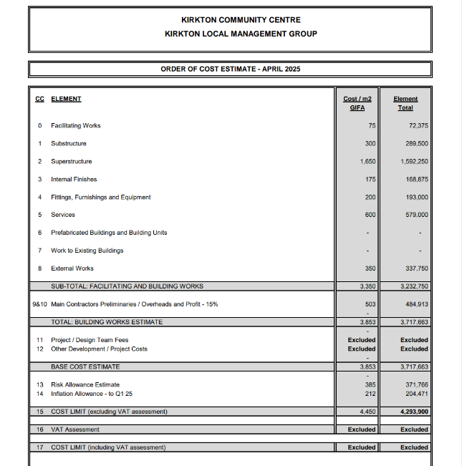  
\* Capital Costs provided by Jon Frullani, Architect.

# 5.2 Indicative Funding Strategy

|  |  |  |
| --- | --- | --- |
| **Source Of Funding** | **Current state and future changes** | **Likely amount** |
| National Lottery community fund - Scottish Land Fund | The NLCF SLF helps communities take ownership of the land and buildings that matter to them, as well as practical support to develop their aspirations into viable projects. It supports communities to become more resilient and sustainable through the ownership and management of land and land assets.    It prioritises applications that can demonstrate significant positive impact for the community. | £5,000 - £1,000,000 |
| Regeneration Capital Fund | The Fund supports locally developed place-based regeneration projects that involve local communities, helping to tackle inequalities and deliver inclusive growth in deprived, disadvantaged, and fragile remote communities across Scotland. Dundee City Council as the local authority applies on behalf of applicants.    See [here](https://www.gov.scot/binaries/content/documents/govscot/publications/transparency-data/2021/01/regeneration-capital-grant-fund-rcgf-recommended-projects-2014-2022/documents/regeneration-capital-grant-fund-rcgf-recommended-projects-2014-2022/regeneration-capital-grant-fund-rcgf-recommended-projects-2014-2022/govscot%3Adocument/Regeneration%2BCapital%2BGrant%2BFund%2B%2528RCGF%2529%2B-%2BRecommended%2BProjects%2B2014-2024.pdf" \t "_blank) for a list of previously funded projects. | Awards can be up to £2m-£3m. |
| Garfield Weston Foundation | The Garfield Weston Foundation is a grant-maker that gives money to support a wide range of charities across the UK. In total we donate around £90 million each year. It offers capital funding, and its priorities are welfare, youth, community, environment, education, health, arts, heritage, and faith.    See [here](https://garfieldweston.org/wp-content/uploads/2024/02/Grants-Pledges-Approved-Aug-23-Jan-24.pdf" \t "_blank) for a list of previously funded projects. | Grants range from £1,000 to several million pounds, depending on each charity’s size and scope of work. |
| Alexander Moncur Trust | Supports cultural, educational, health and social projects within Dundee and its environment. | Grants are normally up to £5k but in exceptional circumstances will be awarded grants significantly in excess of this. |
| Scottish Landfill Communities Fund | The fund will consider applications across all types of projects included in the SLCF Objects including land reclamation, community recycling, public amenities and parks, biodiversity, and historic buildings. Applications must demonstrate wide community support and good quality consultation. | The fund gives between £1 million and £1.5 million annually. They do not operate any minimum or maximum application amounts. |
| Northwood Charitable Trust | The Trust supports a wide range of charitable purposes at the discretion of the Trustees with priority given to assisting Dundee and Tayside charities.    Its main funding themes are addressing deprivation, poverty, and inequality, advancing educational attainment, progressing physical and mental health and wellbeing, and supporting community, heritage, and cultural enrichment.    Previous beneficiaries can be seen [here (p.15)](https://www.oscr.org.uk/charityDocuments/northwood-2023-signed-accounts-redacted-1593c488-9d92-ee11-be37-002248c6f6ad.pdf" \t "_blank) | Amount Awarded varies |
| Charitable Trusts | Main charitable trusts such as Tudor Trust, Esmee Fairbairn Foundation, Garfield Weston etc. are hugely over-subscribed with some indicating a 5% success rate. | £75,000  Would be used for first year revenue costs, staffing and startup costs |
| National Lottery  Community Led Fund | We want to support community-led organisations to deliver longer term work as well as shorter term activity such as supporting communities dealing with the impact of COVID-19. You can apply for funding for up to three years to improve or continue existing services, or to develop new activities.  We welcome some level of match funding, but we can fund up to 100% of the costs of your activity including staff, equipment, premises costs and overheads. We refer to these types of costs as 'revenue costs' and would expect these to be the focus of your application. However, you can also include up to £50,000 of minor capital costs as part of your overall activity for items such as building refurbishment, adaptations, or landscaping.  The National Lottery Community Fund is a Living Wage Friendly Funder. This means that we encourage our applicants to pay their staff the UK Living Wage. | £100, 000 would be used for startup and revenue costs  Plus £50, 000 capital possible for garden area preparation and planting. |
| Changing Places Fund | Changing Places toilets are larger accessible toilets for people with disabilities, with equipment such as hoists, privacy screens, adult-sized changing benches, peninsula toilets and space for carers. | 2023 budget was £30.5 million |

# 5.3 Income Generation and Sustainability

To stay sustainable, the Centre will operate both socially and commercially, applying for grants to deliver social impact initiatives within this area of relative deprivation and securing income from sales (room hire, desk space rental) as well as from fully operational cafe, post office counter, parcel drop of point and rent from retail units, electric vehicle charging points, community washing machines and a car wash facility.

The objective is to work towards self-sufficiency but understand that in the future there might be a need to generate income from a mix of sources. Diversity is the key. A range of income generating activities will work together rather than there being one major income generator. That includes the following which are embedded within the cash flow projection:

* Community lets at £20 per hour this is a similar cost to other community owned spaces in Dundee this will be reviewed annually. As this is a modest space, we are confident that this can be easily exceeded but this has been retained as a contingency.
* Retail Unit lets income estimated at £7200k per year per unit. May include other income such as hourly chair rentals for hair & beauty workers.
* Community café running 5 days per week, it is expected that the café will be grant funded initially and develop to the point where it is able to cover its own costs.
* Fundraising/community-based events – encouraging some income from local events such as bingo nights, quiz nights etc.
* Food larder open 2 days per week
* Additional projects such as Community Growing Space will contribute over time by way of produce for cafe and larder projects.
* Electric vehicle charging points and car wash facility in the car park.

# Environmental Sustainability

The current Kirkton Community Centre is a fifty-year-old building.  The existing building contributes towards carbon emissions and is costly to heat and run.  The new facility will be energy efficient and utilise renewable energy sources such as solar power to generate electricity. The new facility will be built to modern building standards in accordance with environmental procedures using recycled building materials.

By demolishing the exiting community centre, materials will be re-used with waste being recycled for use on alternative building projects by Dundee City Council.

Kirkton Community Centre SCIO are aware of their responsibility to ensuring that the new facility contributes towards environmental sustainability through adopting safe environmentally sound practices.

The community garden will be a space where outdoor education takes place around gardening and community growing.  This will be a large space with opportunities to include naturalised garden to encourage wildflowers, natural growth and encourage insects and other animals to thrive in an urban environment. The outdoor space will also include an orchard with a range of various fruit trees with fruit being given to families or used as ingredients by the community cafe. The community garden will also include an area or community growing with food being given to local people or used to cook healthy meals to be served at the community cafe.

There will be a sensory garden which can be used by people of all ages. A space which can be calming where colours, sounds, taste, and smells can support health & wellbeing.

The outdoor space will also include a seated area situated of the cafe which can be utilised in the spring and summer months. This outdoor space can also be hired for events or host community events organised by Kirkton Community SCIO.

There will be zero food waste on sight as the cafe, community garden and Strathmartine Community Larder will work in partnership to ensure that food is shared equally, and no food is gone to waste.

The new facility will actively encourage and support 20-minute neighbourhood’s by encouraging community members to “go local” as opposed to drive into the city centre.  By being in the heart of Kirkton & Trottick, the new community centre will actively encourage people to use active travel in their local community.

The retail units will also support people to shop locally and to support local businesses.  The retail units will encourage people to reuse items and donate items to be sold rather than items going to landfill, therefore contributing towards a circular economy.

# Appendices

# Appendix 1: Demographic Study

Population Breakdown

According to the National Records of Scotland 2018 Mid-Year Population estimates, the population of the Kirkton/Trottick area is 5,161. This is approximately 3.5% of Dundee City’s total population.

The table below shows that most of the population in the Kirkton/Trottick area are aged 16-64 years.

|  |  |  |  |
| --- | --- | --- | --- |
| **Breakdown** | **Kirkton/Trottick Community Area** | **Dundee City** | **Scotland** |
| Population aged 0-15 years | 1,296 (25.1%) | 24,016 (16.1%) | 919,502 (16.9%) |
| Population aged 16-64 years | 3,149 (61.0%) | 98,747 (66.4%) | 3,492,484 (64.2%) |
| Population aged 65 years and over | 716 (13.9%) | 25,987 (17.5%) | 1,026,114 (18.9%) |
| Total Population | 5,161 | 148,750 | 5,438,100 |

Source: National Records of Scotland – Mid 2018 Small Area Population Estimates for 2011 based data zones

Community Area breakdowns produced by DCC Information and Research Team GIS Analysis

Population figures have been rounded to 0 decimal places.

**Economically Active**

The 2011 Census reported that 65.9% of those aged 16-74 years in the Kirkton/Trottick Area were economically active. This was higher than the overall Dundee City proportion which stood at 64.4%.

The 2011 Census reported that 34.1% of those aged 16-74 years in the Kirkton/Trottick area were economically inactive. This was lower than the overall Dundee City proportion which stood at 35.6%.

|  |  |  |
| --- | --- | --- |
|  | **Kirkton/Trottick Community Area** | **Dundee City** |
| % of individuals aged 16-74 who were Economically Active | 65.9% | 64.4% |
| % of individuals aged 16-74 who were Economically Inactive | 34.1% | 35.6% |

Source: Scottish Census 2011

Table: QS601SC-Economic Activity – All People aged 16 to 74 years

Community area breakdown produced by DCC Information and Research GIS Analysis

**Scottish Index of Multiple Deprivation 2020 – 15% Most Deprived**

The Scottish Index of Multiple Deprivation 2020 reported that 82.0% of the population who live in the Kirkton/Trottick area live in a data zone ranked in the 15% most deprived. At an overall Dundee City level, 30.7% of the population live in a data zone ranked in the 15% most deprived.

|  |  |  |  |
| --- | --- | --- | --- |
| **Area** | **Total Population** | **Population who lives in a data zone ranked in the 15% Most Deprived (SIMD 2020)** | **% of the population who live in a data zone ranked in the 15% Most Deprived (SIMD 2020)** |
| Kirkton / Trottick | 5,161 | 4,243 | 82.0% |
| Dundee City | 148,710 | 45,667 | 30.7% |

Source: Scottish Government, Scottish Index of Multiple Deprivation 2020

Community Area Breakdown produced by DCC Information and Research GIS Analysis

**Scottish Index of Multiple Deprivation 2020 – 20% Most Deprived**

The Scottish Index of Multiple Deprivation 2020 reported that 82.0% of the population who live in the Kirkton/Trottick area live in a data zone ranked in the 20% most deprived. At an overall Dundee City level, 37.5% of the population live in a data zone ranked in the 20% most deprived.

|  |  |  |  |
| --- | --- | --- | --- |
| **Area** | **Total Population** | **Population who lives in a data zone ranked in the 20% Most Deprived (SIMD 2020)** | **% of the population who live in a data zone ranked in the 20% Most Deprived (SIMD 2020)** |
| Kirkton / Trottick | 5,161 | 4,243 | 82.0% |
| Dundee City | 148,710 | 55,840 | 37.5% |

Source: Scottish Government, Scottish Index of Multiple Deprivation 2020

Community Area Breakdown produced by DCC Information and Research GIS Analysis

**COMMUNITY REGENERATION IN KIRKTON & TROTTICK**

The main regeneration within the Kirkton & Trottick Estate has related to the school estate which has undergone major transformation. Since 2008 two Primary Schools (Downfield and Sidlawview Primaries) and two Secondary Schools (St Pauls RC and Baldragon Academy) have been built.  In terms of new private housing, twenty-nine properties were built by H & H Properties within Kirkton & Trottick.  The site is located near Old Glamis Road and the housing stock is a mixture of three-, four- and five-bedroom villas. Persimmons Homes have built sixty-two homes on the Kingspark Site which is situated next to St Pauls RC.  The housing is a mixture of three-bedroom semi-detached homes and four- and five-bedroom detached homes.

Kirkton and Trottick has 1023 Council and Registered Social Landlords.

The tenure within the estate is as follows:

Persimmons – 62 Properties

Abertay Housing Association – 64 Properties

Angus Housing Association – 3 Properties

BIELD Housing – 35 Properties

Caledonia Housing Association – 79 Properties

Hillcrest – 10 Properties

Dundee City Council – 832 Properties of which 112 are sheltered houses.

# Appendix 2: Trustees Skills Audit

**Project and Initiatives – Please rate your skills in each of the following areas (from 0 no experience to 5 high level experience)**

Forms response chart. Question title: Participating in the delivery of an event
. Number of responses: 7 responses.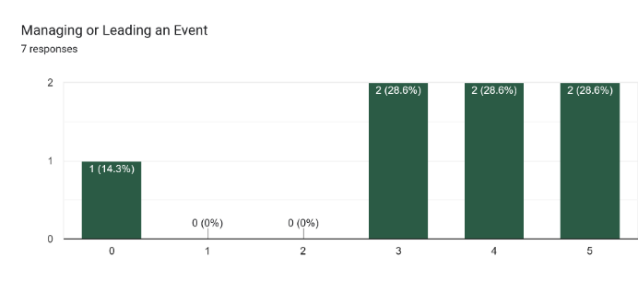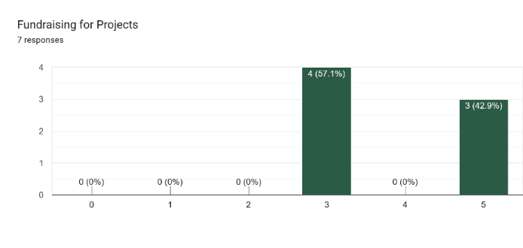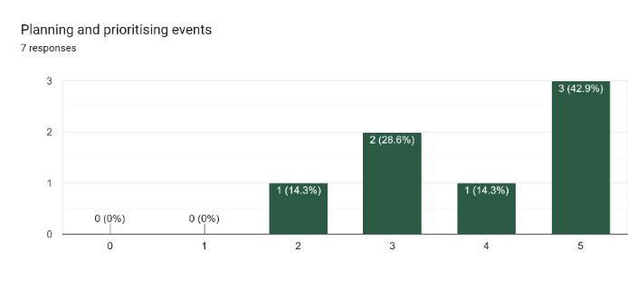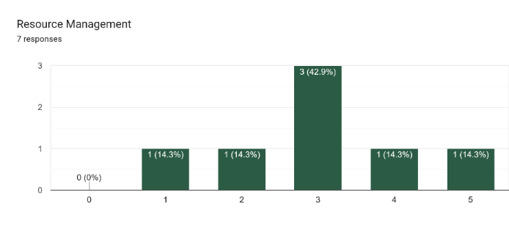

Planning and prioritising events and fundraising is a key strength for KLMG.  Whereas resource management is an area for development.

**Business Planning and Management**

**Business planning and management – Please rate your skills in each of the following areas (from 0 no experience to 5 high level experience)**

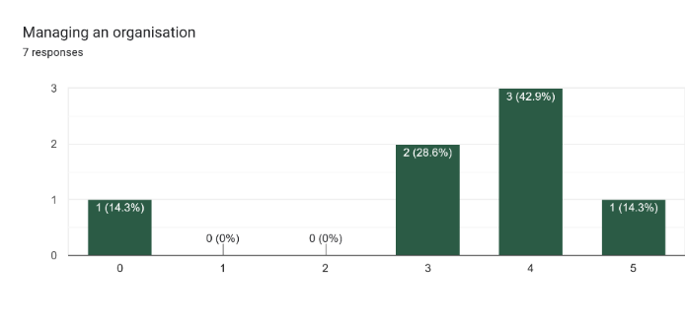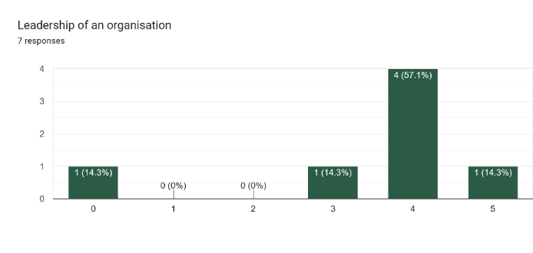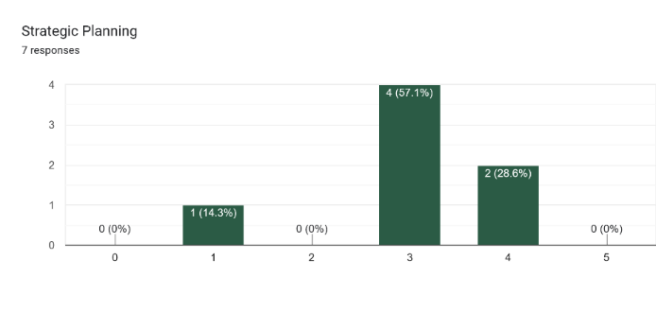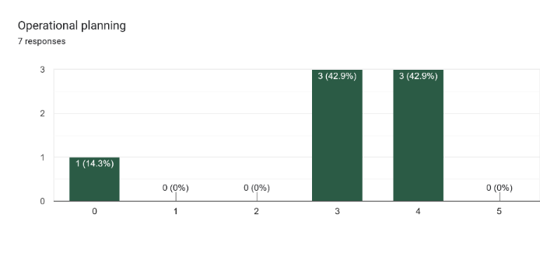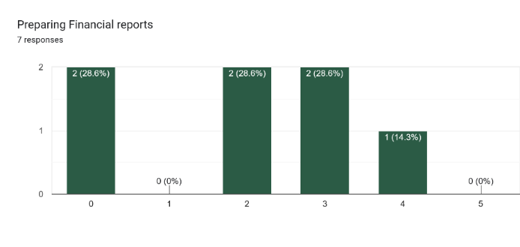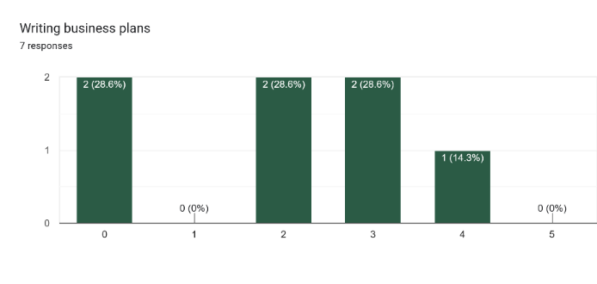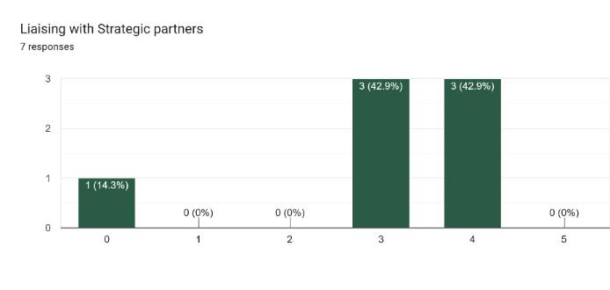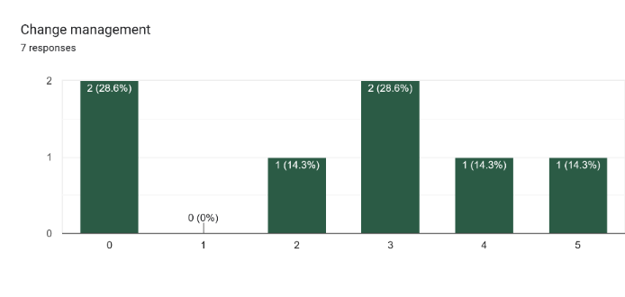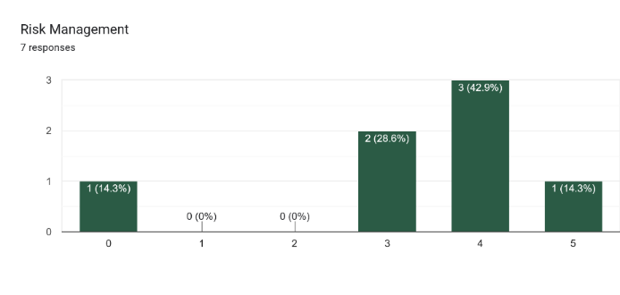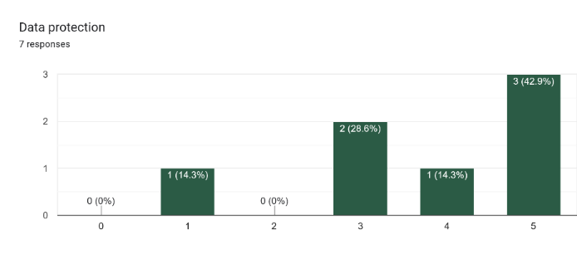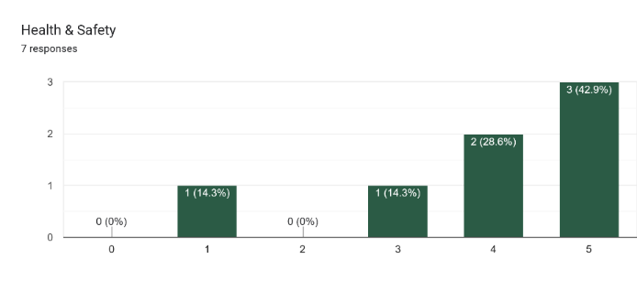

A range of areas relevant to the overall management and leadership of organisations were assessed, many of these had mixed levels of skill throughout the trustee group.

**Governance – Please rate your skills in each of the following areas (from 0 no experience to 5 high level experience)**

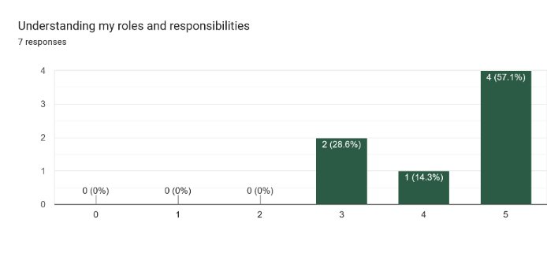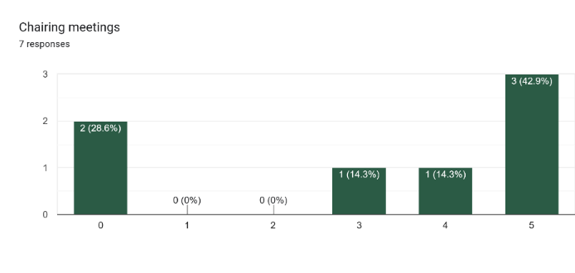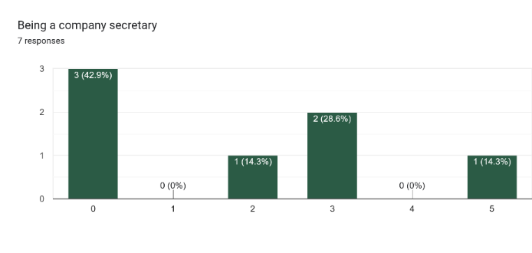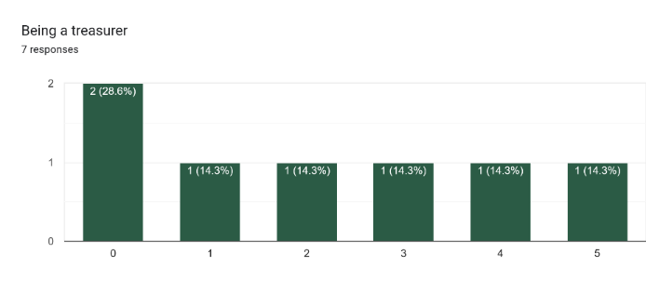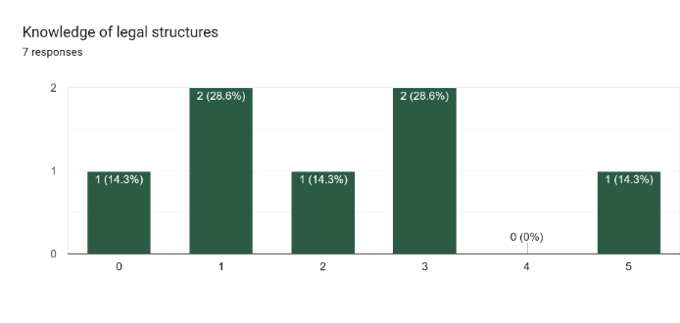

There are good levels of experience across all governance sections between the trustees.

**Working with people – Please rate your skills in each of the following areas (from 0 no experience to 5 high level experience)**

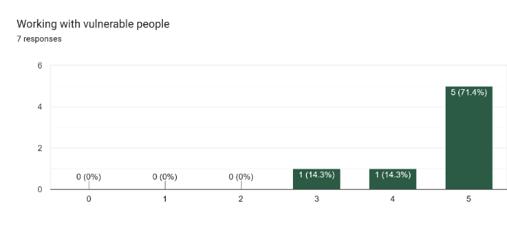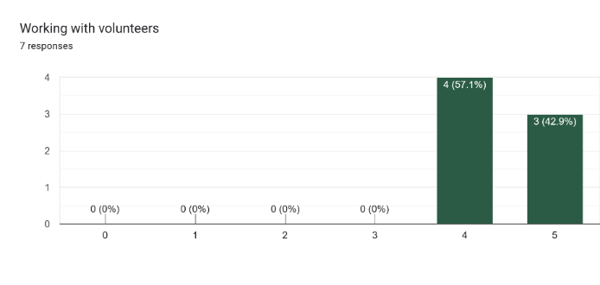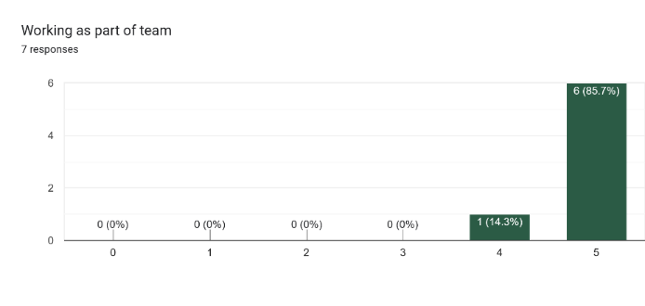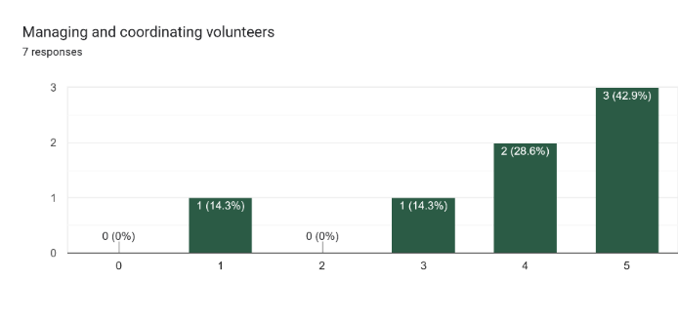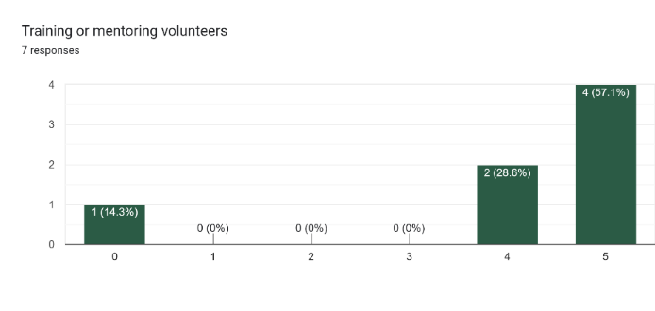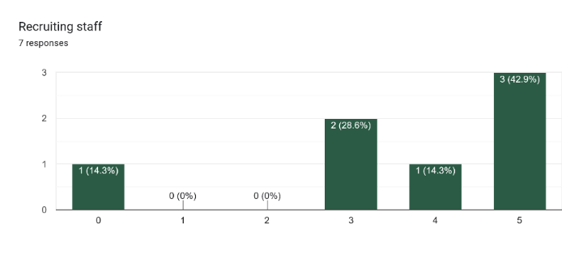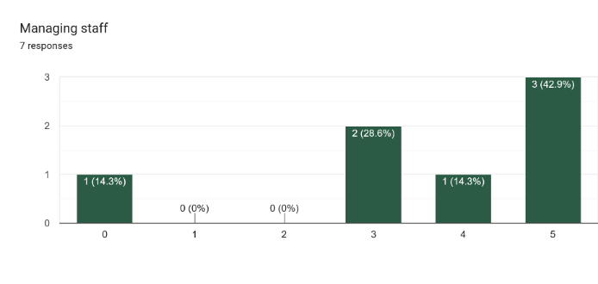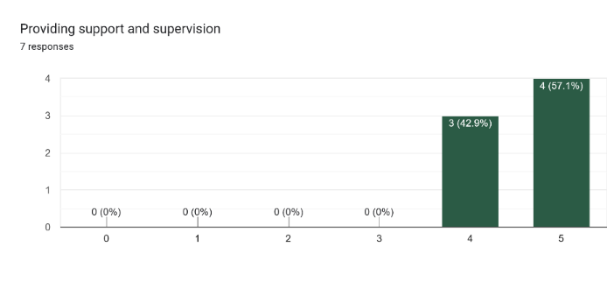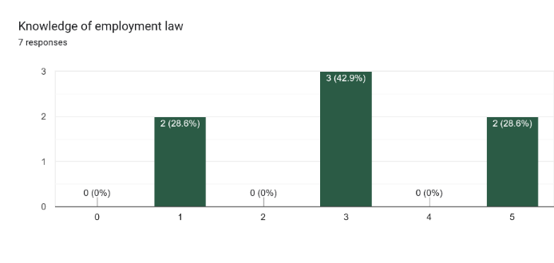

We have a wide variety of knowledge across the trustees regarding working with others.  Trustees have a vast knowledge of working as part of a team and working with volunteers.

**Marketing – Please rate your skills in each of the following areas (from 0 no experience to 5 high level experience)**

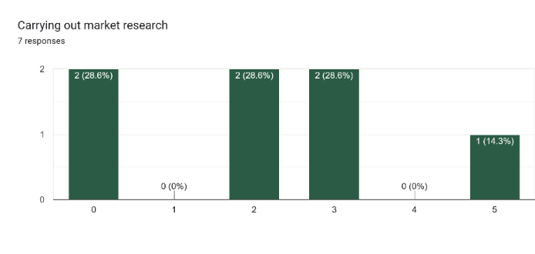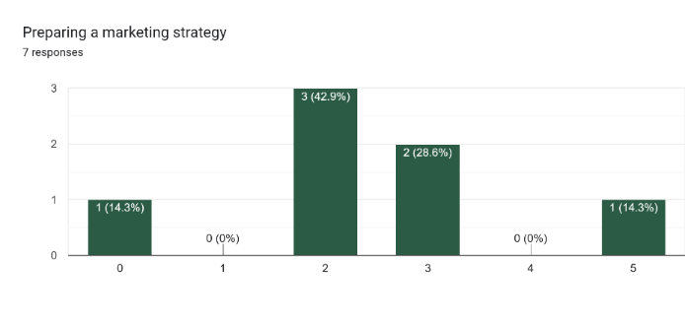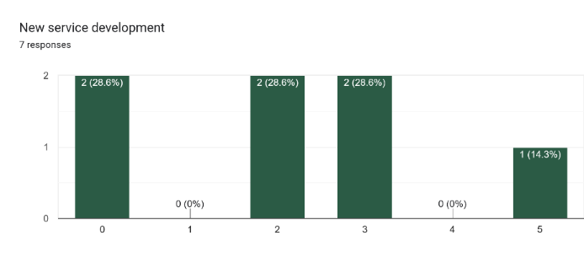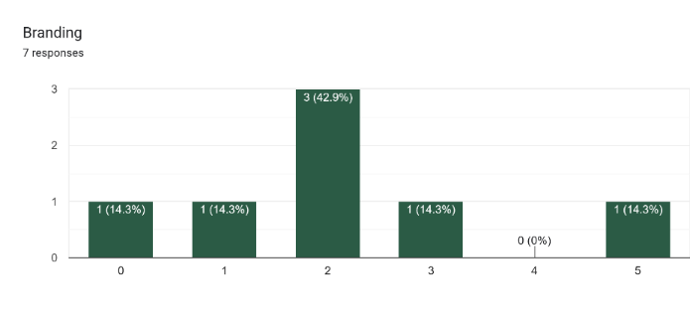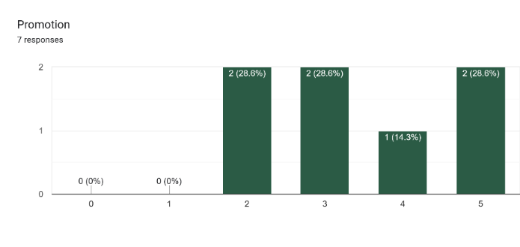

Marketing experience is mixed across the team.  Areas for development include Branding, New service development and preparing a marketing strategy.

**Communications – Please rate your skills in each of the following areas (from 0 no experience to 5 high level experience)**

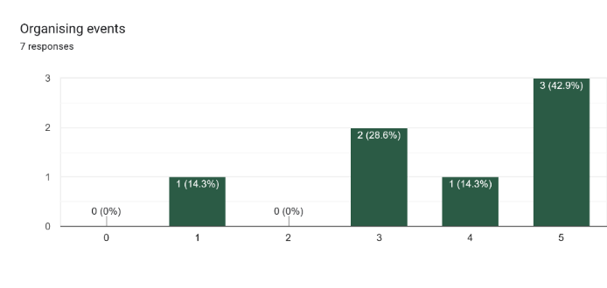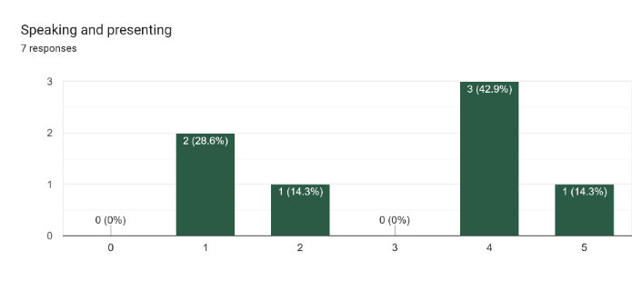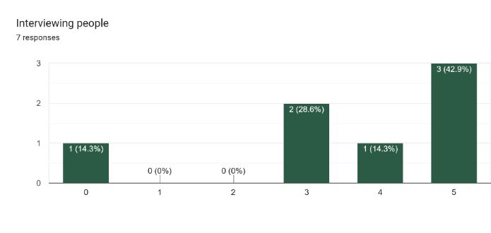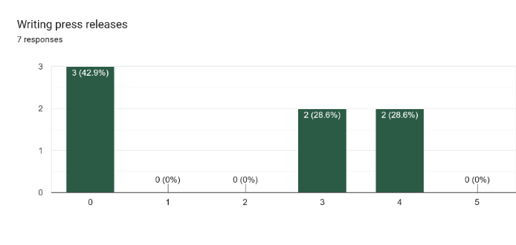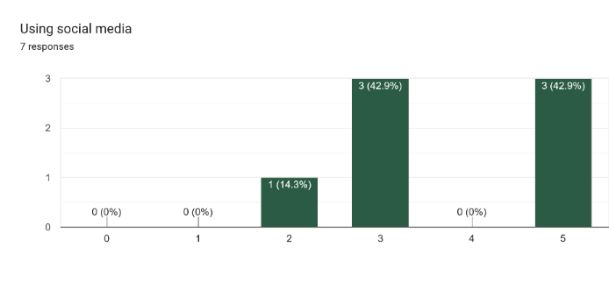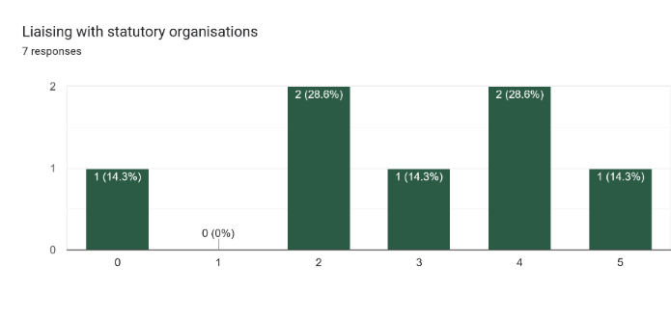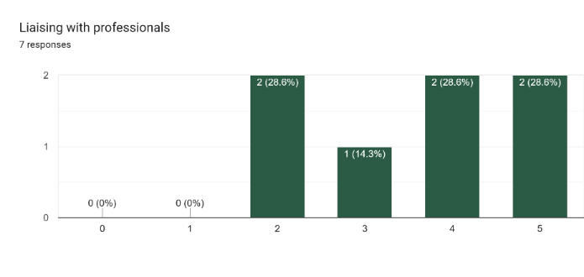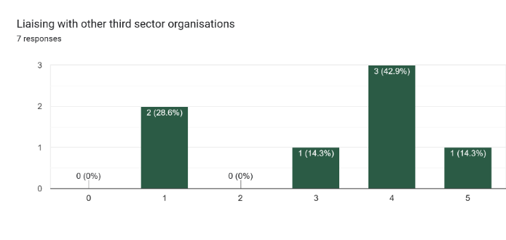

Networking and partnership are key strengths of trustees including liaising with professionals and other third sector organisations.  There is also a good working knowledge of event management, speaking and presenting and using social media within the organisation.

**Finance – Please rate your skills in each of the following areas (from 0 no experience to 5 high level experience)**

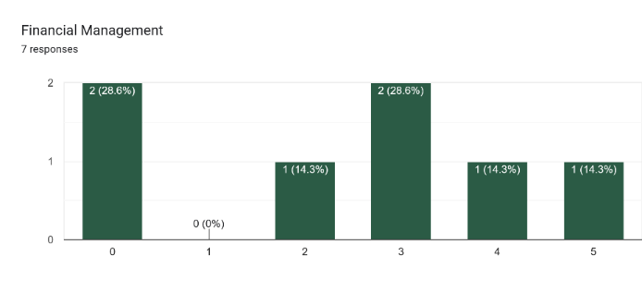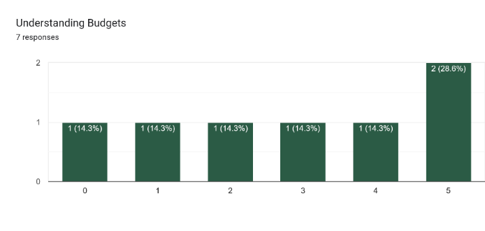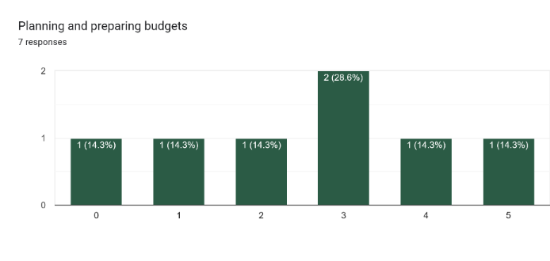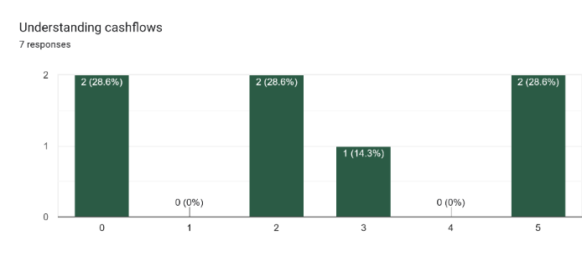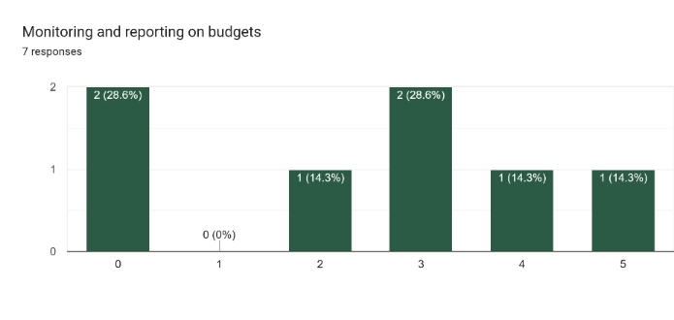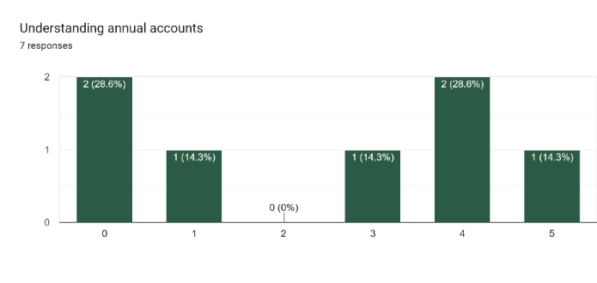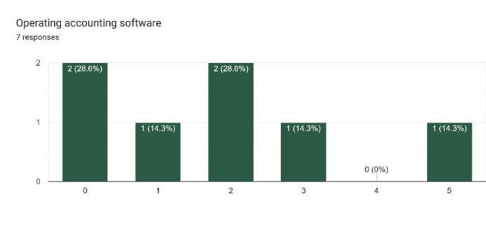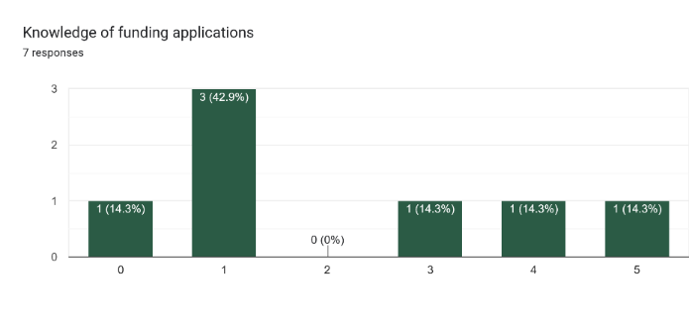

Trustees have a varied level of expertise in most areas of finance.

**Digital and ICT - Please rate your skills in each of the following areas (from 0 no experience to 5 high level experience)**

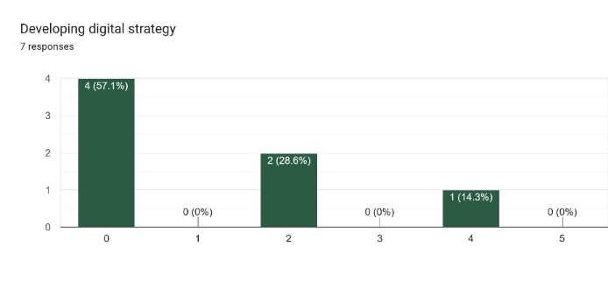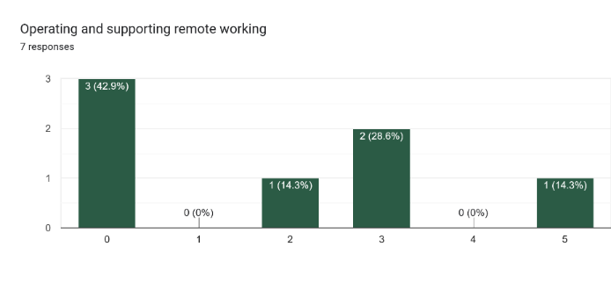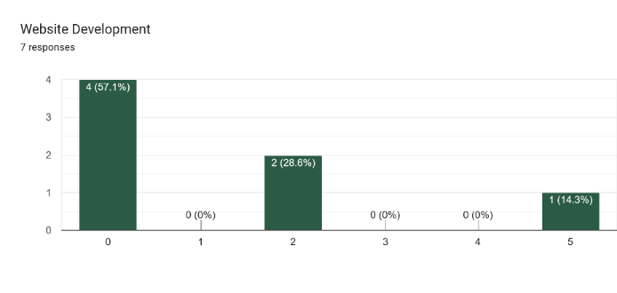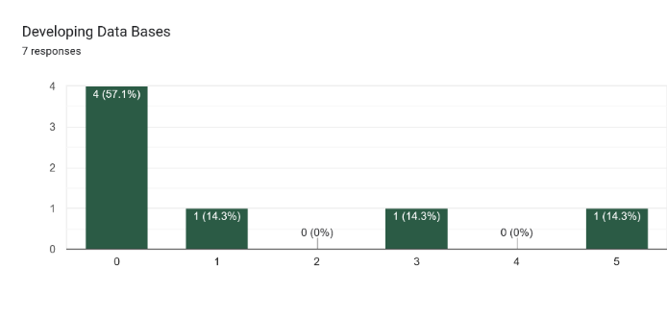

Most trustees have a limited knowledge is regards to digital skills, this has been identified as an area for development.

**Impact Assessment – Please rate your skills in each of the following areas (from 0 no experience to 5 high level experience)**

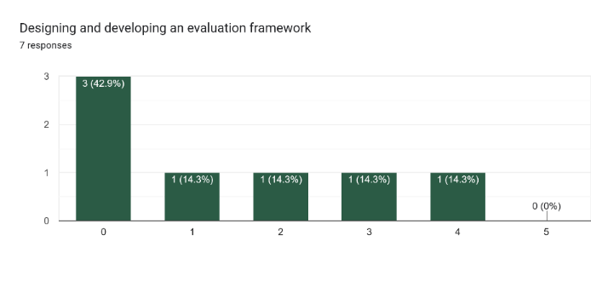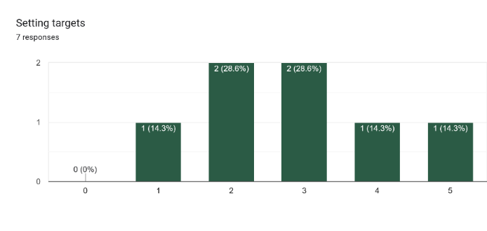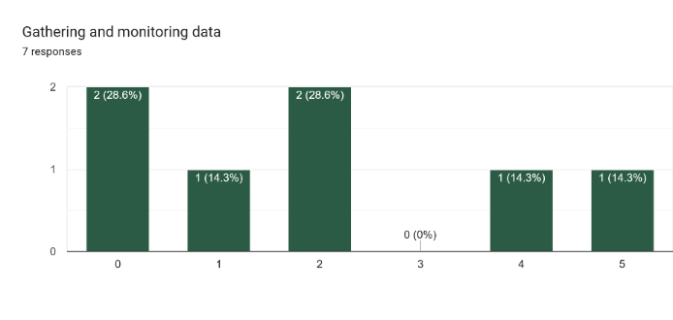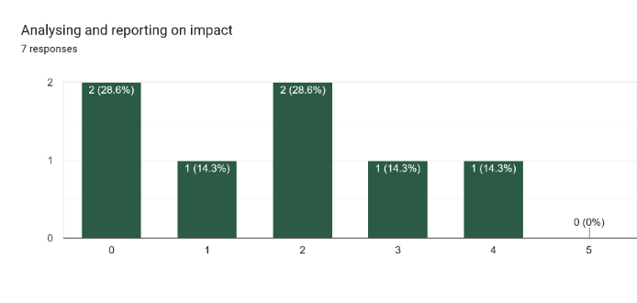

Impact assessment is an area for development for trustees.  There is a working knowledge of gathering and monitoring data.  However, the design and development of evaluation frameworks is an area for developments.

# Appendix 3: Community Survey Results

We put together an online survey for local people to have their say here are the results.

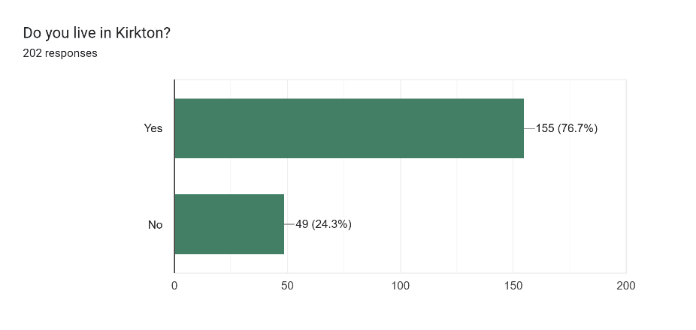

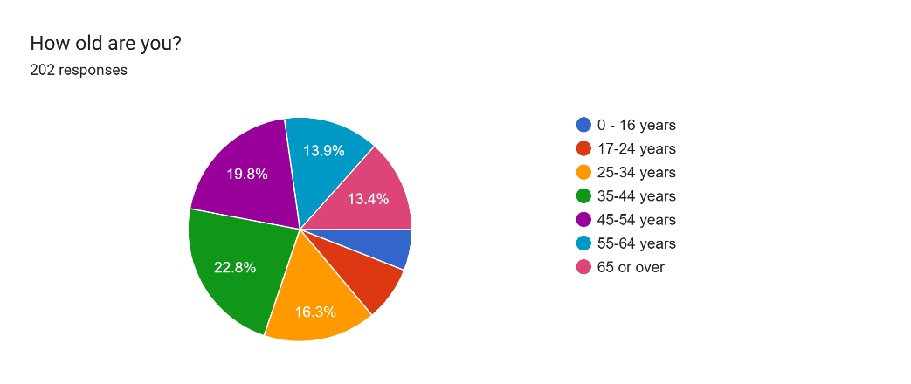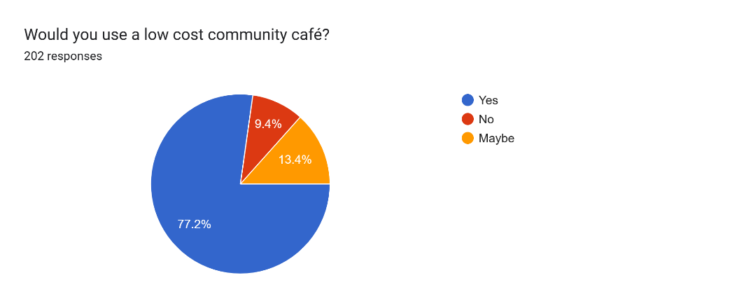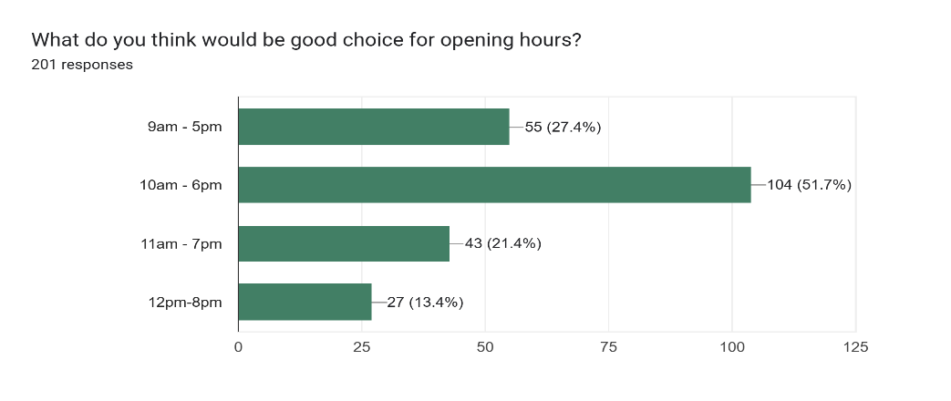

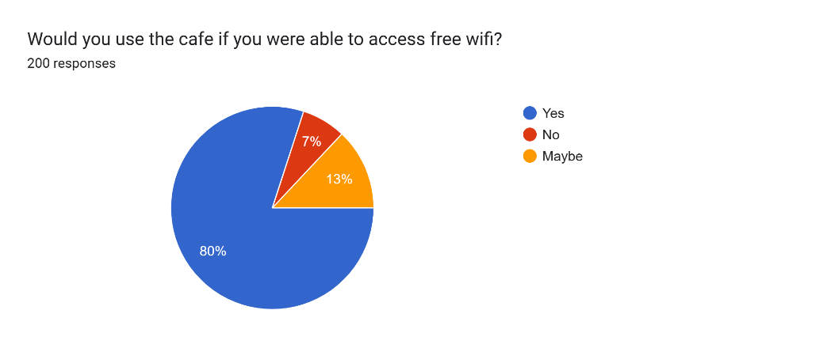

 We are looking to include a space that allows local people to showcase talents such as hair and beauty, crafts etc.  This can be on a short term affordable let.

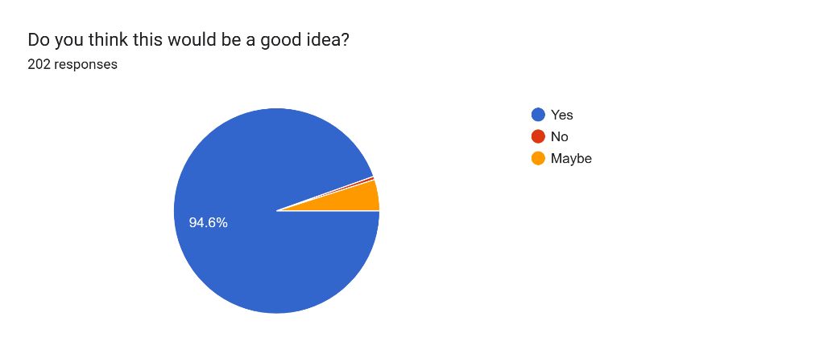

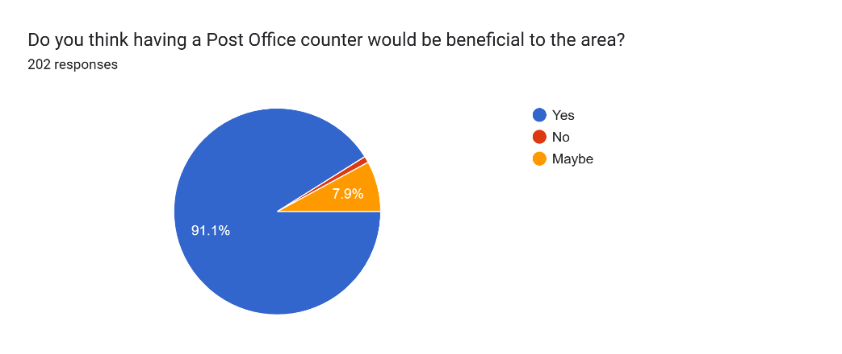

We are planning to have a multipurpose space that can be rented by local people for different events including birthday parties, weddings, christenings etc.

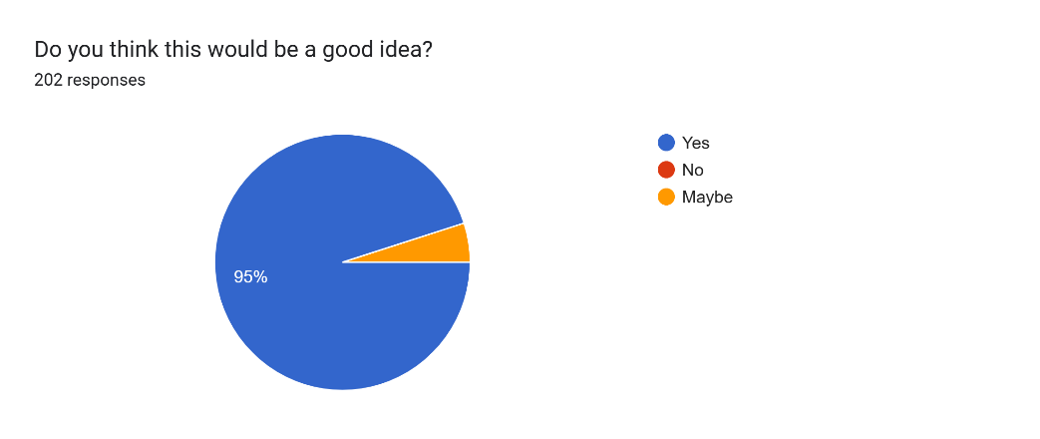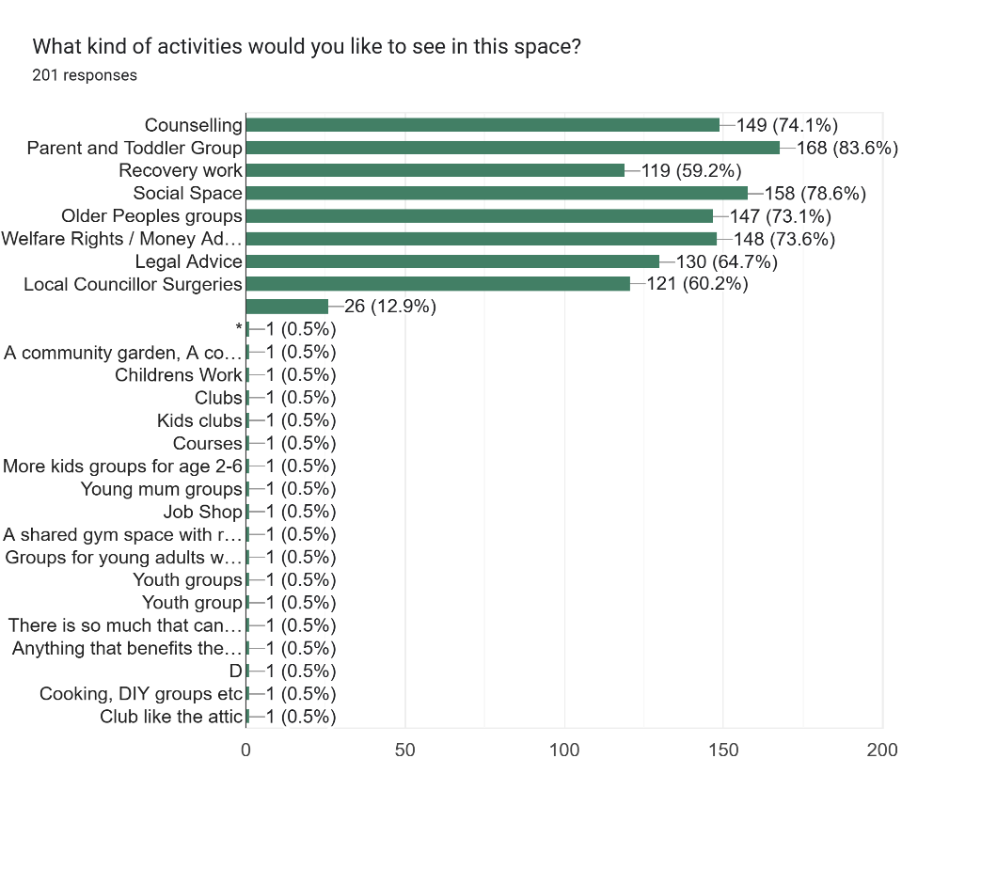

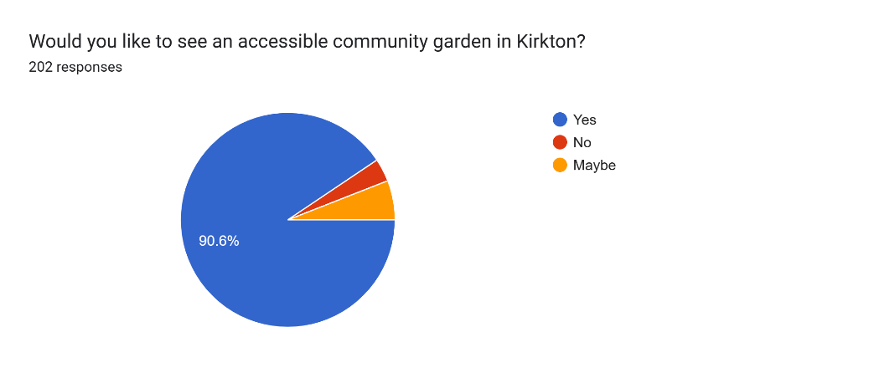

Social Events

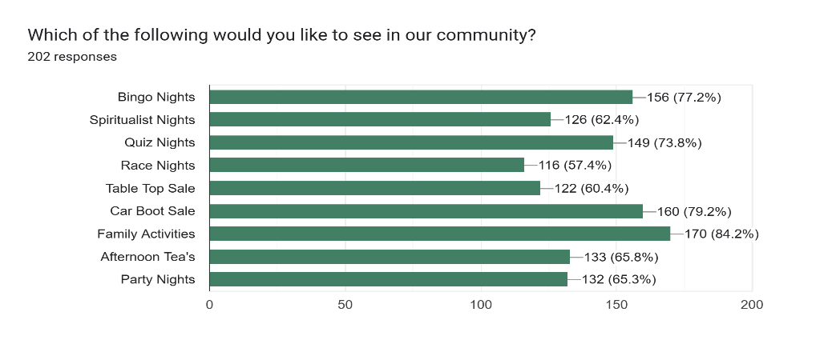

# Appendix 4 – Cash Flow Forecast

Appendix 5 – Projected Weekly Timetable and Income