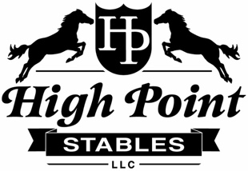
High Point Stables, LLC

2534 E. Vermontville Hwy., Charlotte, MI 48813
Release Form
Under the Michigan Equine Liability Act, an equine professional may not be liable for an injury to or the death of a participant in an equine activity. The undersigned does hereby acknowledge that horseback riding is inherently dangerous and agrees to hold blameless High Point Stables, LLC, it’s owners, employees, agents, and landlords including Lindsey Miller, Joseph Miller, Casey Flietstra, Pat Flietstra, and any other affiliates or representatives from any and all liability for death, personal injury of any type, and loss to personal equipment or property. This release shall also constitute a release of any and all liability beyond the provisions of the Michigan Equine Liability Act [1994 PA 351] to High Point Stables, LLC, its owners, employees, agents, and landlords.
Name: __________________________________________ DOB: ___________________
Contact number: (_______)__________-_________________
Signature: _______________________________________ Date: ___________________
If minor, parent or court appointed guardian signature: ___________________________

