**Above Board**

The term today means someone who is honest, forthright. It's origin comes from the days when pirates would masquerade as honest merchantmen, hiding most of their crew behind the bulwark (side of the ship on the upper deck). They hid below the boards.

**Ahoy!**

This old traditional greeting for hailing other vessels was originally a Viking battle cry.

**Between the Devil and the Deep**

In wooden ships, the ["devil"](http://www.navy.mil/navydata/traditions/html/navyterm.html#devil) was the longest seam of the ship. It ran from the bow to the stern. When at sea and the "devil" had to be caulked, the sailor sat in a bo'sun's chair to do so. He was suspended between the "devil" and the sea -- the "deep" -- a very precarious position, especially when the ship was underway.

**Chewing the Fat**

"God made the vittles but the devil made the cook," was a popular saying used by seafaring men in the 19th century when salted beef was staple diet aboard ship.

This tough cured beef, suitable only for long voyages when nothing else was cheap or would keep as well (remember, there was no refrigeration), required prolonged chewing to make it edible. Men often chewed one chunk for hours, just as it were chewing gum and referred to this practice as "chewing the fat."

**Crow's Nest**

The raven, or crow, was an essential part of the Vikings' navigation equipment. These land-lubbing birds were carried on aboard to help the ship's navigator determine where the closest land lay when weather prevented sighting the shore. In cases of poor visibility, a crow was released and the navigator plotted a course corresponding to the bird's flight path because the crow invariably headed towards land.

The Norsemen carried the birds in a cage secured to the top of the mast. Later on, as ships grew and the lookout stood his watch in a tub located high on the main mast, the name "crow's nest" was given to this tub. While today's Navy still uses lookouts in addition to radars, etc., the crow's nest is a thing of the past.

**Cup of Joe**

Josephus Daniels (18 May 1862-15 January 1948) was appointed Secretary of the Navy by President Woodrow Wilson in 1913. Among his reforms of the Navy were inaugurating the practice of making 100 Sailors from the Fleet eligible for entrance into the Naval Academy, the introduction of women into the service, and the abolishment of the officers' wine mess. From that time on, the strongest drink aboard Navy ships could only be coffee and over the years, a cup of coffee became known as "a cup of Joe".

**Devil to Pay**

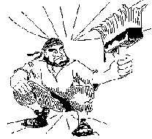Today the expression "devil to pay" is used primarily to describe having an unpleasant result from some action that has been taken, as in someone has done something they shouldn't have and, as a result, "there will be the devil to pay." Originally, this expression described one of the unpleasant tasks aboard a wooden ship.

The "devil" was the wooden ship's longest seam in the hull. Caulking was done with "pay" or pitch (a kind of tar). The task of "paying the devil" (caulking the longest seam) by squatting in the bilges was despised by every seaman.

**Eight Bells**

Aboard Navy ships, bells are struck to designate the hours of being on [watch](http://www.navy.mil/navydata/traditions/html/navyterm.html#watches). Each watch is four hours in length. One bell is struck after the first half-hour has passed, two bells after one hour has passed, three bells after an hour and a half, four bells after two hours, and so forth up to eight bells are struck at the completion of the four hours. Completing a watch with no incidents to report was "Eight bells and all is well."

The practice of using bells stems from the days of the sailing ships. Sailors couldn't afford to have their own time pieces and relied on the ship's bells to tell time. The ship's boy kept time by using a half-hour glass. Each time the sand ran out, he would turn the glass over and ring the appropriate number of bells.

**Fathom**

Fathom was originally a land measuring term derived from the Ango-Saxon word "faetm" meaning to embrace. In those days, most measurements were based on average size of parts of the body, such as the hand (horses are still measured this way) or the foot (that's why 12 inches are so named). A fathom is the average distance from fingertip to fingertip of the outstretched arms of a man -- about six feet. Since a man stretches out his arms to embrace his sweetheart, Britain's Parliament declared that distance be called a "fathom" and it be a unit of measure. A fathom remains six feet. The word was also used to describe taking the measure or "to fathom" something. Today, of course, when one is trying to figure something out, they are trying to "fathom" it.

**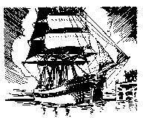****Feeling Blue**

If you are sad and describe yourself as "feeling blue," you are using a phrase coined from a custom among many old deepwater sailing ships. If the ship lost the captain or any of the officers during its voyage, she would fly blue flags and have a blue band painted along her entire hull when returning to home port.

**Forecastle**

The appropriate pronunciation for this word is *fo'ksul*. The forecastle is the forward part of the main deck. It derives its name from the days of Viking galleys when wooden castles were built on the forward and after parts the main deck from which archers and other fighting men could shoot arrows and throw spears, rocks, etc.

**Galley**

The galley is the kitchen of the ship. The best explanation as to its origin is that it is a corruption of "gallery". Ancient sailors cooked their meals on a brick or stone gallery laid amidships.

**Gun Salutes**

Gun salutes were first fired as an act of good faith. In the days when it took so long to reload a gun, it was a proof of friendly intention when the ship's cannon were discharged upon entering port.

**Head**

The "head" aboard a Navy ship is the bathroom. The term comes from the days of sailing ships when the place for the crew to relieve themselves was all the way forward on either side of the bowsprit, the integral part of the hull to which the figurehead was fastened.

**He Knows the Ropes**

In the very early days, this phrase was written on a seaman's discharge to indicate that he was still a novice. All he knew about being a sailor was just the names and uses of the principal ropes (lines). Today, this same phrase means the opposite -- that the person fully knows and understands the operation (usually of the organization).

**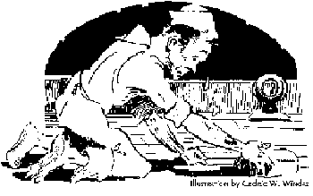****Holystone**

The last Navy ships with teak decks were the battleships, now since decommissioned. Teak, and other wooden decks, were scrubbed with a piece of sandstone, nicknamed at one time by an anonymous witty sailor as the "holystone." It was so named because since its use always brought a man to his knees, it must be holy! However, holystones were banned by the Navy by General Order Number 215 of 5 March 1931 because they wore down the expensive teak decks too fast.

**Hunky-Dory**

The term meaning everything is O.K. was coined from a street named "Honki-Dori" in Yokohama, Japan. Since the inhabitants of this street catered to the pleasures of sailors, it is easy to understand why the street's name became synonymous for anything that is enjoyable or at least satisfactory. And, the logical follow-on is "Okey-dokey."

**Listless**

Today it means to be dull or without pep. It comes from the days of sail when a ship was becalmed and rode on an even keel .... without the port or starbord list experienced under a good breeze. No wind, no list; no list, lifeless.

**Log Book**

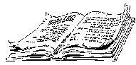In the early days of sailing ships, the ship's records were written on shingles cut from logs. These shingles were hinged and opened like a book. The record was called the "log book." Later on, when paper was readily available and bound into books, the record maintained it name.

**Long Shot**

Today it's a gambling term for an event that would take an inordinate amount of luck. It's origins are nautical. Because ships' guns in early days were very inaccurate except at close quarters, it was an extremely lucky shot that would find its target from any great distance.

**Mayday**

"Mayday" is the internationally recognized voice radio signal for ships and people in serious trouble at sea. Made official in 1948, it is an anglicizing of the French *m'aidez*, "help me".

**No Quarter**

"No quarter given" means that one gives his opponent **no** opportunity to surrender. It stems from the old custom by which officers, upon surrender, could ransom themselves by paying one quarter of a year's pay.

**Pea Coat**

Sailors who have to endure pea-soup weather often don their pea coats but the coat's name isn't derived from the weather. The heavy topcoat worn in cold, miserable weather by seafaring men was once tailored from pilot cloth -- a heavy, course, stout kind of twilled blue cloth with the nap on one side. The cloth was sometimes called P-cloth for the initial letter of "pilot" and the garment made from it was called a p-jacket -- later, a pea coat. The term has been used since 1723 to denote coats made from that cloth.

**Port holes**

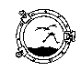The word "port hole" originated during the reign of Henry VI of England (1485). King Henry insisted on mounting guns too large for his ship and the traditional methods of securing these weapons on the forecastle and aftcastle could not be used.

A French shipbuilder named James Baker was commissioned to solve the problem. He put small doors in the side of the ship and mounted the cannon inside the ship. These doors protected the cannon from weather and were opened when the cannon were to be used. The French word for "door" is "porte" which was later Anglicized to "port" and later went on to mean any opening in the ship's side, whether for cannon or not.

**Scuttlebutt**

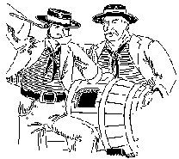The origin of the word "scuttlebutt," which is nautical parlance for a rumor, comes from a combination of "scuttle" -- to make a hole in the ship's hull and thereby causing her to sink --- and "butt" -- a cask or hogshead used in the days of wooden ships to hold drinking water. The cask from which the ship's crew took their drinking water -- like a water fountain -- was the "scuttlebutt". Even in today's Navy a drinking fountain is referred to as such. But, since the crew used to congregate around the "scuttlebutt", that is where the rumors about the ship or voyage would begin. Thus, then and now, rumors are talk from the "scuttlebutt" or just "scuttlebutt".

**S.O.S.**

Contrary to popular notion, the letters S.O.S. do not stand for "Save Our Ship" or "Save Our Souls". They were selected to indicate a distress because, in Morse code, these letters and their combination create an unmistakable sound pattern.

**Splice the Main Brace**

In the age of sail, ship's rigging was a favorite target during sea battles because destroying the opponent's ability to maneuver or get away would put you at obvious advantage. Therefore, the first and most important task after a battle was to repair damaged rigging (also known as lines- but never "rope"!). Examples of lines include braces (lines that adjust the angle at which a sail is set in relation to the wind) and stays (lines supporting the masts).  
The main brace was the principal line controlling the rotation of the main sail. Splicing this line was one of the most difficult chores aboard ship, and one on which the ship's safety depended. It was the custom, after the main brace was properly spliced, to serve grog to the entire crew. Thus, today, after a hard day (or, not so hard day), the phrase has become an invitation to have a drink.

**Starboard**

The Vikings called the side of their ship its board, and they placed the steering oar, the "star" on the right side of the ship, thus that side became known as the "star board." It's been that way ever since. And, because the oar was in the right side, the ship was tied to the dock at the left side. This was known as the loading side or "larboard". Later, it was decided that "larboard" and "starboard" were too similar, especially when trying to be heard over the roar of a heavy sea, so the phrase became the "side at which you tied up to in port" or the "port" side.

**Taken Aback**

One of the hazards faced in days of sailing ships has been incorporated into English to describe someone who has been jolted by unpleasant news. We say that person has been "taken aback." The person is at a momentary loss; unable to act or even to speak. A danger faced by sailing ships was for a sudden shift in wind to come up (from a sudden squall), blowing the sails back against the masts, putting the ship in grave danger of having the masts break off and rendering the ship totally helpless. The ship was taken aback.

**Three Mile Limit**

The original three-mile limit was the recognized distance from a nation's shore over which that nation had jurisdiction. This border of international waters or the "high seas" was established because, at the time this international law was established, three miles was the longest range of any nation's most powerful guns, and therefore, the limit from shore batteries at which they could enforce their laws. (International law and the 1988 Territorial Sea Proclamation established the "high seas" border at the 12-mile limit.)   
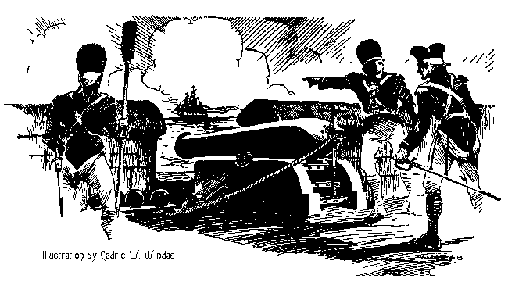

**Three Sheets to the Wind**

We use the term "three sheets to the wind" to describe someone who has too much to drink. As such, they are often bedraggled with perhaps shirttails out, clothes a mess. The reference is to a sailing ship in disarray, that is with sheets (lines -- not "ropes" -- that adjust the angle at which a sail is set in relation to the wind ) flapping loosely in the breeze.

**Took the wind out of his sails**

Often we use "took the wind out of his sails" to describe getting the best of an opponent in an argument. Originally it described a battle maneuver of sailing ships. One ship would pass close to its adversary and on its windward side. The ship and sails would block the wind from the second vessel, causing it to lose headway. Losing motion meant losing maneuverability and the ability to carry on a fight.

**Wallop**

When the French burned the town of Brighton, England, in the 1500s, King Henry VIII send Admiral Wallop to retaliate and teach the French a lesson. He so thoroughly wrecked the French coasts, that ever since, a devestating blow is said to be an "awful wallop."

**Watches**

Traditionally, a 24-hour day is divided into seven watches. These are: midnight to 4 a.m. [0000-0400], the mid-watch; 4 to 8 a.m. [0400-0800], morning watch; 8 a.m. to noon [0800-1200], forenoon watch; noon to 4 p.m. [1200-1600], afternoon watch; 4 to 6 p.m. [1600-1800] first dog watch; 6 to 8 p.m. [1800-2000], second dog watch; and, 8 p.m. to midnight [2000-2400], evening watch. The half hours of the watch are marked by the striking the bell an appropriate number of times.