A Comparison of the 5 Major Religions

Hinduism and its beliefs
Most Hindus worship one Being of ultimate oneness (Brahman) through infinite representations of gods and goddesses. These various deities become incarnate within idols, temples, gurus, rivers, animals, etc.
Hindus believe their position in this present life was determined by their actions in a previous life. Hinduism therefore provides a possible explanation for suffering and evil in this life. If a person’s behavior before was evil, they might justifiably experience tremendous hardships in this life. Pain, disease, poverty or a disaster like a flood is deserved by that person because of their own evil actions, usually from a previous lifetime.
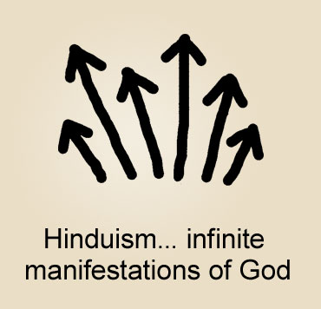
A Hindu's goal is to become free from the law of karma...to be free from continuous reincarnations. Only the soul matters which will one day be free of the cycle of rebirths and be at rest.
Hinduism lets a person choose how to work toward spiritual perfection. There are three possible ways to end this cycle of karma: 1. Be lovingly devoted to any of the Hindu deities; 2. Grow in knowledge through meditation of Brahman (oneness)...to realize that circumstances in life are not real, that selfhood is an illusion and only Brahman is real; 3. Be dedicated to various religious ceremonies and rites.

New Age Spirituality and its beliefs
New Age Spirituality promotes the development of the person's own power or divinity. When referring to deity, a follower of this type of spirituality is not talking about a transcendent, personal God who created the universe, but is referring to a higher consciousness within themselves. A person pursuing spiritual development would see themselves as deity, the cosmos, the universe. In fact, everything that the person sees, hears, feels or imagines is to be considered divine.
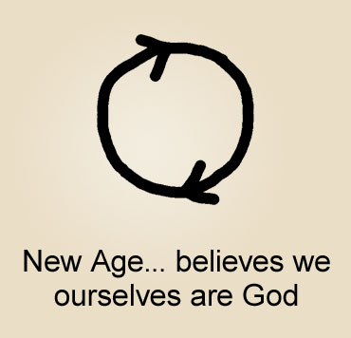
Highly eclectic, New Age Spirituality is a collection of ancient spiritual traditions, taught by a vast array of speakers, books and seminars. It acknowledges many gods and goddesses, as in Hinduism. The Earth is viewed as the source of all spirituality, and has its own intelligence, emotions and deity. But superseding all is self. Self is the originator, controller and power over all. There is no reality outside of what the person determines.
New Age teaches eastern mysticism and spiritual, metaphysical and psychic techniques, such as breathing exercises, chanting, drumming, meditating...to develop an altered consciousness and one's own divinity.
Anything negative a person experiences (failures, sadness, anger…) is considered an illusion. Believing themselves to be completely sovereign over their life, nothing about their life is wrong, negative or painful. Eventually a person develops spiritually to the degree that there is no objective, external reality. A person, becoming a god, creates their own reality.

Buddhism and its beliefs
Buddhists do not worship any gods or God. People outside of Buddhism often think that Buddhists worship the Buddha. However, the Buddha (Siddhartha Gautama) never claimed to be divine, but rather he is viewed by Buddhists as having attained what they are also striving to attain, which is spiritual enlightenment and, with it, freedom from the continuous cycle of life and death.
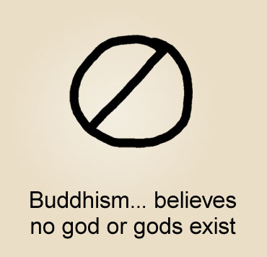
Most Buddhists believe a person has countless rebirths, which inevitably include suffering. A Buddhist seeks to end these rebirths. Buddhists believe it is a person's cravings, aversion and delusion that cause these rebirths. Therefore, the goal of a Buddhist is to purify one's heart and to let go of all yearnings toward sensual desires and to oneself.
Buddhists follow a list of religious principles and adhere to personal restraint, fasting and very dedicated meditation. When a Buddhist meditates it is not the same as praying or focusing on a god, it is more of a self-discipline. Through practiced meditation a person may reach Nirvana -- "the blowing out" of the flame of desire.
Buddhism provides something that is true of most major religions: disciplines, values and directives that a person may want to live by.

Islam and its beliefs
Muslims believe there is the one almighty God, named Allah, who is infinitely superior to and transcendent from humankind. Allah is viewed as the creator of the universe and the source of all good and all evil. Everything that happens is Allah's will. He is a powerful and strict judge, who will be merciful toward followers depending on the sufficiency of their life's good works and religious devotion. A follower's relationship with Allah is as a servant to Allah.
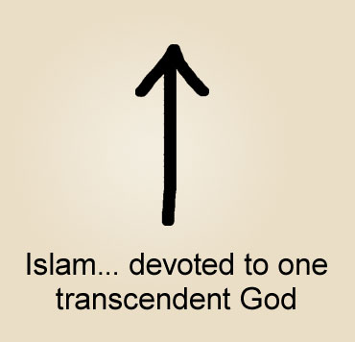
Though a Muslim honors several prophets, Muhammad is considered the last prophet and his words and lifestyle are that person's authority. To be a Muslim, one must follow five religious duties: 1. Repeat a creed about Allah and Muhammad; 2. Recite certain prayers in Arabic five times a day; 3. Give to the needy; 4. One month each year, fast from food, drink, sex and smoking from sunrise to sunset; 5. Pilgrimage once in one's lifetime to worship at a shrine in Mecca. At death -- based on one's faithfulness to these duties -- a Muslim hopes to enter Paradise. If not, they will be eternally punished in hell.
Islam teaches that there is one supreme deity, who is worshiped through good deeds and disciplined religious rituals. After death a person is rewarded or punished according to their religious devotion. Muslims believe that giving up one’s life for Allah is a sure way of entering Paradise.

Christianity and its beliefs
Christians believe in one eternal God who is creator of all that is. He is viewed as a loving God who offers everyone a personal relationship with himself now in this life.
In his life on Earth, Jesus Christ did not identify himself as a prophet pointing to God or as a teacher of enlightenment. Rather, Jesus claimed to be God in human form. He performed miracles, forgave people of their sin and said that anyone who believed in him would have eternal life.
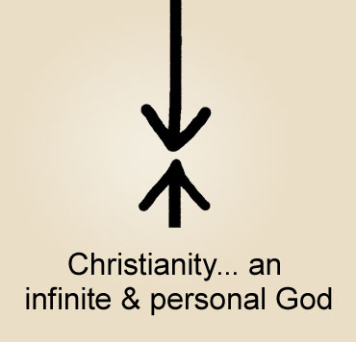
Followers of Jesus regard the Bible as God's written message to humankind, and a historical record of Jesus' life and miracles. The Bible reveals His personality, His love and truth, and how one can know and relate to God, as to a friend.
Christians believe that all people sin, including themselves. They see Jesus as their Savior, as the Messiah who was prophesied by all the prophets of the Old Testament, in the Bible. They believe that Jesus Christ, out of love for us, paid for the sin for all of humanity by dying on a cross. Three days later, he rose from the dead as he promised, proving his deity.

Each Major Religion is Very Different.
- Hindus acknowledge multitudes of gods and goddesses.
- Buddhists say there is no deity.
- New Age Spirituality followers believe they are God.
- Muslims believe in a powerful but unknowable God.
- Christians believe a loving God who created us to know him.
Are all worshiping the same God? New Age Spirituality teaches that everyone should come to center on a cosmic consciousness, but it would require Islam to give up their one God, Hinduism to give up their numerous gods, and Buddhism to establish that there is a God. Of these, only one affirms that there is a loving God who can be known now in this life.

Each Major Religion Requires Different Things.
Most of the world religions place an individual on their own, striving for spiritual perfection. In Hinduism a person is on their own trying to gain release from karma. In New Age a person is working at their own divinity. In Buddhism it is an individual quest at being free from desire. And in Islam, the individual follows religious laws for the sake of paradise after death. With Jesus Christ, you see God offering us a relationship with himself, not based on our efforts, but based on what he did for us.

All religions are working on the same problem.
We’re all aware of personal failings and the need to be better. This is what leads to the creation of religions. We also want to feel at peace, fulfilled and having inner strength. And so we practice meditation, religious rituals, self-help books, fasting, prayer, personal sacrifice, pilgrimages, etc.
However, when it comes to connecting with God who is there and created us, our problem is not lack of personal effort. Our problem is our sin. No amount of good works is going to cover up those times we’ve acted contrary to God’s holy ways.
It’s interesting that Buddha never claimed sinlessness. Muhammad also admitted that he needed forgiveness. "No matter how wise, no matter how gifted, no matter how influential other prophets, gurus, and teachers might be, they knew they were imperfect just like the rest of us."¹
God tells us that our sin stands as a barrier between us and him. We sense that separation, that distance. That’s what leads to religious practices.
God acknowledges this separation between us and him and provided a solution to it. He said the payment for sin is death…eternal spiritual separation from him. Yet out of love for us, Jesus Christ, God himself, came in human form to pay for our sin for us.
Jesus took all of our sin on himself, suffered on a cross, and willingly died in our place. The Bible says, "By this we know love, that he laid down his life for us." (1 John 3:16)
“For the wages [payment] for sin is death, but the free gift of God is eternal life through Christ Jesus our Lord. (Ro 6:23)
God is offering us complete forgiveness because of Jesus' death for us. This means forgiveness for all our sins...past, present and future. Jesus paid for them all. God, who created the universe, loves us and wants to be in a relationship with us. "This is how God showed his love among us: he sent his one and only Son into the world that we might live through him." (1 John 4:9)
"For God so loved the world that he sent his one and only Son, that whoever believes in him should not perish, but have eternal life.” (John 3:16) Christ offers us real freedom from our sin and guilt. He does not leave a person's failures on their shoulders, with a dim hope of becoming a better person tomorrow. In Jesus Christ, God reached toward humanity, providing a way for us to connect with him.

God wants us to know him.
Jesus said, "He who comes to me will never go hungry, and he who believes in me will never be thirsty...and whoever comes to me I will never drive away.” (John 6:35) Jesus called people not only to follow his teachings, but to follow him. He said, "I am the way, and the truth and the life.” (John 14:6) In claiming to be the truth, Christ goes beyond mere prophets and teachers who simply said they were speaking the truth.⁸
Jesus identified himself as equal to God, and even gave proof. Jesus said that he would be crucified on a cross and that three days after his death, he would come back to life, and he DID! He didn't say he would reincarnate someday into a future life. On that third day, Jesus' tomb was found empty and many people testified that they saw him alive again. He now offers eternal life to us.

Unlike many world religions...
This is not a commitment to a method of self-improvement like the Eightfold Path, the Five Pillars, or meditation, or good works or even the Ten Commandments. Those ways become a burdensome striving for perfection, and connection with God is still distant.
With Jesus Christ it’s a two-way interaction between you and God. He welcomes us to go to him. “The Lord is near to all who call upon him, to all who call upon him in truth.”⁹ You can communicate with God, who will answer your prayer, give you greater peace and joy, provide direction, show you his love, and transform your life.
Jesus said, “I came that they might have life, and have it more abundantly.”¹⁰ It will not mean that life will become perfect and free of problems. But it means that in the midst of life, you can relate to God who is willing to be involved in your life and faithful in his love.
Our hope is not in following laws or standards, but in knowing a Savior who fully accepts us because of our faith in him and his sacrifice for us. We don't earn our place in heaven by religious efforts or good deeds. Heaven is a free gift to us, when we begin a relationship with Jesus Christ.
Would you like to be totally forgiven and personally come to know God's love for you?

Beginning a relationship with God.
In the world’s religions a person has a relationship with teachings, ideas, paths, rituals. Through Jesus, a person can have a relationship with the loving and powerful God. You can talk with him and he will guide you in this life now. He doesn’t just point you to a path, a philosophy, or a religion.
He welcomes you to know him, to experience joy, and to have confidence in his love in the midst of life's challenges. “See what love the Father has given us, that we should be called children of God.”¹¹
You can begin a relationship with God right now. It is as simple as sincerely asking him for his forgiveness of your sin and inviting him to enter your life. Jesus said, "Behold, I stand at the door [of your heart] and knock. If anyone hears my voice and opens the door, I will come into him."¹²
Would like to begin a relationship with the God who created you, who deeply loves you? You can do so right now, if it is your heart's desire: "God, I ask you to forgive me and invite you to enter my heart right now. Thank you Jesus for dying for my sins. Thank you for coming into my life as you said you would."
If you sincerely asked God to come into your life, you have begun a personal relationship with him. It is like you have just met God and he wants you to know him better.

