Churches Mobilize God’s People
Through the past 40 years I have led people to Christ and helped many to become motivated disciples/evangelists who take personal responsibility to share their testimony regularly with those around them and to feed themselves from God's Word, instead of relying on me, or some other preacher/teacher to digest God's Word for them.
I have discipled others through a role, in the church, as a staff member or small group leader and often have proclaimed Him in my neighborhood, in the marketplace (secular jobs) or while serving as a jail minister.
I have found 99.9% of pastors to be godly, hardworking, focused men and women who are sacrificing to be involved in ministry. Yet, biblical ignorance and immorality rises among Christians. Instead of creating a praying self-feeding warrior army of disciples who "Go and tell..." I see leaders constantly emphasizing big events, and a "Come and bring" approach.
The Great Commission
In His last words to His disciples, Jesus said: Therefore go and make disciples of all nations, baptizing them in the name of the Father and of the Son and of the Holy Spirit, and teaching them to obey everything I have commanded you. And surely I am with you always, to the very end of the age. (NIV, Matthew 28:19-20)
“Go”
It is urgent that church leaders refocus their emphasis on training their people to "Go" instead of "Bring." It can be as simple as teaching people to concisely share their personal salvation testimony and testimonies of God's daily provision and grace in their lives with co-workers and those they meet.
My husband and I both have both written out a very concise version of our testimony in a "track" or business card that we may share several times a day. I always begin with, "Can I share some encouragement with you? (They ALWAYS respond "yes." Then, I say, God loves you and wants great things for you....If I only have a minute, I give them my testimony card and tell them, "Here is a summary of how God has changed my life." Otherwise, we talk more, with their permission.)
Below is an example of a one-minute one-verse evangelism video, you can show, in a service/small group with an easy approach to sharing the Gospel message. Also, why not show a 1-2 minute video guiding them in writing a concise testimony, and assign them to do it. Pass out topic summary handouts to each person in attendance, and make the videos and handouts accessible under a "training" tab on your website.
One Verse Evangelism video - https://www.youtube.com/watch?v=rHnSIHIg4XI
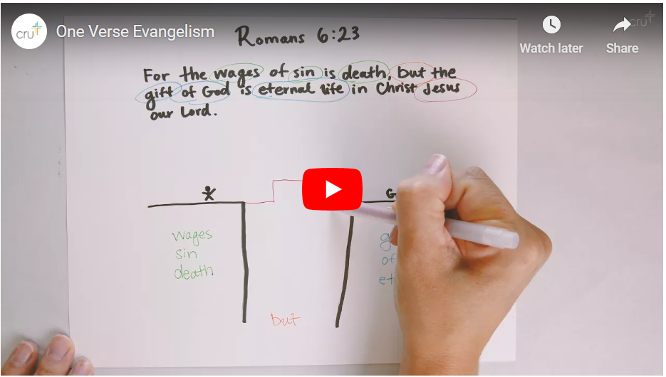
“Make disciples”
We need to have in place a plan to help someone who prays the sinner’s prayer become an actual life-long follower of Christ, or we are failing to make disciples. This means we must train the believers in our congregation how to lead people to Christ AND we must have an intentional first steps ministry to help those who pray a sinner’s prayer become a life-long follower of Christ. Let's provide our congregation with information that will enthuse them as to how amazing the Bible and Gospel is, that they not be lulled by society into believing that Christianity is just another religion, and make a video Gospel Presentation, Basic Discipleship, Study Bible Recommendations, and Handouts they can refer back to guiding them in their study, as well as Bible apps they can download.
“Baptizing them”
So then, “Is a disciple one willing to acknowledge before men that he is a disciple?” That’s just what takes place in baptism…public acknowledge of a disciple’s death, burial and resurrection in Christ!
“Teaching them”
Now…two more questions, “Is it possible for you to teach them all the Bible says about everything they may face, through your sermons and classes?” “What is the best way to help the believers in your congregation to be transformed daily into the image of Christ?”
Essentially you can only teach them “bits” of what they need. The best way to help them be daily transformed is to teach them to be “self-feeders.” They have to learn to teach themselves from God’s Word. This means that solid Bible-based carefully prepared sermons need to be viewed as “salt” to make them thirsty for more and that believers must be taught to teach themselves from God’s Word, daily, by following sound principles of Bible interpretation. Believers must be moved from being spectators to participants. They must learn to stand on their own, in the power of the Word and Spirit! Attached is a link to printouts you can provide them in services, in a foyer Bible Information Center, and on your website for download.
https://upwardlivingpublications.com/free-courses
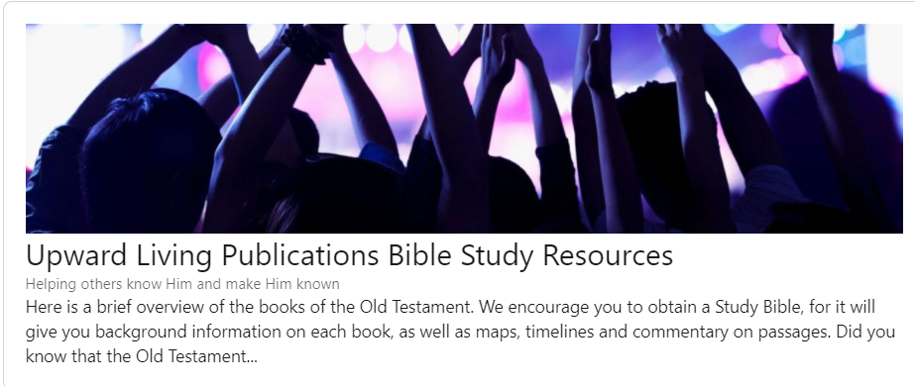
THERE ARE MANY 1-2 MINUTE VIDEOS AVAILABLE ONLINE THAT YOU CAN SHOW IN A SERVICE OR SMALL GROUP TO GET PEOPLE EXCITED ABOUT THE BIBLE. DO IT!
Draw, Keep, Grow and GO
In order for a church to experience healthy disciple-making growth, it must be able to draw, keep and grow.
Believers grow in a church where solid Biblically-based well-prepared sermons are presented each week, but they will explode in growth when they participate in small group Bible studies and are taught to feed themselves from God’s Word, applying solid principles of Biblical interpretation. DO YOU CONSTANTLY PUT THE RESPONSIBILITY FOR GROWTH ON THE BELIEVER THEMSELVES AND PROVIDE WITH HELPS TO DO SO?
They also grow and become agents of growth and change when they learn to share their faith and minister outside the church. Remember, pastors, just because you don’t see your people serving in ministries that you see, inside the church, doesn’t mean they aren’t serving. Generally, “Go” is outside the church, in their community, family, or job!
Speak Truth and Speak/Vote Against Evil
As we are praying and proclaiming Christ, we must not be silent or inactive toward evil, otherwise our children may be led to believe society's message that evil is good and good is evil. We must protect our society's children by voting into place candidates who support good philosophies, especially in regard to our schools, and in regard to parental protective authority.

