THE NEW TESTAMENT:

The Central Focus on Jesus
…the life, character, and teaching of Christ …constitute the most fascinating feature in the history of Westernman.
Historian Will Durant

Jesus’ life, ministry, and words, were written down and passed on by His main followers. They spread this message throughout the world, in spite of terrible persecution. “The Gospel of Christ was boldly proclaimed as God’s ultimate word, God manifested in human flesh. Christ, they said, came to show us what God was like, how He would save us, and how we should live.” For many it seemed crazy. For the thousands who believed,—this message completely changed their lives, just as it does today.

The New Testament writers present Jesus as more than a great religious leader. He is presented as the personal fulfillment of centuries of promise, prophecy, waiting, and hope that is woven throughout the Old Testament, whose last book was written some 400 years before Jesus’ birth. “And the New Testament also clearly and repeatedly speaks of Jesus coming again, a second time, to establish a kingdom of justice, love, truth and righteousness.”

“The Jesus of the New Testament is seen offering an invitation to every human being on the face of the earth. The invitation is to repent of our sins, turn to God, accept Christ’s death on the cross in our place for our sins, turn to Him in love and faith, make Him central in our lives, and seek His strength to live our lives in a way that will please God.”

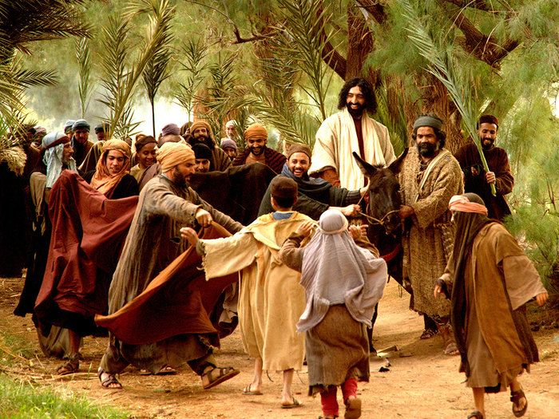

Jesus Fulfilled over 100 Old Testament Prophesies. Here are just a few.

Old Testament Prediction | New Testament Fulfillment | Subject
Micah 5:2 Isaiah 7:14 Isaiah 35:5-6 Zech 11:12  Psalm 41:9 Psalm 2:16 | Matthew 2:1 Matthew 1:23 Matthew 9:35 Matt 26:14-15  Mark 14:17-21 Luke 23:33 | Born in Bethlehem Born of a virgin Cure deaf and blind Sold for 30 pieces of silver  Betrayed by a friend Killed amidst criminals

