The Scrolls

The Dead Sea Scrolls
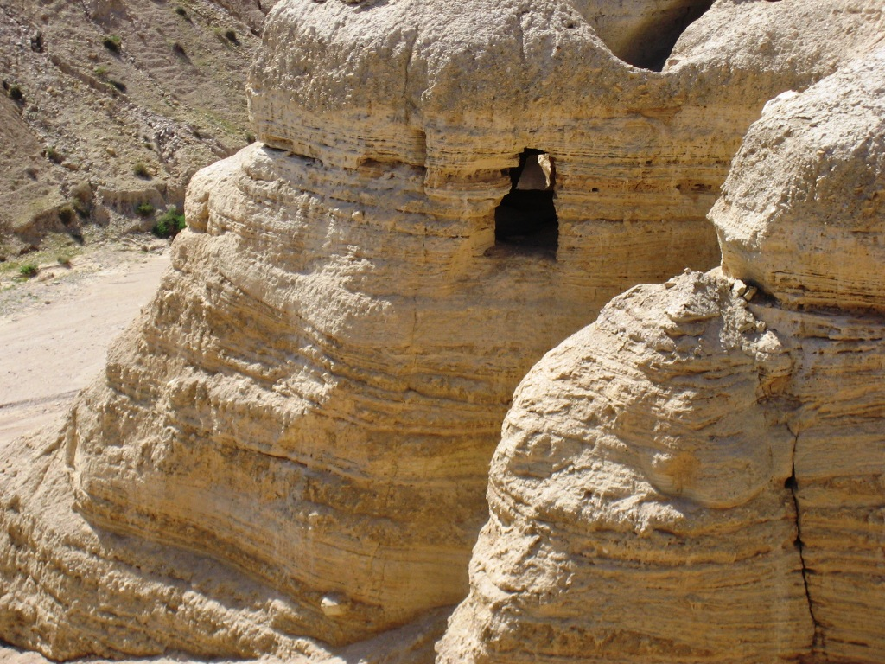
You may have heard the amazing story of how, in 1947, a Bedouin shepherd boy was out with his flock along the cliffs on the northwest side of the Dead Sea, when he thoughtlessly threw a rock into one of the caves.

When he heard something break, he investigated and found ancient scrolls stored in large pottery jars.

By mistake, this young shepherd had found the greatest manuscript discovery of modern times. Many of these scrolls date back to before the time of Jesus, and they include copies of sections of every Old Testament book except Esther. There is an almost complete copy of the book of Isaiah. Until this discovery, the oldest available copies of the Hebrew Scriptures were from around 900 AD.

“These Dead Sea scrolls provided Hebrew text that was one thousand years earlier and would show if the text had been corrupted over ten centuries.” So it was a priceless opportunity to see if copies done so much later in any way resembled much earlier copies, which were closer to the originals.

So, just how well had the scribes done their job over so many generations? Scholars analyzed and discovered very few differences, primarily on small matters such as minor spelling variations. This is amazing and nearly impossible. “The first ancient Qumran texts led to just thirteen minor yet clarifying alterations in the modern Revised Standard Version of the Bible.”

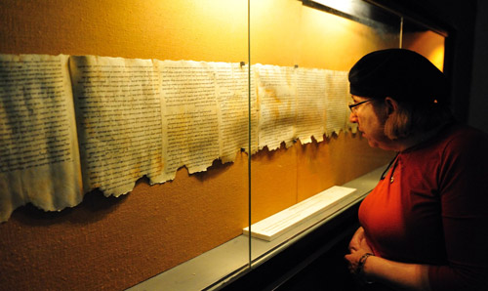

Section of scroll of Isaiah from the Dead Sea Scrolls

Ibid
Ibid

