**New Testament Archaeological Finds**

The New Testament has been extensively verified through archaeological discoveries, confirming its historical accuracy and reliability. Here are some notable examples:

1. **Pool of Siloam**: Excavations in Jerusalem uncovered the ancient Pool of Siloam, dating back to the 1st century AD, matching the biblical account of Jesus’ healing of the blind man (John 9:1-7).

During construction work to repair a large water pipe south of [Jerusalem’s Temple Mount](https://www.biblicalarchaeology.org/daily/biblical-sites-places/temple-at-jerusalem/the-stones-of-herods-temple-reveal-temple-mount-history/), at the southern end of the ridge known as the City of David, [archaeologists Ronny Reich and Eli Shukron](https://www.biblicalarchaeology.org/daily/biblical-sites-places/biblical-archaeology-sites/canaanite-fortress-discovered-in-the-city-of-david/) identified two ancient stone steps. Further excavation revealed that they were part of a monumental pool from the Second Temple period, the period in which [Jesus lived](https://www.biblicalarchaeology.org/daily/people-cultures-in-the-bible/jesus-historical-jesus/where-jesus-walked/). The structure Reich and Shukron discovered was 225 feet long, with corners that are slightly greater than 90 degrees, indicating a trapezoidal shape, with the widening end oriented toward Tyropoeon valley.

1. **Nazareth Inscription and excavation of Nazareth homes**: A 1st-century inscription discovered in Nazareth confirms the city’s existence during Jesus’ lifetime, supporting the New Testament’s account of Jesus’ childhood (Matthew 2:23, Luke 2:4).
2. **Qumran Caves**: The discovery of the Dead Sea Scrolls in Qumran caves has provided numerous fragments of biblical texts, including passages from Zechariah and Nahum, which are unrelated to the Qumran community’s texts.
3. **Arrowheads and Coins**: Excavations at Capernaum and other sites have yielded arrowheads and coins dating back to the 1st century AD, matching the time period of Jesus’ ministry (Matthew 4:13, Mark 1:21).
4. **Mummified Remains**: The discovery of a mummified young girl in a tomb in Jerusalem, dated to the 1st century AD, provides independent evidence for the cultural practices and burial customs described in the New Testament (Matthew 27:52-53).
5. **Archaeological Verification of Biblical Cities**: Excavations have confirmed the existence of cities mentioned in the New Testament, such as Capernaum, Magdala, and Sepphoris, during the 1st century AD.

These archaeological finds, among many others, demonstrate the historical reliability of the New Testament and provide independent verification of its accounts. As Nelson Glueck, a renowned biblical archaeologist, stated, “No archaeological discovery has ever controverted a biblical reference.”

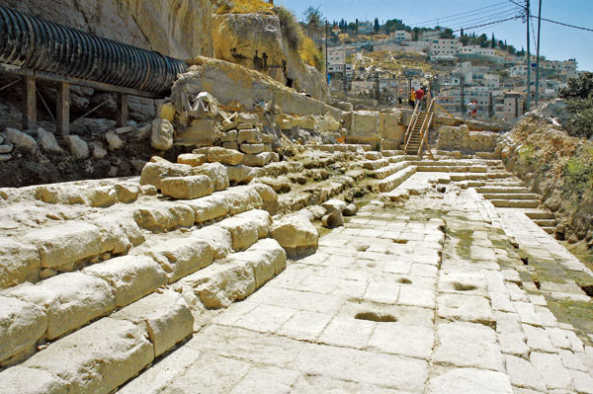

In 2004, the stepped remains of the ancient Siloam Pool, long thought to be located elsewhere, were uncovered near the City of David. According to the Gospel of John, it was at this sacred Christian site that Jesus healed the blind man. *Photo: Todd Bolen/BiblePlaces.com.*

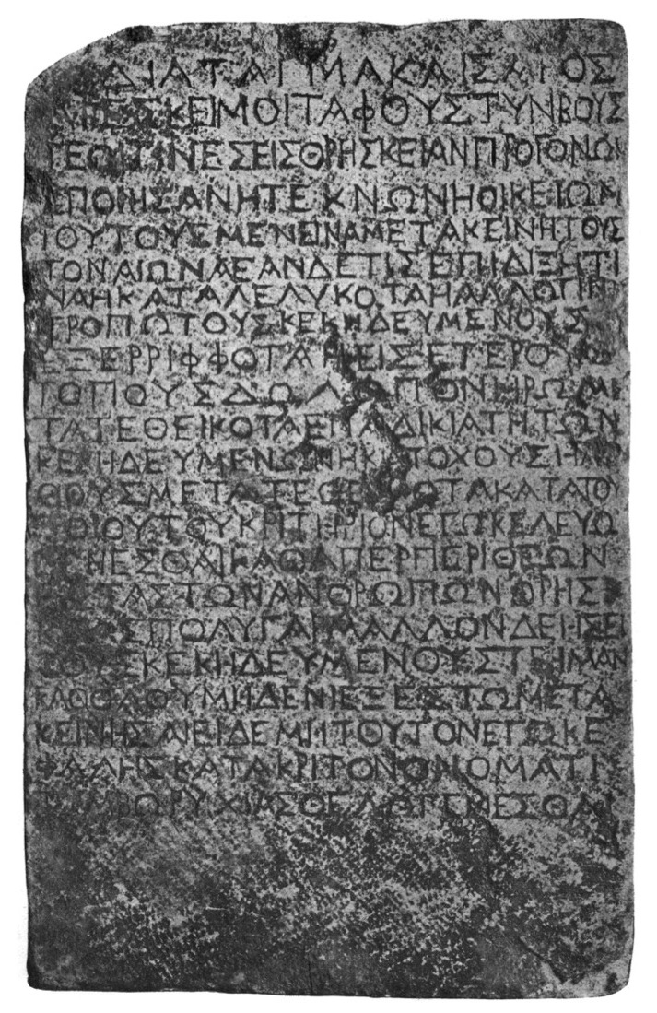

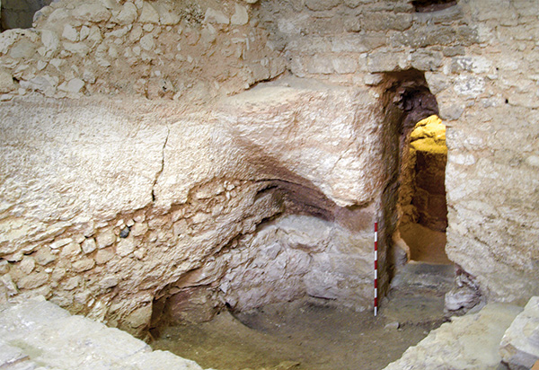The

rock-cut doorway of a first-century house discovered near the Sisters of Nazareth Convent, which may have been the childhood home of Jesus. Photo Credit: Ken Dark. Used by permission.

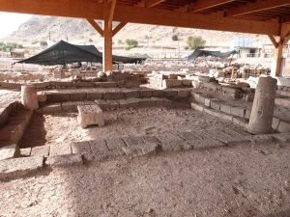

[**Synagogue uncovered at Magdala (Seetheholyland.net)**](https://www.seetheholyland.net/magdala/) . Magdala is a fishing village on the western shore of the Sea of Galilee that is mentioned in the Bible indirectly, and is also the home of Mary Magdalene, a follower of Jesus

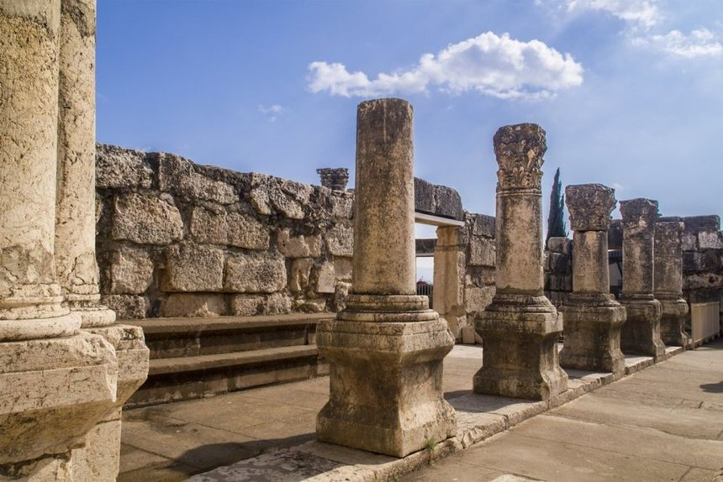

Capernaum appears in 16 Bible verses: Matt 4:13, Matt 8:5, Matt 11:23, Matt 17:24, Mark 1:21, Mark 2:1, Mark 9:33, Luke 4:23, Luke 4:31, Luke 7:1, Luke 10:15, John 2:12, John 4:46, John 6:17, John 6:24 and John 6:59.

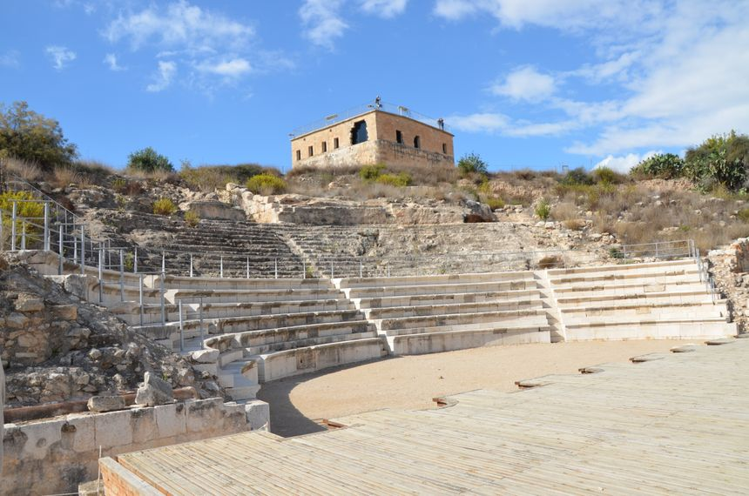

Sepphoris was the capital of Galilee from the first century B.C.E. to the first century C.E. Sepphoris was located less than 4 miles from Jesus' childhood village of Nazareth. It was a commercial center with many carpenters, so it's likely that Jesus worked there before his ministry.