.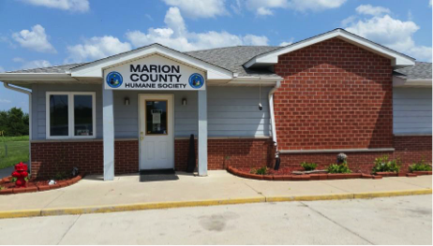

2019 Marion County Humane Society Annual Membership Form

Memberships are good through Dec. 31, 2019. All memberships include the following:
• Free tour of the shelter
• 20% discount on all MCHS merchandise
• 20% discount on one adoption
• MCHS Decal
• Opportunity to choose a name for a MCHS adoptable (be unique to avoid duplication)
Address: Marion County Humane Society, PO Box 655, Knoxville, Iowa 50138
Questions: Call 641-828-7387
Other Info: www.marioncountyhumane.org or www.facebook.com/marioncountyhumanesociety

Name: _________________________________________________
Address: ________________________________________________
________________________________________________________
Email: __________________________________________________
Adoptable name suggestion: ________________________________

Membership Dues:
_____ $10.00 Junior Membership (18 years and younger)
_____ $20.00 Individual Membership
_____ $30.00 Family Membership
_____ $55.00 Corporate Membership
____________ Total Memberships
Paid by: _____ Check #__________ Cash_______________ or
Debit/Credit Card:
Name on Card: ___________________________________________
Card number: ____-____-____-____ Exp. Date: _______ CCV______

