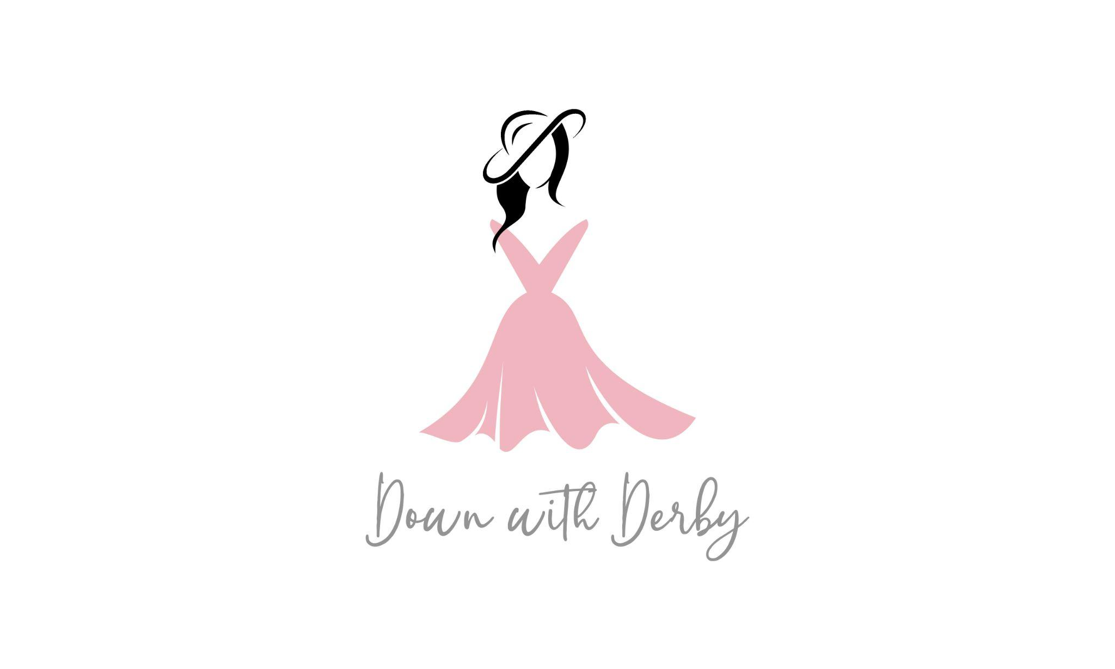

2023 DWD Model Fundraising Page Setup Guide

Thank you for being a part of the Down with Derby fashion show, we are so excited to share this experience with you and look forward to what we can accomplish together. As you know, each model has a suggested fundraising goal of $250, we hope that each of you not only meet this goal but exceed it! We are here to help you along the way, ensuring Down with Derby and YOU are a huge success! Below you will find the step-to-step guide to setting up your model fundraising page on a desktop or laptop computer, please have your model fundraising page active no later than Friday February 17, 2023 at 5:00 PM.

Step One: Go to: http://events.handbid.com/fundraisers/down-with-derby

Step Two: Click on the top of the screen that says “Become a Fundraiser” (see below)
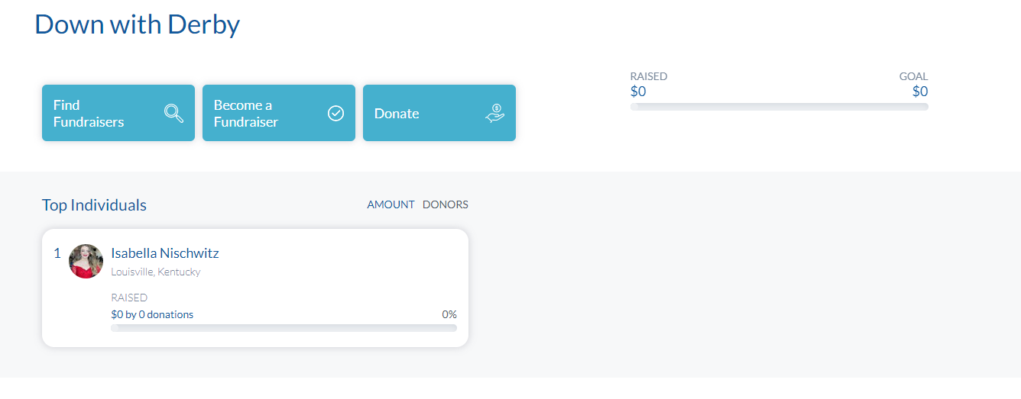

***** IF YOU HAVE NOT PARTICIPATED IN DOWN WITH DERBY IN THE PAST SKIP TO STEP SEVEN NOW*****

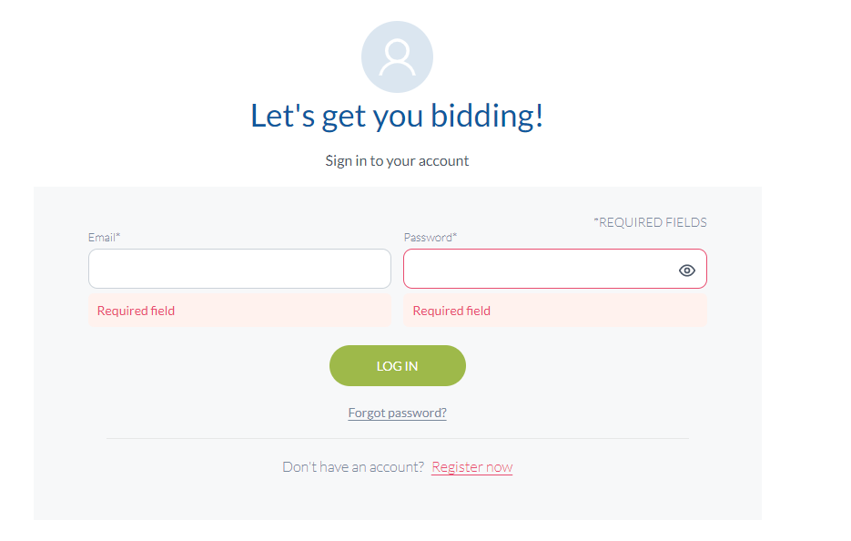
Step Three: If you have participated in Down with Derby before, please click on the words “sign in” and enter your username and password. If you have forgotten your password, click the “reset password” link on the bottom of the page. (See below)

Step Four: Click “Okay”, a home page will populate, once at the homepage, type Down with Derby in the search box on the left side of the screen

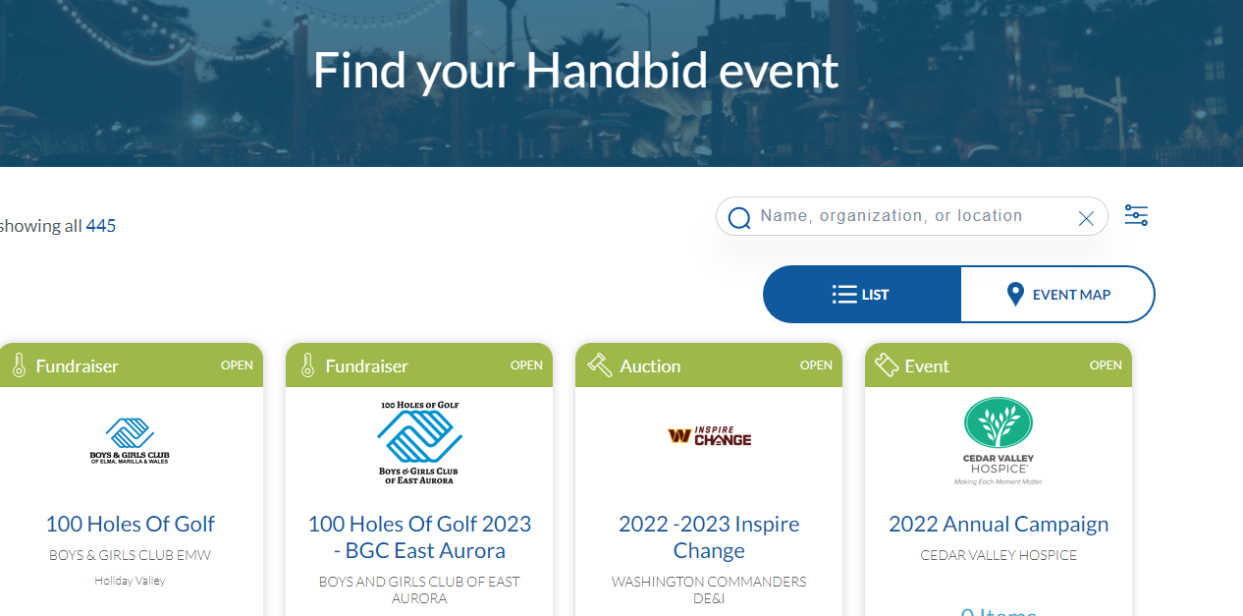
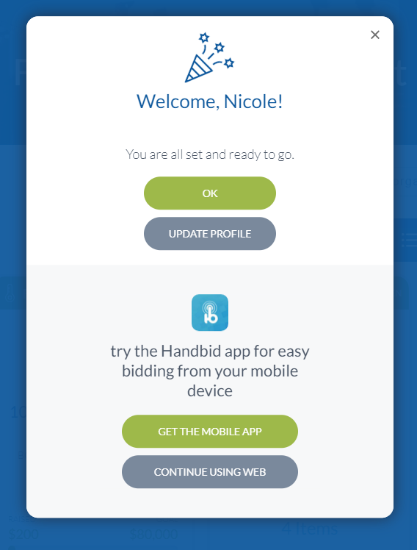

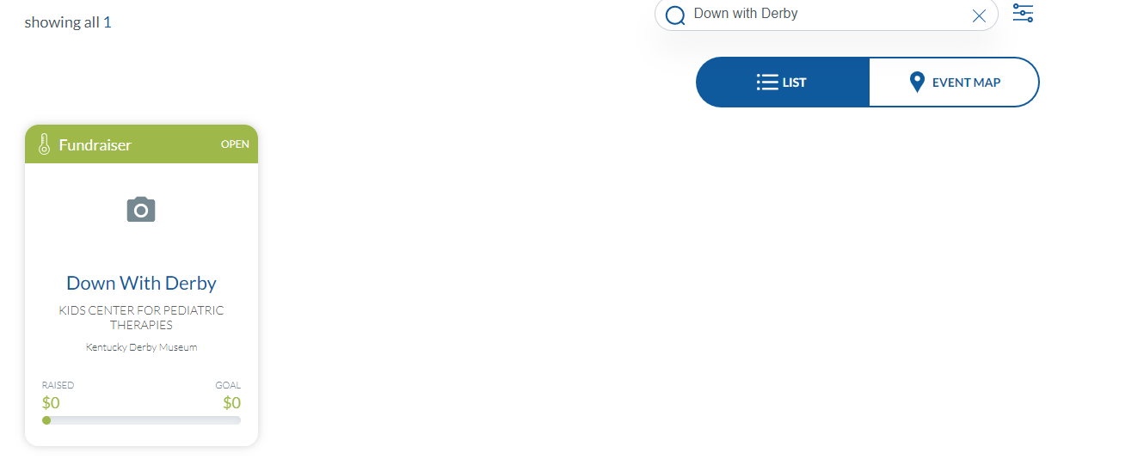

Step Five: Click on the event page “Down with Derby” it will take you to the screen below, click the box that says “become a fundraiser”, then skip to step eight on this setup guide.

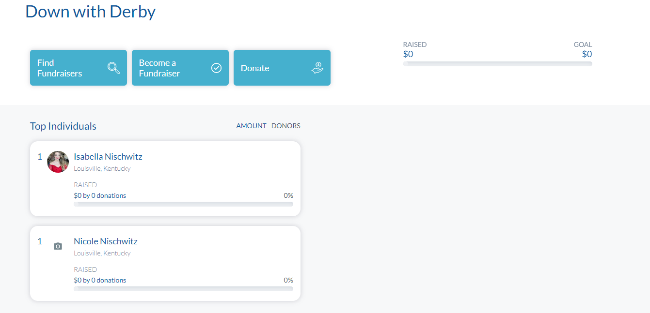

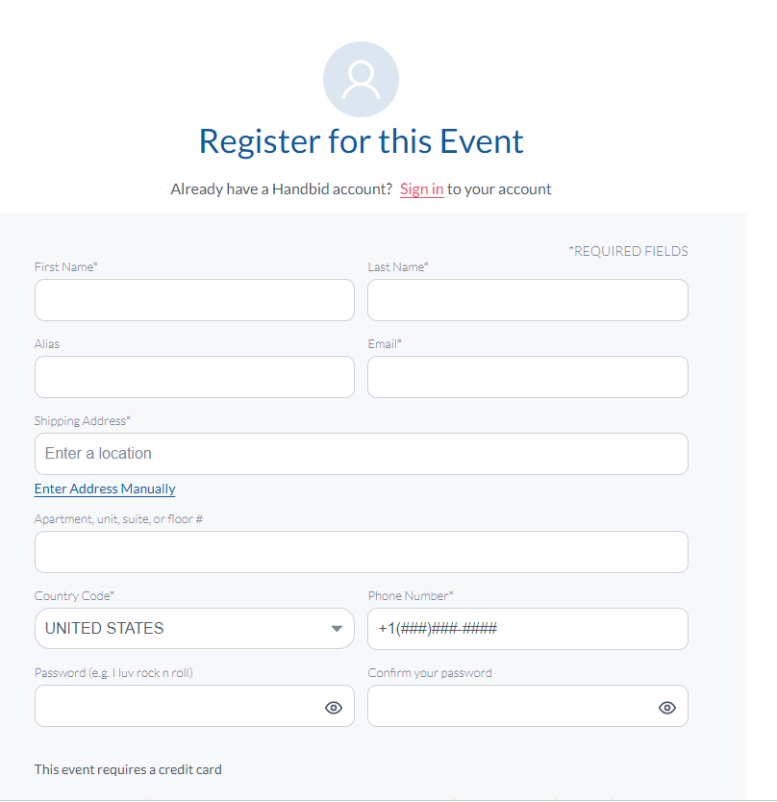
Step Seven: If you HAVE NOT participated in Down with Derby before, complete the form you see below and hit continue.

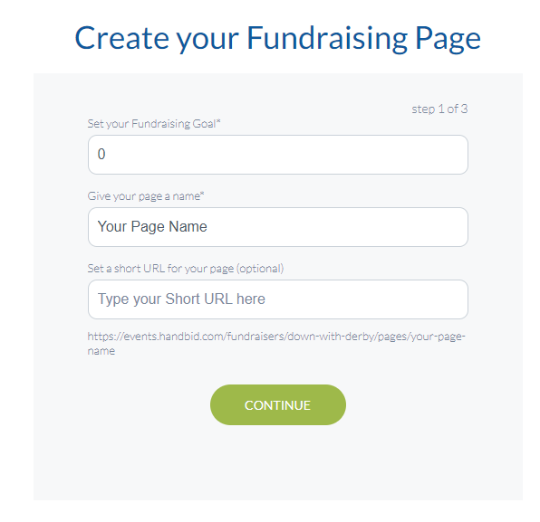
Step Eight: Create Your fundraising Page: Input your fundraising goal (min is $250) then in the next box under “page name” put your first and last name. Leave the third box “type your short url” blank, the system will auto populate your personalized url for you that you will have access to once you have completed your fundraising page.

Step Nine: Please upload a photo or video of yourself to your page, photos are imperative in ensuring people find the right fundraiser. If you want to make a video, please click the dropdown arrow at the top and select video. (see below) Once you have selected a photo or video click the green button that says “Next”.
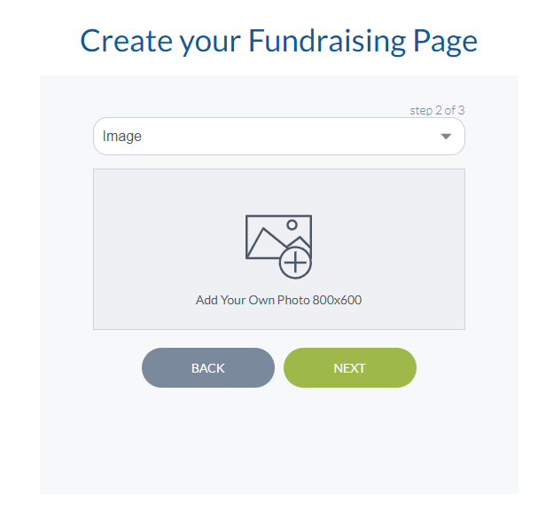

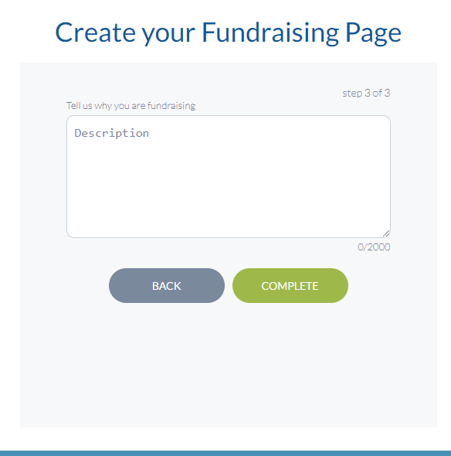
Step Ten: Please describe why being a part of Down with Derby is important to you. PLEASE complete this section, your “why” is the single most important part of your fundraising page. Tell your family,friends,and fans why YOU are participating in the show…this special section helps someone decide just how much they want to support YOU! Once you have inputted your “why” click the green complete button.

Step Eleven: Register for the event. This will allow you to make donations to your fundraising page or others. Now, go do the thing!!!! So excited to rock the runway for a GREAT cause!!!
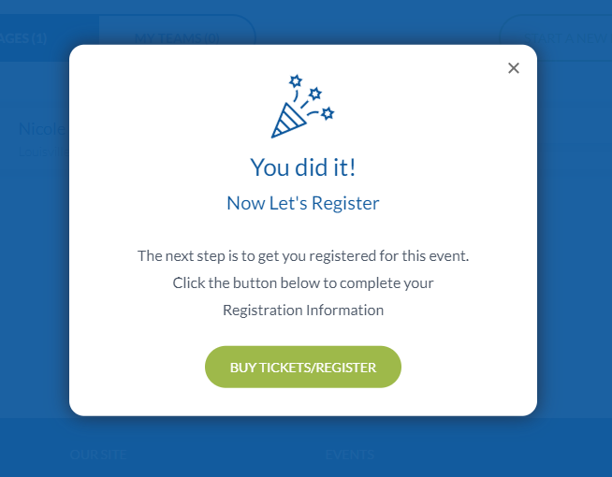

Each model gets (1) general admission ticket at the discounted price of $45 that can be used for a friend or a chaperone (if one is required for you). You must purchase this ticket separately from any other tickets you may want to purchase for the event, so we suggest you do it at the end of your page registration. Models under the age of 18 must have a chaperone present at all times and require a chaperone at the event.

If you have any questions or get stuck during this process please reach out to Nicole Nischwitz at downwithderby@gmail.com or 317-999-7108.

