Welcoming Garden – Easel Card

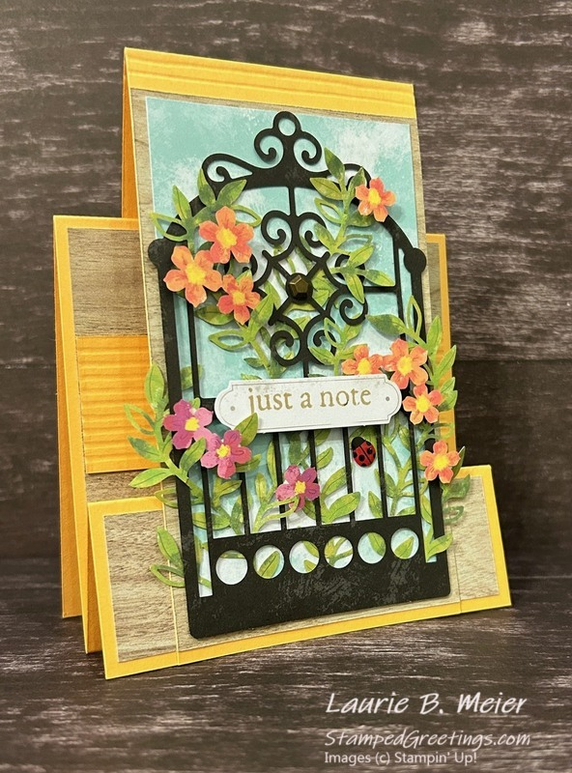
All images © 1990-2026 Stampin’ Up!®

Supplies:
- Stamp Set/Bundle: Welcoming Garden Kit (165661)
- Cardstock: Basic White (166780), Peach Pie (163799)
- Ink: Crumb Cake (from the kit)
- Designer Series Paper: Country Woods (163393)
- Tools & Accessories: Bone Folder (102300), Paper Trimmer (152392), Simply Scored Scoring Tool (122334), Ladybug Garden Epoxy Shapes (167005), Faux Bronze Pentagons (166931)
- Adhesives: Multipurpose Liquid Glue (110755)

Measurements:
- Peach Pie Cardstock: 4 ½” x 11”, 3” x 11”, 1 ¼” x 4”
- Basic White Cardstock: 3 ¾” x 4”
- Country Woods DSP: 3” x 5”, 3 ¾” x 4”, 1 ¼” x 4

Instructions:
- Create the first layer of your card base –
  - Use 4 ¼” x 11” piece of Peach Pie cardstock to create the first layer of your card base.
  - On the 11” side, score at 1 ½”, 3”, and 7”.
  - Burnish the 1 ½” score as a mountain fold, the 3” score as a valley fold, and the 7” score as a mountain fold.
  - Reference the picture of the card to see the folds on the first layer of the card base.
- Decorate the first layer of your card base –
  - If the DSP has a pattern that is vertical or horizontal, pay attention to how you cut your paper.
  - Adhere the 3 ¾” x 4” piece of Country Woods DSP to the front of the larger step.
  - Score the 1 ¼” x 4” piece of Peach Pie cardstock at every 1/8” on the 1 ¼” side. Adhere the scored piece on top of the Country Wood DSP piece. Reference the picture.
  - Adhere the 1 ¼” x 4” piece of Country Woods DSP to the front of the smaller step.
- Create the second layer of your card base –
  - Use the 3” x 11” piece of Peach Pie cardstock to create the second layer of your card base.
  - On the 11” side, score at 5 ½”.
  - If you would like the decorative score lines, as pictured, also score at 5 3/8” and 5 ¼”.
  - Burnish the 5 ½” score line as a mountain fold. The cardstock will be folded in half.
  - Adhere the second layer of your card base by centering it on the first layer of your card base. First, add some adhesive to the center of the smaller, front step. Be careful to only add the adhesive where the second layer of your card base will be placed. Make sure to also adhere the back of the second layer of your card base to the back of the first layer of your card base. This will give the card some stability.
- Decorate the second layer of your card base –
  - Adhere the 5” x 3” piece of Country Woods DSP to the front of the second layer of your card front. Align the bottom of this DSP piece with the bottom of the DSP piece on the front step. Reference the picture.
  - In the Welcoming Garden Kit, you’ll find pages of punch out designs. One is the rod iron gate. Another piece includes multiple leaves. Take a few minutes to intertwine the leaves through parts of the rod iron gate to give a layered effect. Adhere the bottom of the multiple leaves piece to the back of the rod iron gate piece.
  - Also in your kit, you’ll have several card bases that have clouds and a blue-sky design on the front and back. From one of those card bases, cut a piece that is 2 ¾” x 4 ¾”. Attach the rod iron gate/multiple leaves piece to the cloud/blue sky piece. Reference the picture.
  - Attach the completed cloud/rod iron gate piece to the front of the card, centering it onto the Country Woods DSP.
  - Use some of the flower punch out designs and mini dimensionals from the kit to add color and depth to the leaves.
- Create your sentiment by stamping “just a note” with Crumb Cake onto a punch out label. All pieces are found in the kit. Adhere the sentiment to the front of the gate with dimensionals.
- Add one Ladybug Garden Epoxy Shape among the leaves. Add one large Faux Bronze Pentagon to adorn the middle of the rod iron gate.

