Beautiful Gallery – Ellipse Card

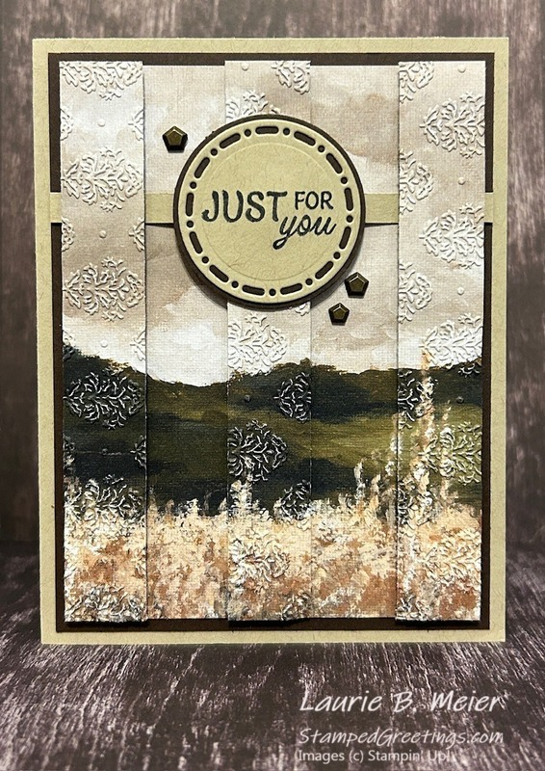
All images © 1990-2026 Stampin’ Up!®

Supplies:
- Stamp Set/Bundle: A Rainbow of Thanks (167233)
- Cardstock: Crumb Cake (120953), Early Espresso (119686)
- Ink: Tuxedo Black Memento Ink (132708)
- Designer Series Paper: Beautiful Gallery (165196)
- Tools & Accessories: Damask Designs Embossing Folder (165214), Spotlight on Nature Dies (163580), Faux Bronze Pentagons (166931), 1 ¾” Circle Punch (119850), Bone Folder (102300), Paper Trimmer (152392), Clear Block C (118486)
- Adhesives: Multipurpose Liquid Glue (110755)

Measurements:
- Crumb Cake Cardstock: 8 ½” x 5 ½”, 2 ½” x 2 ½”, ½” x 4 ¼”
- Early Espresso Cardstock: 4” x 5 ¼”, 4 ½” x 6”, 2” x 2”
- Beautiful Gallery DSP: 2 pieces measuring 3 ¾” x 5”

Instructions:
- Create the card base with the Crumb Cake cardstock measuring 8 ½” x 5 ½”. Score at 4 ¼” on the 8 ½” side and burnish to create an A2 card base.
- Create the ellipse focal point of the card –
  - Use two pieces of the Beautiful Gallery Designer Series Paper (DSP) to make the focal point for the card. Make sure the designs are exactly the same. Trim each piece to 3 ¾” x 5” so that the finished pieces have the exact same design.
  - Attach one of the DSP pieces to the Early Espresso cardstock measuring 4” x 5 ¼”.
  - Cut the second DSP piece into five strips measuring ½” x 5”.
  - Keep the two end strips and the middle strip. They will be attached to the card.
  - Emboss the two end strips and middle strip using the Damask Designs Embossing Folder.
  - Cut the Early Espresso cardstock piece measuring 4 ½” x 6” into twelve pieces that are ½” x 4 ½”.
  - Glue together three sets of four of the ½” x 4 ½” pieces by stacking them together. Attach the finished stacks to the back of each embossed DSP piece. This will give each piece dimension and a clean finish when the card is viewed from the side.
  - Glue one end of the Crumb Cake cardstock piece measuring ½” x 4 ¼” to the left edge of the Early Espresso cardstock piece. Reference the picture. Attach the left finished DSP piece to the card front, being careful to align the design to the DSP already on the front of the card.
  - Attach the middle finished DSP piece to the card front allowing the thin Crumb Cake cardstock piece to lay on top of the DSP piece. This will help weave the thin Crumb Cake piece.
  - Glue the open end of the thin Crumb Cake piece to the right edge of the Early Espresso cardstock piece. Attach the right finished DSP piece to the front of the card.
  - Trim off the excess of the thin Crumb Cake piece.
  - Attach the Early Espresso/focal point piece to the front of the card.
- Stamp “Just for you” from the A Rainbow of Thanks stamp set onto the 2 ½” x 2 ½” piece of Crumb Cake cardstock. Die cut the sentiment using the second to smallest die in the Spotlight on Nature Dies.
- Punch out a circle from the piece of 2” x 2” Early Espresso cardstock using the 1 ¾” Circle Punch.
- Adhere the die cut sentiment to the Early Espresso cardstock punched circle. Adhere the finished sentiment piece to the front of the card.
- Add a few Faux Bronze Pentagons as embellishments.

