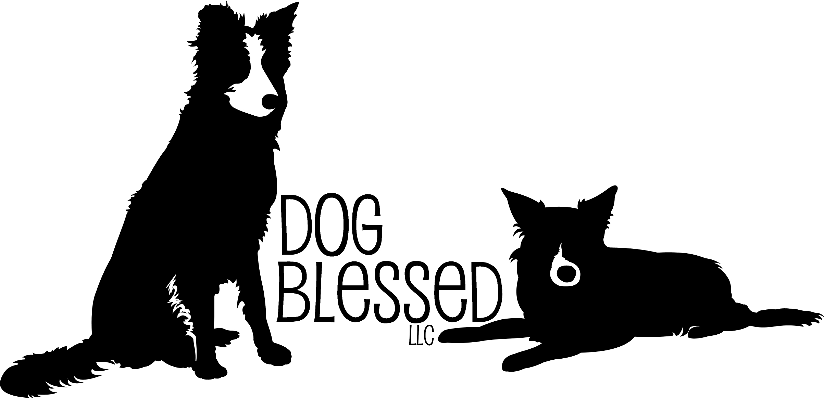
C-WAGS Scent & Rally Trial

Newaygo County Fairgrounds
815 Stewart Ave.
Fremont, MI 49412

Saturday at 10:00am
October 4, 2025

Rally | 2 Rounds Each  Starter Rally  Advanced Rally  Zoom 1  Zoom 1.5  1 Round Each  Zoom 2  Zoom Pro | Judges  Jodi Jarvis-Therrian  Leah Dykstra

Open to all dogs of any breed – Including “All Americans!”
Handicapped Handlers and Dogs Welcome!
Space Sensitive Handlers and Dogs Welcome!

Entry Limited to 100 entries.
If not filled, day of show entries accepted prior to class.

*These are sanctioned events under
Canine – Work And Games, LLC
For complete rules go to www.c-wags.org

This is an indoor show with limited crating.
Space inside for human spectators.
Move Ups are Allowed.
Resets are also offered so more that one dog may participate with same handler.

Entry Fees: $20 first entry, $15 each additional for same dog IF received by September 23rd.

Entries received after September 23rd
and Day of Show will be $5 extra.
“For Exhibition Only” - $10

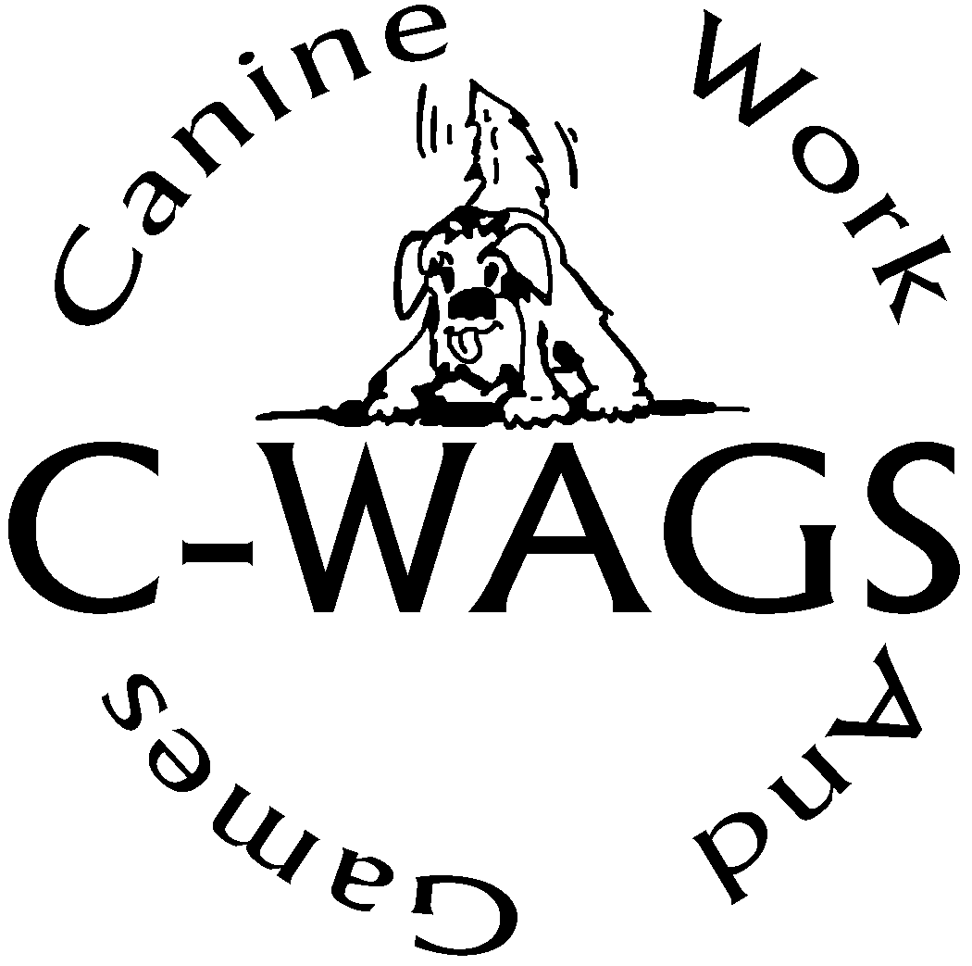
Show Committee
Paula Smith & Jayne Meyer

Trial Secretary
Stacey Chen
schendogsports@gmail.com
(231) 292-2443

Judges
Jodi Jarvis-Therrian & Leah Dykstra

C-WAGS Advocate
Paula Smith

Volunteer Workers Needed
To Help Our Trial Run Smoothly

If you would be able to help, please return this form with your entry.

Name: ___________________________________

Please indicate the jobs you would be willing to help with.
- Timer
- Gate Steward
- Course Setter
- Table Steward

Entries must be received by September 23rd for discounted rate. Entries submitted via Federal Express or Express Mail will be accepted only if the signature waiver is signed. No telephone or fax entries will be accepted. Any changes to entries will be accepted until trial begins. Changes must be made to the Secretary by telephone, e-mail, or in writing. Cancellations received after September 24th will be charged $20 processing fee.

Dogs must be registered with C-WAGS to participate and receive credit in the C-WAGS classes. “For Exhibition Only” may enter but will receive no credit. Day of show registrations accepted.

Awards
Qualifying ribbons will be awarded to each team who qualifies.
Placement ribbons will be available for rally and zoom
New title ribbons will be available.

Directions

From US 131, take Howard City exit (#118) and head west on B-82 26 miles and turn right onto Stewart Ave. Location is about .5 of mile on the right.

From US 31, take M120 east (North Muskegon Exit #118) to B-82.Turn right onto B-82. Or Holton-Whitehall Rd east (Whitehall/Colby Rd Exit #128) to M120. Turn left onto M120. Turn right onto B-82.

From the I-96, take Nunica exit #10 and head north on Maple Island Rd to B-82. Turn right and head east for five miles to S, Stewart Ave. Turn right onto S. Stewart Ave. Location is about .5 of mile on the right.

Accommodations (verify that they still accept dogs, ask about fees):
Rodeway Inn, Coopersville, MI: - 1-888-489-9290
Gerber Guest House, 130 E. Dayton, St., Fremont, MI – 1-231-924-7005
Camping onsite for $30 per night. Email dogblessedllctrialsec@gmail.com
Please call to confirm dog policy.

Food
There will be no food on site, but there are restaurants nearby.

OFFICIAL C-WAGS ENTRY FORM
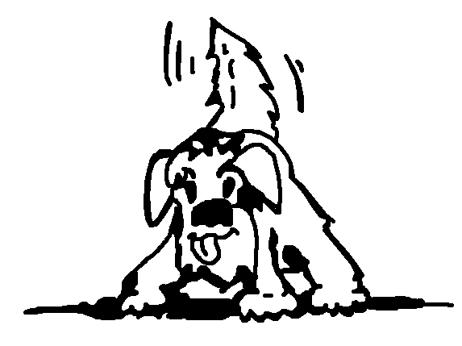
October 4, 2025

Location: Newaygo County Fair Ground, Fremont, MI

Make entry fees payable to: Dog Blessed LLC

Mail Entries to: Stacey Chen
7444 Easy St.
Whitehall, MI 49461

ENTRY INFORMATION – check classes & round(s) entering

⃝ Starter Rally Rd 1
⃝ Starter Rally Rd 2
⃝ Advanced Rally Rd 1
⃝ Advanced Rally Rd 2
⃝ Zoom 1.0 Rd 1
⃝ Zoom 1.0 Rd 2
⃝ Zoom 1.5 Rd 1
⃝ Zoom 1.5 Rd 2
⃝ Zoom 2 Rd 1
⃝ Zoom Pro Rd 1

Number of classes/rounds entered _______

Early Entry: $20 first entry, $15 each additional for same dog IF received by September 24th After September 23rd $5 extra per entry
Total fees enclosed _________

This entry is not valid unless the disclaimer on the opposite side of this form has been completed, signed and dated. In order to be valid, entries must also be received with correct fees by the closing date at the address provided. Confirmations will be e-mailed after November 12th.

Attach Dog/Handler Registration below or enter information if you have not yet received registration back:

Call Name _____________________________Reg. No. ___________________________

Breed ___________________________________________________________________

Owner’s Name ____________________________________________________________

Address _________________________________________________________________

City _________________________________ State __________ Zip _________________

Phone __________________________________________________________________

Email ___________________________________________________________________
DISCLAIMER – MUST BE SENT WITH ENTRY

I/we acknowledge that I am/we are familiar with the current rules applying to Canine-Work And GameS Trials. I/we agree that the Host Club holding the Trial has the right to refuse entry for cause which the Host Club shall deem to be sufficient. Upon acceptance of this entry, I/we agree to hold Canine-Work And GameS, LLC, and its members and officers, this Host Club, its members, directors, officers, agents, show secretary, show chairperson, show committee and the owner or lessor of the premises and any employees of the aforementioned parties, any sponsors of this event, harmless from any claim or loss or injury which may be alleged to have been caused directly or indirectly to any person or thing by the act of this dog or handler while in or upon the show trial premises or grounds or near any entrance thereto, and I/we further agree to hold the fore mentioned parties harmless from any claim or loss of this dog by disappearance, theft, death or otherwise, and from any claim for damage or injury to the dog, whether any claim be caused or alleged to be caused by the negligence of the Host Club or any of the parties aforementioned, or by the negligence of any other person, or any other cause or causes. I/we hereby assume sole responsibility for and agree to indemnify and save the aforementioned parties harmless from any and all loss and expense (including legal fees) by reason of the liability imposed by law upon any of the aforementioned parties for damage because of bodily injuries, including death at any time resulting there from, sustained by any person or persons, including myself/ ourselves or on account of damage to property, arising out of or in consequence of my/our participation in the Trial, howsoever such injuries, death or damage to property may be caused and whether or not the same may have been caused by negligence of the aforementioned parties or any of their employees or agents, or any other persons.

THIS DISCLAIMER MUST BE SIGNED AND INCLUDED FOR A VALID ENTRY

I/we agree to abide by the rules of C-WAGS currently in effect at the time of the trial. I/we testify that the dog entered is healthy and vaccinated or titered. I/we certify that the dog entered is not dangerous to any person or other dog. By signing below, I/we agree to the disclaimer on this entry form.

______________________________________ _______________
Signature – Owner or Parent / Guardian if Minor Date

Entry form MUST be signed and the Disclaimer MUST be attached for a valid entry.

C-WAGS Notice to Exhibitors
Competitors, through submission of entry, acknowledge that they are knowledgeable of C-WAGS rules and regulations including but not limited to the following rules regarding entry:
- All exhibitors are expected to treat the judges, trial hosts, your canine partner and all other exhibitors with respect.
- All judges and trial hosts are expected to show respect to all exhibitors.
- This trial is open to all dogs registered with C-WAGS.
- Trial Hosts may elect to accept FOR EXIBITION ONLY entries of non-registered dogs.
- Teams may be entered in multiple levels/classes at the same trial.
- Dogs must be shown by a member of the owner’s immediate family.
- Collars: The dog must wear a flat type collar (buckle, snap or proper fit martingale) and/or body harness in the ring. Electronic training collars are not allowed on the show grounds.
- Owners with disabilities are encouraged to compete. Any necessary modifications to the exercises must be provided by the handler to the judge and approved by the judge
- Safety shall always be of foremost consideration in actions and conduct by handlers at all times. Handlers, through entry at this event, accept full responsibility for themselves and the actions of their dogs.
In addition,
- The organizing committee may refuse any entry for any reason.
- THERE SHALL BE NO REFUND for entries in the event a dog and/or handler are dismissed from competition, regardless of reason for such dismissal. There will be no refunds if the trial has to be cancelled for any reason.
- Refunds will be made for females in season upon written request accompanied by a statement from the exhibitor’s veterinarian.
- Returned checks do not constitute a valid entry. There will be a $25.00 service charge for returned checks. Payment of entry fees and service charges shall be made by money order within 7 days of notice to exhibitor of returned check. Any fees not received within 7 days of notice result in cancellation of event results for all classes for the registration number(s) of delinquent entry/entries. No reinstatement of results is possible.
- All competitors through entry at this event waive any and all rights relative to video broadcast of this event. Competitors shall have the right to videotape portions of this event for their personal use only. No portion of this event may be videotaped for commercial or other purposes.
- Dogs must be on leash while on show grounds unless being shown.

