TOWN OF EMMET  Established in 1848  W6777 SECOND STREET RD • WATERTOWN, WI 53098 DODGE COUNTY • WISCONSIN | 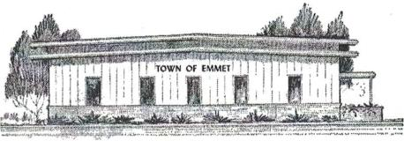

TOWN OF EMMET
W6777 Second Street Road, Watertown WI 53098
BOARD MEETING NOTICE AND AGENDA
September 16, 2025, 7:00 PM
Items on the agenda are up for consideration by the Emmet Town Board for the purposes of Budget planning for 2026
AGENDA
- Meeting call to order
- Pledge of Allegiance
- Establish quorum (roll call)/notices posted town website/hall/waste site.
- Approve Agenda
- Discuss 2026 Budget
  - Rural Fire Contract
  - Lebanon Fire Contract
  - Emmet/Lebanon Police
    - Computer for Police Squad
  - Insurance
  - Trash/Recycle
  - Equipment Repairs e.g. Loader repair, TD 35 Forklift, gen vehicle/equip maintenance, other
  - Roads Maintenance: repairs on town roads e.g. those in the 5/10-year plan, annual seal/chip, crack fill, etc. e.g. gravel, cold mix, gravel, fuel, salt,
  - Town Hall repairs – e.g. electrical in hall & office, shelving for office for storage of historical records, windows, front door.
- Set date and motion: for additional Budget Planning Workshop
- Adjourn

