TOWN OF EMMET  Established in 1848  W6777 SECOND STREET RD • WATERTOWN, WI 53098 DODGE COUNTY • WISCONSIN | 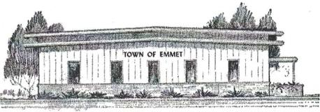

TOWN OF EMMET
W6777 Second Street Road, Watertown WI 53098
Town of Emmet Budget Hearing and Special Town Elector Meeting of Electors

BOARD MEETING NOTICE AND AGENDA
November 18, 2025, 5:30 PM Budget Hearing
November 18, 2025 5:45PM – Board Meeting to Adopt Budget

Items on the agenda are up for consideration by the Emmet Town Board.

AGENDA
- Meeting call to order
- Pledge of Allegiance
- Establish quorum (roll call)/notices posted town website/hall/waste site.
- Approve Agenda
- Approval of Minutes (Budget Mtg 2024)
- Town Electors Meeting and Tax Levy Adoption
  - Roll call vote of Town Electors
- Adjourn Town Electors Meeting

