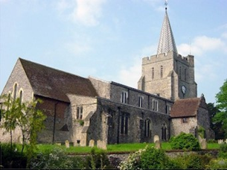
Please visit our website for information about our churches, services & events www.elhamvalleygroupofchurches.co.uk

Every Tuesday at St. Mary’s…

Traditional Morning Prayer at 8.30am in the Jesus Chapel. Download the free Church of England app or use the red book. A good way to begin the day. https://play.google.
com/store/apps/details?id=com.aimermedia.dailyprayer&pli=1


Every Monday at the Methodist Hall …
Coffee and cake, a warm welcome and friendship, 10.30am –
12pm

Churches Together in Elham Valley March
Please contact -: Ruth Collie (01303 840773) for information

1st March – 2nd Sunday in Lent
08:00 Said Eucharist 09.30 Service of the Word

Lectionary readings:
Genesis 12.1-4a; Psalm 121; Romans 4.1-5,13-17; John 3.1-17

8th March – 3rd Sunday in Lent
09.30 Service of the Word

Lectionary readings:
Exodus 17.1-7; Psalm 95; Romans 5.1-11 ; John 4.5-42

15th March – 4th Sunday in Lent – Mothering Sunday
09:30 Sung Eucharist

Lectionary readings:
Exodus 2.1-10 or 1 Samuel 1.20-28; Psalm 34.11-20 or Psalm 127.1-4; 2 Corinthians 1.3-7 or Colossians 3.12-17; Luke 2.33-35 or John 19.25-27

22nd March – 5th Sunday in Lent- Passion Sunday
09:30 Service of the Word

Lectionary readings:
Ezekiel 37.1-14; Psalm 130 ; Romans 8.6-11; John 11.1-45

29th March – Palm Sunday
10.00 Benefice Eucharist at St Mary & St Radegund, Postling

Lectionary readings:
Liturgy of the Palms: Matthew 21.1-11; Psalm 118.1-2,19-29;
Liturgy of the Passion: Isaiah 50.4-9a; Psalm 31.9-16; Philippians 2.5-11; Matthew 26.14 - 27.66 or
Matthew 27.11-54

Events for the March Notice sheet Please send to Margaret Keeble by 5th of each preceding month. m.keeble@outlook.com

Elham Methodist Church
(all at 9.30am unless otherwise stated)
Services for March
1st Mrs K Taylor
8th United Service at Lyminge
15th United Service at St Mary’s
22nd Local Arrangement
29th Richard Blackwell

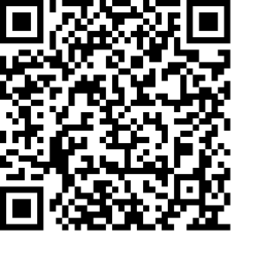
Donations
We would greatly appreciate your help to continue our work for God in the village of Elham and surrounding areas. If you can, please consider making a donation. This is our QR code for St Mary’s Elham. To donate using this code, open up the camera on a mobile phone - point the camera at the QR code – follow the instructions.
The offertory plate will go round in the service, during one of the hymns. There is also the opportunity to donate by card using the PAYAZ machine by the North door.

Safeguarding / ‘A Safe Church’:
If you ever have any concerns, contact our Parish Safeguarding Officer:
Susannah Pallot : susannahpallot@gmail.com

Paper Copies of Notices
Some copies are available on back table in church. Please take a copy to give to those unable to access the internet.

