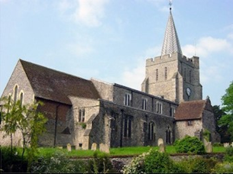
Please visit our website for information about our churches, services & events www.elhamvalleygroupofchurches.co.uk

Every Tuesday at St. Mary’s…

Traditional Morning Prayer at 8.30am in the Jesus Chapel. Download the free Church of England app or use the red book. A good way to begin the day. https://play.google.
com/store/apps/details?id=com.aimermedia.dailyprayer&pli=1


Every Monday at the Methodist Hall …
Coffee and cake, a warm welcome and friendship, 10.30am –
12pm

Churches Together in Elham Valley February
Please contact -: Ruth Collie (01303 840773) for information

1st February – Candlemas
08:00 Said Eucharist 09.30 Service of the Word

Lectionary readings:
Malachi 3.1-5; Psalm 24.[1-6]7-10; Hebrews 2.14-18; Luke 2.22-40

8th February – 2nd Sunday before Lent
09.30 Service of the Word

Lectionary readings:
Genesis 1.1 - 2.3; Psalm 136 or Psalm 136.1-9,23-26; Romans 8.18-25; Matthew 6.25-34

15th February – Sunday next before Lent
09:30 Sung Eucharist

Lectionary readings:
Exodus 24.12-18; Psalm 2 or Psalm 99; 2 Peter 1.16-21; Matthew 17.1-9

22nd February – 1st Sunday in Lent
09:30 Service of the Word

Lectionary readings:
Genesis 2.15-17; 3.1-7; Psalm 32; Romans 5.12-19; Matthew 4.1-11

Events for the March Notice sheet Please send to Margaret Keeble by 5th of each preceding month. m.keeble@outlook.com

Elham Methodist Church
(all at 9.30am unless otherwise stated)
Services for FEBRUARY
1st David Songer HC
8th Richard Blackwell
15th Valley United Service at Rhodes Minnis 10.15
22nd Video Sermon

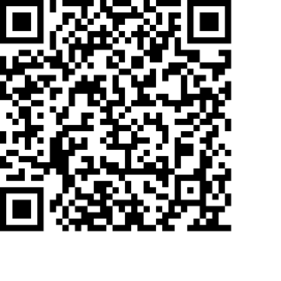
Donations
We would greatly appreciate your help to continue our work for God in the village of Elham and surrounding areas. If you can, please consider making a donation. This is our QR code for St Mary’s Elham. To donate using this code, open up the camera on a mobile phone - point the camera at the QR code – follow the instructions.
The offertory plate will go round in the service, during one of the hymns. There is also the opportunity to donate by card using the PAYAZ machine by the North door.

Safeguarding / ‘A Safe Church’:
If you ever have any concerns, contact our Parish Safeguarding Officer:
Susannah Pallot : susannahpallot@gmail.com

Paper Copies of Notices
Some copies are available on back table in church. Please take a copy to give to those unable to access the internet.

