Acrise Church News: January 2025
Reminder
There is a Benefice Eucharist at St Mary’s Elham on Sunday 29th December, starting at 10.00am. No service at Acrise.

January Services
Sunday 5th January Holy Communion Sharon 9.30am
Sunday 12th January Matins BCP Bill 9.30am
Sunday 19th January Morning Prayer Paul 9.30am
Sunday 26th January Family Christingle Service Family Worship Team 9.30am

Benefice Eucharist at Canterbury Cathedral on 1st December
Eleven members from Acrise church enjoyed the experience of attending a service in our magnificent cathedral, with refreshments afterwards and the opportunity to talk to the cathedral clergy, including the Dean who had taken services at Goodnestone and Nonnington earlier that morning. There was also the opportunity to browse the Christmas Market in the Cathedral grounds and to venture into the town for Christmas shopping if we wished.

Christmas Fair in Elham Village Hall on Saturday 7th December
Last year we had snow and this year rain and wind. Despite the weather, which kept some people away, the event was successful. Once all the money is collected we are likely to match the £1400 we raised last year. Much preparation goes into organising the fair and we are grateful to all the people who help.
We thank all the stallholders who supported us and everyone who helped with our own stalls, with the raffle and tombola and the refreshments. Many thanks for all the donations of cakes and other refreshments as well as raffle and tombola prizes. Thanks also to Father Christmas who was kept busy for much of the time and had nothing in his sack at the end.
As usual the happy and friendly atmosphere was evident and gave many of us the chance to meet up with friends and acquaintances. We hope to hold the Fair again in 2025 on the first Saturday of December.
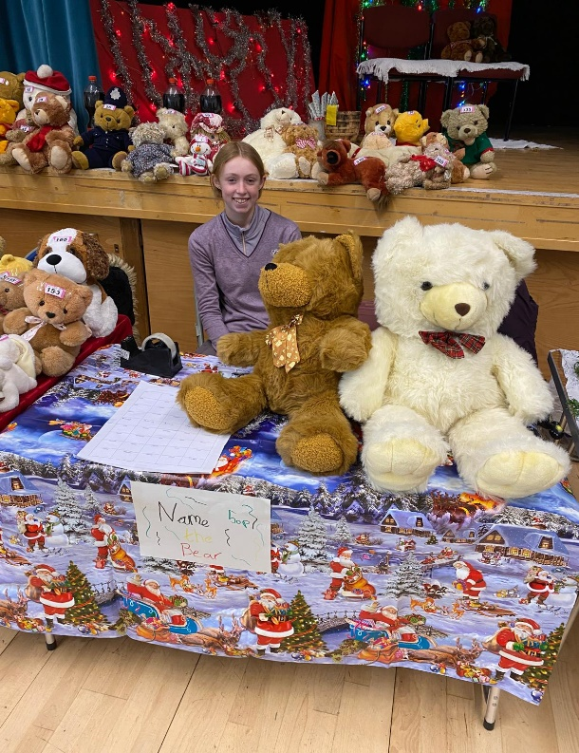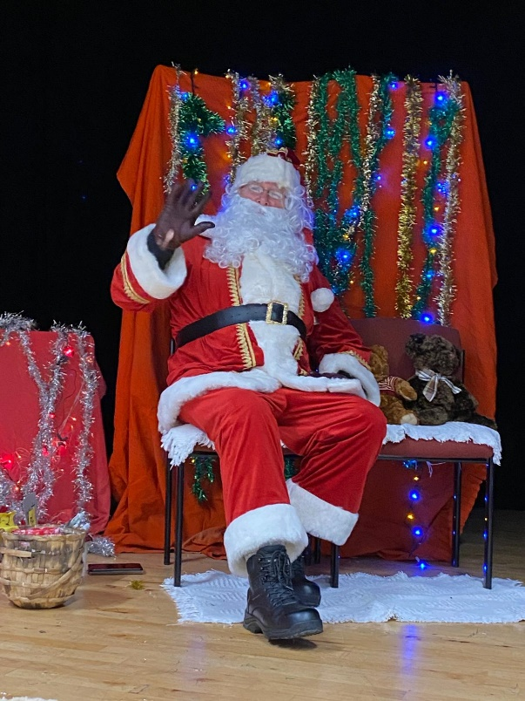
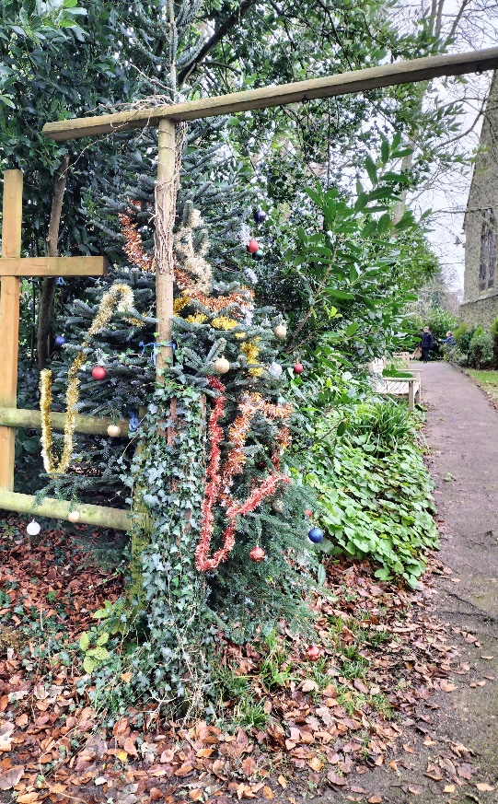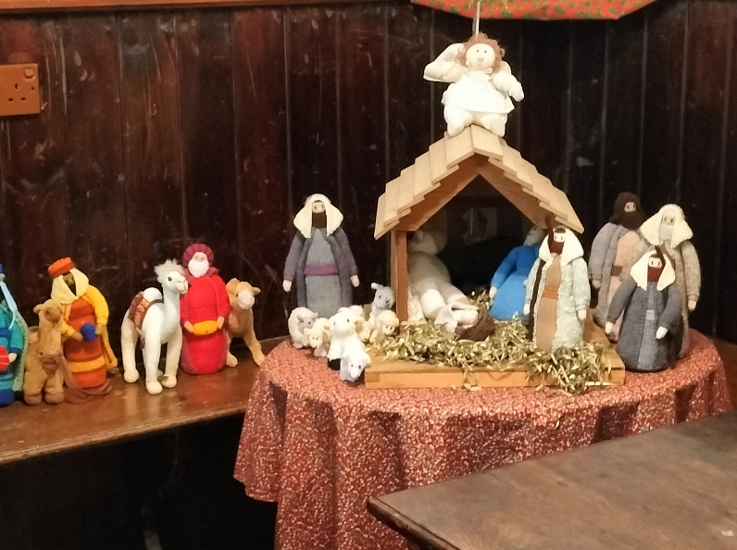

Family Carol Service on Sunday 15th December
Despite some of our regulars being ill we were pleased to welcome 43 people to the service, including ten children. We also welcomed Bill who led the service and began by reading the poem ‘The Night Before Christmas’ which was much enjoyed. Activity bags were given out and the children could create wreaths and wands to take home. Our readings and carols told the story of the Nativity. Thanks to Irene for playing the organ and to all our readers. One of the readers was Daisy who has been a regular reader at family services since they began in autumn 2019. She and Teddy read the prayers very well. Thanks also to Alison who supervised the refreshments which were available throughout the service.
Near the end of the service the children and some adults brought up the characters and animals to create the nativity scene in the Squire’s Pew. Finally, the children had the chance to ring the bell before going outside to decorate the 10-foot Christmas tree which had been given to us by residents of Acrise Mews.
The service was a happy and enjoyable occasion which conveyed the true meaning of Christmas. Our next Family Service will be Christingle on Sunday 26th January 2025.

Carol Singing in School and Coach Roads: Monday 16th December
Nine of us met up at the crossroads to go carol singing, the first stop being at Robert and Linda Stewart’s where we joined with their friends and family to sing requested carols as well as songs for granddaughter Juno. After drinks and mince pies we went down School Road and then back to Coach Road. Once we reached the home of Kelvin and Liz we enjoyed their hospitality with mulled wine and refreshments. More visits were made until we reached our final destination at the home of Jerry and Laura who provided mulled wine, mince pies, sausage rolls and biscuits. Thanks to all who fed and watered us and to the generosity from everyone who gave money for the Royal National Lifeboat Institute. The total collected for RNLI was £180, which was an amazing amount for one evening.
The Thursday evening carol singing did not happen this year.
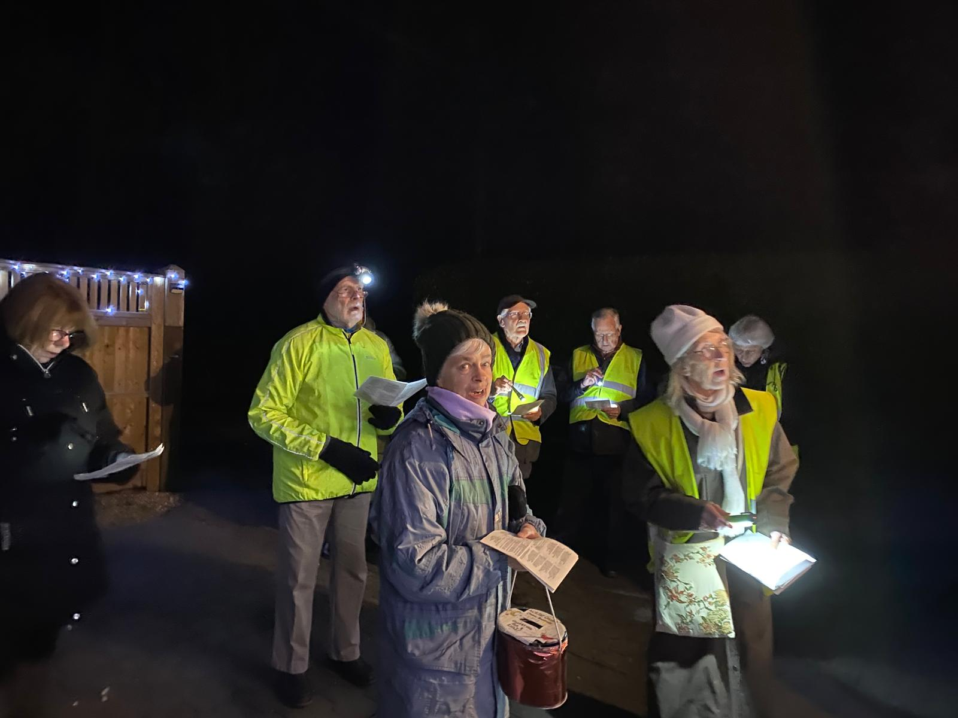

The Compostable Toilet Project
The PCC is pleased to announce that after more than a year since deciding to buy a toilet the project is now complete. Final details about use and maintenance will be decided at the PCC Meeting on 9th January. We will have some sort of opening event to which we will invite the local community. One reason for having a toilet was to encourage the use of the church by the community for non-religious events such as meetings or coffee mornings.
We thank the Friends of Acrise Church and the Produce Team who have worked for some years to raise money for a toilet. In the end the £7,300 which they provided was used to buy the toilet and to go towards undertaking the groundwork, electrics and fittings. To this we added a grant of £2000 from the Diocese and £500 from the District Council. We also thank Barry Bushell who allowed us to site the toilet on his land adjacent to the car park. We are also grateful to Luke Kirby and his son of Acrise Building Contractors who were very helpful and produced work of high quality.

Shepway Foodbank
Please support the foodbank this winter if you can by leaving items in the porch or at the back of the church when it is open.
Most urgently needed items are: coffee, marmite, tinned meat, long life juice, instant noodles, toilet rolls.
Other items often needed are: tinned fruit, tinned vegetables, long life milk, cuppa soup, jam, biscuits/chocolate, cooking sauces, washing pods.

St Martin’s Church Garage sale is Ongoing
The Garage Sales Team led by Richard is involved with buying and selling second hand items throughout the year and not just at the Garage Sale or other fundraising events.
If you have any unwanted items that could be recycled to raise money for St Martin’s, please contact Richard on 01303 893584 or 07919393302.

Christmas Tractor Run on Saturday 21st December.
The run started from Capel at 5.00 pm with 40 tractors and a few trucks lit up with Christmas lights and sounding horns or jingles. The route was up through Hawkinge to the Blackhorse Pub at Densole and then back down to the Harbour Arm at Folkestone.
The event was organised by Henry Burrows, with the help of many local farmers, to raise money for a Folkestone charity called Touchbase Care. This is a community day care centre located in the Creative Quarter which supports adults and young people with physical disabilities, learning difficulties, neurodiversity and sensory impairment. It aims to improve wellbeing and develop skills by providing a programme of creative, active and therapeutic activities.
Henry and his team said that they were overwhelmed by how many people came out to support the event, with seven collection buckets full by the end of the evening as well as online donations. At the time of writing just over £3000 has been raised but the final total could be more than this. There were many people at Densole lining the road towards Hawkinge and waving and cheering as the tractors went by, ranging in size from a small combine to a vintage David Brown. It was an amazing sight (and sound) as so many local farmers joined together to support such a worthy charity. Those of us living in the local community and with links to farming were very proud of their achievement.
Henry, who comes from Alkham, where his parents also live, has a farming background. His father Neil was born and brought up in Acrise where the family farmed at Acrise Court and were neighbours to the Youngs at White Lodge (Sue Prebble’s family). Henry was married to Kelly at St Martin’s Church in Acrise in October 2020. The service was memorable as it included a sheep which transported the wedding rings up the aisle to the altar.
Henry said that they will be back next year when the event will be bigger and better. If you missed this year’s event it will be worth going next year.
