Acrise Church News: June 2026
Reminder: On Sunday 31st June there is a Benefice Service at St Peter’s Swingfield at 10.00am
Services for June
Sunday 7th June Holy Communion BCP Sharon 9.30am
Sunday 14th June Matins BCP Bill 9.30am
Sunday 21st June Family Service Janet 9.30am
Sunday 28th June Benefice Eucharist to celebrate Rev Stephen Dougal’s 20 Years of ordained ministry. All Saints Stanford at 10.00am
Rogation Walk on Sunday 10th May
Beating the Bounds of the parish. After a brief prayer at church a small group set off to walk a short section of our parish boundary on a rather cold and windy morning. From church we walked to Acrise Green and then across the footpath from the Old Rectory through glebeland before heading through woodland down to Ladwood Farm. From there we walked up the bank to Winterdown and along the bridleway to Blandred Farm, turning left until we reached the top of Rakeshole Hill. From there we retraced our steps to the boundary with Swingfield and ended with lunch at Reast Lane Gate. Thanks to Joan for the food. As is traditional we painted red ‘A’s to mark the boundary at certain points, some of which are seen in the photographs.
Such a walk enabled us to experience the beauty of the countryside from a different perspective, seeing views we would never see from a road. It was also an opportunity to enjoy conversations with fellow walkers as well as giving thanks to God for our countryside and its growing crops.
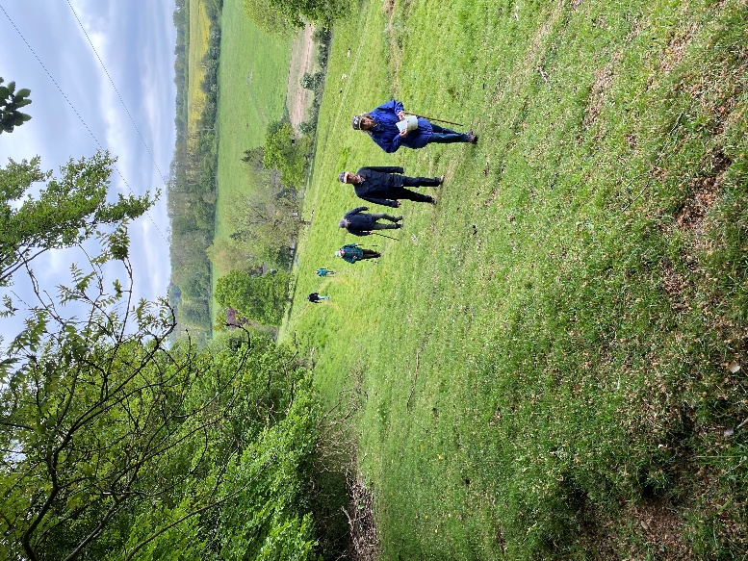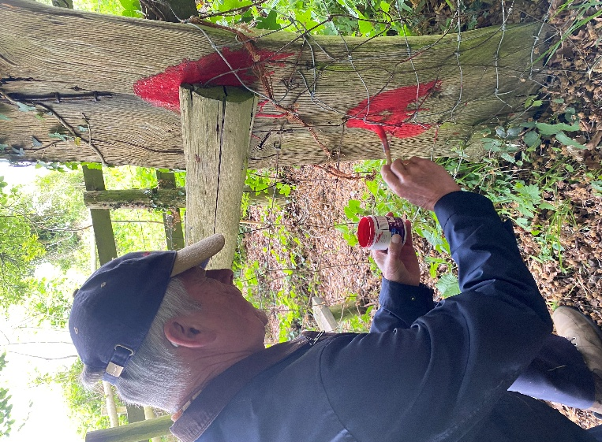
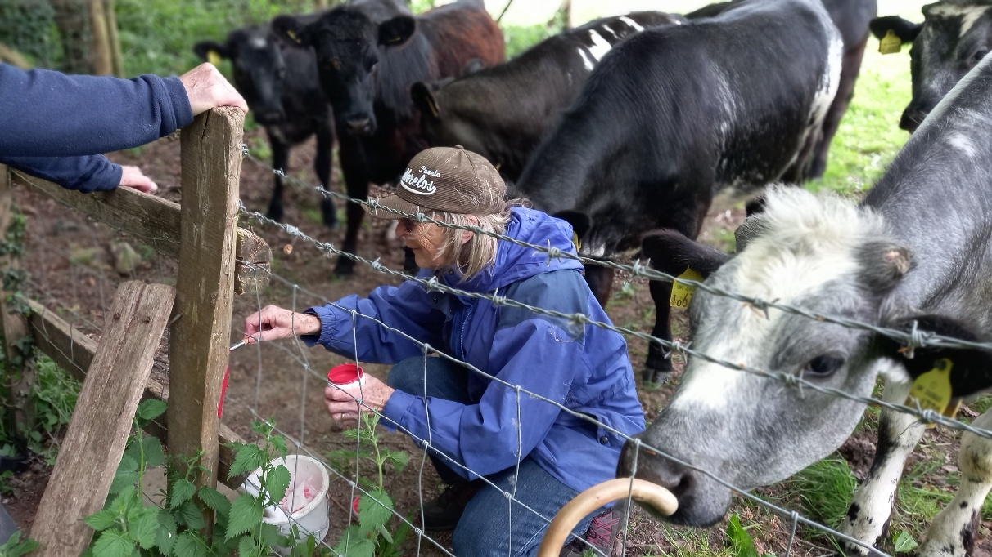
Sunday 10th May: Licensing of Rev. Sharon Paine
This took place at St Mary and St Ethelburga’s Church,Lyminge at the 6.00pm Evensong. The service was led by Rev. Stephen Dougal and the licensing conducted by Archdeacon Darren Miller. The church was full, with a congregation of people from across the benefice who came to support Sharon on this joyous occasion as she became an associate priest for the Elham benefice after three years of ministry, which is a great achievement.
Here is the final prayer from Archdeacon Darren before Sharon received her licence:
Almighty Father, give your servant Sharon the grace to fulfil her calling in this benefice. Give her reverence in ministering the sacraments, faithfulness in proclaiming your word, diligence in pastoral care, tenderness in comforting, power in healing the wounds of Christ’s people and humility and self-sacrifice in all things: that following the steps of your son, she may guide your people to eternal joy; through Jesus Christ our Lord.
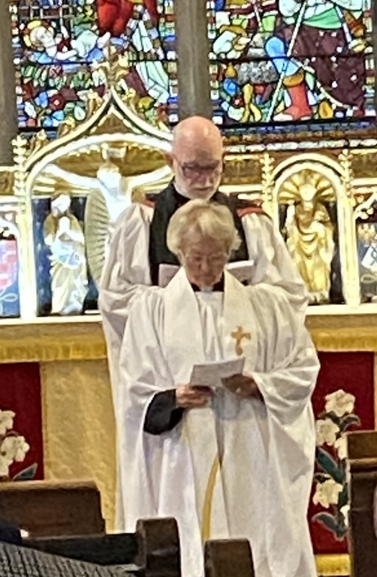
After receiving her licence, Sharon’s first act was to lead the intercessions. After celebrating Sharon’s licensing with Evensong, the celebration continued with a buffet and drinks organised by members of Lyminge church, which was much enjoyed and was an opportunity for benefice members to meet informally and get to know one another better. Many thanks for all at Lyminge church who prepared for this special occasion.

Congratulations Sharon and thank you for your ministry.
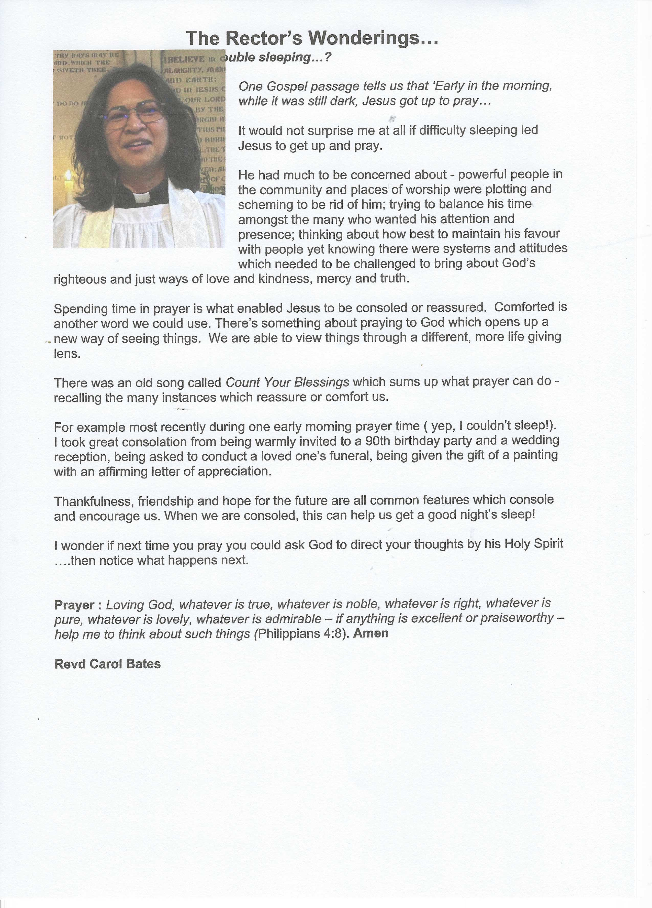
Fundraising Events: June - August
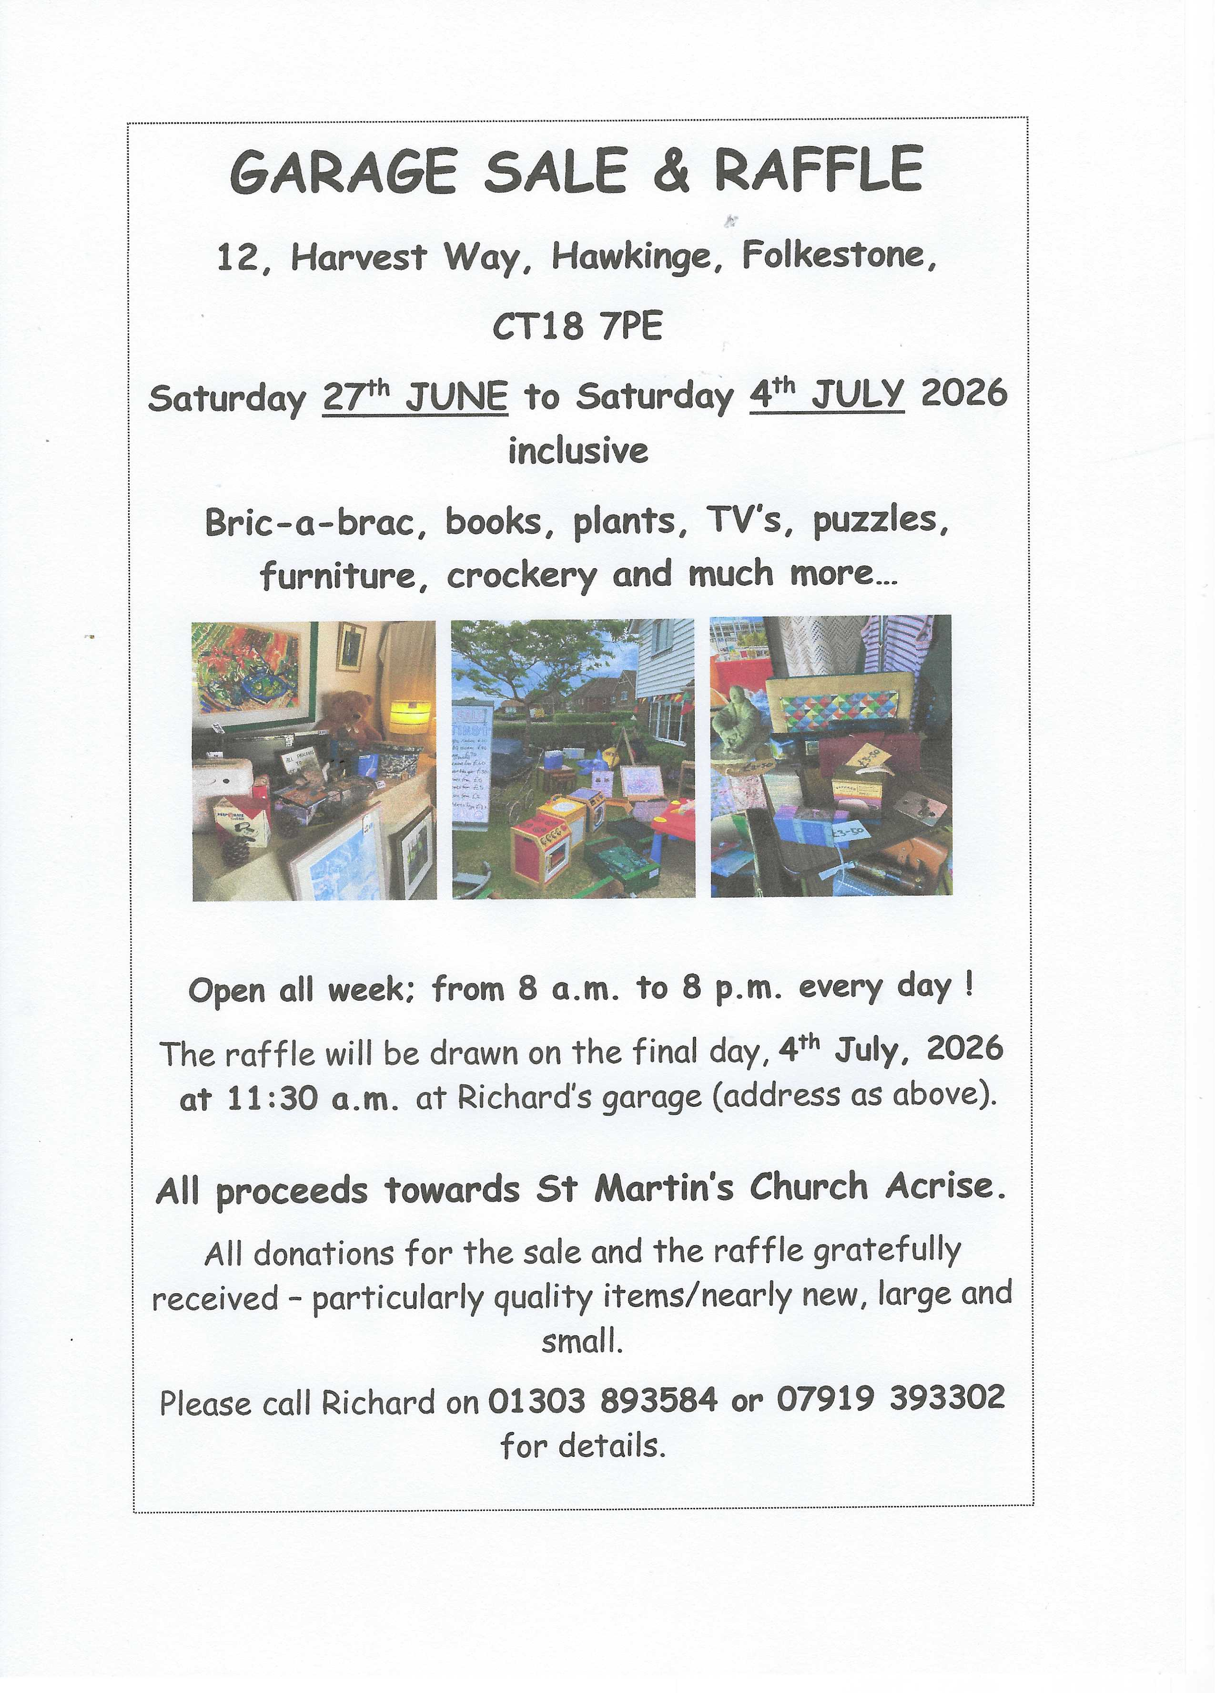
Many thanks to Richard for organising this event at his home in Hawkinge
Acrise Festival
of Flowers and Music
Saturday 1st August 10.00am - 5.00pm
Flowers in the church and music on the green. Church records will be displayed. There will be a variety of stalls, raffle, tombola, children’s games and pony rides.
Refreshments, including ploughmen’s lunches, will be available.
Volunteers
Early in the last week of July we will be spring cleaning the church from 10.00am and tidying the paths, graveyard and parking area. We would be grateful for volunteers to help – date to be decided.
On Friday 31st July the church will be decorated with flowers and the site prepared for 1st August. Any volunteers who can help with preparations on the Friday or with the event on the Saturday will be welcome.
Donations
We would be grateful for donations of cake, biscuits or savouries; raffle and tombola prizes, good quality bric-a-brac; any home grown produce or plants.
If anyone could donate foliage or flowers from their gardens and leave them at the church on the morning of 31st July, we would be grateful.
Contact
Please contact Sue on 01303844640 or
(sue1954prebble@gmail.com) if you could volunteer or make a donation for the 1st August.
Jean Grieb will be grateful for any tombola prizes or any costume jewellery. She can be contacted on 01303892364

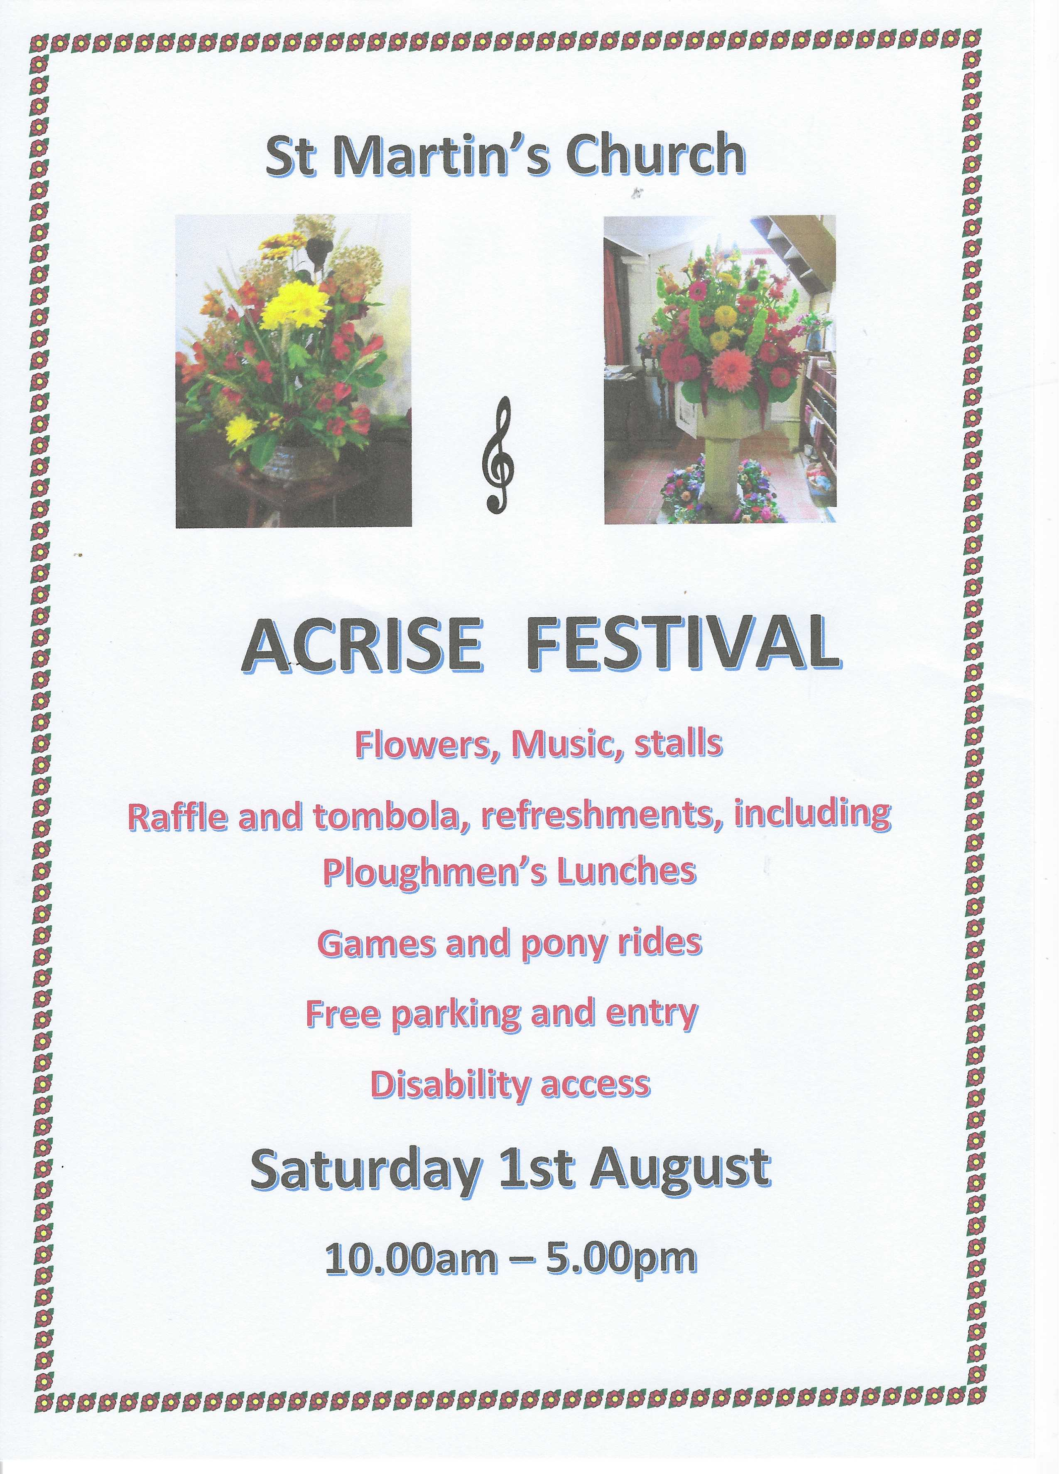

Acrise Environmental Group
Heritage Pond Presentation
This was given by Sarah Harrington-James at Elham Village Hall on 28th April. Sarah works for Kent Downs Natural Landscape and formerly for Natural England. Her presentation was in two parts: firstly ‘The Demise of the Villager Pond’ and then the progress of the Heritage Ponds Project on the Kent Downs. Members of the Acrise Environmental Group were joined by members from the Elham Environmental Group.
Sarah’s first photo was of a village pond from Otford in 1890. It survives as it was listed because of the original brickwork around it and as it was spring fed. Ninety percent of Kent ponds are manmade and many have not survived. There are two types of ponds on the Downs: dew ponds and sole ponds. Dew ponds are manmade and shallow with a clay lining. Sheep were penned in to the pond to puddle the clay and give the pond its lining. Sole ponds were clay caps on top of chalk. There were clay and chalk pits on the downs which became ponds and many medieval communities had fishponds.
Some ponds were used as cart washes for horses and carts, as can be seen at Bethesden with its Bethersden marble base. Sarah showed us a photos of an old ghost dewpond at Boyington Court Farm Swingfield, a dewpond and clay pit in Ryarsh Woods and a gore pond at Bredegar. A pond at the junction of roads was known as a ‘gore pond’.
Great Dowles Farm, which is off Stone Street, has twelve ghost ponds linked to the one remaining pond which survived as it was near farm buildings and was regularly used.
The decline in ponds is due to a number of factors, such as house building and drainage of ponds, industrial pollution, and the use of piped water and standpipes for watering animals. Many ponds were filled in or silted up, becoming ’ghost’ or ‘lost’ ponds.
The Heritage Pond Project: Progress
The project has been going for two years on the North Downs which is a water depleted area with 1,730 ponds recorded. It received a grant from Kent County Council and now has 55 volunteers. Heritage records have been investigated and the process of restoring some of the ponds has started. Field records of 300 ponds that have been visited give their size, depth and geology. Many are near farms and some don’t have public access.
Sarah mentioned ponds on the Downs, such as Winchcombe Down at Wye and one at Knockholt, the highest village on the Kent Downs. There are ponds in woods such as sole ponds at Eggridge Wood and Comb Wood.
The big question for the project is to decide which ponds should be restored. A dewpond has been restored at Frinsted and one at Hurst Farm, Otterden, though the latter has dried up. Last year Cobham Wood Pond and one in Hackney Community Orchard were restored. Digging cross trenches at ghost ponds is the latest technique to help explore the history of these ponds.
In Acrise Parish, where the local environmental group led by Stephen Scoffham have obtained a £10,000 green grant from Folkestone and Hythe District Council, there are 42 pre-1900 sole and dew ponds, There are up to seven ponds at the Winterage Farms, most of them ghost ponds, two at White Gates and three remaining of six at Hoad Farm, not to mention ponds or ghost ponds at other farms in the parish.
The three ponds that the Acrise Environmental Group are concentrating on are at Pillars Wood, Winterage Lane/White Lodge (could this be called a ‘gore’ pond?), and the Ice House Hill Pond. So far work has been carried out to improve the Winterage Lane Pond and extend the hedging, while a test pit has been dug at the Ice House Hill which dates the pond as 19th Century. Earlier auger samples had suggested that the pond was much older.
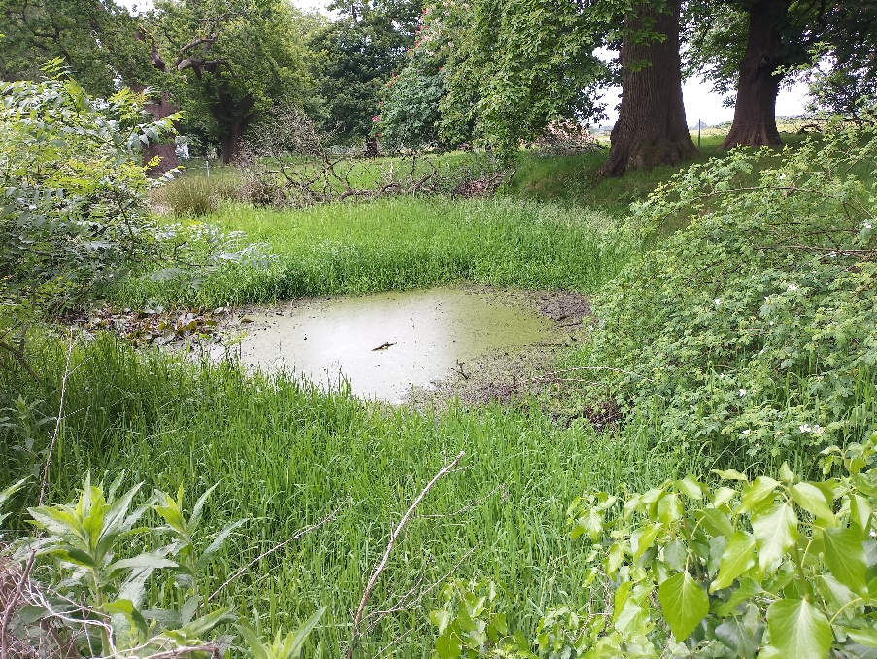
Winterage Lane/White Lodge Pond where the lane joins the Avenue to Acrise Place could be a ‘gore’ pond.
Next Pond Dipping at the above pond is on Saturday 30th May at 2pm (finish es at 4pm or earlier), Any one interested is welcome.

Shepway Foodbank: Folkestone Rainbow Centre
If you can support the foodbank plese leave items at the back of the church or in the porch if the church is shut. We will be taking donations to our local collection point at the end of May.
Most needed items are: white sauce, curry sauce, custard, long life milk and juice, pickles, coffee, cooking oil, noodles, mayonnaise.

