Acrise Church News: February 2026

Services for February (all at 9.30am)
Sunday 1st February Holy Communion Sharon
Sunday 8th February Matins BCP Paul
Sunday15th February Morning Prayer CW Janet
Sunday 22nd February Service of the Word Diana

End of Year Service on Sunday 28th December
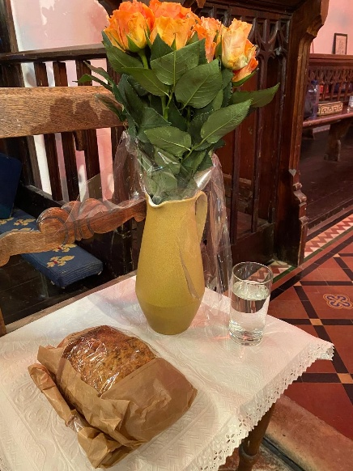
This was a reflection, looking back on the past year and forward to the new year. Images were used to represent aspects of the past year. Bread represented the everyday things, sad and difficult things were represented by water (tears), while flowers were reminders of happy times and celebrations.
It was good to have time for quiet reflection on what had gone well and to give thanks, as well as looking forward to the future with hope.
Thanks to Janet for preparing this service of reflection which is more common in German churches.

Family Christingle Service on Sunday 25th January
This special service, ably led by Janet, was attended by 50 adults and 22 children. We were pleased to welcome six families who had not been before. The readings and prayers were on the theme of light overcoming darkness and bringing hope to the world: Jesus, the light of the world brought light and love to the world. Through good deeds and kindness to others we reflect this light and bring hope to our world, a world that can be dark and difficult. Here is one of the children’s prayers:
We pray that Jesus will bring light into
The dark places of the world
Where there is war, hunger, poverty and sickness.
We pray that Jesus will bring light to
Anyone in our family or among our friends who is
Suffering from illness or unhappiness.
Janet told us of the origin of Christingles in the Moravian Church in Germany in 1747 and how the idea was adapted By the Children’s Society in 1968, with an orange encircled by a red ribbon and holding a candle, dried fruit and sweets. The children were able to answer questions about the meaning of the parts of the Christingle.
It was then time to make the Christingles, which gave us a break for refreshments. Once the Christingles were completed Joan and John went round and lit each one. With the lights switched off and the church in darkness on a dull January morning, a magical atmosphere was created by the many shining candles. The light shone in the darkness, and we hope that good in our world will overcome evil for us, and for our children’s future.
Thanks to Janet for leading this enjoyable and significant service and to Irene for playing the organ. We sang ‘Jesus bids Us Shine’, ‘This Little Light of Mine’ and ‘Shine, Jesus Shine’. We thank all our readers who did very well in front of a large congregation, and particularly to 6-year-old Freddie who read for the first time. Thanks also to the team who bought and prepared the Christingle items, and to those who prepared and organised the refreshments.
This event was a good example of teamwork with the Family Service Team and many other church members working together to make the service a success. Thanks to everyone who attended. It was good to see you all.

Our next Family Service is on Sunday 15th March: Mothering Sunday at 9.30am

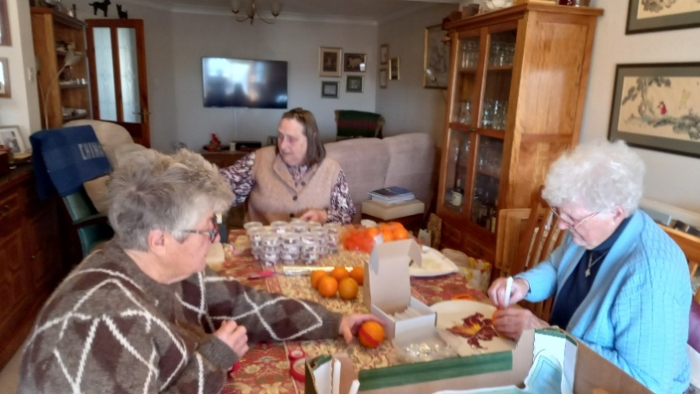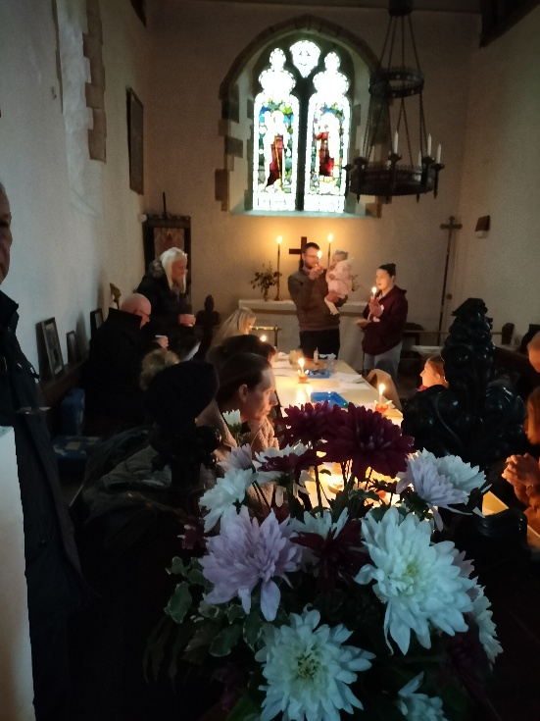
. Preparing the Christingles

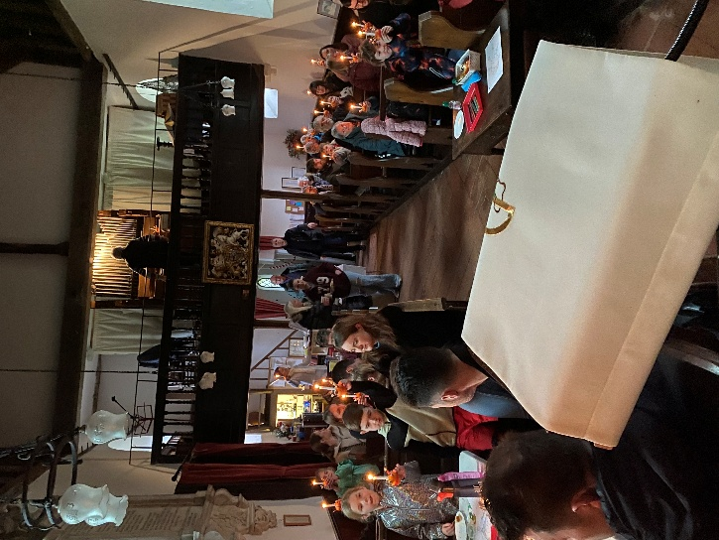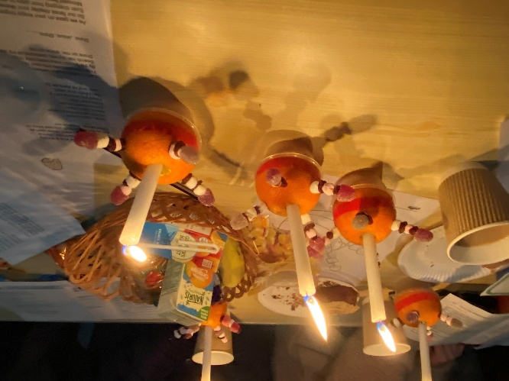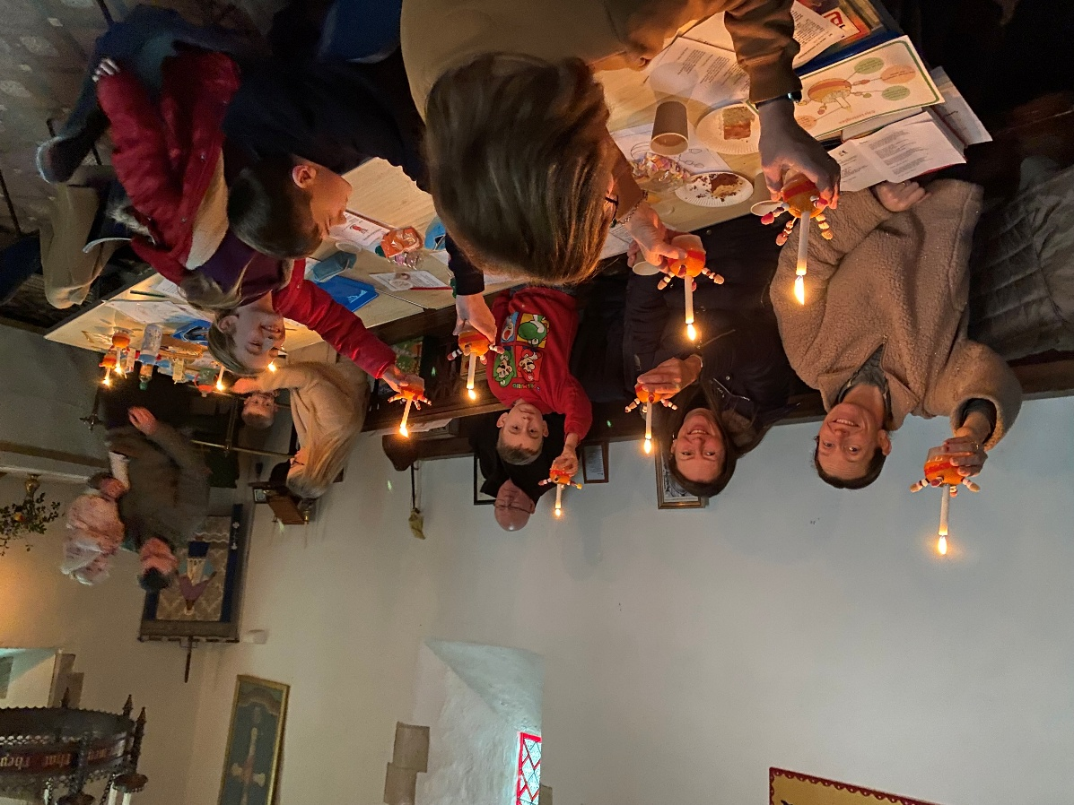

Acrise Environment Group: Heritage Ponds Project
Draft Timetable for February/ May (From Stephen Scoffham)
This will be focusing on three ponds in 2026. They are:
Pillars Wood Pond (at the junction of School Lane and Pay Street);
Winterage Pond (where Winterage Lane meets Acrise Park Road near White Lodge);
Ice House Hill Pond (to the left of the dip in the road to Elham just down from Acrise Place).
Initial work has already begun and there are a number of events planned for the coming months.
- Working Party at Winterage Pond
This will focus on clearing brushwood and vegetation at Winterage Pond. There may also be he chance to plant tree saplings to extend surrounding hedgerows. The session will be led by Alfie Gay from the White Cliffs Countryside Project and is timetabled from 10.00 – 12.30am on Saturday 7th February. Some members of the Acrise Environmental Group are joining this working party. Anyone else interested please let me know ASAP (michael1946prebble@gmail.com) as passes and access to the site have to be arranged with the MOD.
Saturday 14th and Saturday 21st of February have been identified as reserve dates in the event of inclement weather.
- Heritage Pond Project Talk
Sarah – Harrington Jones from the Kent Downs National Landscape unit will be giving a talk about the heritage ponds project and how it is developing. Date and location in March/April to be confirmed.
- Archaeological Findings
Mark Williams from the Canterbury Archaeological Trust will be sharing the findings from pit samples at some point in the spring. Details to follow.

Shepway Foodbank: Folkestone Rainbow Centre
Please support the foodbank this winter if you can by leaving items in the porch or at the back of the church when it is open.
We will be taking our food donations to the local collection point at the beginning of February so any more donations are welcome.
Most needed items are: white cooking sauce, curry sauce, custard, drinking sauce, long life milk and juice, pickles, coffee, cooking oil, noodles, mayonnaise.
Also needed: tinned fruit, puddings, gluten free foods, honey, marmalade, chocolate spread, chocolate/snacks, tinned fish (not tuna), pesto, pasta in sauce (packets), cereal, razors, toilet rolls, washing up liquid, deodorant.

Fundraising and Giving
13th September Ride and Stride for Kent Churches £325
Kent Churches have half and half is returned to St Martin’s
28th September Pilgrims Hospice £37
Our donation for a harvest loaf
15th November Emerge: £100
(A local charity for young people with challenging circumstances)
29th November Church Funds (Christmas Fair) £1700
15th December Royal National Lifeboat Institute £322
(Carol singing collection)
25th December Demelza Kent £70
(Church Christmas card donations)
25th December Church Funds (Service collection) £130
25th January The Children’s Society £160
(Family Service donations)

