Acrise Church News: May 2026
Church Services for May
Sunday 3rd May Holy Communion Stephen 9.30am
Sunday 10th May No service at Acrise.
Elham Morning Prayer at 8.45am to begin walk to Denton.
Licensing of Rev Sharon Paine at Lyminge Church: 6pm Evensong.
Sunday 17th May Morning Prayer CW Janet 9.30am
Sunday 24th May Service of the Word Paul 9.30am
Sunday 31st May Benefice Service at Swingfield Carol & Sharon 10.00am
NB We are planning to hold a Family Service on Sunday June 21st. Details to follow.

Easter Services 2026
Thanks to Sharon for her Good Friday service, ‘The Nail’, a reflection on Christ’s Crucifixion through readings, prayer, music and silence. It was attended by people from across the benefice and was a solemn and thought-provoking service.
Easter Sunday Holy Communion
A small working party had decorated the church on Easter Saturday morning, and the church looked beautiful with a variety of arrangements of flowers and foliage. On a sunny morning these reflected the sense of joy, thanksgiving and hope brought by Christ’s resurrection. Thanks to Sharon who led the service, which was well attended.

Wedding Blessing for Hannah and Will
This took place on Saturday 28th March at Acrise and was for family and friends who were unable to attend Hannah and Will’s wedding in Puerto Morales, Mexico, in March 2025. It was good to see the church full for what was a happy occasion on a sunny afternoon. Hannah and Will are extremely grateful to Rev Sharon for her help in organising the service, which involved a number of long distance ‘discussions’, and for conducting it in such a positive way, including giving the blessing in Spanish. It was clear to everyone present how devoted Hannah and Will are to each other.
Sue was proud that Hannah and Will were the 5th generation of her family to be married at Acrise. The celebration in the evening took place at Boyington Court Farm, Swingfield where the Prebble family have farmed for almost 300 years.

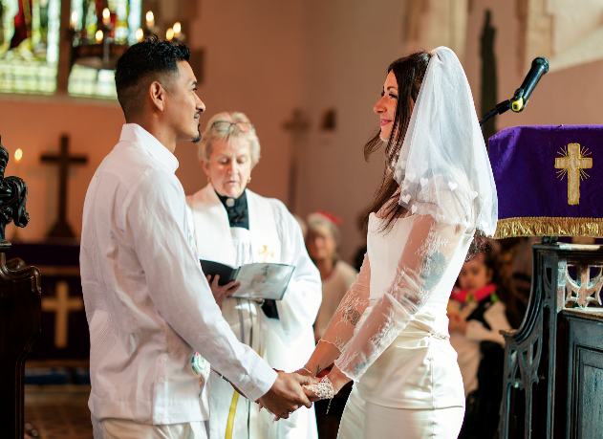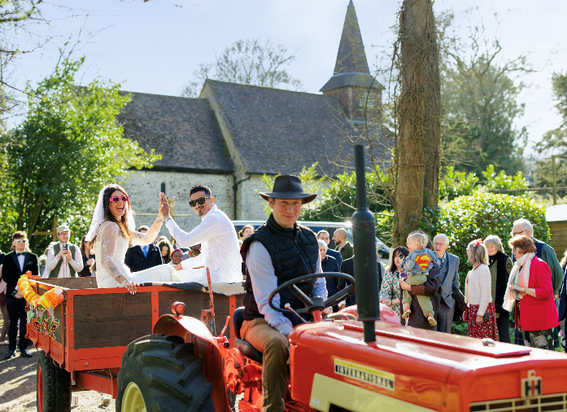

The Manchester Marathon
As most of you know our granddaughter Poppy has Rett Syndrome and she, her mother Victoria and sister Daisy are living with us. Reverse Rett is a charity that supports research into Rett Syndrome and supports families who have a child with the condition, usually girls.
On Sunday 19th April Hannah and Will took part in the Manchester Marathon to raise funds for Reverse Rett which is based in Manchester. Victoria and Daisy went along to support them. There were 51 runners for Reverse Rett and between them they raised £82,000. Hannah and Will raised £3700 and thank all those who kindly sponsored them.
We have recently gained a Planning Certificate which will enable us to have a temporary building which will be adapted to Poppy’s needs and will be large enough for Victoria and Daisy to have their own home. This good news may have been helped by the ITV Meridian News interview with Victoria and Poppy and Andy Stevenson of Reverse Rett which was shown on TV on Thursday 16th April.
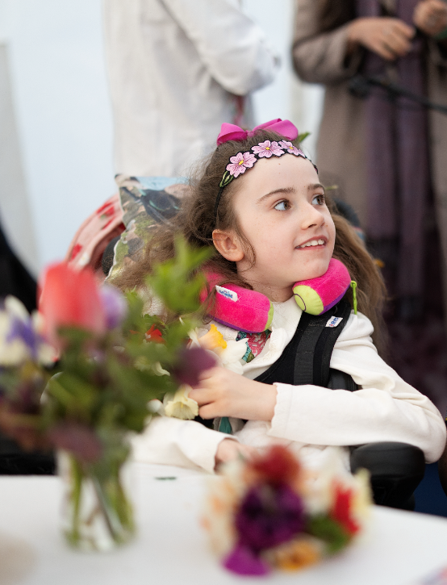
Community Open Day: Saturday 18th April 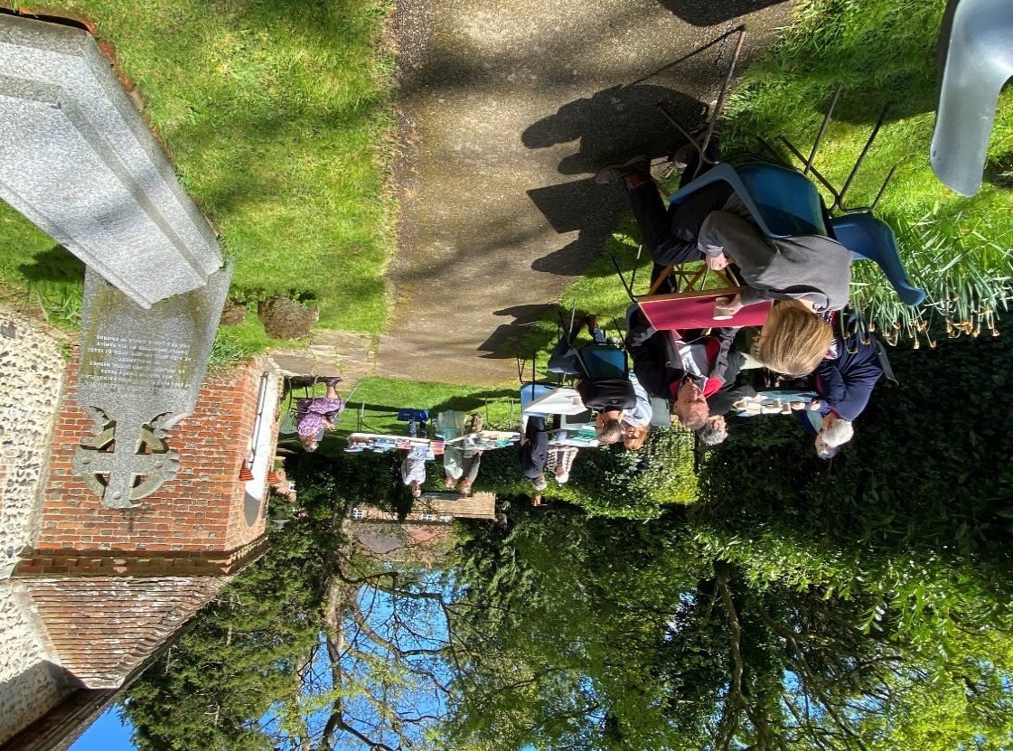
After a damp early morning we were lucky to have a fine day so that visitors could sit out in the sun to enjoy the refreshments of soup and bread, savouries, cakes and hot drinks. There were stalls including jams and chutneys, books and puzzles, and ‘the Cut Above’ to browse. The raffle for a cream tea hamper did well.
The church records were on display, and Nicky was there to discuss them. There were display boards about the history of the Acrise Young Farmers and of the recently formed Acrise Environmental Group.
The main display was a tribute to Ted Harrison who died on 3rd January 2025. Part of the display was ‘The Stations of the Cross’ which was created in Acrise Church in 2010. Ted wrote:
‘This work has been executed through Lent, and with the St Martin’s churchwardens and congregation kindly allowing me to work on the art project in the church. It is the final project of the MA in Fine Arts for which I am studying at the University of the Creative Arts in Canterbury.
The first stage in producing the images was to create the underlying colour and shapes with spray paints and charcoal, varnish and acrylic paint.
I have been painting and drawing for as long as I can remember and probably some of my earliest ‘art works’ were executed in St Martin’s Church where I attended Sunday School when my father was incumbent. I have a vague memory of an early religious picture – a man flying an aeroplane – which I explained was the flight into Egypt with Pontious the Pilot.
After a long and somewhat varied career of 40 years as a radio presenter, BBC qreligion, television producer, animator and cartoonist, I am now focussing on the art which has long interested me. I am trying out new mixes of media and styles to explore both theological and secular issues.’
Also on view were some of Ted’s art works given to us by his wife Helen recently: the Epiphany triptych, Lord of the Dance, Ghost Bishop and ‘Is this the face of Christ?’ While he was still a member of our congregation, he created the image of Saint Martin seen in the top middle of the display.
It was good to welcome Arthur Bailey and his daughter Toni to the Open Day. Now in his late nineties, Arthur grew up in Acrise and his family were an important part of church and village life. Arthur brought us a 1907 map of Acrise and a photograph of Elham from the Acrise side of the valley. This was his first competitive photo.
Thanks to everyone who contributed to the success of the event. While the main purpose is to meet old friends and acquaintances as well as new visitors, we also raise some money towards the upkeep of the church, which this year will be around £800.
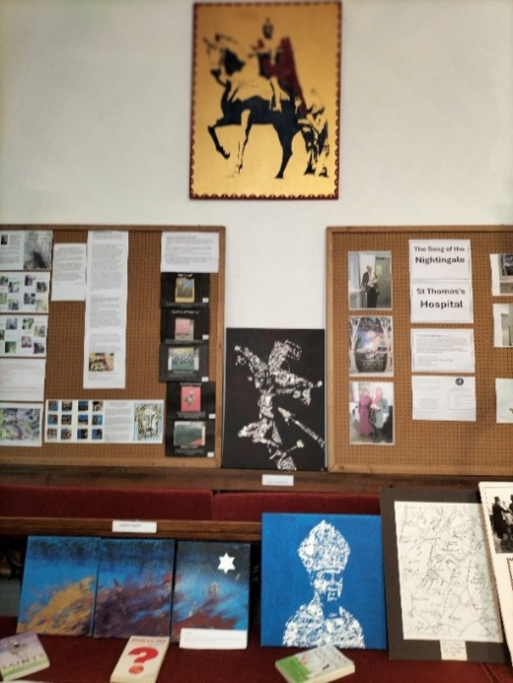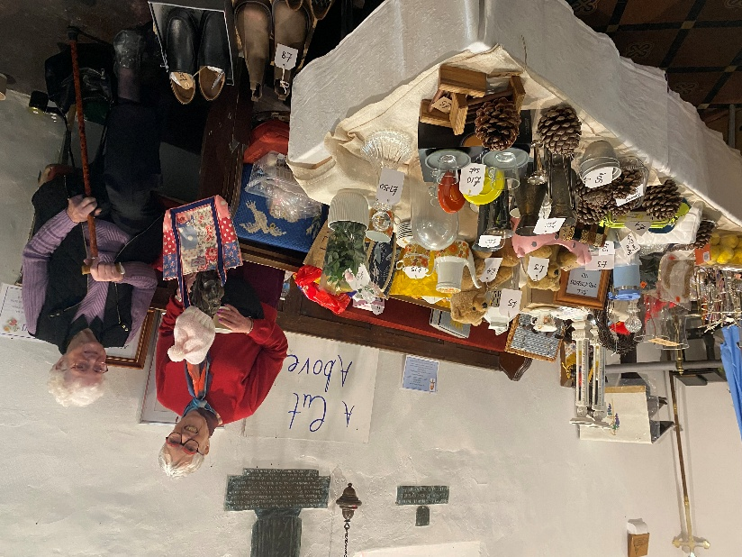

St Martin’s Church 2026 Garage Sale and Grand Raffle
Ths will be on Saturday 27th June and continues until Saturday 4th July when the Grand Raffle Draw will take place that morning.
The Garage Sales Team, led by Richard, are involved with buying and selling secondhand items throughout the year, and not just at the Garage Sale or other fundraising events.
If you have any unwanted items that could be recycled to raise money for St Martin’s please contact Richard on :
01303 893 584 or 07919393302

St Martin’s Festival Day will be on Saturday 1st August 2026
10 am – 5.00 pm. Flowers, Music, stalls, games, refreshments and much more. Put the date in your diary. Details nearer the time.
Shepway Foodbank: Folkestone Rainbow Centre
If you can support the foodbank please leave items at the back of the church or in the porch if the church is shut.
Most needed items are: white sauce, curry sauce, custard, long life milk and juice, pickles, coffee, cooking oil, noodles, mayonnaise.

