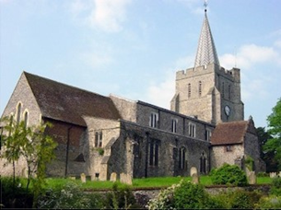
Please visit our website for information about our churches, services & events www.elhamvalleygroupofchurches.co.uk

Every Tuesday at St. Mary’s…

Traditional Morning Prayer at 8.30am in the Jesus Chapel. Download the free Church of England app or use the red book. A good way to begin the day. https://play.google.
com/store/apps/details?id=com.aimermedia.dailyprayer&pli=1


Every Monday at the Methodist Hall …
Coffee and cake, a warm welcome and friendship, 10.30am –
12pm

Churches Together in Elham Valley
Please contact -: Ruth Collie (01303 840773) for information

1st November – All Saints Day
0800 Said Holy Communion
1500 – Service of Commemoration of our Loved Ones Departed for All Souls – at Lyminge Church
Lectionary readings:
Revelation 7:9-end; Psalm 34: 1-10; John 3:1-3; Matthew 5:1-12;
8th November – 3rd Sunday before Advent/Remembrance Sunday
1040 Parade to War Memorial for 1050 Act of Remembrance, followed by Service of the Word
Lectionary readings:
Amos 5 :18-24; Psalm 70; 1 Thess 4:13- end; Matthew 25: 1-13

15th November – 2nd Sunday before Advent
0930 Eucharist
Lectionary readings:
Zephaniah 1:7,12-18; Psalm 90: 1-8,12; 1 Thess 5:1-11; Matthew 25: 14-30

22nd November – Sunday next before Advent/Christ the King
0930 Morning Service
Lectionary readings:
Ezekiel 34:11-16,20-24; Psalm 95: 1-7; Ephesians 1:15—end; Matthew 25: 31-end

29th November – 1st Sunday of Advent
1100 Sung Eucharist for Advent at Canterbury Cathedral
Lectionary readings:
Isaiah 64:1-9; Psalm 80:1-8; 1 Cor 1:3-9; Mark 13:24-end

Elham Methodist Church
(all at 9.30am unless otherwise stated)
Services for October
1st Valley United Service 1015 at Rhodes Minnis
8th War Memorial 1045
15th United Service at Rhodes Minnis
22nd Valley United Service 1015 at Lyminge
29th Café Church at St Andrew’s

Events for the December Notice sheet Please send to Margaret Keeble by 5th of each preceding month. m.keeble@outlook.com

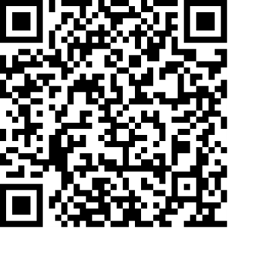
Donations
We would greatly appreciate your help to continue our work for God in the village of Elham and surrounding areas. If you can, please consider making a donation. This is our QR code for St Mary’s Elham. To donate using this code, open up the camera on a mobile phone - point the camera at the QR code – follow the instructions.
The offertory plate will go round in the service, during one of the hymns. There is also the opportunity to donate by card using the PAYAZ machine by the North door.

Safeguarding / ‘A Safe Church’:
If you ever have any concerns, contact our Parish Safeguarding Officer:
Susannah Pallot : susannahpallot@gmail.com

Paper Copies of Notices
Some copies are available on back table in church. Please take a copy to give to those unable to access the internet.

