Acrise Church News: June 2025
Services for June
Sunday 3rd June Eucharist
Sunday 10th June Matins BCP Bill
Sunday 17th June Morning Prayer CW Paul
Sunday 24th June Service of the word Bill
This month we have details about our upcoming Fundraising events, and you might like to know about our newly formed Environmental Group.

The Acrise Environmental Group
On 19th March, Stephen Scoffham held the initial meeting to see who might be interested in the Heritage Ponds project. He explained that the Kent Downs National Landscape Team have compiled details of ancient ponds across the North Downs and have identified 20 for restoration. Three of the ponds are in Acrise. The MOD, who own the land, are keen for the project to go ahead.
The first phase will be an ecological and archaeological survey. Silt at the bottom of these ponds has the potential to contain seeds dating back many centuries which will give information about farming and wildlife at the time. The second phase will be the physical work to restore the pods, most of which will be done by contractors.
There are a number of potential roles for the environmental/pond wardens. An initial suggestion is for individual members to ‘adopt’ a pond, record it over a year and post information on the website. Learning about the work of the archaeological and ecological specialists and assisting with soft landscaping once the restoration work has been undertaken, are obvious activities.
Stephen referred to the District Council’s recently launched Green Grants Scheme. He is talking with the Kent Downs team and the MOD about applying for funds from this scheme (maximum £10,000) to conduct a trial project in Acrise.

At the second meeting on 28th April Stephen reported that he had put in a bid for funds from the Green Grants Scheme. There were 59 bids and hopefully most applications will be supported. The awards would be announced at the end of June or in July.
Stephen agreed to liaise with Sally Evans of Kent Downs National Landscapes, to arrange a talk from ecology and archaeology experts on what the heritage ponds will involve. This would give the group more confidence in what they were doing. The discussion looked at the widening of the project to possibly involve children from Churchill School (or other local schools), and residents from neighbouring parishes such as Densole and Elham.
At some future stage we might like to decide whether the group would like to ‘adopt’ a pond and chronicle it through the seasons. The group could also consider other aspects of the local environment, such as wildflowers and heritage trees.
Diane agreed to find out about hiring Hawkinge Village Hall as we might need a larger venue for a future talk/meeting. Mike agreed to write about the project for the Acrise Newsletter.
We will let you know when the next meeting is, either when we hear whether our grant application has been successful and then how the project is progressing.
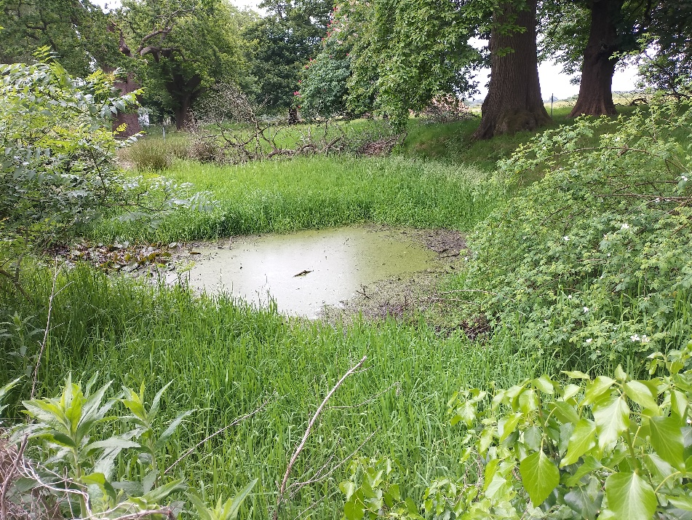 Pond1 White Lodge
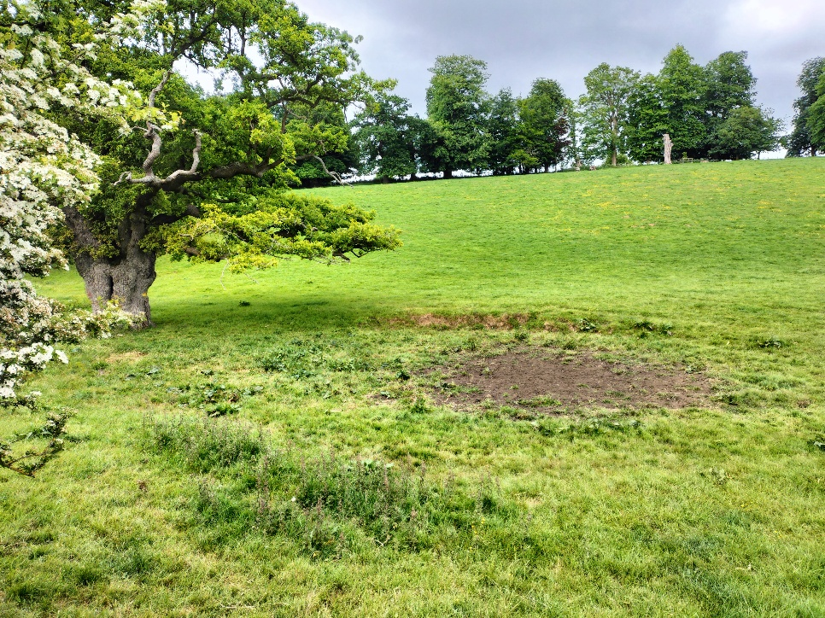 Pond 2 Ice House Hill
The third Acrise pond is just off the road in the field opposite Pillars Wood, 200 yards beyond the Winterage crossroad

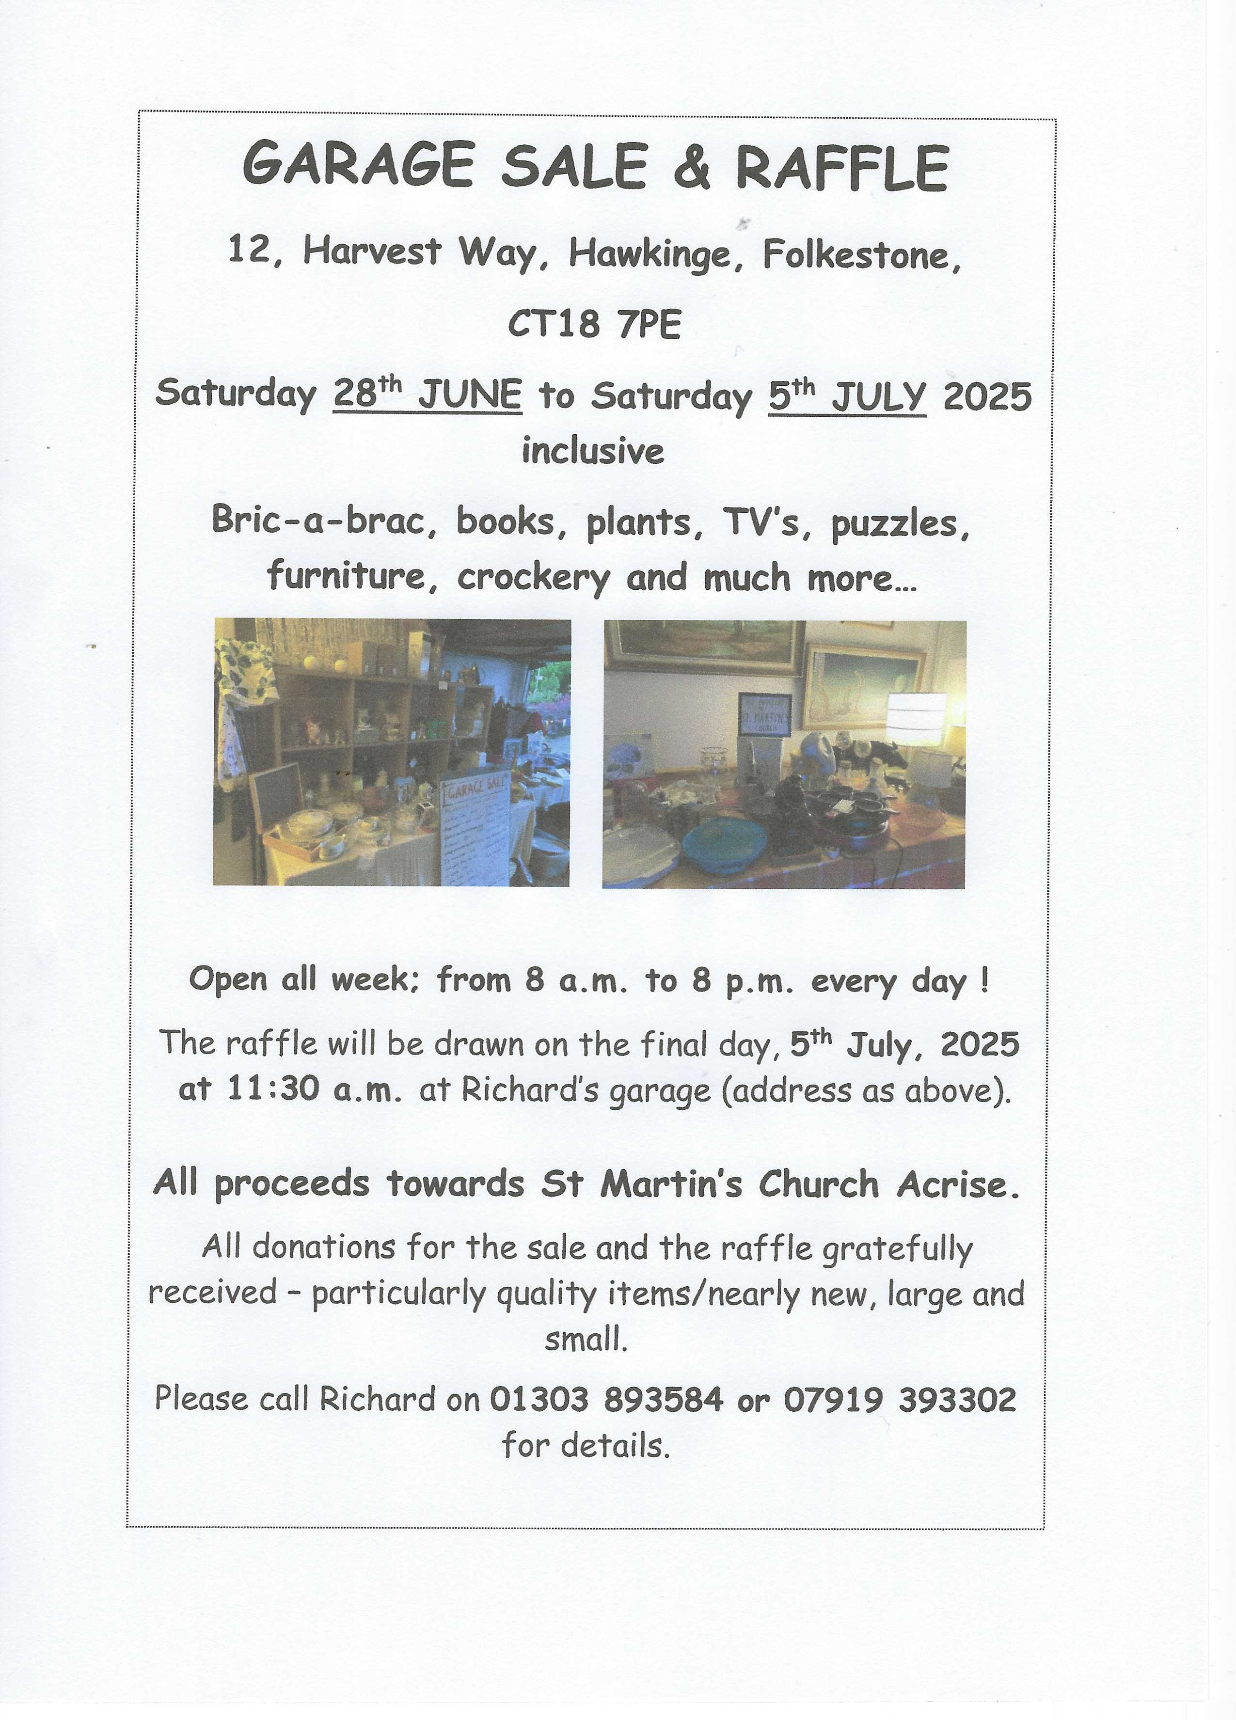
Acrise Festival
Of Flowers and Music
Saturday 2nd August 10.00am – 5.00pm
Flowers in the church and music on the green. Church records will be displayed. There will be a variety of stalls, raffle, tombola, children’s games, and pony rides.
Refreshments, including ploughmen’s lunches, will be available.
Volunteers
On Monday 28th July from 10.00am we will be spring cleaning the church and tidying the paths, graveyard and parking area. We would be grateful for any volunteers to help on that day.
On Friday 1st August the church will be decorated with flowers and the site prepared for 2nd August. Any volunteers who can give some help over those two days will be welcome.
Donations
We would also be grateful for donations of cakes, biscuits and savouries; raffle and tombola prizes, good quality bric a brac; books/puzzles, any home grown produce for the produce stall.
If anyone could donate foliage or flowers from their gardens and leave them at the church on the morning of 1st August, we would be grateful.
Contact
Please contact Sue on 01303844640 (sue1954prebble@gmail.com) if you could volunteer on 28th July or on the day, or could make a donation for the 2nd August.
Jean Grieb has already started collecting tombola prizes so give them to her. She can be contacted on 01303892364.

Shepway Foodbank
We will soon be taking our donation of food and toiletries to the local collection point. If you can support the foodbank, please leave items at the back of the church or in the porch if the church is locked. Thank you.
Most urgently needed items are Gluten Free Foods, White Cooking Sauce, Tinned Meat, Mashed Potatoes, Washing Pods, Toilet rolls.
Other items often needed are tinned fruit, tinned vegetables, long life milk, jam, biscuits/chocolate, long life juice.

Rogation Sunday 25th May
We had a relevant, interesting and enjoyable service for Rogation Sunday organised and led by Janet B-W. It comprised readings, hymns and prayers related to the gifts of the natural world given to us by God. Thanks to Janet and also to Sue who played appropriate hymns: Morning Has Broken, For the Beauty of the Earth, For the Fruits of His Creation, and Go Out With Joy.
The service reminded us of the way in which we should appreciate and use God’s gifts, as well as how we should treat one another. We were certainly thankful for the rain in the last few days to help the crops grow after a long dry period.
As part of the service, we were given information about the origin of Rogation and the custom of beating the parish bounds. (There is a small display in the church). We had coffee and then a group of us set off to walk a section of our northern boundary and marked a number of trees in the Ladwood Farm, Winterdown and Blandred Farm area, before finishing at Reast Lane Gate for lunch.
Despite overnight rain we had warm weather and were able to appreciate the beauty of the countryside in our parish. We were also able to sit outside and enjoy an excellent lunch provided by Joan with help from Victoria and Sue. If possible, we will beat the bounds of the southern part of the parish in the autumn.

