Acrise Church News for December 2025
Services for December (all at 9.30am)
Sunday 7th December Holy Communion Sharon
Sunday 14th December Family Carol Service Diana
Sunday 21st December Lessons and Carols Bill
Thursday 25th December Christmas Morning Service Janet
Sunday 28th December Service of the Word Janet
Carol Singing on Monday 15th December
Meet at the crossroads of Coach and School Road. We will start at White Gates and finish at J`erry and Laura’s home in Coach Road. The collection will be for the Royal National Lifeboat institute.

The Rector’s Message
We come to the darkest time of the year, a month with the shortest day, and then mornings get still darker. Short days, cold nights, little light can all lead us to feeling we have nothing to look forward to.
Christmas speaks to us of hope - the light that shines in the darkness - the baby in the manger showing us that God loves us and is with us even in the darkest of times.
However you may find yourself this Christmas, know that you are loved and share that love with everyone you meet – and laugh as much as you can. Laughter, as the saying goes, is the best medicine!
May God who has called us out of darkness into his marvellous light, bless us and fill us with peace. Amen
The Acrise Church Christmas Fair
(Held in Elham Village Hall)
We will be setting up the hall on Friday 28th December from 3.30pm and welcome anyone who can help. If anyone still has tombola prizes please give them to Jean.
Any raffle prizes can be brought to the hall on the morning and donations of cakes and savories would also be welcome.

Come and enjoy the seasonal atmosphere of this traditional event
St John’s Commandery: Time line and Tenant’s
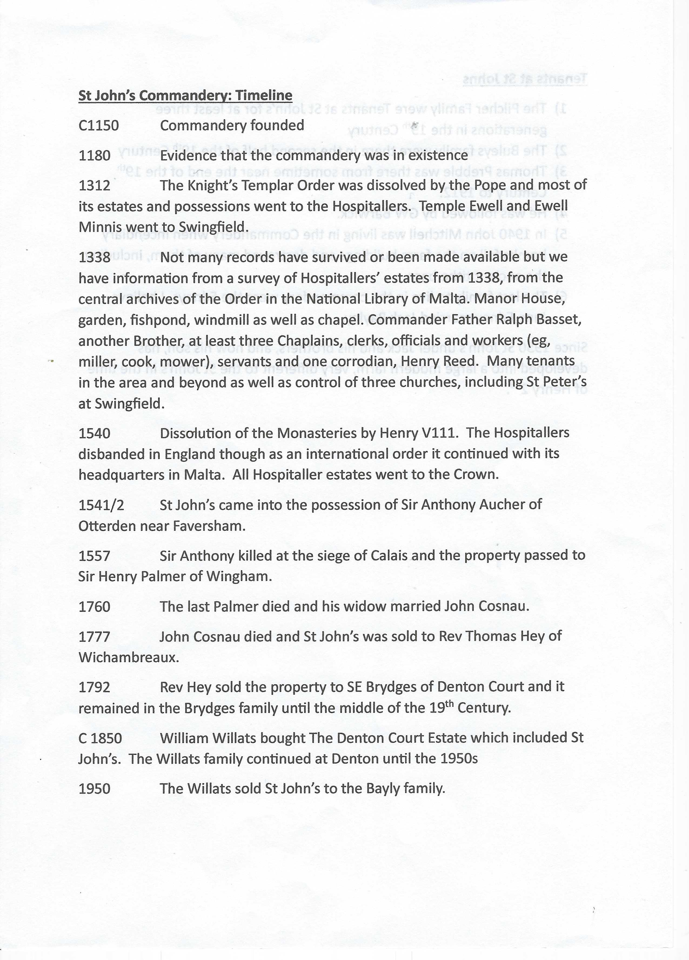
Tenants at St John’s
- The Pilcher Family were tenants at St John’s for at least three generations from the latter years of the 18th Century to the middle of the 19th Century.

- The Buleys Family were there in the second half of the19th Century.

- Thomas Prebble was there from sometime near the end of the 19th Century until 1912.

- He was followed by GW Barwick.

- In 1940 John Mitchell was living in the Commandery when incendiary bombs fell on the farm buildings and destroyed many of them, including the ancient tithe barn.

- As far as we know, the last family to live in the Commanderv were the Edneys, June Edney married Jack Bayly.

Since 1950 St John’s under Jack and his brothers, and now his son, has developed into a large modern farm, very different to the St John’s in the time of Henry 2nd.
The Commandery was open for a few weeks in September which was a great success, with many visitors. If you wish to visit please ring Ryan on 07590753394.
Early 20th Century photo - Note the staircase to the second floor of the building which was where itinerant farm workers lived. The well and water carrier can also be seen.

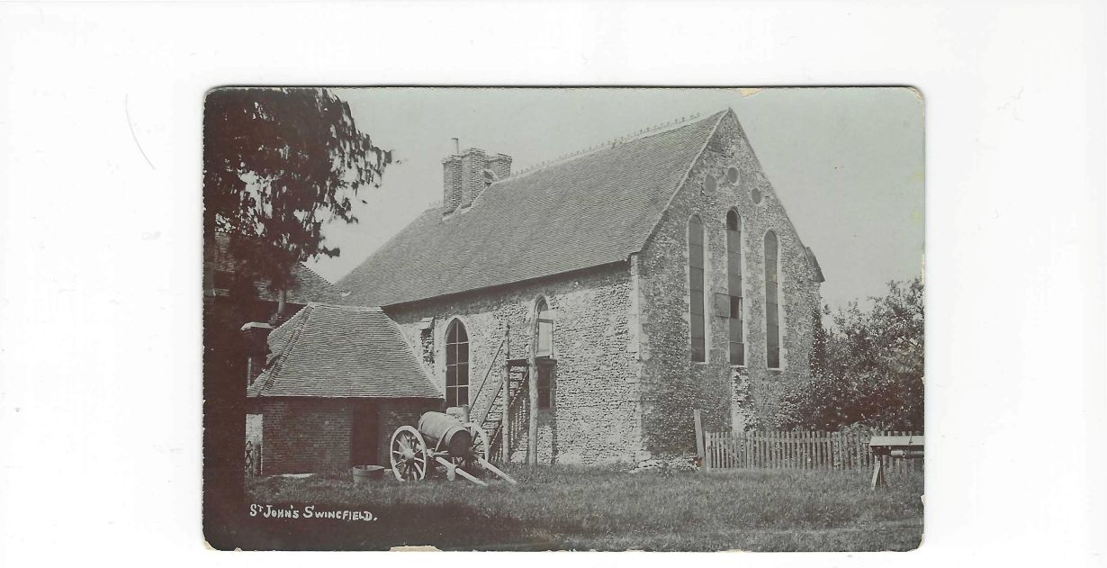
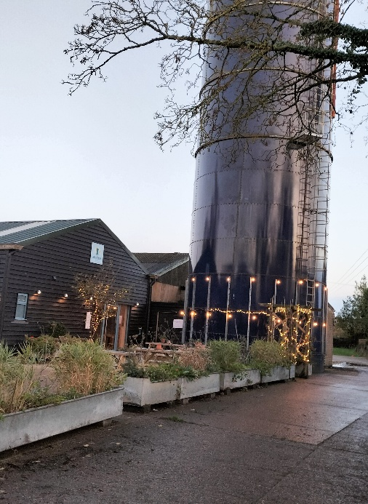
Blandred Farm: The Blue Silo Some of you may know that we now have a micropub in Acrise run by Adrian and Kim Gower and family at Blandred Farm. This may be the first ever pub in the parish of Acrise as there is no memory or any record of one in the village. The Blue Silo is open on Fridays from 4 until 10.30pm, Saturdays 12 midday until 10.30pm and Sundays midday until 6pm. Since opening in the summer the micropub has become a popular meeting place for people from the local community and from further afield. There has already been a Vintage Tractor Day on Sunday 2nd November with 31 tractors taking part, and many people from the farming community, and others, meeting up and having a good time. Thanks to Adrian, Kim and family for their energy and hard work in providing such an asset set in our beautiful rural surroundings.
On Friday 5th December there is a Christmas Fair in the large barn with over 25 stalls offering a range of festive goods for sale. The event starts at 4.00pm.
The Folkestone Tractor Run which took place for the first time last year was a great success. This year it will start from Blandred Farm and will leave at 4.45pm on Saturday 20th December and follow a route to the Harbour Arm via Densole, Hawkinge and Capel, arriving there around 7pm.(see map).
The event, organised by Henry Burrows and other local farmers, raises money for a Folkestone charity called Touchbase Care. This is a community day care centre located in the Creative Quarter which supports adults and young people with physical disabilities, learning difficulties, neurodiversity and sensory impairment. It aims to improve wellbeing and develop skills by providing a programme of creative, active and therapeutic activities.
The entry fee is £20 per tractor with a limit of 50 tractors. This is being organised by Andy Harmer and the entry money will go to Kent Surrey and Sussex Air Ambulance.
Collecting buckets for donations to the Touchbase charity will be found at The Black Horse pub at Densole, the Mayfly and White Horse pubs in Hawkinge, the New Dover Road and the Royal Oak in Capel, and the Black Bull and Harbour Arm in Folkestone. Last year £4,706 was raised for Touchbase.

.

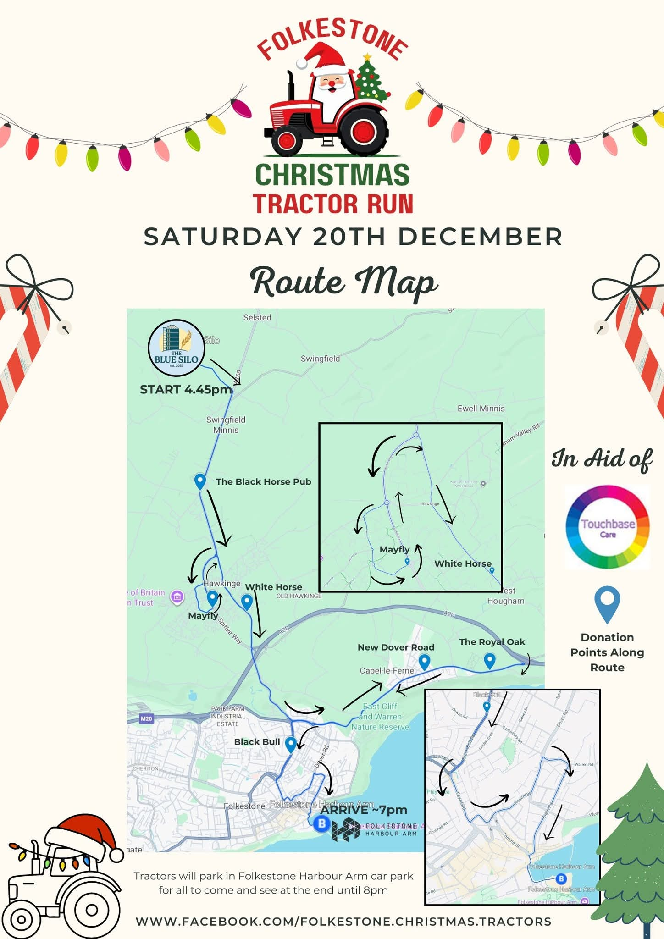
The Acrise Environmental Group News (From Stephen Scoffham)
It’s a long time since I have been in touch but I am pleased to say the ponds project is finally beginning to get going. The first event will be a volunteer working group in January/February. This will involve cutting back some (but not all) of the brambles around the ponds and creating piles of dead wood nearby to provide additional cover/refuge for amphibians and invertebrates. It is envisaged this might take around half a day. The details of access to the land still have to be finalised with the MOD. I will be at a meeting in early December when this can be discussed.
I am hopeful that the working group event can then be followed with a talk about the ecology and wildlife of the ponds in March/April. Again, the details have yet to be confirmed. However, once the group gets going, I am sure we will all have lots of ideas for projects for our area. The link to the Norfolk ghost ponds project gives an idea of what might be possible.
https://www.fba.org.uk/fba-voice/ghost-pond-resurrection-the-most-successful-ecological-restoration-ever-known
I’ll be in contact again in early January with a further update.
(If you would like to be put on the mailing list for this group then please let me know – Mike)
Shepway Foodbank; Folkestone Rainbow Centre
We made a great effort to donate to the foodbank over the Harvest Festival period. Many thanks to those who gave so generously. Over 90% of food distributed is donated by the public.
As we approach Christmas it would be good to help those who are living in poverty and have insufficient food. There are containers at the back of the church or in the porch for donations.
Most needed are: white cooking sauce, curry sauce, custard, drinking squash, long life milk and juice, pickles, coffee (large and small), cooking oil, noodles, mayonnaise.
Running low are: tinned fruit, puddings (long life), gluten free foods, honey, marmalade, chocolate spread, chocolate/snacks/crisps/, tinned fish (not tuna), pesto, pasta in sauce (packets), cereal (not porridge), razors, toilet rolls, washing up liquid, deodorant.
AGM of the Ride and Stride: 24th November at Charing Heath
This year was the 75th anniversary of the Friends of Kent Churches and the 40th anniversary of the Ride and Stride event. Acrise has contributed in each of those 40 years. This year the total raised will be around £130,000 which is a great effort considering the wet weather, Half the amount raised by each church is given back to
The committee of Ride and Stride are grateful to everyone who took part in this year’s event whether walking or cycling or welcoming people and providing refreshments in their church.
This was the first time we had been to a meeting of Ride and Stride as Sue is now local organiser for the Benefice. It was well organised and all roles were filled by competent and enthusiastic people.
Let’s hope for better weather next year.

