Acrise Church News for January 2026
Services for January
Sunday 4th January Holy Communion Stephen
Sunday 11th January Matins BCP Paul
Sunday 18th January Morning Prayer CW Diana
Sunday 25th January Family Christingle Service Janet


The Rector’s wonderings ….
I wonder if you had any surprises last year?
The beginning of a New Year is often a time when we look over the past year, take stock and consider how we might make some improvement to our lives. New Year’s resolutions have become very popular.
For Christians it’s a time for us to consider our gifts and talents, and what we can give to God and the church in terms of our service.
We are asked to think about our vocation (calling) like the magi, are you being called to something new?
There were a record number of baptisms in some benefice churches last year, including 3 adult baptisms - these were lovely surprises to all those concerned.
Encountering Jesus in the waters of our baptism, we are called to be children of God. It’s something which doesn’t leave us, no matter what happens to us in life.
You are never too old to come to Christ, please get in touch with your local church or priest if you want to explore your journey further. I would love to baptise even more adults this year!
Whether we would call ourselves Christians or not, the prayer of St Teresa of Avila ( 1515- 1582) reminds us of our calling;
Christ has no body but yours,
No hands, no feet on earth but yours,
Yours are the eyes with which he looks
Compassion on this world,
Yours are the feet with which he walks to do good,
Yours are the hands, with which he blesses all the world.
Yours are the hands, yours are the feet,
Yours are the eyes, you are his body.
Christ has no body now but yours,
No hands, no feet on earth but yours,
Yours are the eyes with which he looks
compassion on this world.
Christ has no body now on earth but yours. Revd Carol

Acrise Church Christmas Fair on Saturday 29th November
Fortunately, the heavy rain which covered most of the country didn’t fall until around 12.30 and was quite short lived, so preparations for the Fair were not affected. Elham Village Hall was transformed into a Christmas market selling a variety of Christmas decorations and gifts, such as arts and crafts, knitted toys, preserves, cakes and much more. Homemade refreshments were available and the Peggy Pike Room was used as a café where people could meet up and chat while having a break. Father Christmas made his usual appearance in his grotto and also did a tour of the stalls. As well as the stalls there were the tombola and raffle both of which did well.
Thanks to all who helped with the fair which included preparations on the afternoon and evening before and clearing up afterwards; it is amazing how everything is cleared up so quickly. This event is an example of what can be achieved by working together to create a festive and friendly atmosphere.
Thanks to the stallholders for bringing their goods and all our visitors who gave their support. The total raised for church funds was £1,700 which was an excellent outcome.
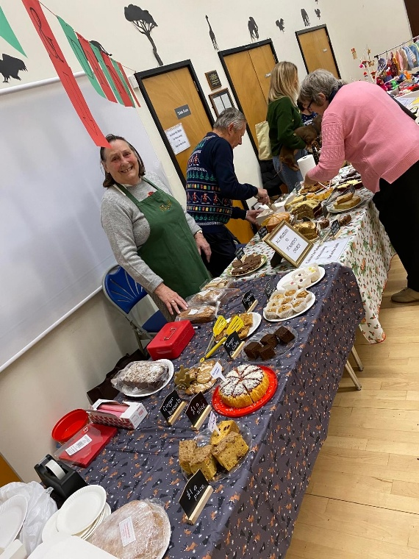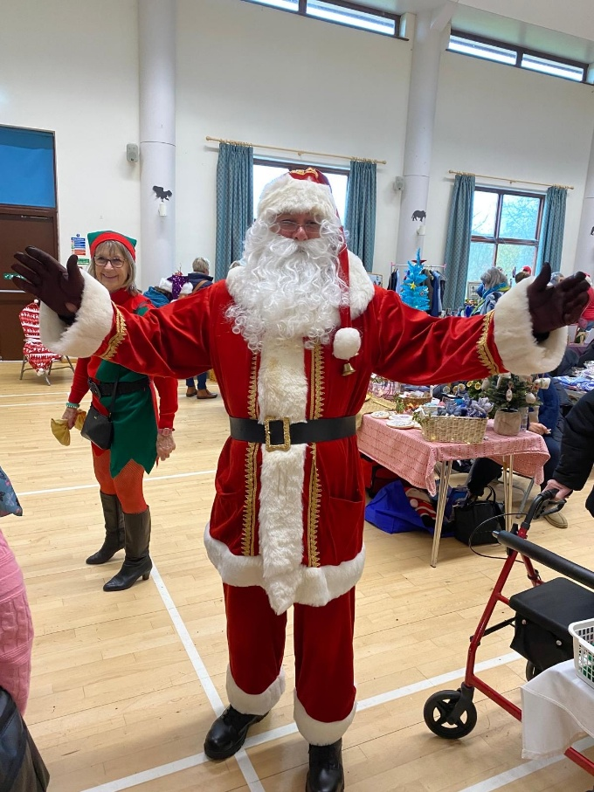

Family Carol Service: Sunday 14th December
This was held on Sunday 14th December and was attended by 31 adults and 12 children. Diana led the service and we were pleased to welcome some of her family members. In her introduction she spoke about us all having reasons to be thankful and that sometimes children need to remind adults of this when they become overburdened with life’s problems. Joan then explained the activity to the children which was making angels. As these were completed the children hung them on a small white tree (see photo) which will be on display over the Christmas period.
The readings told the story of the Nativity and were interspersed with traditional carols, ending with ‘O Come all ye Faithful’. The children’s prayers focused on the image of light shining in dark places where there is conflict, where people are ill or sad, or anxious and lonely, and how we can bring light into the world by helping others and considering their needs before our own.
Thanks to everyone who read, including the children who now read so confidently. Thanks to Diana for leading the service, to Irene for playing the organ and to the refreshment team. It was an enjoyable occasion which reflected the Christmas values of peace and goodwill to others. At the end the children lined up to take their turn to ring the church bell.
Our next family service will be Christingle on Sunday 25th January at 9.30am

Children’s Prayers The Angel Tree
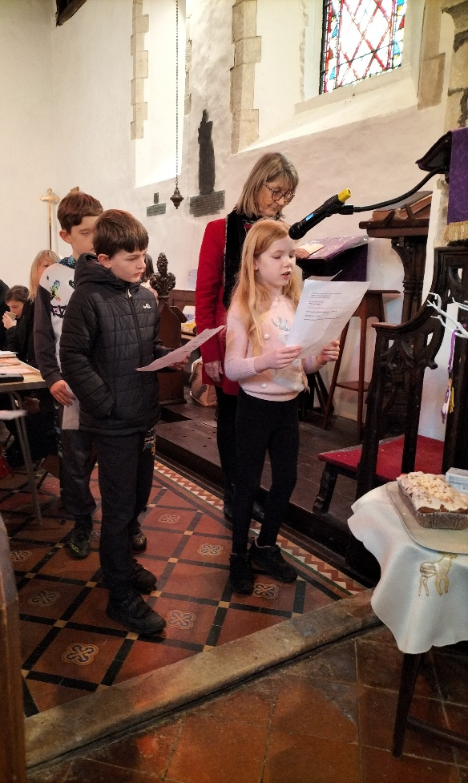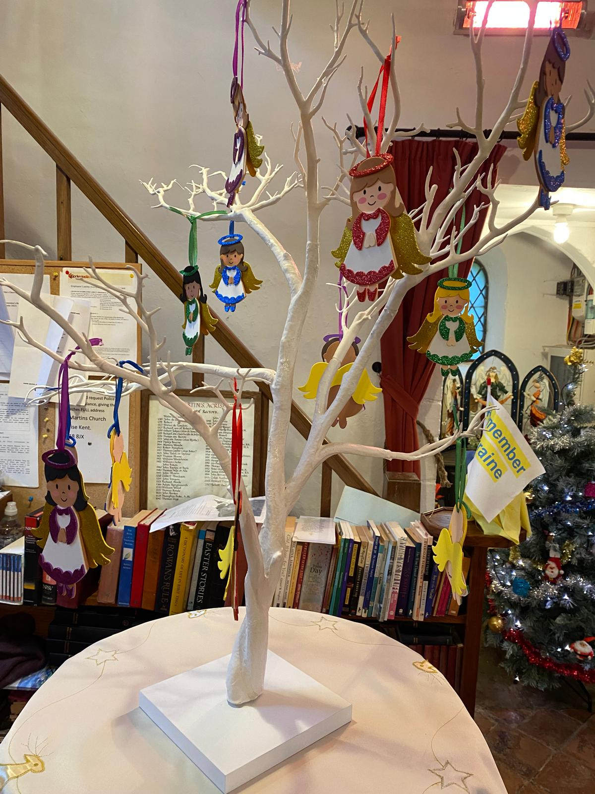
Carol Singing: Monday 15th December
A small band of seven intrepid carol singers met at the crossroads of School Road and Coach Road soon after 7.00pm before beginning carol singing round the village. The first stop was at White Gates at the invitation of Robert and Linda Stewart where we joined them, their family and guests to sing carols (as well as ‘Rudolf the Red Nosed Reindeer’ and ‘Jingle Bells’ for the children), around the outdoor fire. We then moved indoors for more carols and a drink, eventually finishing with ’O Come all ye Faithful’ and ‘We All Want Some Figgy Pudding’. The rousing singing added to the festive atmosphere and was much enjoyed.
We then went along School Road and then back to Coach Road singing at many houses before we were given refreshments at Liz and Kelvin’s home, for which we thank them. Our final stop was at Jerry and Laura’s home where we sang carols and were treated to drinks and festive food. Here we were joined by Hannah from Mexico via facetime. Many thanks to Laura and Gerry for their hospitality.
Over the evening we collected £320 for the Royal National Lifeboat, thanks to the generosity of local people.
Traditional Carol Service: Sunday 21st December
Thanks to Bill for leading our traditional carol service. We began with the Advent carol ’O Come O Come Emmanuel’ and the lighting of the 4th Advent candle. There followed the story of the Nativity through six scripture readings and seven popular carols. During the service members of the congregation brought up characters and animals of the Nativity and placed them around the crib and stable. Thanks to our readers and to Irene for the music. It was an enjoyable service which reminded us of the true meaning of Christmas.
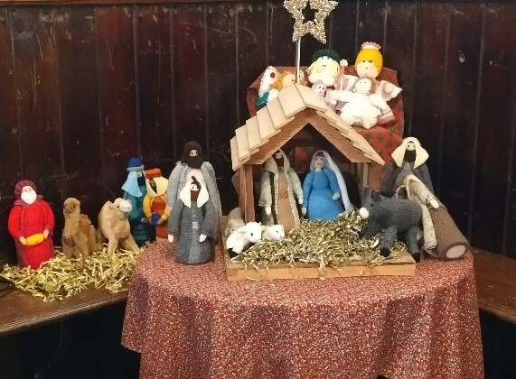
The Folkestone Tractor Run
The first Tractor Run on 21st December 2024 was a great success: Henry Burrows, one of the main organisers, said that they would be back again in 2025 with a bigger and better event. How right he was.
This year 60 tractors took part as opposed to 40 last year. The route was changed , with the starting point being Blandred Farm, Acrise, the home of the Blue Silo micro-pub. Soon after 4.50 pm the colourfully lit and brightly decorated tractors set out on the route up Reece Lane to the A260 then through Densole,and Hawkinge before turning left to Capel at the roundabout into Folkestone. It was then back to Folkestone, down Caterbury Road to the Black Bull pub and then left through the skew arches before going down Tram Road to the Harbour Arm where more space for tractor parking was provided this year.
The Tractor Run was very popular in 2024 and with good advertising for the 2025 event many more people turned out to support it. The roads were lined with people through the villages and along the route through Folkestone, while the Harbour Arm was more crowded than on a fine summer day. There was an air of excitement and expectancy as 7.00pm approached. At first the sound of tractor horns and musical jingles could be heard in the distance before the escort vehicle appeared to loud cheers and the tractors made their way past the Hotel Burstin and into the Harbour Arm parking area. It took some time to get the tractors neatly parked up, then when all engines were switched off the public were allowed to walk round and see the tractors close up.
It was good to see this local community event enjoyed and supported by so many people. It raises money for Touchbase, a Folkestone Charity which is located in the Creative Quarter and supports adults and young people with physical disabilities, learning difficulties, neurodiversity and sensory impairment. Touchbase aims to improve well-being by developing a programme of creative, physical and therapeutic activities. Last year around £4500 was raised which is likely to be exceeded this year.
The event was a credit to the local farming community; those of us living locally and with connections to farming are proud of such an achievement. 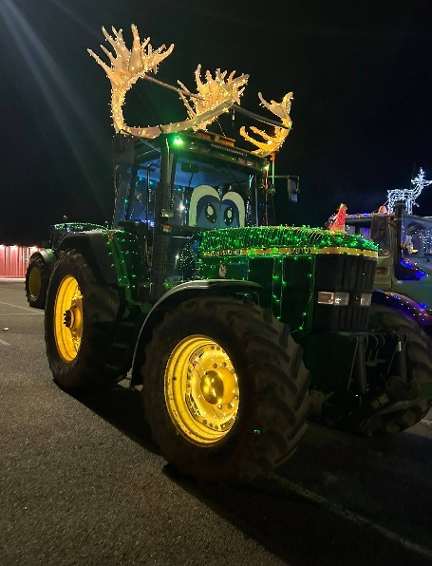 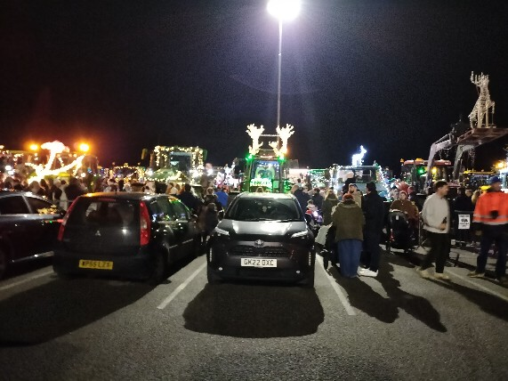
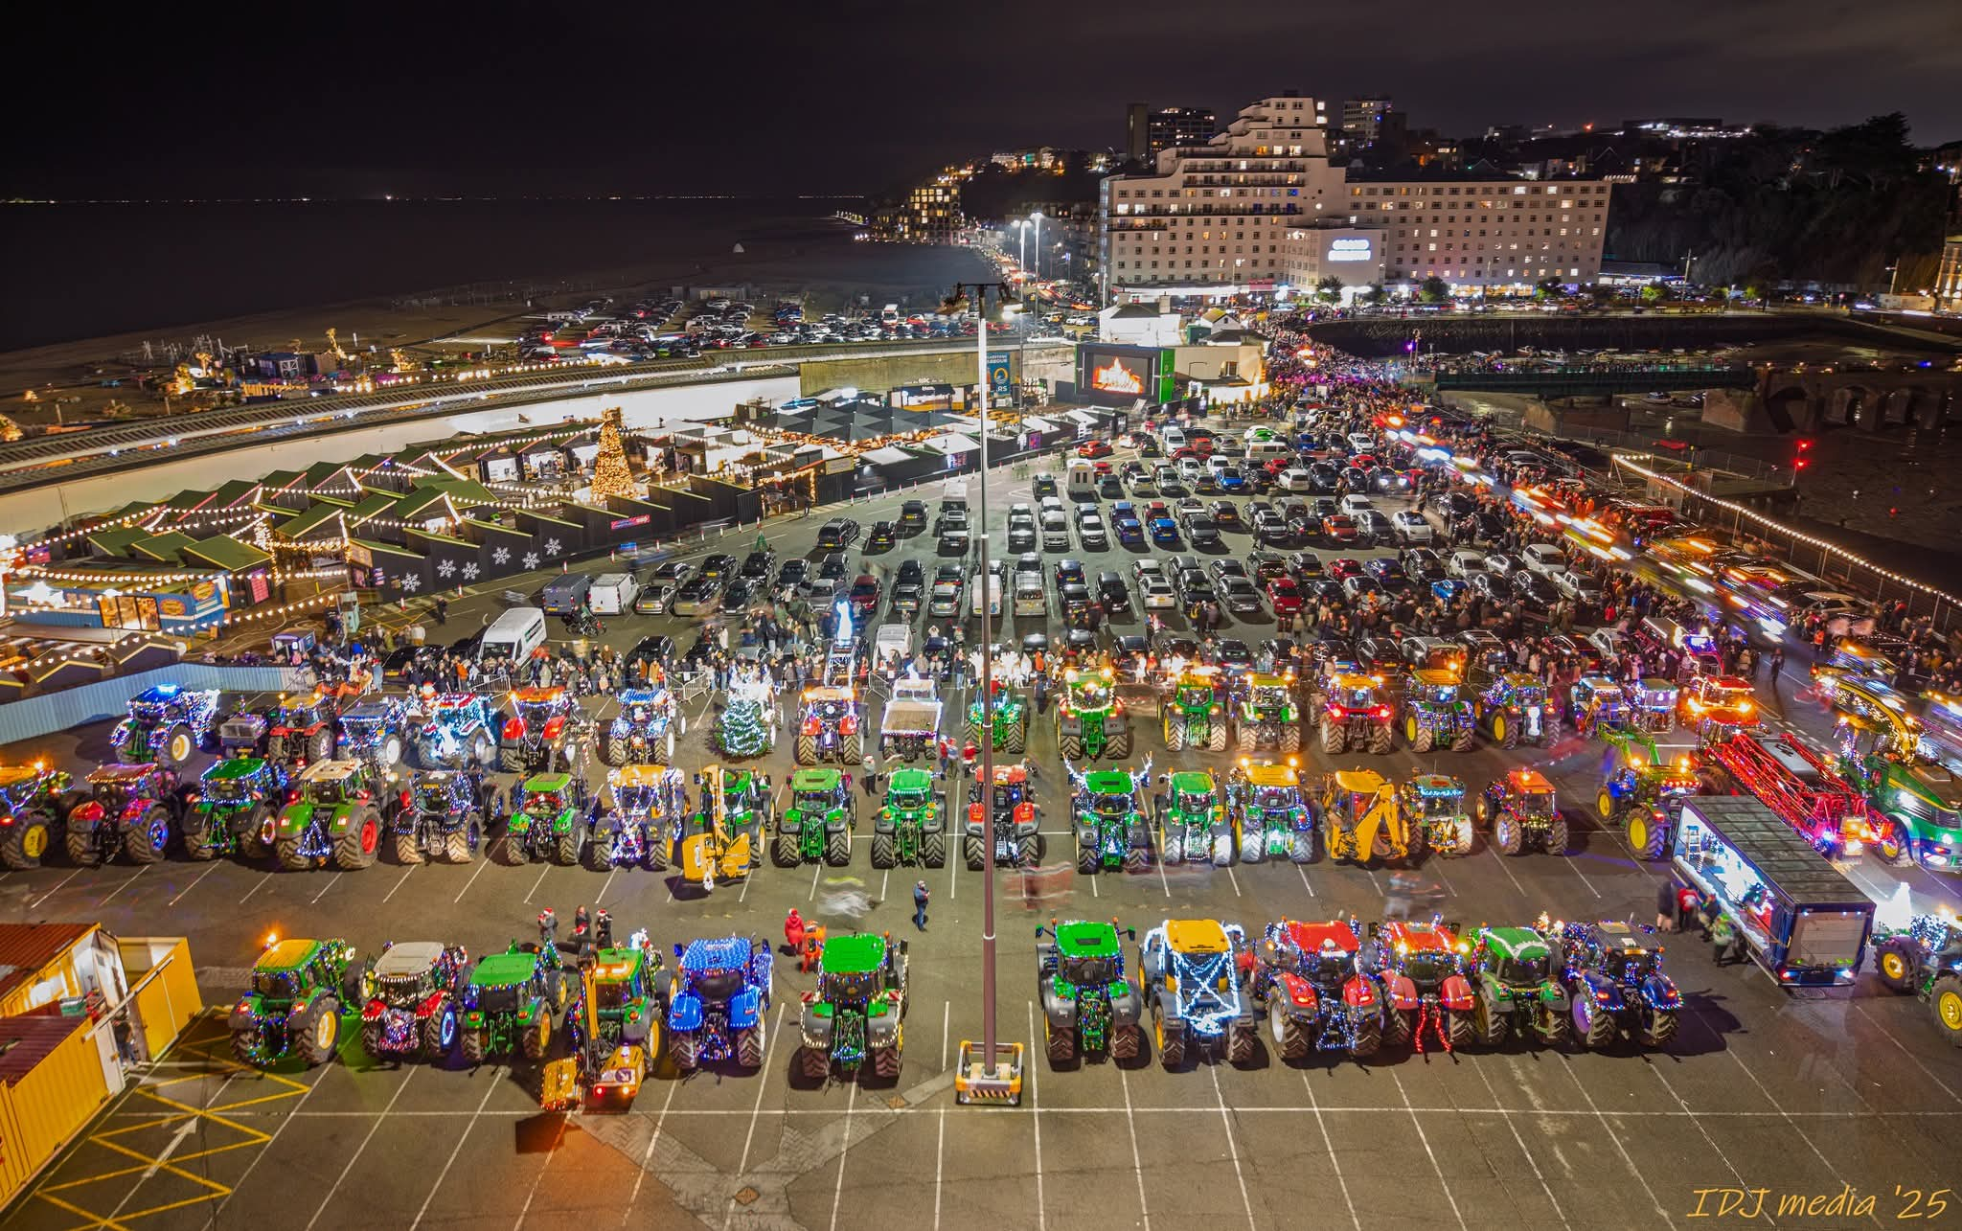

Shepway Foodbank: Folkestone Rainbow Centre
Please support the foodbank this winter if you can by leaving items in the porch or at the back of the church when it is open.
Most needed items are: white cooking sauce, curry sauce, custard, drinking squash, long life milk and juice, pickles, coffee, cooking oil, noodles, mayonnaise.
Running low are: tinned fruit, puddings (long life), gluten free foods, honey, marmalade, chocolate spread, chocolate/snacks/crisps, tinned fish (not tuna), pesto, pasta in sauce (packets), cereal, razors, toilet rolls, washing up liquid, deodorant.

Christmas Day Service
On a cold but bright morning the church was full and resonated with Christmas cheer and goodwill with 62 people attending at this most significant time.
Thanks to Janet for preparing and leading us in a Service of the Word for Christmas Day and to Irene for playing the organ. Everyone enjoyed this service of carols, readings, poems and prayers which conveyed the story and message of the nativity.

