Nehemiah Project

Ministry Innovation Grant for Seminary Students and pastors

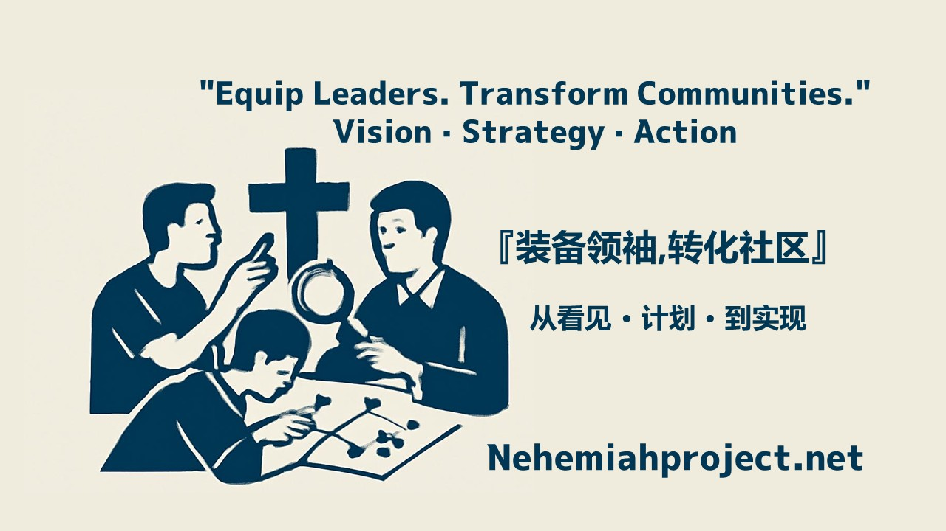

Program Overview
Vision: Empower future ministry leaders to experiment with innovative approaches to sharing the Gospel and serving communities.
Grant Amount: $500 USD per recipient
Duration: 6 -12 months or, TBD
Number of Recipients: TBD per cycle

Eligibility

Basic Requirements
- Currently enrolled at our Cooperative Program
- Completed at least one year of theological education
- Good academic standing
- Recommended by the Principal or Denominational Leader

Ministry Requirements
- Proposed ministry should be innovative or experimental
- Clear Gospel focus
- Addresses a real community need
- Applicant must be the primary leader (team allowed)
- Feasible to implement and evaluate within 6 months

What Qualifies as "Innovative"?

Examples of Eligible Ministries:
Digital & Technology
- Faith-based apps or online platforms
- Podcasts/YouTube for specific audiences
- Online discipleship tools
Community Transformation
- Creative outreach to marginalized groups
- Community cafes/spaces with Gospel integration
- Environmental stewardship + faith
- Workplace ministry innovations
Cross-Cultural & Generational
- Gen-Z specific worship/fellowship models
- Cross-cultural bridge ministries
- Special needs faith formation

Not Eligible:
- Replication of existing programs
- Minor tweaks to traditional ministry
- Social service without clear Gospel element
- Projects where applicant is not the primary leader

Application Process

Stage 1: Vision Sharing (Letter of Intent - 1,000 words)
Deadline: [Date]
Submit:
- Personal introduction & calling (300 words)
- Ministry concept (500 words)
- Why is this innovative? (200 words)
- Preliminary budget

Full Proposal

Required Sections:
- Vision & Mission What change do you want to see?
- Needs Assessment
  - Who are you serving?
  - What are their needs?
  - What's the current gap?
  - How do you know? (research/interviews)
- Ministry Strategy
  - What will you do?
  - How will you do it?
  - 6-month timeline
  - Required resources
  - Potential partners
- Innovation Element
  - What makes this different?
  - Why might this be more effective?
- Impact Evaluation
  - How will you measure success?
  - Expected reach
  - Feedback collection methods
- Sustainability How will this continue after 6 months?
  - Is it replicable by you or someone else?
  - Future funding sources?
- Detailed Budget (1 page)

Selection Criteria (100 points total)
Criteria | Points | Focus
Innovation | 25 | Truly creative? Unique insight?
Need | 20 | Addresses real need? Well-researched?
Feasibility | 20 | Achievable in 6 months? Realistic?
Impact | 15 | Expected reach and depth?
Spiritual Depth | 10 | Gospel-centered? Theological foundation?
Capacity | 10 | Applicant capable? Past experience?

6-Month Implementation Timeline

Month 1: Launch Phase
Tasks:
- Attend an online one-hour kickoff workshop hosted by Dr. Jeff Lee
- Finalize detailed plan
- Build team (if needed)
- Acquire resources
Deliverable: Revised execution plan

Months 2-3: Pilot Phase
Tasks:
- Begin ministry execution
- Small-scale testing
- Collect initial feedback
- Adjust strategy
Deliverables:
- Monthly progress reports
- First mentor meeting (if applicable)

Months 4-5: Expansion Phase
Tasks:
- Full implementation
- Ongoing evaluation
- Document stories/testimonies
Deliverables:
- Mid-term report (end of Month 3)
- Video/photo documentation
- Second mentor meeting (if applicable)

Month 6: Conclusion Phase
Tasks:
- Complete ministry goals
- Comprehensive evaluation
- Write final report
- Plan future direction
- Prepare presentation
Deliverables:
- Final report
- Financial report
- Final video presentation

Support Structure

Mentorship
We strongly encourage each recipient to be paired with an experienced ministry mentor for:
- Guidance and encouragement
- Accountability and support

Accountability Requirements
WhatsApp Group Communication:
- All participants join a WhatsApp group with donors
- Share monthly progress updates
Video Documentation (5 minutes each):
- Introduction Video (Month 1)
  - Introduce yourself and your team
  - Show the people and place of your project
  - Share your vision
- Mid-Point Video (Month 3)
  - Progress update
  - Challenges and adjustments
  - Initial testimonies
Final Video (Month 6)
- Must include:
  - Executive summary of the project
  - Ministry review
  - Results evaluation (quantitative & qualitative)
  - Spiritual reflections
  - Lessons learned & recommendations
  - Future outlook
  - Financial summary

Financial Management

Disbursement
- 50% upon approval
- 30% after mid-term report approval
- 20% after final report approval

Allowed Expenses
✓ Ministry activity costs
✓ Necessary equipment/materials
✓ Venue rental
✓ Marketing & promotion
✓ Transportation
✓ Reasonable meals (ministry-related)

Not Allowed
✗ Personal living expenses, self-compensation, or tuition
✗ Luxury items
✗ Non-ministry related expenses
✗ Personal gifts

Requirements
- Keep all receipts
- Submit final expense report
- Return unused funds or redirect/expand with approval

FAQ
Q: Can I apply with other students?
A: Yes, but designate one primary leader who receives and manages the grant.
Q: What if my ministry "fails"?
A: We encourage risk-taking. Failure is part of learning. Honest documentation and reflection = success.
Q: Can I use funds for salary?
A: No. This is for ministry, not personal support. But reasonable ministry-related expenses are allowed.
Q: My ministry needs more than 6 months to show results. Can I still apply?
A: Yes, but explain achievable 6-month milestones and how you'll evaluate initial impact.
Q: Do I need church support?
A: Yes. Principal's recommendation is required. Ministry should connect to your church context (but doesn't have to happen inside the church building).

Contact Information
Program Director: Principal
Email: [email]
Phone: [phone]

Closing Statement
We look forward to seeing how God will use your creativity and courage to do new things in this generation.
"See, I am doing a new thing! Now it springs up; do you not perceive it? I am making a way in the wilderness and streams in the wasteland."
— Isaiah 43:19
May God bless your ministry!

Application Opens: [Date]
Apply Now: [Application Link/Email]

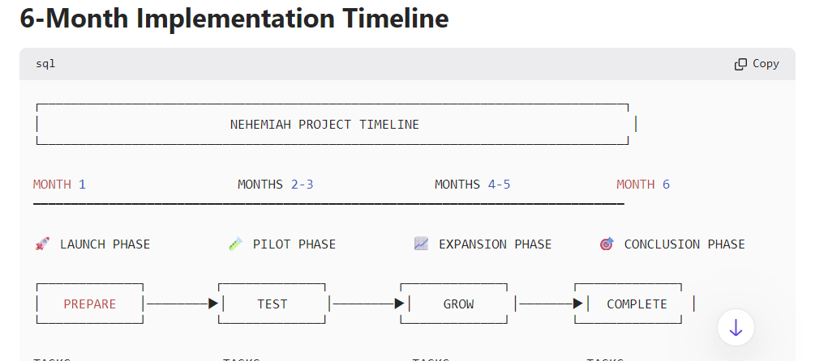
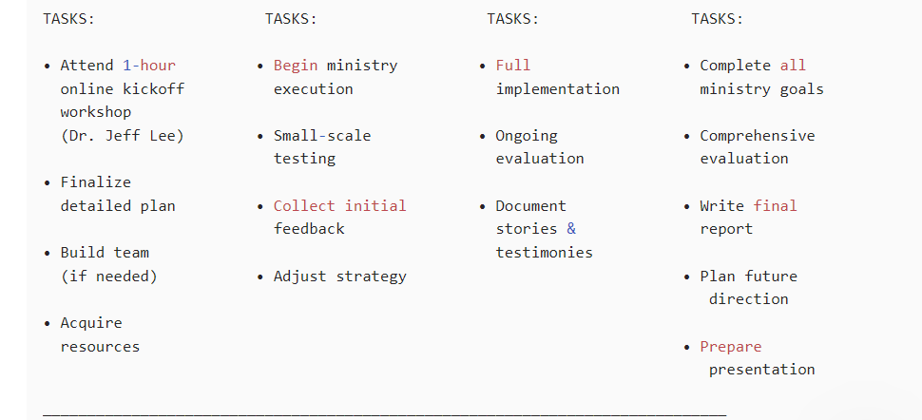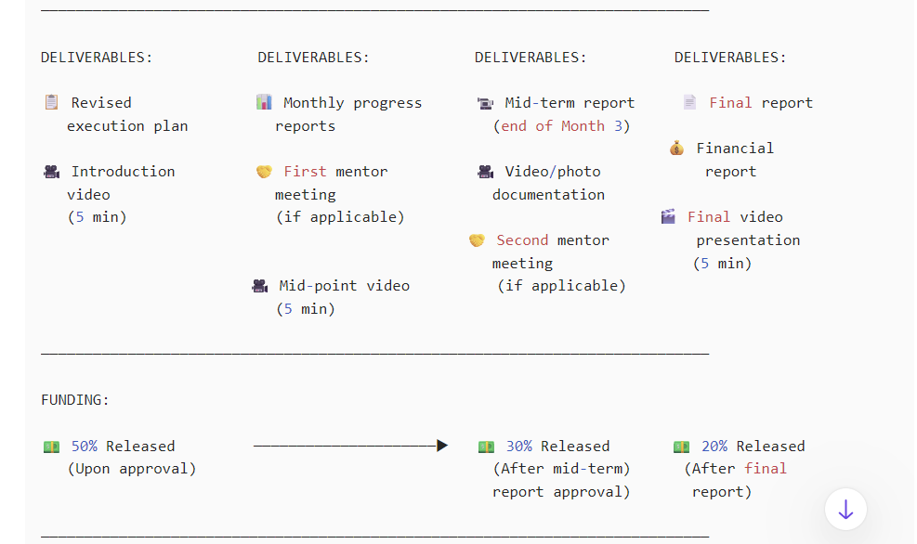

# 6-Month Implementation Timeline

```
┌─────────────────────────────────────────────────────────────────────────────┐
│ NEHEMIAH PROJECT TIMELINE │
└─────────────────────────────────────────────────────────────────────────────┘

MONTH 1 MONTHS 2-3 MONTHS 4-5 MONTH 6
━━━━━━━━━━━━━━━━━━━━━━━━━━━━━━━━━━━━━━━━━━━━━━━━━━━━━━━━━━━━━━━━━━━━━━━━━━━━━━

🚀 LAUNCH PHASE 🧪 PILOT PHASE 📈 EXPANSION PHASE 🎯 CONCLUSION PHASE

┌─────────────┐ ┌─────────────┐ ┌─────────────┐ ┌─────────────┐
│ PREPARE │────────▶│ TEST │────────▶│ GROW │───────▶│ COMPLETE │
└─────────────┘ └─────────────┘ └─────────────┘ └─────────────┘

TASKS: TASKS: TASKS: TASKS:

• Attend 1-hour • Begin ministry • Full • Complete all
online kickoff execution implementation ministry goals
workshop
(Dr. Jeff Lee) • Small-scale • Ongoing • Comprehensive
testing evaluation evaluation
• Finalize
detailed plan • Collect initial • Document • Write final
feedback stories & report
• Build team testimonies
(if needed) • Adjust strategy • Plan future
direction
• Acquire
resources • Prepare
presentation

─────────────────────────────────────────────────────────────────────────────

DELIVERABLES: DELIVERABLES: DELIVERABLES: DELIVERABLES:

📋 Revised 📊 Monthly progress 📹 Mid-term report 📄 Final report
execution plan reports (end of Month 3)
💰 Financial
🎥 Introduction 🤝 First mentor 🎥 Video/photo report
video meeting documentation
(5 min) (if applicable) 🎬 Final video
🤝 Second mentor presentation
meeting (5 min)
🎥 Mid-point video (if applicable)
(5 min)

─────────────────────────────────────────────────────────────────────────────

FUNDING:

💵 50% Released ─────────────────────▶ 💵 30% Released 💵 20% Released
(Upon approval) (After mid-term) (After final
report approval) report)

─────────────────────────────────────────────────────────────────────────────

MILESTONES:

✓ ✓ ✓ ✓
Project Start Pilot Launch Full Scale Project Complete
│ │ │ │
└────────────────────────┴────────────────────────┴────────────────────┘
6 MONTHS
```

---

## Quick Reference Guide

| **Phase** | **Duration** | **Focus** | **Key Deliverable** |
|-----------|-------------|-----------|---------------------|
| 🚀 **Launch** | Month 1 | Preparation | Execution plan + Intro video |
| 🧪 **Pilot** | Months 2-3 | Testing | Monthly reports + Mid-point video |
| 📈 **Expansion** | Months 4-5 | Growth | Mid-term report + Documentation |
| 🎯 **Conclusion** | Month 6 | Completion | Final report + Final video |
---
Video Documentation Schedule
```
Month 1 Month 3 Month 6
│ │ │
▼ ▼ ▼
🎥 Intro 🎥 Mid-Point 🎥 Final
(5 min) (5 min) (5 min)
```

┌─────────────────────────────────────────────────────────────────────────────┐
│ NEHEMIAH PROJECT TIMELINE │
└─────────────────────────────────────────────────────────────────────────────┘

MONTH 1 MONTHS 2-3 MONTHS 4-5 MONTH 6
━━━━━━━━━━━━━━━━━━━━━━━━━━━━━━━━━━━━━━━━━━━━━━━━━━━━━━━━━━━━━━━━━━━━━━━━━━━━━━

🚀 LAUNCH PHASE 🧪 PILOT PHASE 📈 EXPANSION PHASE 🎯 CONCLUSION PHASE

┌─────────────┐ ┌─────────────┐ ┌─────────────┐ ┌─────────────┐
│ PREPARE │────────▶│ TEST │────────▶│ GROW │───────▶│ COMPLETE │
└─────────────┘ └─────────────┘ └─────────────┘ └─────────────┘

TASKS: TASKS: TASKS: TASKS:

• Attend 1-hour • Begin ministry • Full • Complete all
online kickoff execution implementation ministry goals
workshop
(Dr. Jeff Lee) • Small-scale • Ongoing • Comprehensive
testing evaluation evaluation
• Finalize
detailed plan • Collect initial • Document • Write final
feedback stories & report
• Build team testimonies
(if needed) • Adjust strategy • Plan future
direction
• Acquire
resources • Prepare
presentation

────────────────────────────────────────────────────────────

DELIVERABLES: DELIVERABLES: DELIVERABLES: DELIVERABLES:

📋 Revised 📊 Monthly progress 📹 Mid-term report 📄 Final report
execution plan reports (end of Month 3)
💰 Financial
🎥 Introduction 🤝 First mentor 🎥 Video/photo report
video meeting documentation
(5 min) (if applicable) 🎬 Final video
🤝 Second mentor presentation
meeting (5 min)
🎥 Mid-point video (if applicable)
(5 min)

────────────────────────────────────────────────────────────
FUNDING:

💵 50% Released ─────────────────────▶ 💵 30% Released 💵 20% Released
(Upon approval) (After mid-term) (After final
report approval) report)

────────────────────────────────────────────────────────────

MILESTONES:

✓ ✓ ✓ ✓
Project Start Pilot Launch Full Scale Project Complete
│ │ │ │
└────────────────────────┴────────────────────────┴────────────────────┘
6 MONTHS

