Shakyamuni Buddha Puja
h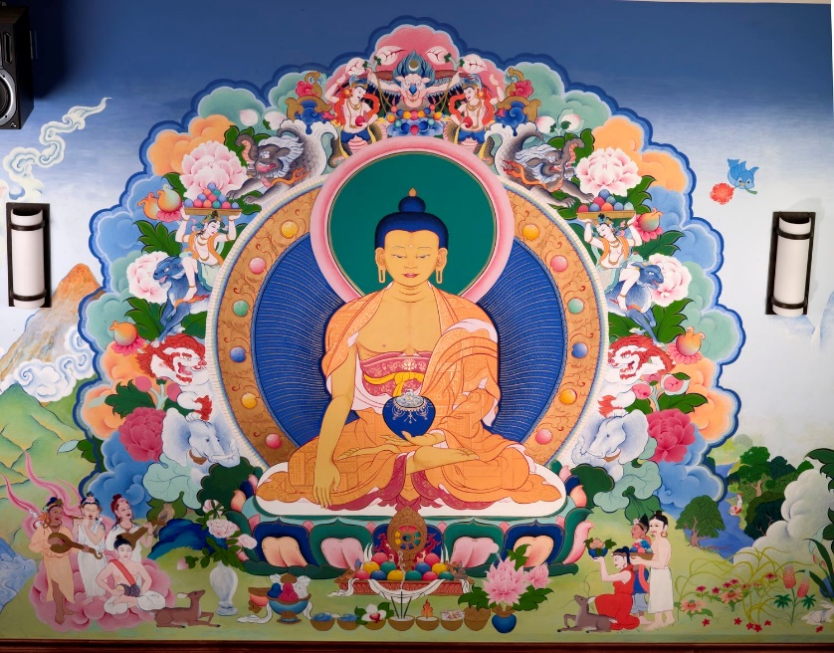

Buddha Puja: Opening the Path of Stainless Wisdom
NAMO GURU SHAKYMUNAYE:
In the Samadhi Sutra it is said: “Whoever remembers the moon-like Buddha while walking, sitting, standing or sleeping, in front of that person the Buddha will always remain until they attain nirvana.” It is also said, “The complexion of his body is like gold. The protector of the world is glorious in all aspects. Whoever meditates on him practices the contemplation of the Bodhisattvas.”
Refuge:
Buddham Sharanam Gacchami
Dhammam Sharanam Gacchami
Sangham Sharanam Gacchami
To the excellent Buddha, Dharma and Sangha I go for refuge until the attainment of enlightenment. By the gathering of all merit may I attain the state of Buddhahood for the sake of all sentient beings.

Bodhicitta:
May all beings have happiness and the causes of pure joy. May all be free from suffering and the causes of their pain. May all abide in equal view not caught up in loss and gain.
Through this great wish for every being may I know their hearts as mine.
Appearances appear and yet are empty. Emptiness is empty and yet appearances present themselves. Although phenomena appear, they exist only like a dream, a water moon. Keeping this in mind:
Visualization:
Union of the unborn vastness and the luminous vast display, manifesting as the throne seat and a lotus, sun and moon. Peerless is the precious Buddha, Lion of the Shakya clan, golden-colored, smiling gently, clothed in robes like early sunrise.
His right hand in the earth-touch mudra, his left hand holds a bowl of nectar. The brilliant glory of his wisdom, his luminous nature of compassion, shines like rays of golden sunlight, filling space in all directions. Lord of refuge and compassion, lord of bliss and emptiness, contemplating your dispassion liberates from all extremes.
The extreme of eternalism is cut through by Buddha’s wisdom of emptiness and the extreme of nihilism is cut through by Buddha’s compassion.
If you concentrate on the Buddha with a mind of devotion he will, in fact, in his wisdom form, be present. His blessing will dwell wherever he is visualized with the union of concentration and devotion. By making offerings to the Buddha in this form, merit will accumulate and disperse the clouds of obscuration and hindrance until all suffering in samsara is exhausted.
Homage:
You who are the foremost victor, you who are the supreme lotus, compassionate one of aspiration, who holds all beings in loving kindness,
To you whose wisdom penetrating liberates delusion’s root, whose rays of blessing shine like sunlight, with devotion I pay homage.
Offering:
OM: From the boundless nature of space,
with boundless pure sublime intention,
inconceivable the boundless offerings,
drinking water spontaneously present.
OM GURU SARVA TATHAGATA SAPARIVARA ARGHAM PRATICHA SOHA
OM: From the boundless nature of space,
with boundless pure sublime intention,
inconceivable the boundless offerings,
bathing water spontaneously present
OM GURU SARVA TATHAGATA SAPARIVARA PADYAM PRATICHA SOHA
OM: From the boundless nature of space,
with boundless pure sublime intention,
inconceivable the boundless offerings,
flowers pleasing spontaneously present.
OM GURU SARVA TATHAGATA SAPARIVARA PUSHPE PRATICHA SOHA
OM: From the boundless nature of space,
with boundless pure sublime intention,
inconceivable the boundless offerings,
fragrant incense spontaneously present.
OM GURU SARVA TATHAGATA SAPARIVARA DHUPE PRATICHA SOHA
OM: From the boundless nature of space,
with boundless pure sublime intention,
inconceivable the boundless offerings,
lamps and lights spontaneously present.
OM GURU SARVA TATHAGATA SAPARIVARA ALOKE PRATICHA SOHA
OM: From the boundless nature of space,
with boundless pure sublime intention,
inconceivable the boundless offerings,
perfumes, scent spontaneously present.
OM GURU SARVA TATHAGATA SAPARIVARA GENDHE PRATICHA SOHA
OM: From the boundless nature of space,
with boundless pure sublime intention,
inconceivable the boundless offerings,
celestial food spontaneously present.
OM GURU SARVA TATHAGATA SAPARIVARA NEVIDYA PRATICHA SOHA
OM: From the boundless nature of space,
with boundless pure sublime intention,
inconceivable the boundless offerings,
wondrous Music spontaneously present.
OM GURU SARVA TATHAGATA SAPARIVARA SHABDA PRATICHA SOHA
Confession:
Actions born from fierce delusion, arisen from my clouded view, confessed now with remorse, repentance, purified in wisdom bliss.
Rejoicing:
I rejoice in every action filled with merit and with wisdom, and rejoice in joy and loving, filling all the lives of beings.
Requesting/Beseeching:
May the wheel of sacred teachings, spread to beings vast in number and may the precious wisdom body, for the sake of beings, remain.
Dedication:
Through intentions of pure love, through the merit generated, may all beings without exception realize your unborn mind. Within the fortress of your wisdom, compassion, bliss and emptiness, all appearance, every atom luminous empty pure appearance, playful beauty manifesting, uncontrived your vast display.
With confidence and heart felt yearning I call to you with pure devotion.
Reciting the Names of the Buddha:
With strong confidence in the blessing force and with the actual Buddha before you, arisen from the alchemical mixture of concentration and devotion according to the Buddha’s word, recite the following and visualize a stream of offerings from your heart carried by rainbow light to the heart of the Buddha. Repeat many times.
Supreme teacher, Blessed One, Thus Gone, Subduer of Delusion, Fully Enlightened, Glorious Lion, Conquering Lord Shakyamuni, to you I pray and offer homage; in you I take my only refuge.
Invocation of the Buddha’s Mind:
TADYATHA: OM MUNE MUNE MAHAMUNAYE SOHA
From repeating the names of Buddha and the mantra of the Buddha, rays of wisdom light and love pour forth from the form of the Buddha and pervade all space and your own body. Light and love purify all obscurations and restore all beings to their natural state.
When getting ready to arise from meditation, engage the two-fold breath of compassion (tonglen). During between-meditation times, “flash” on the presence of the sublime compassionate one throughout the day and feel his rays of wisdom love pervading all appearance. Recite the mantra at any time and engage the practice of tonglen. It is good to make small offerings throughout the day – when you see water make a mental offering of this water, when you see light, beauty ... Read the Prajnaparamita aloud as an offering, make tsa tsas, sing mantras, build stupas and offer friendship; this firmly establishes the Mahayana.
Final Dedication:
Just as the Bodhisattvas Manjushri and Samantabhadra, and all noble ones attained wisdom through following the steps of your path, I too will train myself to follow them. For the sake of every precious sentient being, I dedicate the merit of virtuous action.
Aspiration:
May the intention of the bliss gone ones be my intention.
May the wisdom of the bliss gone ones be my wisdom.
May the compassion of the bliss gone ones be my compassion. May the deeds of the bliss gone ones be my deeds.
May all beings not even know the word suffering and
may all beings attain the state of the Thus Gone One.
no wisdom, no attainment, and no non-attainment. Therefore, Shariputra, since the bodhisattvas have no attainment, they abide by means of Prajnaparamita.
Since there is no obscuration of mind, there is no fear. They transcend falsity and attain complete nirvana. All the Buddhas of the three times, by means of Prajnaparamita, fully awaken to unsurpassable, true, complete enlightenment. Therefore, the great mantra of Prajnaparamita, the mantra of great insight, the unsurpassed mantra, the unequaled mantra, the mantra that calms all suffering, should be known as truth, since there is no deception. The Prajnaparamita mantra is said in this way:
OM GATE GATE PARAGATE PARASAMGATE BODHI SVAHA
Thus, Shariputra, the bodhisattva mahasattva should train in the profound Prajnaparamita.
Then the Blessed One arose from that samadhi and praised noble Avalokiteshvara, the bodhisattva mahasattva, saying “Good, good, O son of noble family; thus it is, O son of noble family, thus it is. One should practice the profound Prajnaparamita just as you have taught and all the Tathagatas will rejoice.”
When the Blessed One had said this, venerable Shariputra and noble Avalokiteshvara, the bodhisattva mahasattva, that whole assembly and the world with its gods, humans, asuras, and gandharvas rejoiced and praised the words of the Blessed One.

